1. **How Do We Find Disease-Causing Mutations? (Week 1)**

5 questions

1  
point

1.

True or False: The most efficient way to map reads to a reference genome is by using global alignment to align each read to the reference genome.



True



False

1  
point

2.

What is the runtime of BruteForcePatternMatching?



O(|*LongestPattern*|)



O(|*Text*|*|*Patterns*| + |*Patterns*|)



O(|*Text*|*|*Patterns*|)



O(|*Text*|2)

1  
point

3. Which patterns could have been used to construct the following trie? (Select all that apply.)

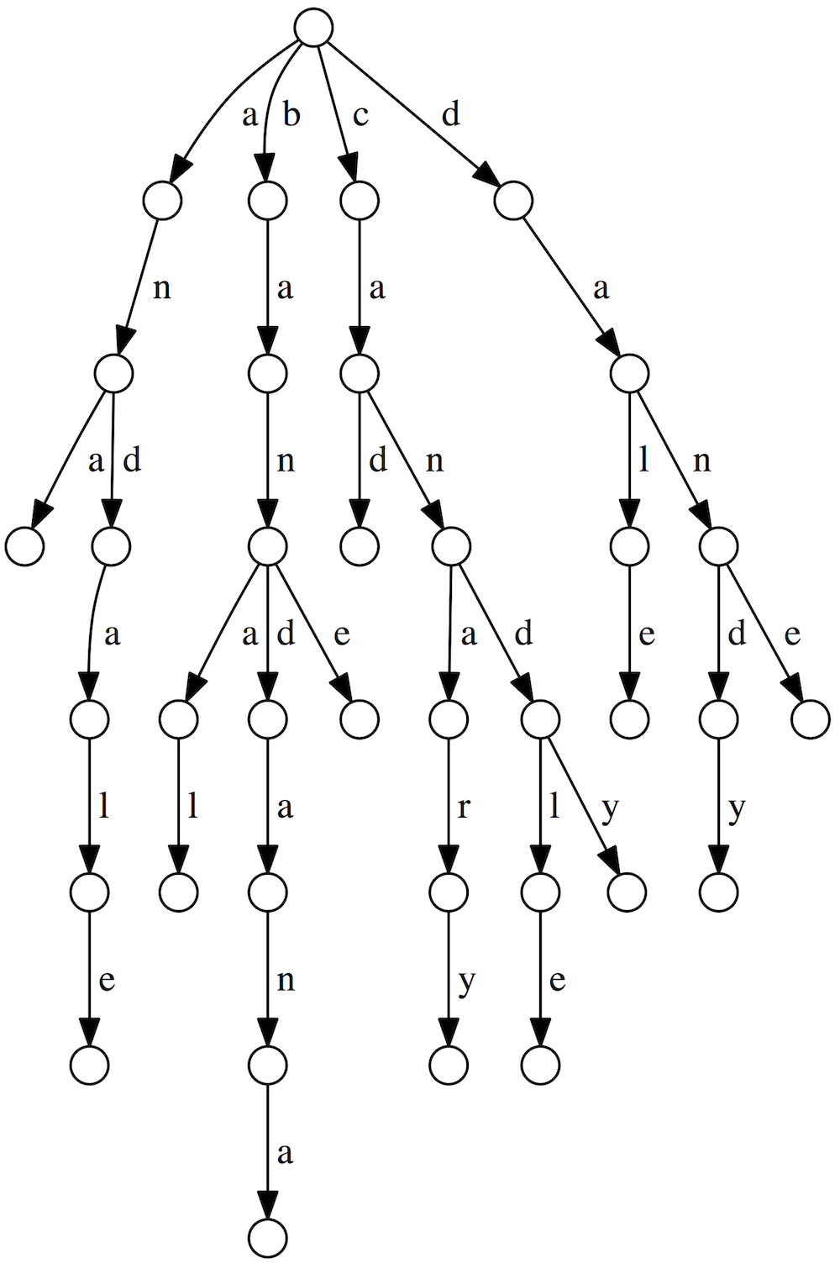

and



cad



ananas



cane

1  
point

4.

Given the following suffix trie/suffix tree of an unknown text, identify all starting positions in the underlying text of Pattern = "an". Use 0-based indexing and enter the starting positions as space-separated integers **in increasing order**.

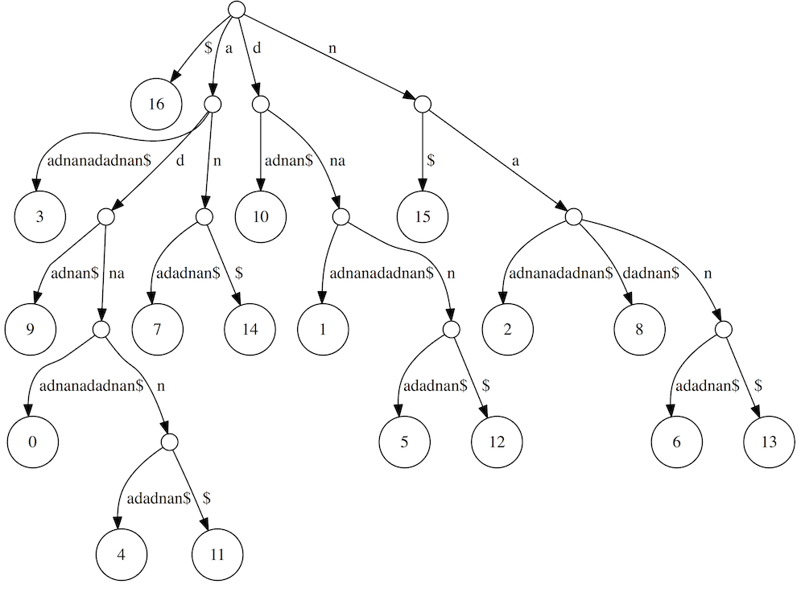



1  
point

5.

How many leaves will *SuffixTree*("GCCAGCTCTTTCAGTATCATGGAGCCCATGG$") have?

