Matlab科学计算课程论文

题目：
班级：
姓名：
学号：

考 察 项 目
界面的美观性 | 功能的完整性 |  | 论文的规范性 | 代码的规范性
评语：
总 分
阅 卷 人
日 期

二维图形的GUI程序设计

一、GUI的布局
本程序中的GUI界面布局主要采取的是Box Layout的布局方式。其中左边依次是二维图形绘画的组件“轴”，以及两个标题面板。两个标题面板是“x的取值范围（必填）”和“函数（必填）”，用于输入二维图形的函数，以及自变量的取值范围。
右边主要包括两个标题面板，分别是“图像属性设置”和“坐标系的设置（必填）”。“图像属性设置”面板用于设置绘制出来的图形的颜色，线宽，以及线型，这三个属性的设置采用“弹出式菜单项组件”。而网格的设置则采用“单选按钮”组件。“坐标系的设置（必填）”面板是用来设置纵轴和横轴的刻度。
GUI界面的最下方则是按钮“画图”，当用户输入了x的取值范围、函数以及坐标系的设置这三个必填项，点击“画图”按钮，则可以绘制出图形。
具体的GUI布局界面如图1所示。
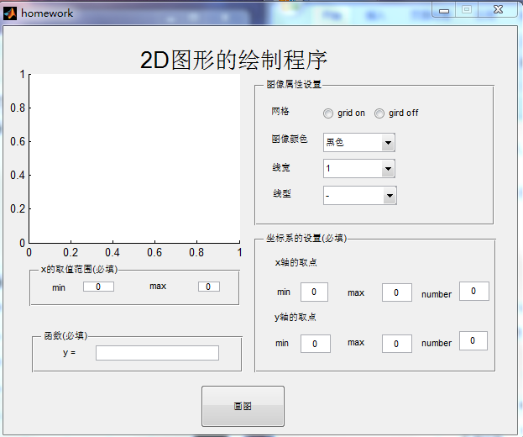
图1 GUI界面
二、功能模块实现
本程序中的功能模块主要分为三部分。第一部分是函数的输入，自变量取值范围的限定，如图2。当用户输入了函数和自变量的取值范围，相应的程序获取用户的输入值。第二部分是坐标系的设置，如图3。这部分是用于限定坐标系的刻度。当确定第一、二部分的正确输入，则可以点击“画图”按钮，绘制图形。具体的实现代码如下：
function pushbutton1_Callback(hObject, eventdata, handles)
% hObject handle to pushbutton1 (see GCBO)
% eventdata reserved - to be defined in a future version of MATLAB
% handles structure with handles and user data (see GUIDATA)
global h
a = get(handles.min,'String');
b = get(handles.max,'String');
a = str2double(a);
b = str2double(b);
x = linspace(a,b,100);
y = get(handles.edit5,'String');
xmin = get(handles.xmin,'String');
xmin = str2double(xmin);
xmax = get(handles.xmax,'String');
xmax = str2double(xmax);
xnumber = get(handles.xnumber,'String');
xnumber = str2double(xnumber);

ymin = get(handles.ymin,'String');
ymin = str2double(ymin);
ymax = get(handles.ymax,'String');
ymax = str2double(ymax);
ynumber = get(handles.ynumber,'String');
ynumber = str2double(ynumber);
xlabel = linspace(xmin,xmax,xnumber);
ylabel = linspace(ymin,ymax,ynumber);
h = plot(x,eval(y),'k');
set(gca,'Xtick',xlabel,'Ytick',ylabel);

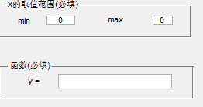
图2 函数输入
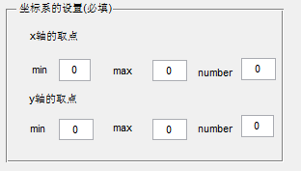
图3 坐标系的设置

功能模块的第三部分是图形的属性设置。当绘制出图形后，用户可根据观察需要，设置图形的颜色、线宽、线型以及网格的开启，如图4。具体的实现代码如下：
1、颜色设置代码
function colorChoose_Callback(hObject, eventdata, handles)
global h;
val = get(hObject ,'value');
switch (val)
case 1
set(h,'Color','k');
case 2
set(h,'Color','r');
case 3
set(h,'Color','g');
case 4
set(h,'Color','b');
end

2、线宽设置代码
function lineWidth_Callback(hObject, eventdata, handles)
global h;
val = get(hObject ,'value');
switch (val)
case 1
set(h,'LineWidth',1);
case 2
set(h,'LineWidth',2);
case 3
set(h,'LineWidth',3);
case 4
set(h,'LineWidth',4);
end
3、线型设置代码
function popupmenu4_Callback(hObject, eventdata, handles)
global h;
val = get(hObject ,'value');
switch (val)
case 1
set(h,'LineStyle','-');
case 2
set(h,'LineStyle','-.');
case 3
set(h,'LineStyle',':');
case 4
set(h,'LineStyle','--');
end

4、网格设置代码
function gridon_Callback(hObject, eventdata, handles)
set(handles.gridoff,'Value',0);
grid on

function gridoff_Callback(hObject, eventdata, handles)
set(handles.gridon,'Value',0);
grid off

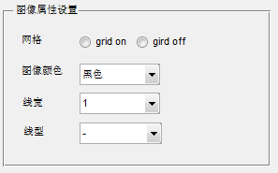
图4 图像的属性设置

三、结果演示和说明

1、输入函数、自变量取值范围、坐标系，绘制的图形如图5
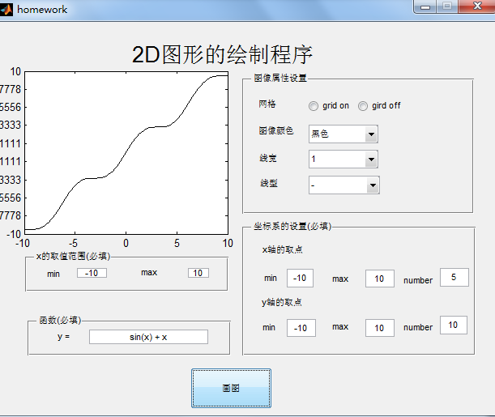
图5
2、图形属性的设置
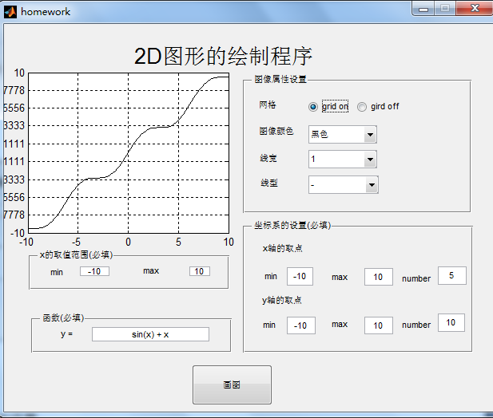
图6 开启网格

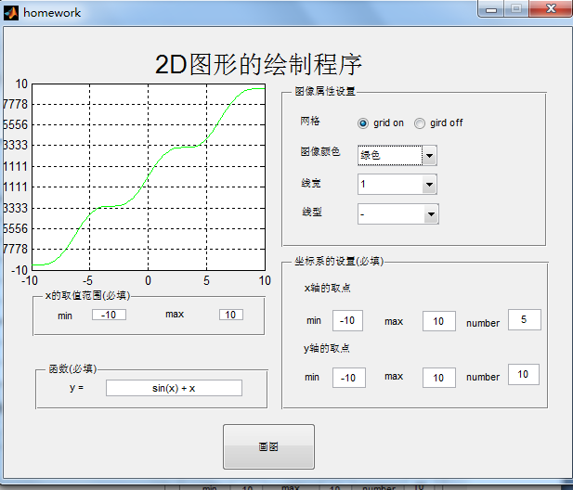
图7 设置图像颜色

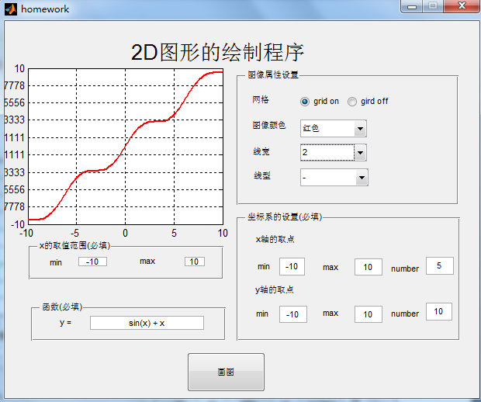
图8 图形颜色设置和线宽设置

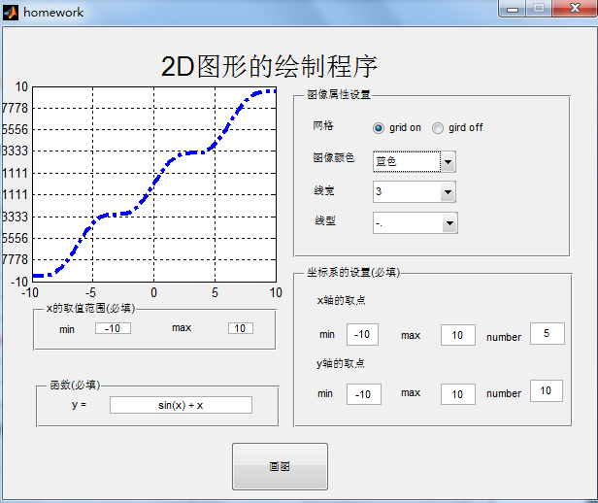
图9 图形颜色、线宽、线型的设置
四、实验心得
在程序设计过程中，经常会遇到不懂的问题，比如如何获取用户的输入值，如何获取全局变量。不懂的时候，自己就会尝试独立思考，努力寻找合适的解决方案。同时，也会和同学积极地讨论问题。或者，上网查询资料。
本程序中有明显的不足之处在于容错性能不高，比如用户的不规范操作，输入的不是数字，必填项没有填写完整，在没有绘制出图形的时候就设置图形属性，这些都会导致程序出错。所以，本程序仍然需要不断地改进，update!

附录（可执行的完整代码）
function varargout = homework(varargin)
% HOMEWORK MATLAB code for homework.fig
% HOMEWORK, by itself, creates a new HOMEWORK or raises the existing
% singleton*.
%
% H = HOMEWORK returns the handle to a new HOMEWORK or the handle to
% the existing singleton*.
%
% HOMEWORK('CALLBACK',hObject,eventData,handles,...) calls the local
% function named CALLBACK in HOMEWORK.M with the given input arguments.
%
% HOMEWORK('Property','Value',...) creates a new HOMEWORK or raises the
% existing singleton*. Starting from the left, property value pairs are
% applied to the GUI before homework_OpeningFcn gets called. An
% unrecognized property name or invalid value makes property application
% stop. All inputs are passed to homework_OpeningFcn via varargin.
%
% *See GUI Options on GUIDE's Tools menu. Choose "GUI allows only one
% instance to run (singleton)".
%
% See also: GUIDE, GUIDATA, GUIHANDLES

% Edit the above text to modify the response to help homework

% Last Modified by GUIDE v2.5 22-Jun-2016 23:12:22

% Begin initialization code - DO NOT EDIT
gui_Singleton = 1;
gui_State = struct('gui_Name', mfilename, ...
'gui_Singleton', gui_Singleton, ...
'gui_OpeningFcn', @homework_OpeningFcn, ...
'gui_OutputFcn', @homework_OutputFcn, ...
'gui_LayoutFcn', [] , ...
'gui_Callback', []);
if nargin && ischar(varargin{1})
gui_State.gui_Callback = str2func(varargin{1});
end

if nargout
[varargout{1:nargout}] = gui_mainfcn(gui_State, varargin{:});
else
gui_mainfcn(gui_State, varargin{:});
end
% End initialization code - DO NOT EDIT

% --- Executes just before homework is made visible.
function homework_OpeningFcn(hObject, eventdata, handles, varargin)
% This function has no output args, see OutputFcn.
% hObject handle to figure
% eventdata reserved - to be defined in a future version of MATLAB
% handles structure with handles and user data (see GUIDATA)
% varargin command line arguments to homework (see VARARGIN)

% Choose default command line output for homework
handles.output = hObject;

% Update handles structure
guidata(hObject, handles);

% UIWAIT makes homework wait for user response (see UIRESUME)
% uiwait(handles.figure1);

% --- Outputs from this function are returned to the command line.
function varargout = homework_OutputFcn(hObject, eventdata, handles)
% varargout cell array for returning output args (see VARARGOUT);
% hObject handle to figure
% eventdata reserved - to be defined in a future version of MATLAB
% handles structure with handles and user data (see GUIDATA)

% Get default command line output from handles structure
varargout{1} = handles.output;

% --- Executes on button press in pushbutton1.
function pushbutton1_Callback(hObject, eventdata, handles)
% hObject handle to pushbutton1 (see GCBO)
% eventdata reserved - to be defined in a future version of MATLAB
% handles structure with handles and user data (see GUIDATA)
global h %¶¨ÒåÈ«¾Ö±äÁ¿h
%a¡¢bÎªxµÄÈ¡Öµ·¶Î§
a = get(handles.min,'String');
b = get(handles.max,'String');
a = str2double(a);
b = str2double(b);
x = linspace(a,b,100);
y = get(handles.edit5,'String');
%xmin,xmax,ymin,ymax,·Ö±ð±íÊ¾xÖáºÍyÖá×ø±êÏµµÄ¿Ì¶ÈµÄÈ¡Öµ·¶Î§
%xnumber,ynumber·Ö±ð±íÊ¾xÖáºÍyÖá×ø±êÏµµÄ¿Ì¶ÈµãµÄ¸öÊý
xmin = get(handles.xmin,'String');
xmin = str2double(xmin);
xmax = get(handles.xmax,'String');
xmax = str2double(xmax);
xnumber = get(handles.xnumber,'String');
xnumber = str2double(xnumber);

ymin = get(handles.ymin,'String');
ymin = str2double(ymin);
ymax = get(handles.ymax,'String');
ymax = str2double(ymax);
ynumber = get(handles.ynumber,'String');
ynumber = str2double(ynumber);
xlabel = linspace(xmin,xmax,xnumber);
ylabel = linspace(ymin,ymax,ynumber);

% axis([xmin xmax ymin ymax]);

h = plot(x,eval(y),'k');

set(gca,'Xtick',xlabel,'Ytick',ylabel);
function edit5_Callback(hObject, eventdata, handles)
% hObject handle to edit5 (see GCBO)
% eventdata reserved - to be defined in a future version of MATLAB
% handles structure with handles and user data (see GUIDATA)

% Hints: get(hObject,'String') returns contents of edit5 as text
% str2double(get(hObject,'String')) returns contents of edit5 as a double

% --- Executes during object creation, after setting all properties.
function edit5_CreateFcn(hObject, eventdata, handles)
% hObject handle to edit5 (see GCBO)
% eventdata reserved - to be defined in a future version of MATLAB
% handles empty - handles not created until after all CreateFcns called

% Hint: edit controls usually have a white background on Windows.
% See ISPC and COMPUTER.
if ispc && isequal(get(hObject,'BackgroundColor'), get(0,'defaultUicontrolBackgroundColor'))
set(hObject,'BackgroundColor','white');
end

function min_Callback(hObject, eventdata, handles)
% hObject handle to min (see GCBO)
% eventdata reserved - to be defined in a future version of MATLAB
% handles structure with handles and user data (see GUIDATA)

% Hints: get(hObject,'String') returns contents of min as text
% str2double(get(hObject,'String')) returns contents of min as a double

% --- Executes during object creation, after setting all properties.
function min_CreateFcn(hObject, eventdata, handles)
% hObject handle to min (see GCBO)
% eventdata reserved - to be defined in a future version of MATLAB
% handles empty - handles not created until after all CreateFcns called

% Hint: edit controls usually have a white background on Windows.
% See ISPC and COMPUTER.
if ispc && isequal(get(hObject,'BackgroundColor'), get(0,'defaultUicontrolBackgroundColor'))
set(hObject,'BackgroundColor','white');
end

function max_Callback(hObject, eventdata, handles)
% hObject handle to max (see GCBO)
% eventdata reserved - to be defined in a future version of MATLAB
% handles structure with handles and user data (see GUIDATA)

% Hints: get(hObject,'String') returns contents of max as text
% str2double(get(hObject,'String')) returns contents of max as a double

% --- Executes during object creation, after setting all properties.
function max_CreateFcn(hObject, eventdata, handles)
% hObject handle to max (see GCBO)
% eventdata reserved - to be defined in a future version of MATLAB
% handles empty - handles not created until after all CreateFcns called

% Hint: edit controls usually have a white background on Windows.
% See ISPC and COMPUTER.
if ispc && isequal(get(hObject,'BackgroundColor'), get(0,'defaultUicontrolBackgroundColor'))
set(hObject,'BackgroundColor','white');
end

% --- Executes on button press in gridon.
function gridon_Callback(hObject, eventdata, handles)
% hObject handle to gridon (see GCBO)
% eventdata reserved - to be defined in a future version of MATLAB
% handles structure with handles and user data (see GUIDATA)
set(handles.gridoff,'Value',0);
grid on
% Hint: get(hObject,'Value') returns toggle state of gridon

% --- Executes on button press in gridoff.
function gridoff_Callback(hObject, eventdata, handles)
% hObject handle to gridoff (see GCBO)
% eventdata reserved - to be defined in a future version of MATLAB
% handles structure with handles and user data (see GUIDATA)
set(handles.gridon,'Value',0);
grid off
% Hint: get(hObject,'Value') returns toggle state of gridoff

% --- Executes on selection change in colorChoose.
function colorChoose_Callback(hObject, eventdata, handles)
% hObject handle to colorChoose (see GCBO)
% eventdata reserved - to be defined in a future version of MATLAB
% handles structure with handles and user data (see GUIDATA)
global h;
val = get(hObject ,'value');
switch (val)
case 1
set(h,'Color','k');
case 2
set(h,'Color','r');
case 3
set(h,'Color','g');
case 4
set(h,'Color','b');
end
% Hints: contents = cellstr(get(hObject,'String')) returns colorChoose contents as cell array
% contents{get(hObject,'Value')} returns selected item from colorChoose

% --- Executes during object creation, after setting all properties.
function colorChoose_CreateFcn(hObject, eventdata, handles)
% hObject handle to colorChoose (see GCBO)
% eventdata reserved - to be defined in a future version of MATLAB
% handles empty - handles not created until after all CreateFcns called

% Hint: popupmenu controls usually have a white background on Windows.
% See ISPC and COMPUTER.
if ispc && isequal(get(hObject,'BackgroundColor'), get(0,'defaultUicontrolBackgroundColor'))
set(hObject,'BackgroundColor','white');
end

% --- Executes on selection change in lineWidth.
function lineWidth_Callback(hObject, eventdata, handles)
% hObject handle to lineWidth (see GCBO)
% eventdata reserved - to be defined in a future version of MATLAB
% handles structure with handles and user data (see GUIDATA)
global h;
val = get(hObject ,'value');
switch (val)
case 1
set(h,'LineWidth',1);
case 2
set(h,'LineWidth',2);
case 3
set(h,'LineWidth',3);
case 4
set(h,'LineWidth',4);
end
% Hints: contents = cellstr(get(hObject,'String')) returns lineWidth contents as cell array
% contents{get(hObject,'Value')} returns selected item from lineWidth

% --- Executes during object creation, after setting all properties.
function lineWidth_CreateFcn(hObject, eventdata, handles)
% hObject handle to lineWidth (see GCBO)
% eventdata reserved - to be defined in a future version of MATLAB
% handles empty - handles not created until after all CreateFcns called

% Hint: popupmenu controls usually have a white background on Windows.
% See ISPC and COMPUTER.
if ispc && isequal(get(hObject,'BackgroundColor'), get(0,'defaultUicontrolBackgroundColor'))
set(hObject,'BackgroundColor','white');
end

% --- Executes on selection change in popupmenu4.
function popupmenu4_Callback(hObject, eventdata, handles)
% hObject handle to popupmenu4 (see GCBO)
% eventdata reserved - to be defined in a future version of MATLAB
% handles structure with handles and user data (see GUIDATA)
global h;
val = get(hObject ,'value');
switch (val)
case 1
set(h,'LineStyle','-');
case 2
set(h,'LineStyle','-.');
case 3
set(h,'LineStyle',':');
case 4
set(h,'LineStyle','--');
end
% Hints: contents = cellstr(get(hObject,'String')) returns popupmenu4 contents as cell array
% contents{get(hObject,'Value')} returns selected item from popupmenu4

% --- Executes during object creation, after setting all properties.
function popupmenu4_CreateFcn(hObject, eventdata, handles)
% hObject handle to popupmenu4 (see GCBO)
% eventdata reserved - to be defined in a future version of MATLAB
% handles empty - handles not created until after all CreateFcns called

% Hint: popupmenu controls usually have a white background on Windows.
% See ISPC and COMPUTER.
if ispc && isequal(get(hObject,'BackgroundColor'), get(0,'defaultUicontrolBackgroundColor'))
set(hObject,'BackgroundColor','white');
end

function xmin_Callback(hObject, eventdata, handles)
% hObject handle to xmin (see GCBO)
% eventdata reserved - to be defined in a future version of MATLAB
% handles structure with handles and user data (see GUIDATA)

% Hints: get(hObject,'String') returns contents of xmin as text
% str2double(get(hObject,'String')) returns contents of xmin as a double

% --- Executes during object creation, after setting all properties.
function xmin_CreateFcn(hObject, eventdata, handles)
% hObject handle to xmin (see GCBO)
% eventdata reserved - to be defined in a future version of MATLAB
% handles empty - handles not created until after all CreateFcns called

% Hint: edit controls usually have a white background on Windows.
% See ISPC and COMPUTER.
if ispc && isequal(get(hObject,'BackgroundColor'), get(0,'defaultUicontrolBackgroundColor'))
set(hObject,'BackgroundColor','white');
end

function xmax_Callback(hObject, eventdata, handles)
% hObject handle to xmax (see GCBO)
% eventdata reserved - to be defined in a future version of MATLAB
% handles structure with handles and user data (see GUIDATA)

% Hints: get(hObject,'String') returns contents of xmax as text
% str2double(get(hObject,'String')) returns contents of xmax as a double

% --- Executes during object creation, after setting all properties.
function xmax_CreateFcn(hObject, eventdata, handles)
% hObject handle to xmax (see GCBO)
% eventdata reserved - to be defined in a future version of MATLAB
% handles empty - handles not created until after all CreateFcns called

% Hint: edit controls usually have a white background on Windows.
% See ISPC and COMPUTER.
if ispc && isequal(get(hObject,'BackgroundColor'), get(0,'defaultUicontrolBackgroundColor'))
set(hObject,'BackgroundColor','white');
end

function ymin_Callback(hObject, eventdata, handles)
% hObject handle to ymin (see GCBO)
% eventdata reserved - to be defined in a future version of MATLAB
% handles structure with handles and user data (see GUIDATA)

% Hints: get(hObject,'String') returns contents of ymin as text
% str2double(get(hObject,'String')) returns contents of ymin as a double

% --- Executes during object creation, after setting all properties.
function ymin_CreateFcn(hObject, eventdata, handles)
% hObject handle to ymin (see GCBO)
% eventdata reserved - to be defined in a future version of MATLAB
% handles empty - handles not created until after all CreateFcns called

% Hint: edit controls usually have a white background on Windows.
% See ISPC and COMPUTER.
if ispc && isequal(get(hObject,'BackgroundColor'), get(0,'defaultUicontrolBackgroundColor'))
set(hObject,'BackgroundColor','white');
end

function ymax_Callback(hObject, eventdata, handles)
% hObject handle to ymax (see GCBO)
% eventdata reserved - to be defined in a future version of MATLAB
% handles structure with handles and user data (see GUIDATA)

% Hints: get(hObject,'String') returns contents of ymax as text
% str2double(get(hObject,'String')) returns contents of ymax as a double

% --- Executes during object creation, after setting all properties.
function ymax_CreateFcn(hObject, eventdata, handles)
% hObject handle to ymax (see GCBO)
% eventdata reserved - to be defined in a future version of MATLAB
% handles empty - handles not created until after all CreateFcns called

% Hint: edit controls usually have a white background on Windows.
% See ISPC and COMPUTER.
if ispc && isequal(get(hObject,'BackgroundColor'), get(0,'defaultUicontrolBackgroundColor'))
set(hObject,'BackgroundColor','white');
end

function xnumber_Callback(hObject, eventdata, handles)
% hObject handle to xnumber (see GCBO)
% eventdata reserved - to be defined in a future version of MATLAB
% handles structure with handles and user data (see GUIDATA)

% Hints: get(hObject,'String') returns contents of xnumber as text
% str2double(get(hObject,'String')) returns contents of xnumber as a double

% --- Executes during object creation, after setting all properties.
function xnumber_CreateFcn(hObject, eventdata, handles)
% hObject handle to xnumber (see GCBO)
% eventdata reserved - to be defined in a future version of MATLAB
% handles empty - handles not created until after all CreateFcns called

% Hint: edit controls usually have a white background on Windows.
% See ISPC and COMPUTER.
if ispc && isequal(get(hObject,'BackgroundColor'), get(0,'defaultUicontrolBackgroundColor'))
set(hObject,'BackgroundColor','white');
end

function ynumber_Callback(hObject, eventdata, handles)
% hObject handle to ynumber (see GCBO)
% eventdata reserved - to be defined in a future version of MATLAB
% handles structure with handles and user data (see GUIDATA)

% Hints: get(hObject,'String') returns contents of ynumber as text
% str2double(get(hObject,'String')) returns contents of ynumber as a double

% --- Executes during object creation, after setting all properties.
function ynumber_CreateFcn(hObject, eventdata, handles)
% hObject handle to ynumber (see GCBO)
% eventdata reserved - to be defined in a future version of MATLAB
% handles empty - handles not created until after all CreateFcns called

% Hint: edit controls usually have a white background on Windows.
% See ISPC and COMPUTER.
if ispc && isequal(get(hObject,'BackgroundColor'), get(0,'defaultUicontrolBackgroundColor'))
set(hObject,'BackgroundColor','white');
end

