Roche Digital Technology
Solution Architecture
RD China Enterprise AI Knowledge Hub

Document ID: PRJ-XXXXXXXX
Version: 1.0
Effective Date: Date of last signature
PMM Template Version: 6.0 [February 2014]

Document Information
Solution Name | RD China Enterprise AI Knowledge Hub
Document Name | Solution Architecture
Document Owner | Product Manager
Document Location | Veeva Quality Docs
Associated Documents

Author
Role | Name | Signature | Date
Solution Architect |  | Electronically signed

Review
Role | Name | Signature | Date
Project Manager |  | Electronically signed

Approval
Role | Name | Signature | Date
Product Manager |  | Electronically signed

Note: The electronic signatures for this document can be found on the e-signature page(s). Manual signatures (if any) are scanned and stored in a separate PDF file in the same location as the original document. This document is considered uncontrolled when printed.
Document History
Version | Changes | Effective Date
1.0 | First Approved version | Date of last signature

Table of Contents Page

1. Document Purpose 4
2. Definitions 5
3. Solution Overview 6
3.1. System/Product Introduction 6
3.2. Business Challenges & Pain Points 6
3.3. High-Level Solution Description & Value Proposition 6
4. Application Architecture 7
4.1. System Context Diagram 7
4.2. Logical Architecture 7
5. Data Architecture 8
5.1. Conceptual Data Model – Information Entities 8
5.2. Data Governance and Compliance 8
5.3. Data Entity Structure and Relation 9
6. Integration Architecture 10
6.1. Integration Strategy 10
6.2. Integration Flow 10
6.3. System Context 10
6.4. API Inventory 11
7. Solutions to Non-Functional Requirements (NFRs) 12
7.1. User Profile Table 12
7.2. Security NFRs 12
7.3. Performance NFRs 13
7.4. Capacity NFRs 13
7.5. Architectural NFRs 13
7.6. AI Specific NFRs 13
7.7. Business Continuity 14
7.7.1 High Availability NFRs 14
7.7.2 Disaster Recovery NFRs 14
7.7.3 Backup NFRs 14
8. Physical Architecture 15
8.1. Physical Architecture Diagram 15
8.2. Network Architecture 15

Document Purpose
The Solution Architecture document serves as a crucial artifact within our Roche Agile Framework implementation, with its primary purpose being to provide a comprehensive blueprint that outlines the intentional architecture of our solutions. This document plays a pivotal role in ensuring that our architecture aligns with our business objectives and continues to evolve to meet emerging design needs and technological advancements.
By fostering collaboration between architecture and DevOps teams, it facilitates seamless integration of architectural principles into our continuous delivery pipeline, thus enabling the creation of robust, scalable, and adaptable solutions that can swiftly respond to changing customer demands while maintaining high levels of quality and reliability.
The architecture in this document is described at the conceptual and logical levels and does not replace detailed design documents (e.g., Design Specification, API Specifications).

Definitions
The following terms and abbreviations are used in this document:
Term |  | Definition
APP |  | Application
LLM |  | Large Language Model
API |  | Application Programming Interface
Leap |  | LEAP is a component of the Rapid Application Development informatics product in the Automation & Rapid Application Development product line.
ADP |  | Agent Development Platform
Trace ID |  | Cross-service tracking ID based on the W3C traceparent standard, used to associate sessions, operations and audit logs
RAG |  | Retrieval-Augmented Generation
MCP |  | Model Context Protocol

Solution Overview

System Introduction
Roche Diagnostics China is constructing an enterprise-grade, AI-driven knowledge hub to centralize and intelligently serve critical business knowledge across multiple domains, including Finance Delegation of Authority (DoA), Finance Travel & Expense (T&E), and Compliance. By integrating and orchestrating knowledge management, intelligent Q&A, and other AI capabilities into a unified platform, this initiative is positioned to become the first pilot project under the company's "Reshape" AI strategy, resonating with the numerous AI-related initiatives across departments under the "Do MORE with LESS" (DMWL) strategic OKR.

Business Challenges & Pain Points
- Business knowledge is fragmented across repositories and domains, increasing search effort and interpretation risk.
- Users need accurate and consistent answers with traceable source references.
- The production solution must go beyond PoC by adding enterprise integration, mobile/WeCom access, admin controls, monitoring and operational tooling.
- Agentic RAG requires a polyglot persistence strategy combining metadata, object storage, vectors, graph relationships and analytics.
- WeCom access introduces edge security, network isolation and availability requirements.

Solution Description
The solution leverages Generative AI (GenAI) and Retrieval-Augmented Generation (RAG) technologies to transform fragmented, siloed documents into a unified, searchable, and intelligent knowledge asset. Following a validated Proof-of-Concept (PoC) phase, this project seeks to evolve the system into a production-grade enterprise application, encompassing full enterprise integration, security hardening, mobile/WeCom access, admin & operations consoles, and operational tooling.
The implementation is aligned to the NGKB reference pattern: source connectors, document parsing, chunking, metadata, vector and graph retrieval, agent orchestration, governance workflow, monitoring and grounded answer generation. NGKB is used in this document as the normalized project architecture reference label.

Application Architecture
The objective of this section is to describe the components that make up the application architecture and how it relates to enterprise resources such as the foundational services, single sign-on, and user interface/device.
Designing a robust and intelligent enterprise knowledge hub presents several multifaceted technical challenges that this architecture aims to resolve:
- Secure WeCom Access and Isolation: The WeCom access introduces new network touchpoints that demand stringent edge security hardening (e.g., WAF, DDoS protection). Furthermore, the architecture must ensure strict resource isolation to protect internal networks, generate fine-grained access logs for security monitoring, and maintain high service availability across diverse user bases without bottlenecking performance.
- Agentic RAG Data Requirements: Delivering an advanced, Agentic RAG (Retrieval-Augmented Generation) experience requires moving beyond simple keyword or document search. It demands a polyglot persistence strategy—combining vector databases for semantic search, graph databases for complex relationship mapping, and relational/OLAP stores—to enable the fine-grained, multi-step knowledge retrieval necessary for accurate AI reasoning.
- Compliant AI Access and Extensibility: The platform must securely orchestrate AI capabilities while strictly adhering to enterprise data privacy and regulatory compliance standards. It also requires on-premises GPU capacity for model hosting and the fine-tuning of localized Small Language Models (SLMs).

System Context Diagram
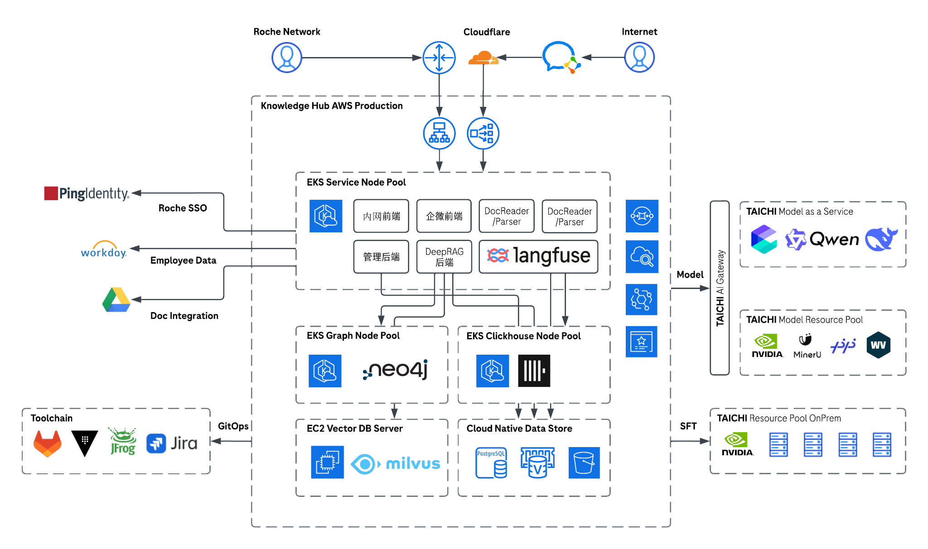

1. User Access
This layer manages how users interact with the system, handling traffic routing, load balancing, and edge security.
- Roche China Diagnostics Users (via Roche Network): Connect securely to the system via internal networks, routed through an AWS Load Balancer (ALB/NLB).
- Roche China Diagnostics Users (via WeCom): Access the system via WeCom. Traffic is protected and routed through Cloudflare for edge security (WAF, CDN, DDoS protection) before hitting the AWS Load Balancers.

2. Identity and SSO
This layer handles authentication, authorization, and user integration.
- Authentication (Roche SSO): Integrates with PingIdentity to provide Single Sign-On for secure access.
- Authentication via WeCom SSO (Internal System Name: WeChatPortal): Integrates with PingIdentity to provide Single Sign-On for secure access. This authentication route needs further discussion and decision.
- User Data: Pulls organizational and user information from Workday and EPP via MuleSoft API.

3. Application Service Pool
Hosted within an Amazon Elastic Kubernetes Service (EKS) environment, this layer contains the core microservices and business logic of the knowledge hub.
- Frontends:
  - Intranet Frontend (内网前端): Web interface for internal user access.
  - WeCom Frontend (企微前端): H5 Web interface for WeCom access channel.
- Backends:
  - Management Backend (管理后端): Handles administrative tasks, user management, and system configuration.
  - DeepRAG Backend: The core engine coordinating Retrieval-Augmented Generation (RAG) workflows, interfacing with databases and the AI models.
- Processing & Observability:
  - DocReader / Parser: Dedicated services for extracting text and processing uploaded documents.
  - Langfuse: An open-source LLM engineering platform used to trace, evaluate, and monitor AI application performance.

4. Data and Storage
The architecture utilizes different database technologies tailored for specific RAG and application needs.
- Graph Database (EKS Graph Node Pool): Uses Neo4j to manage complex relationships and build knowledge graphs.
- Vector Database (EC2 Vector DB Server): Uses Milvus standalone on dedicated EC2 instances for storing and querying high-dimensional vector embeddings, critical for semantic search in RAG.
- OLAP / Analytics (EKS Clickhouse Node Pool): Uses ClickHouse for high-performance analytical queries and processing large volumes of operational data.
- Cloud Native Data Store:
  - PostgreSQL: Relational database for structured application data and metadata.
  - Redis (ElastiCache): In-memory caching to improve read performance and manage sessions.
  - Amazon S3: Object storage for raw documents, backups, and static assets.

5. Document Integration
The architecture will connect to business managed document stores to retrieve recent documents. It requires a knowledge manager to further verify and publish them to the knowledge hub.
- Document Integration: Connects with Google Drive to ingest, index, and sync documents into the knowledge hub.

6. AI and Model Capacities
This layer represents the AI backbone, isolated through an AI Gateway to manage routing, quotas, and security.
- TAICHI AI Gateway: Acts as a centralized proxy router, mediating requests between the DeepRAG backend and the underlying AI models.
- Model as a Service (MaaS): Access to Bailian models, including the Qwen and DeepSeek series.
- Model Resource Pool: Infrastructure for model serving and document parsing, utilizing NVIDIA GPUs, MinerU (for intelligent document extraction), PaddleOCR (for text extraction), and inference engines like vLLM.
- Model Training & FineTuning Resource Pool OnPrem: Dedicated on-premises NVIDIA GPU server racks utilized for Supervised Fine-Tuning (SFT) of localized SLMs.

7. Toolchain for DevSecOps
This layer provides the supporting tools for deployment, secret management, and project management.
- GitOps Toolchain: Continuous Integration and Continuous Deployment (CI/CD) pipelines are managed via a centralized toolchain consisting of GitLab, Vault, and JFrog Artifactory, ensuring automated, version-controlled deployments to the AWS environment.
- Project Management: Utilizes Jira for project management and issue tracking.

Logical Architecture
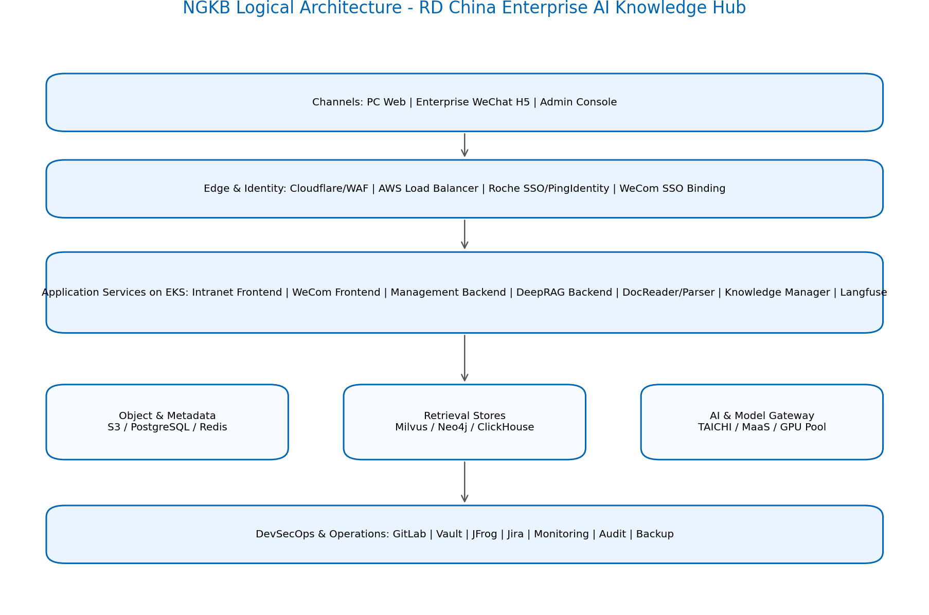
Layer | Components | Responsibilities
User Experience | Intranet Frontend, WeCom Frontend, Admin Console | Questions, citations, management operations and administration
Access and Identity | Cloudflare, AWS LB, Roche SSO, PingIdentity | Secure ingress, authentication and identity mapping
Application Services | Management Backend, DeepRAG Backend, Parser, Knowledge Manager, Langfuse | Knowledge lifecycle, RAG orchestration, parsing, tracing and operations
Knowledge and Retrieval | S3, PostgreSQL, Redis, Milvus, Neo4j, ClickHouse | Document, metadata, cache, vector, graph and analytics storage
AI Services | TAICHI AI Gateway, MaaS models, GPU resource pools | Embedding, inference, parsing, routing and quotas

4.3 Data Ingestion Process Flow
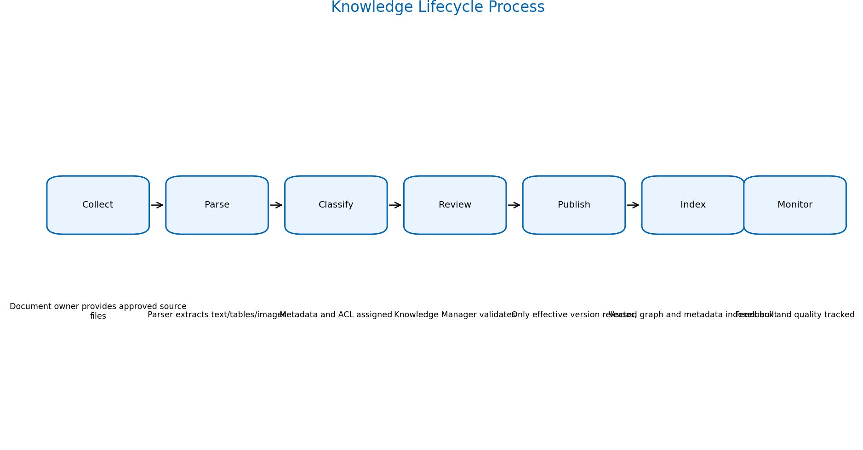
- Source documents are collected from approved business-managed repositories.
- Parser services extract text, tables, charts and images from heterogeneous documents.
- Documents are enriched with domain, owner, language, version, effective date, review status and ACL metadata.
- Knowledge Managers validate staged content before publishing to production retrieval indexes.
- Published content is indexed into vector, graph and metadata stores; unpublished content is excluded from answer generation.

4.4 Agentic Rag Process Flow
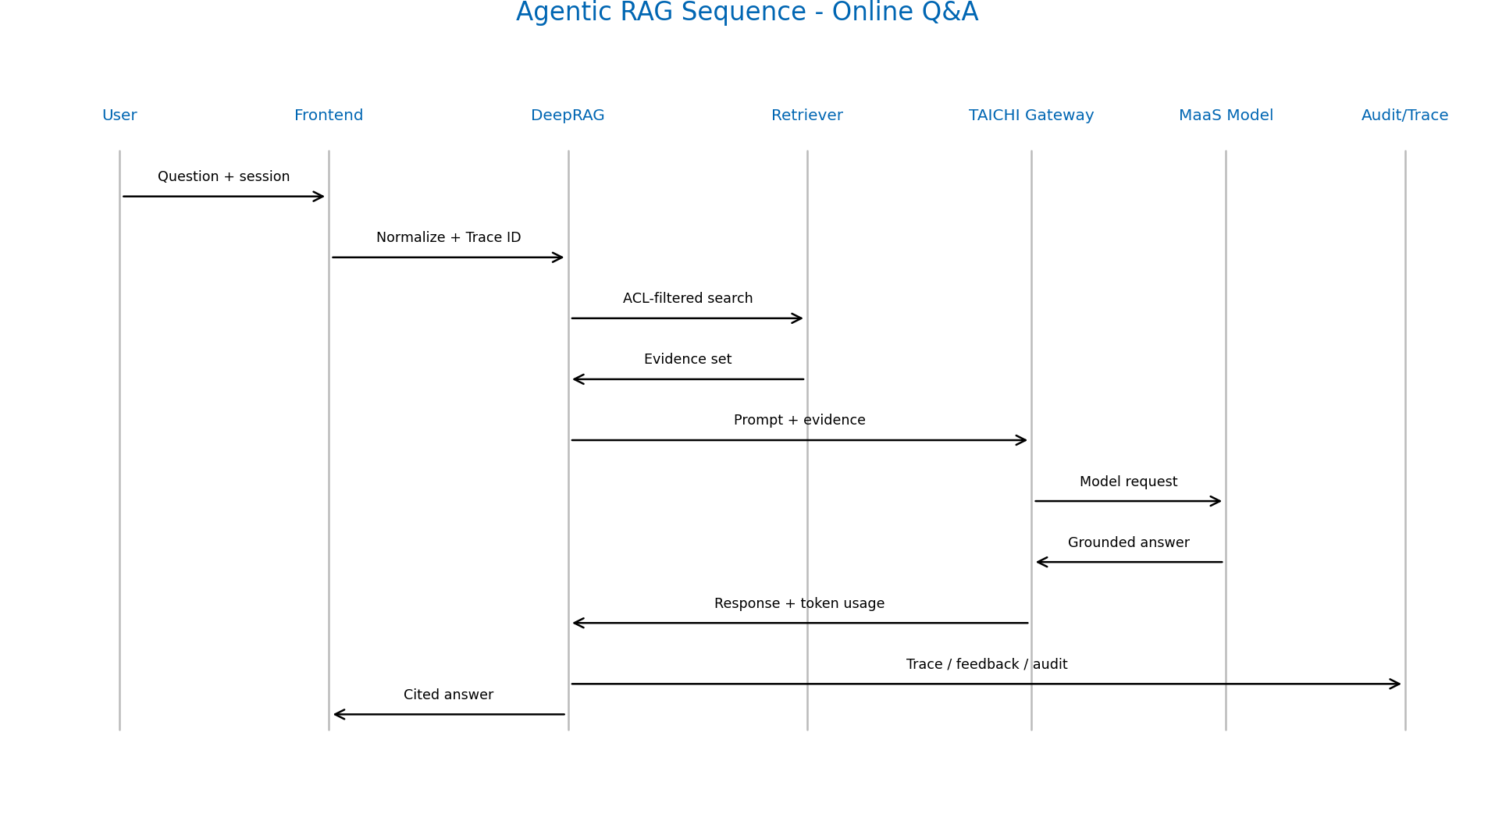
Step | Process | Architectural Controls
1 | User submits a question via PC Web or WeCom H5 | SSO validation, channel logging and rate control
2 | DeepRAG normalizes intent, language and domain context | Prompt template versioning and trace ID
3 | Retriever searches metadata, vector and graph stores | ACL, effective-state and domain filters
4 | Reranker selects evidence passages | Freshness, source and quality scoring
5 | MaaS model generates grounded answer | TAICHI AI Gateway, token limit and model routing
6 | System persists trace, feedback and token usage | Audit logs, Langfuse traces and evaluation loop

Data Architecture

Conceptual Data Model – Information Entities
The objective of this section is to list the Information Entities (i.e., the major/high-level data entities) in scope for the project, and - if applicable - their potential relationships to master data.
The following list depicts the major information entities relevant to the project.
Information Entity | Description | Retention
User | Represents a platform user account and identity. A user acts as creator, owner, operator, or participant in most business processes. | Long-term
Knowledge Base | Represents the primary knowledge container. It stores high-level metadata such as name, type, chunking strategy, indexing strategy, model bindings, storage settings, and vector store linkage. | Long-term
Knowledge | Represents an individual knowledge item within a knowledge base, such as an uploaded file, URL-based content, or manually authored content. It is the primary source object for parsing, indexing, and retrieval. | Long-term
Chunk | Represents the smallest parsed and indexed unit derived from a knowledge item. Chunks support vector retrieval, keyword retrieval, question generation, and graph extraction. | Long-term
FAQ Entry | Represents a structured question-answer record within an FAQ-type knowledge base, including canonical questions, answers, and similar questions. | Long-term
Knowledge Graph | Represents graph nodes and relationships extracted from knowledge content for Graph RAG and relationship exploration use cases. | Derived knowledge representation data. Retained only while the source knowledge exists; deleted or rebuilt during reprocessing.
Session | Represents a conversational session between a user and the system. It groups messages, retrieval context, and runtime interaction state. | Retained until explicitly deleted by the user or an administrator. No global TTL is evident in the implementation.
Message | Represents an individual message within a session, including user prompts, assistant responses, citations, and related metadata. | Retained with the parent session and deleted when the session is deleted, unless separate retention rules are introduced.
Vector Store | Represents a configured vector database or retrieval engine connection, such as Milvus | Long-term
Data Source | Represents an external content source configuration, such as GDriver, used for synchronization into the platform. | Long-term
Audit / Operation Log | Represents administrative and operational trace records such as configuration changes, permission updates, and sharing actions. | 180 days

Data Governance and Compliance
Data Domain (Information Entity or Subject Area) | Data Domain Contact | Compliance Policies
User | Platform | COREMAP
Knowledge Base | Platform | COREMAP
Knowledge | Platform | COREMAP
Chunk | Platform | COREMAP
FAQ Entry | Platform | COREMAP
Knowledge Graph | Platform | COREMAP
Session | Platform | COREMAP
Message | Platform | COREMAP
Vector Store | Platform | COREMAP
Data Source | Platform | COREMAP
Audit / Operation Log | Platform | COREMAP

Data Entity Structure and Relation
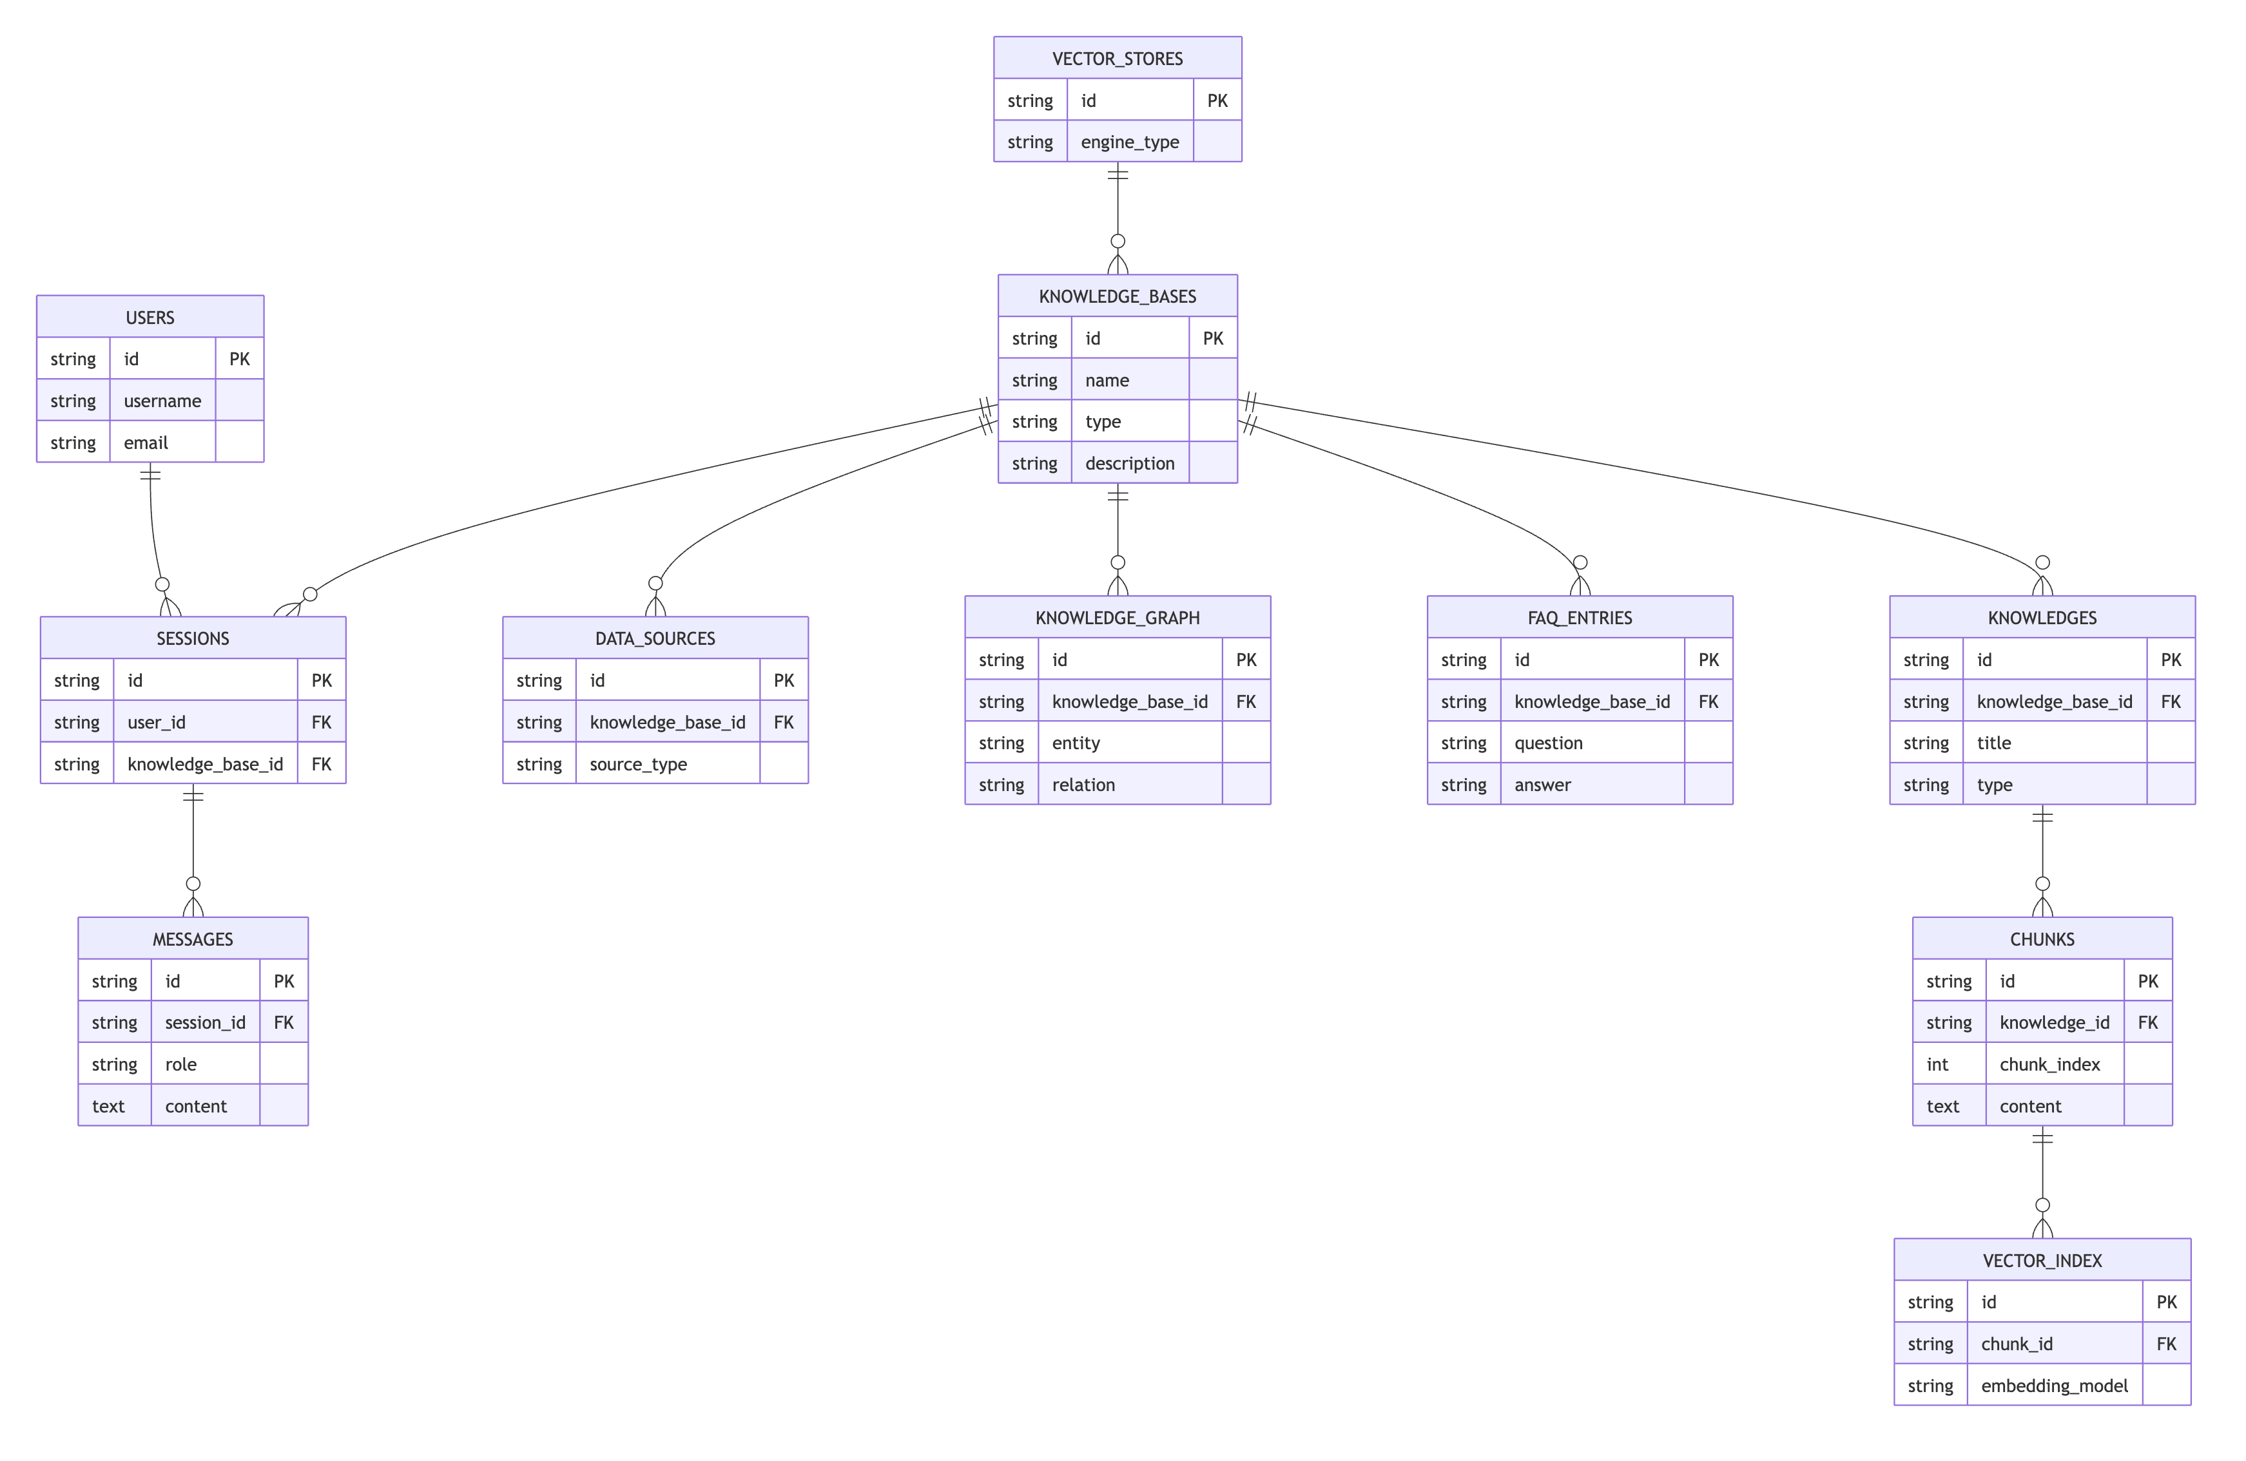
Data Object Name | Description
User | 系统用户，支持 Roche SSO、WeCom 用户映射及本地补充用户
Knowledge Base | 知识库逻辑容器，用于隔离不同业务域知识（DoA、T&E、Compliance 等）
Knowledge | 知识库中的知识对象，可来源于文档、FAQ、网页等
Chunk | 知识切块，用于向量检索和 RAG 检索
FAQ Entry | FAQ问答知识项
Knowledge Graph | 图谱实体和关系，用于 GraphRAG
Session | 用户会话
Message | 会话中的聊天消息
Vector Store | 向量数据库配置（Milvus 等）
Data Source | 外部知识来源（GDrive、SharePoint、本地文件服务器等）
Audit / Operation Log | 审计日志和操作日志

Document Meta Data Design
Metadata Field | Purpose | Example / Notes
DocumentId | Unique document identity | Repository ID or GUID
SourceSystem | Origin repository | GDrive, SharePoint, local server
SourceUri | Original document link | Used for citation preview
BusinessDomain | Domain classification | Finance DoA, Finance T&E, Compliance
Owner | Business content owner | Accountable for correctness
Language | Document language | Chinese, English or bilingual
EffectiveDate | Official effective date | Freshness filtering
ExpirationDate | Expiry date if applicable | Review trigger
ReviewStatus | Lifecycle status | Draft, staged, published, deprecated
Sensitivity | Confidentiality label | Internal, restricted, confidential
EmbeddingModel | Embedding model version | Index traceability

Document Permission Access Design
Permission Control | Design
Authentication | All users authenticate through Roche SSO. WeCom users must be mapped and bound to a Roche employee identity before access is granted.
System Administrator | Full platform administrative access across all knowledge bases, users, configurations, and operational functions.
Knowledge Manager | Granted management permissions for designated knowledge bases, including document upload, review, publication, deprecation, permission management, and knowledge lifecycle operations.
Standard User | Can access chatbot and search functions only within authorized knowledge bases.
Knowledge Base Authorization | Knowledge base permissions can be assigned by department, group, or individual employee. Individual users may be added explicitly, including users not yet synchronized into the platform user directory.
Document Authorization | Documents inherit permissions from their parent knowledge base by default.

Integration Architecture

Integration Strategy
Intent: Establish the strict architectural boundaries, security protocols, and operational guardrails that govern how different layers or systems communicate within the solution.

Integration Flow

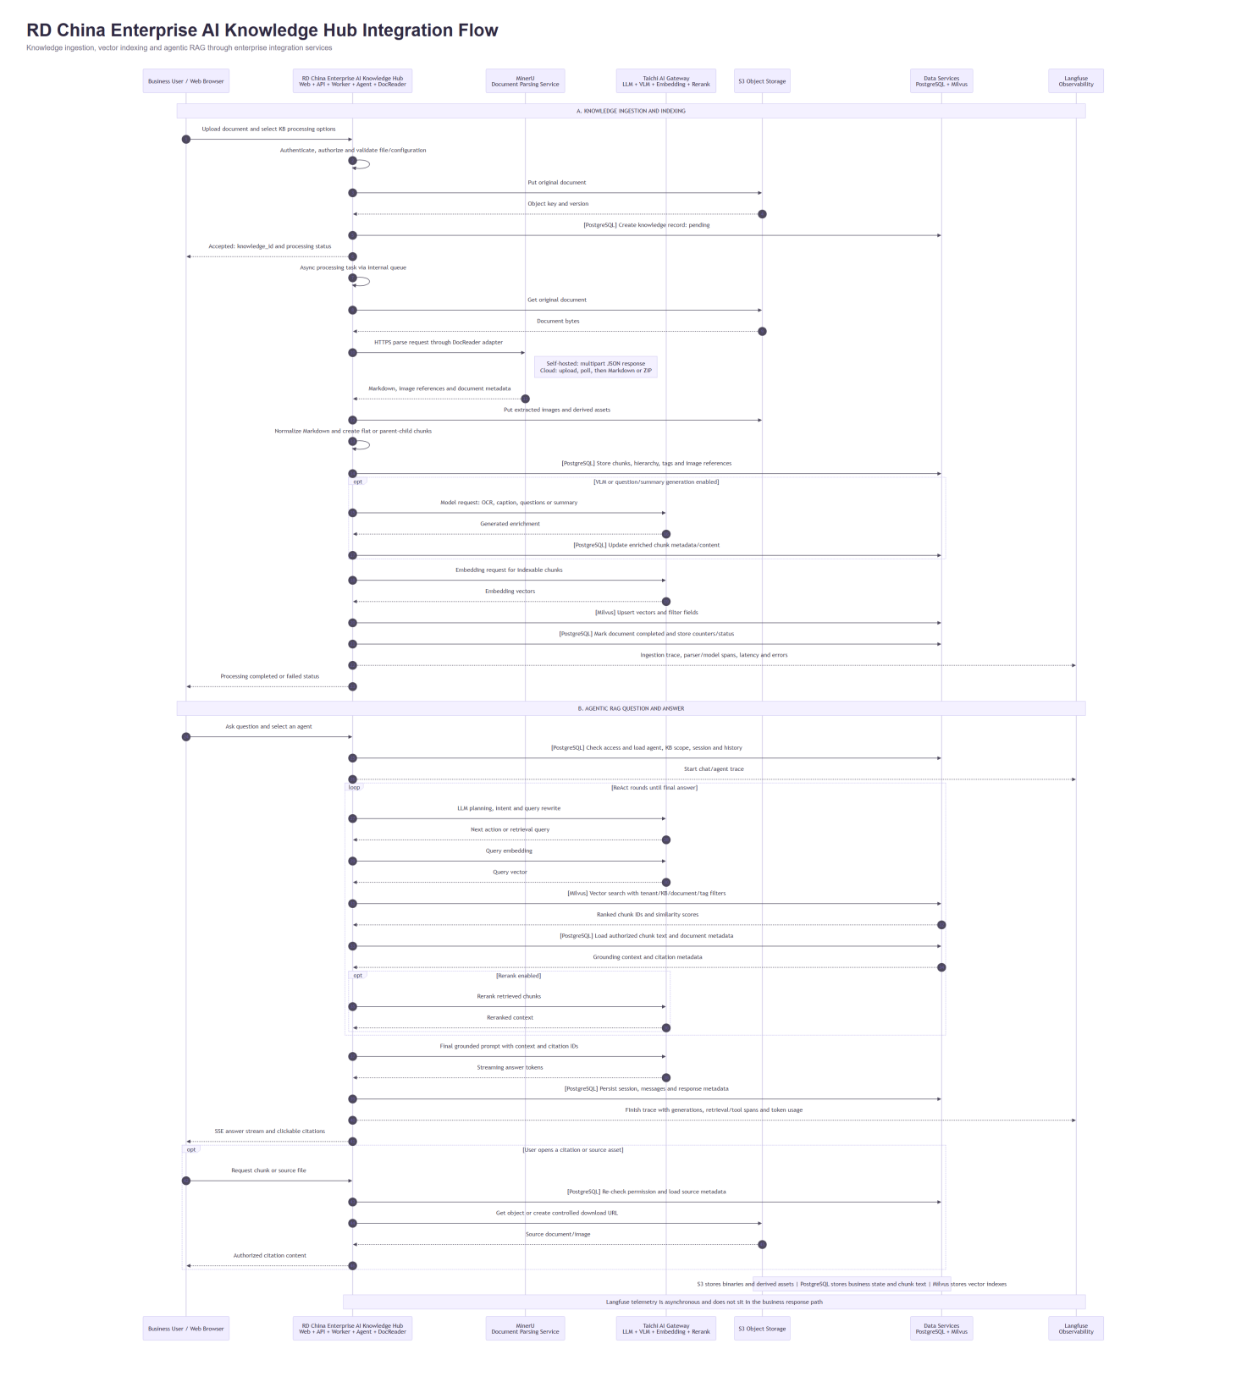

A. Knowledge Ingestion and Indexing
Flow ID | Source system | Target system | Flow breakdown description
K01 | Business User / Web Browser | RD China Enterprise AI Knowledge Hub | Upload document and select KB processing options.
K02 | RD China Enterprise AI Knowledge Hub | RD China Enterprise AI Knowledge Hub | Authenticate, authorize and validate file/configuration.
K03 | RD China Enterprise AI Knowledge Hub | S3 Object Storage | Put original document.
K04 | S3 Object Storage | RD China Enterprise AI Knowledge Hub | Object key and version.
K05 | RD China Enterprise AI Knowledge Hub | Data Services | [PostgreSQL] Create knowledge record: pending.
K06 | RD China Enterprise AI Knowledge Hub | Business User / Web Browser | Accepted: knowledge_id and processing status.
K07 | RD China Enterprise AI Knowledge Hub | RD China Enterprise AI Knowledge Hub | Async processing task via internal queue.
K08 | RD China Enterprise AI Knowledge Hub | S3 Object Storage | Get original document.
K09 | S3 Object Storage | RD China Enterprise AI Knowledge Hub | Document bytes.
K10 | RD China Enterprise AI Knowledge Hub | MinerU | HTTPS parse request through DocReader adapter.
K11 | MinerU | RD China Enterprise AI Knowledge Hub | Markdown, image references and document metadata.
K12 | RD China Enterprise AI Knowledge Hub | S3 Object Storage | Put extracted images and derived assets.
K13 | RD China Enterprise AI Knowledge Hub | RD China Enterprise AI Knowledge Hub | Normalize Markdown and create flat or parent-child chunks.
K14 | RD China Enterprise AI Knowledge Hub | Data Services | [PostgreSQL] Store chunks, hierarchy, tags and image references.
K15 | RD China Enterprise AI Knowledge Hub | Taichi AI Gateway | [VLM or question/summary generation enabled] Model request: OCR, caption, questions or summary.
K16 | Taichi AI Gateway | RD China Enterprise AI Knowledge Hub | [VLM or question/summary generation enabled] Generated enrichment.
K17 | RD China Enterprise AI Knowledge Hub | Data Services | [VLM or question/summary generation enabled] [PostgreSQL] Update enriched chunk metadata/content.
K18 | RD China Enterprise AI Knowledge Hub | Taichi AI Gateway | Embedding request for indexable chunks.
K19 | Taichi AI Gateway | RD China Enterprise AI Knowledge Hub | Embedding vectors.
K20 | RD China Enterprise AI Knowledge Hub | Data Services | [Milvus] Upsert vectors and filter fields.
K21 | RD China Enterprise AI Knowledge Hub | Data Services | [PostgreSQL] Mark document completed and store counters/status.
K22 | RD China Enterprise AI Knowledge Hub | Langfuse | Ingestion trace, parser/model spans, latency and errors.
K23 | RD China Enterprise AI Knowledge Hub | Business User / Web Browser | Processing completed or failed status.

B. Agentic RAG Question and Answer
Flow ID | Source system | Target system | Flow breakdown description
Q01 | Business User / Web Browser | RD China Enterprise AI Knowledge Hub | Ask question and select an agent.
Q02 | RD China Enterprise AI Knowledge Hub | Data Services | [PostgreSQL] Check access and load agent, KB scope, session and history.
Q03 | RD China Enterprise AI Knowledge Hub | Langfuse | Start chat/agent trace.
Q04 | RD China Enterprise AI Knowledge Hub | Taichi AI Gateway | [ReAct rounds until final answer] LLM planning, intent and query rewrite.
Q05 | Taichi AI Gateway | RD China Enterprise AI Knowledge Hub | [ReAct rounds until final answer] Next action or retrieval query.
Q06 | RD China Enterprise AI Knowledge Hub | Taichi AI Gateway | [ReAct rounds until final answer] Query embedding.
Q07 | Taichi AI Gateway | RD China Enterprise AI Knowledge Hub | [ReAct rounds until final answer] Query vector.
Q08 | RD China Enterprise AI Knowledge Hub | Data Services | [ReAct rounds until final answer] [Milvus] Vector search with tenant/KB/document/tag filters.
Q09 | Data Services | RD China Enterprise AI Knowledge Hub | [ReAct rounds until final answer] Ranked chunk IDs and similarity scores.
Q10 | RD China Enterprise AI Knowledge Hub | Data Services | [ReAct rounds until final answer] [PostgreSQL] Load authorized chunk text and document metadata.
Q11 | Data Services | RD China Enterprise AI Knowledge Hub | [ReAct rounds until final answer] Grounding context and citation metadata.
Q12 | RD China Enterprise AI Knowledge Hub | Taichi AI Gateway | [ReAct rounds until final answer; Rerank enabled] Rerank retrieved chunks.
Q13 | Taichi AI Gateway | RD China Enterprise AI Knowledge Hub | [ReAct rounds until final answer; Rerank enabled] Reranked context.
Q14 | RD China Enterprise AI Knowledge Hub | Taichi AI Gateway | Final grounded prompt with context and citation IDs.
Q15 | Taichi AI Gateway | RD China Enterprise AI Knowledge Hub | Streaming answer tokens.
Q16 | RD China Enterprise AI Knowledge Hub | Data Services | [PostgreSQL] Persist session, messages and response metadata.
Q17 | RD China Enterprise AI Knowledge Hub | Langfuse | Finish trace with generations, retrieval/tool spans and token usage.
Q18 | RD China Enterprise AI Knowledge Hub | Business User / Web Browser | SSE answer stream and clickable citations.
Q19 | Business User / Web Browser | RD China Enterprise AI Knowledge Hub | [User opens a citation or source asset] Request chunk or source file.
Q20 | RD China Enterprise AI Knowledge Hub | Data Services | [User opens a citation or source asset] [PostgreSQL] Re-check permission and load source metadata.
Q21 | RD China Enterprise AI Knowledge Hub | S3 Object Storage | [User opens a citation or source asset] Get object or create controlled download URL.
Q22 | S3 Object Storage | RD China Enterprise AI Knowledge Hub | [User opens a citation or source asset] Source document/image.
Q23 | RD China Enterprise AI Knowledge Hub | Business User / Web Browser | [User opens a citation or source asset] Authorized citation content.

System Context
System | Role | Protocol | Authentication | Auth Identity | Notes
Intranet Frontend | Consumer | HTTPS | Roche SSO | User identity | Internal web access
WeCom Frontend | Consumer | HTTPS via Cloudflare | WeCom SSO + Roche identity binding | User identity | Final design decision required
Management Backend | Provider/Consumer | HTTPS/internal REST | Service token | Service account | Admin and knowledge lifecycle
DeepRAG Backend | Provider/Consumer | HTTPS/internal REST | Service token | Service account | Agentic RAG orchestration
DocReader / Parser | Provider | Job/internal API | Internal service token | Service account | Document extraction
Milvus | Provider | Private DB/API | Service credentials | Service account | Vector search
Neo4j | Provider | Bolt/HTTPS private | Service credentials | Service account | Graph traversal
PostgreSQL / Redis / S3 | Provider | Private endpoints | IAM/service credentials | Service account | Metadata, cache and objects
Langfuse | Provider | Internal API | Service token | Service account | LLM traces and evaluation
TAICHI AI Gateway | Provider | REST/internal API | Platform-managed | Service account | Gateway to MaaS

API Inventory
<List all the inbound / outbound APIs>
Type | Method | Path | Description
Auth | POST | /api/v1/auth/login | 用户登录
Auth | POST | /api/v1/auth/refresh | 刷新 Token
KB | GET | /api/v1/knowledge-bases | 获取知识库列表
KB | POST | /api/v1/knowledge-bases | 创建知识库
KB | GET | /api/v1/knowledge-bases/{id} | 获取知识库详情
KB | POST | /api/v1/knowledge-bases/{id}/knowledge/file | 上传文件知识
KB | POST | /api/v1/knowledge-bases/{id}/knowledge/url | 添加 URL 知识
KB | POST | /api/v1/knowledge-bases/{id}/hybrid-search | 混合检索
KB | GET | /api/v1/knowledge-bases/{id}/faq/entries | 获取 FAQ 条目列表
KB | POST | /api/v1/knowledge-bases/{id}/faq/entry | 创建 FAQ 条目
Knowledge | GET | /api/v1/knowledge/{id} | 获取知识详情
Knowledge | PUT | /api/v1/knowledge/{id} | 更新知识
Knowledge | POST | /api/v1/knowledge/batch | 批量创建知识
Knowledge | POST | /api/v1/knowledge/{id}/reparse | 重新解析知识
Knowledge | GET | /api/v1/knowledge/{id}/download | 下载知识文件
Knowledge | GET | /api/v1/knowledge/{id}/spans | 获取知识的处理 Span 信息
Knowledge | GET | /api/v1/knowledge/search | 搜索知识
Chunk | GET | /api/v1/chunks/{knowledge_id} | 获取知识的分块列表
Chunk | POST | /api/v1/chunker/preview | 分块预览
Session | POST | /api/v1/sessions | 创建会话
Session | GET | /api/v1/sessions/{id}/messages | 获取会话消息列表
Session | POST | /api/v1/sessions/{session_id}/stop | 停止会话生成
Session | POST | /api/v1/sessions/{session_id}/title | 更新会话标题
Chat | POST | /api/v1/sessions/{session_id}/knowledge-qa | 知识库问答（SSE 流式）
Chat | POST | /api/v1/sessions/{session_id}/agent-qa | Agent 智能问答（SSE 流式）
Message | GET | /api/v1/messages/{session_id}/load | 加载历史消息
Agent | GET | /api/v1/agents | 获取智能体列表
Agent | POST | /api/v1/agents | 创建智能体
Agent | GET | /api/v1/agents/{id} | 获取智能体详情
Agent | PUT | /api/v1/agents/{id} | 更新智能体
Agent | GET | /api/v1/agents/{id}/suggested-questions | 获取推荐问题
Model | GET | /api/v1/models | 获取模型列表

Solutions to Non-Functional Requirements (NFRs)

User Profile Table
The following table provides profiles of the system users:
User Role | Number of Users | User Type* (internal / external) | User Location ** | Peak Usage Level (in # of users) | Expected Growth Rate (over three years)?
Business User | TBD | Internal Roche Diagnostics China | China | TBD | Expected expansion after Phase 1
Knowledge Manager | TBD | Internal | China | TBD | Expands with domains
System Admin | <5 | Internal platform/admin | China | 1-2 | N/A
Notes:
(*) Internal/external users, online/offline users
(**) EMEA, APAC, NA, LATAM

Security NFRs
Unique ID | Requirement | Architectural Solution
Sec-001 | Centralized Identity Management | The system delegates all identity management to the Roche Enterprise Single Sign-On (SSO) framework via OutSystems platform native integrations.
Sec-002 | Permission Management | Enforced via OutSystems Role-Based Access Control (RBAC). Workflows extract the user's role from the validated SSO session token to restrict access to authorized lines-of-business.
Sec-003 | Privileged Access Management | The Logs and telemetry console features are structurally isolated within OutSystems and restricted exclusively to the System Admin role.
Sec-004 | Protect Data at Rest | Leveraging OutSystems platform database native encryption. Audit trails, task records, and token consumption data are securely encrypted at rest.
Sec-005 | Protect Data in transit | All external API endpoints and internal REST integrations use standard HTTPS/TLS encryption. Data is transmitted securely across the Roche Corporate Network (RCP).
Sec-006 | Secure Login (Multi-Factor Authentication) | Rely on Roche enterprise MFA/SSO.
Sec-007 | API Exposure | The system rigorously enforces network perimeter defense. It only exposes deterministic operational atomic APIs externally. Internal communications with the Taichi platform are routed exclusively through secure, trusted intranet paths heavily bound to Service Account Bearer Tokens, strictly rejecting any cross-boundary external LLM traffic pass-through.
Sec-008 | API Security | Service-to-service integration uses standard HTTP REST secured by OutSystems Token mechanisms and Bearer tokens (for LifeTime API).

Performance NFRs
Unique ID | Requirement | Architectural Solution
Perf-001 | API Response(< 1s) | Achieved through the principle of "decoupling interaction and execution". Core operation tasks (like deployment and SQL execution) are placed in background asynchronous workflows within OutSystems.
Perf-002 | Chat Response(< 7s) | Guaranteed by utilizing the highly available Coze routing layer's native LLM capabilities to perform sub-second intent recognition and entity extraction before passing structured payloads to the backend.

Capacity NFRs
Unique ID | Requirement | Architectural Solution
Cap-001 | System Capacity(1000 tasks/yr) | System capacity and elastic scaling are guaranteed by the underlying resource pools of the China LEAP Platform (OutSystems) and Coze, which effortlessly absorb the minimum 1,000 tasks/year workload.
Cap-002 | Token Limit(< 20000/task) | Addressed via decoupled data handling. Raw database rows and massive operational logs are strictly prohibited from entering the LLM context window. Instead, they are processed natively by backend services, keeping token consumption heavily optimized.

Architectural NFRs

Unique ID | Requirement | Architectural Solution
Arc-001 | Modularity | Separate frontend, management, DeepRAG, parser, ingestion and observability services.
Arc-002 | Loose coupling | The Interaction Layer (chat) holds no direct references to the execution backend. They communicate strictly via the standardized REST API integration layer, isolating orchestration logic from platform infrastructure.

AI Specific NFRs
Unique ID | Requirement | Architectural Solution
AI-001 | Training/Test Data Persistence | Version-controlled input/output prompt datasets are maintained externally in a dedicated baseline repository for CI/CD benchmarking.
AI-002 | Test Report Persistence | Accomplished by persisting system telemetry logs and user interactions within the MessageFeedback and Chat entities in the OutSystems database for historical review.
AI-003 | Prompt Versioning | Managed by storing prompt configuration files and metadata in a dedicated enterprise GitHub repository. This externalization ensures strict version control, historical traceability, and alignment with corporate CI/CD practices.
AI-004 | Consumption Token Persistence | The UpdateChatRecord internal service action captures and records combined input/output tokens per interaction into the Chat data entity for precise cost auditing.
AI-005 | Test Automation | Test automation is strategically divided into two tiers: internal business logic and workflows within OutSystems are covered natively by BDD (Behavior-Driven Development) test suites, while external interactions (such as Coze routing and LLM output evaluation) are assessed using automated test scripts. This division bypasses LLM unpredictability and efficiently achieves the 80% coverage target.
AI-006 | RAG Performance | Use hybrid vector + graph + metadata retrieval to consistently hit the >0.95 precision mark.

Business Continuity

7.7.1 High Availability NFRs
Stateless services should run with multiple replicas behind managed load balancers. Heavy parsing and indexing workloads should be isolated from interactive Q&A runtime. Failure of ingestion should not affect Q&A over already published knowledge.

7.7.2 Disaster Recovery NFRs
Application configuration, prompts, knowledge metadata, document objects and indexes should be recoverable from backup or rebuildable from source documents and metadata.

7.7.3 Backup NFRs
Backups should cover objects, metadata stores, audit logs, prompt/config repositories and published index rebuild procedures. Automatically meeting the daily backup and 24h RPO / 4h RTO targets。

Physical Architecture

Physical Architecture Diagram
<Replace with the system Physical Architecture Diagram>
<List all the resource specs in a table, aws / on-prem>
<Add breakdown descriptions>

Network Architecture
<Replace with the system Network Architecture Diagram>
<List all the network components of the solution>
<Add breakdown descriptions>

