**Q1 - SCENARIO**

A car rental company called FastCarz has a .net Web Application and Web API which are recently migrated from on-premise system to Azure cloud using Azure Web App Service

and Web API Service.

The on-premises system had 3 environments Dev, QA and Prod.

The code repository was maintained in TFS and moved to Azure GIT now. The TFS has daily builds which triggers every night which build the solution and copy the build package to drop folder.

deployments were done to the respective environment manually. The customer is planning to setup Azure DevOps service for below requirements:

*1) The build should trigger as soon as anyone in the dev team checks in code to master branch.*

*2) There will be test projects which will create and maintained in the solution along the Web and API. The trigger should build all the 3 projects - Web, API and test.*

*The build should not be successful if any test fails.*

*3) The deployment of code and artifacts should be automated to Dev environment.*

*4) Upon successful deployment to the Dev environment, deployment should be easily promoted to QA and Prod through automated process.*

*5) The deployments to QA and Prod should be enabled with Approvals from approvers only.*

Explain how each of the above the requirements will be met using Azure DevOps configuration.

Explain the steps with configuration details.

**Solutions**

1. We have to enable trigger for master branch.

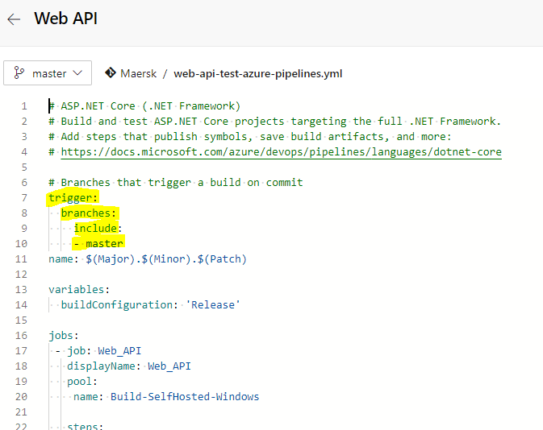

So that any new merge on master branch will trigger build pipeline for Web API and Web UI.

1. Enabling triggers for master branch will trigger both Web API and Web UI which have test tasks.

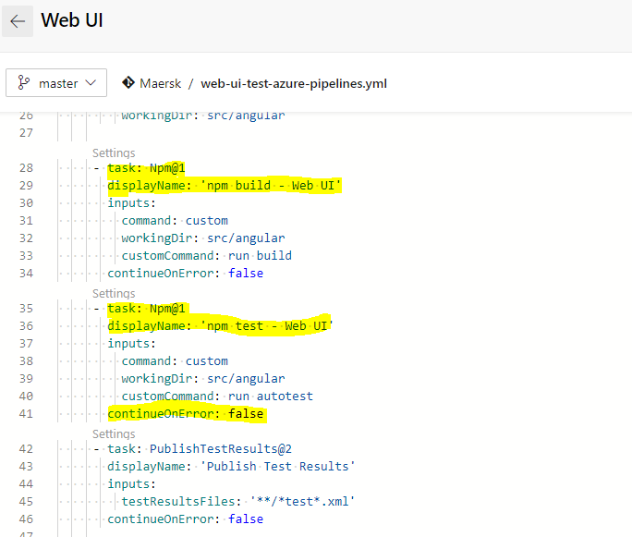

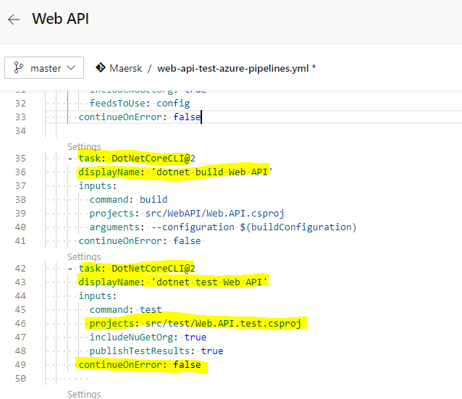

Adding “**continueOnError: false**” will fail the builds if any one of the tests fails.

1. To have automated CD for, we need to enable artifact CD trigger for both Web UI and Web API artifacts as described below. 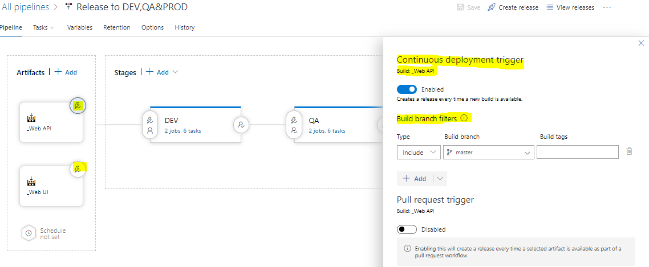

The above set up will trigger a new release for the release pipeline. And Will check for the individual stage pre conditions for DEV.

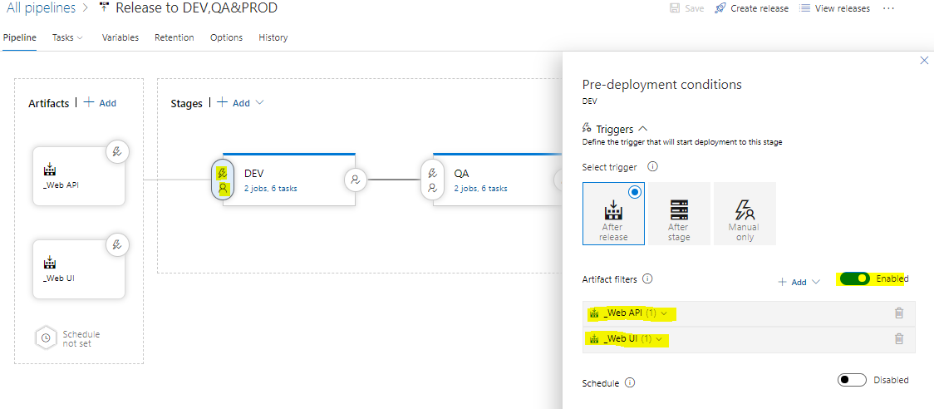

For Dev stage we don’t have any pre deployment approvers so will deploy automatically on DEV environment for Web UI and Web API.

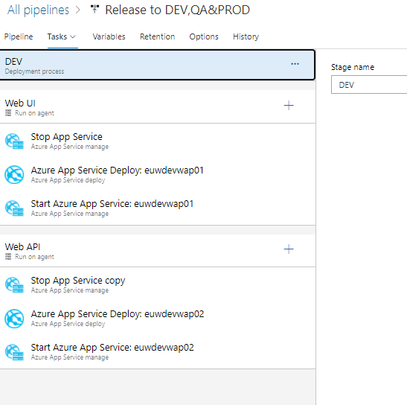

Inside each stage we have separate Agent Job for Web UI and Web API. So that parallelly deployment will be completed for both API and UI. We have extra task to stop before the deployment and start after the deployment. It will help to have a smooth deployment for each stage.

1. All DEV, QA and PROD stages are connected so that will be completing sequentially one after another after it meets all pre deployment conditions. And it is fully automated process.

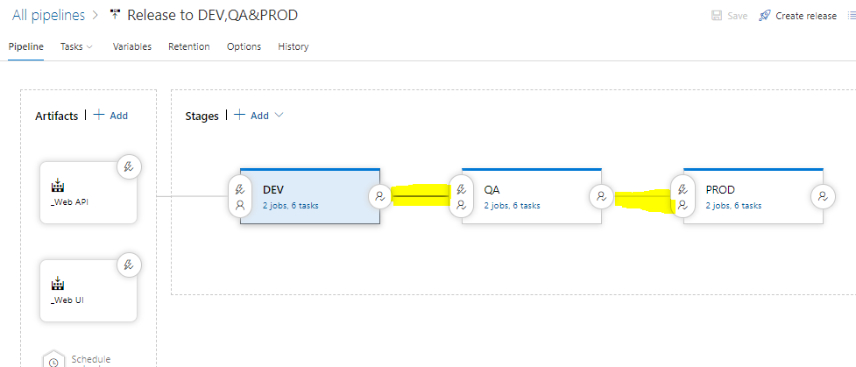

1. Once we have successful deployment to DEV. It can be pushed to QA with necessary approvals. It can be set on each stage pre deployment conditions as mentioned below.

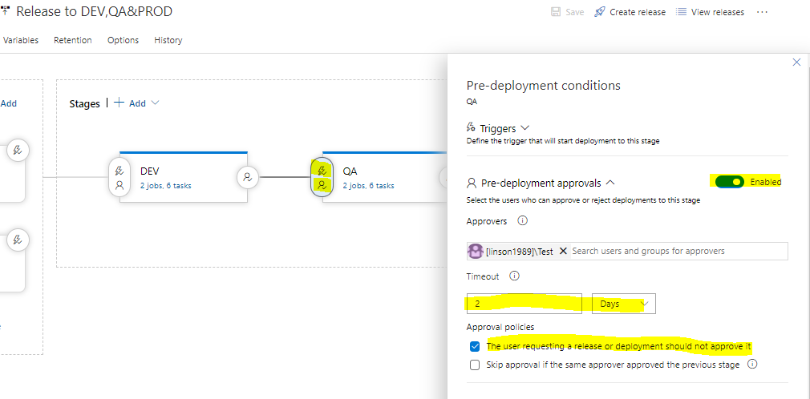

Also it is set that the person who requested/triggered the release cannot approve the same. And can set the timeout period for the approvals as shown above.

