greatperformersacademy.com

Top 25 Most Trending Products to Sell Online in 2017
STAFF

13-16 minutes

The Internet has made it possible for us to enjoy quite a number of opportunities. One of these is the ability to sell products and services online. This form of business is known as e-commerce. Buyers and sellers can meet and buy products from each other on the World Wide Web. There are special websites that facilitate this sort of trade. They are known as online marketplaces. Examples of these are eBay and Amazon. You can register and sell some products or services to willing buyers. The payments are made online using facilities such as Paypal and credit cards. Every year, there are some products that are highly popular online. They are described as trending products. They are cool, hype and a must have for enthusiasts of online shopping. Here are the 25 most trending products you can sell for profit online in 2017.

Wood frame sunglasses
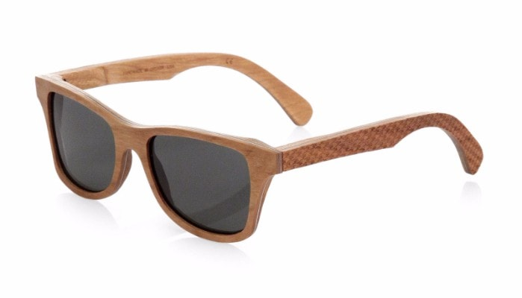
One of the oldest construction materials has been used to refresh a famous fashion staple, sunglasses. The spring and summer months are not far away. Therefore, wood frame sunglasses are bound to be a big hit online. They are trendy and come in all shapes and sizes. They were invented recently and have enjoyed a steady following ever since, wood frame sunglasses have reported favorable reviews across the board. They are a trendy product to sell online in 2017.
Suggested Reading : 15 Things You Must Know Before Launching Any Successful Business

Waterproof phone cases
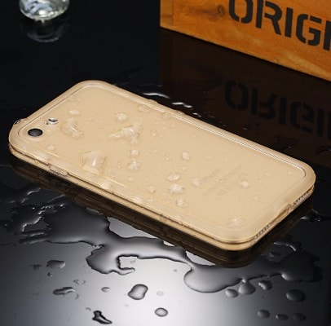
One of the most dangerous elements to a smartphone is water. People have lost their phones to the water in pools, pails of water and other watery locations. In response, the waterproof phone case was invented. There are such cases for various types of phones. The case allows you to interact with your phone normally while giving it 100% protection from water. It is a trending product for this year.

Bluetooth speakers
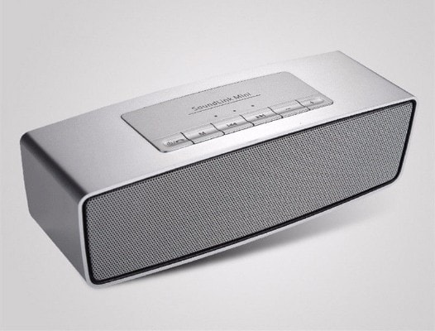
These are a favorite electronic for holiday goers. A Bluetooth speaker allows you to stream music from your phone or any other Bluetooth-enabled device. This gives you a high level of flexibility and freedom of music. This is because this device is highly portable and you can take it with you anywhere. Companies such as Beats by Dr. Dre have cashed in on the popularity of these devices. Thus, they are trending in 2017 and their popularity shows no sign of waning.
Suggested Reading : 9 Simple but Powerful Ways to Effectively Market Your Business Online

Fairy lights

Fairy lights are very small, white LED bulbs. They glow in a warm way and can decorate any living space and make it cozy. They are applicable in outdoor spaces and indoor ones too. You can hang fairy lights in your living room or your bedroom. They make great gifts for people who are fans of indoor decoration. They are also superb as holiday decorations.

Coconut oil
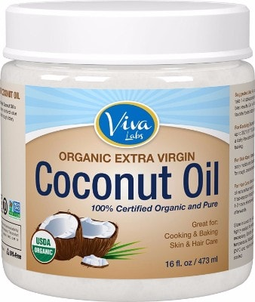
Internet shoppers are gradually gravitating towards natural, organic products. One of the most popular ones is coconut oil. This natural product is suitable for various activities. Examples of these are skin moisturizing, shaving, cooking, body scrubbing, as lip-balm, remover for makeup and treating bites made by bugs. Due to its collection of healing properties, coconut oil is one of the trendy products online in 2017.

3D printers
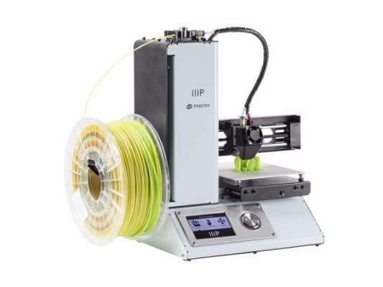
How cool is it to actually print a cup or a sandal? Thanks to 3D printing, it is now entirely possible. These devices blasted on the Internet and generated interest across all platforms. Scientists, technologists and even hobbyists all wanted a 3D printer. Their application in prototyping or even manufacturing has been explored and they are still a trending product online. Their prices are gradually dropping and therefore 3D printers are a profitable product to sell on the Internet.
Suggested Reading : 30 Disruptive Technologies and Ideas That Will Transform Industries

Phone power banks
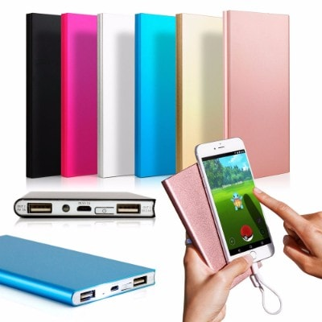
We use our smartphones for hours on end ever day. We run power-hungry applications such as Pokemon Go until our phones are drained. To solve this problem, there are power banks that we can utilize to charge them up and keep going. These banks have a huge capacity of up to 10,000 mAh. Thus, they can fill up your phone from 0% to 100% and allow you to keep using it. They are trending product that can net you a profit when sold online.

Liquid phone cases
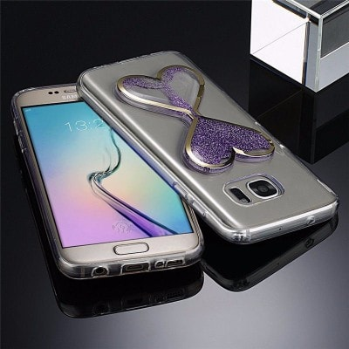
One of the most important accessories for smartphones is a phone case. It protects your phone from shocks and grazes. It also protects your phone screen from cracking or breaking. Today, there are liquid phone cases. They are simply regular phone cases with a twist. The back of the case is filled with a gel-like fluid encased in an interesting ornament design. The fluid moves around in the ornament design when you tilt the phone. It is a hit product and is trending in 2017.

Matcha Powder

Sticking with the natural, organic health products, Matcha powder is another item that Internet users are going crazy about. Matcha is a fine powder made out of milling green tea. It is popular due to its ability to deliver the effects of green tea in a more intense way. There are currently various flavors of Matcha powder which you can sell for a tidy sum online.

Drones
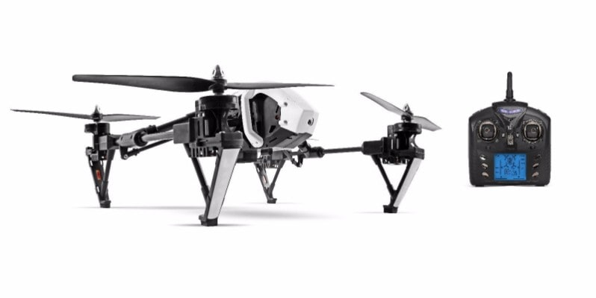
These futuristic, flying devices have really grown in popularity. They are being accepted in the fields of recreation, photography and footage recording. They come in various sizes. Some are small and others are large with up to 6 rotors. They are currently trending and show no signs of slowing down into 2017. They are definitely an item you can sell for a profit online.

The charcoal face mask
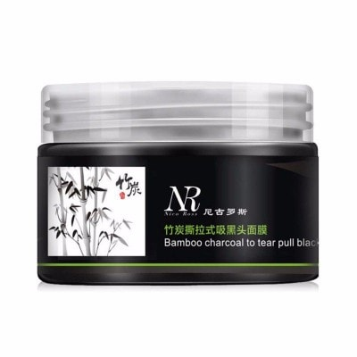
This is an interesting product that is currently trending. The charcoal face mask is one of the most popular beauty items. It is made of activated charcoal. This ingredient has positive effects on the skin and improves it. These masks are Instagram friendly. Moreover, they have a pitch black appearance that wearers love to show. You can definitely make a profit by selling them online in 2017.

Fitness trackers
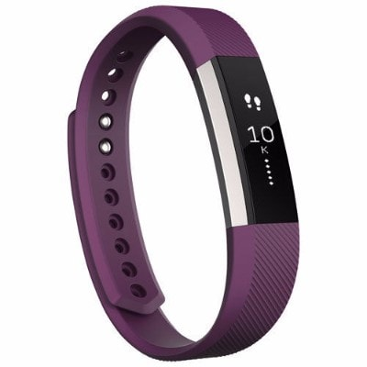
Many people today normally observe fitness as a major part of their daily lives. We use a variety of accessories in our fitness endeavors. One of the devices that we use to this effect is the fitness tracker. This is a device that resembles a wristwatch. It can help us to keep track of how many calories we are burning, our heart rate as well as the distance that we are covering in our exercise efforts. Available in many colors and styles, fitness trackers are highly important today and are in high demand in 2017.

Men's fashion accessories
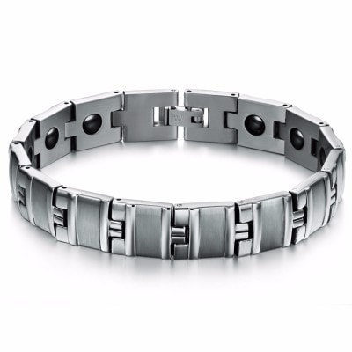
Today, men are just as fashionable as women. Therefore, they are always on the lookout for some accessories to boost their outfits. Examples of these are bow ties, cuff links and pocket squares. Bold colored accessories are highly popular and are commanding attention all over social media and fashion websites. Men are searching for these items and you can sell them for a profit online in 2017.

Gluten-free products
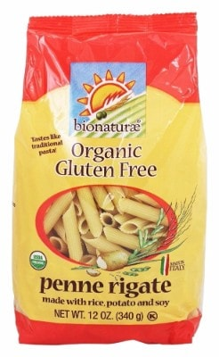
Gluten is an ingredient in processed foods that is undesirable due to its unhealthy effects. Thus, manufacturers are releasing gluten-free products for the masses. They are labeling these items as 'gluten-free'. Interestingly, consumers are very enthusiastic about buying gluten-free products. The interest is so much that the market of gluten-free products is currently worth in excess of $5 billion annually. Get a piece of this pie by selling gluten-free products online in 2017.

Enamel pins
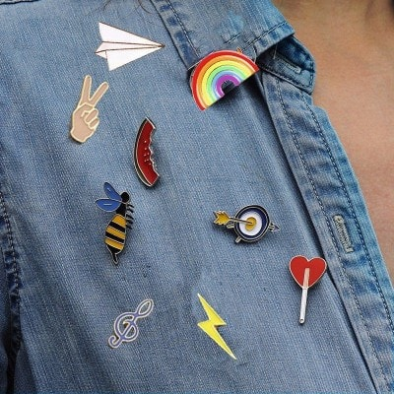
These fashion items have grown in popularity. This is because they are essential ornaments and can accessorize any outfit. They are cute and sometimes quirky in an adorable way. You can put any sort of design or logo on them and pin them on your clothes, your backpack or your laptop bag. Due to this, they are currently trending online.
Suggested Reading : 15 Crazy Business Ideas That Made Millions Against All Odds

Baby products
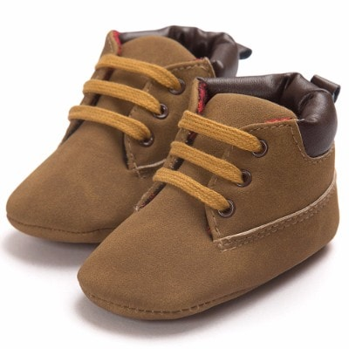
Today, baby items are available for sale online. They come in a variety of interesting designs which are vivid and eye-catching. Baby sleeping sacks, blankets and bibs are popular now more than ever before. They are attractive and beautiful to look at. Moms all over the world are buying them online in droves and this trend is bound to continue right into 2017.

LED skin treatment
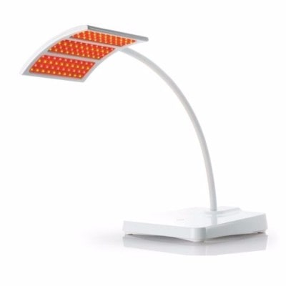
One of the latest technologies in skin care is Light Emitting Diodes (LEDs). They are utilized in skin care therapies for the purpose of eliminating acne and also reducing wrinkles. Today, you can find these LED therapies packaged in devices which you can hold in your hands. They are also available in form of a face mask and arrays of light for you. They range in price from $50 to $5,000. You can sell these devices online and make a fortune from all the people looking to fix up their skin problems using the painless magic of LED light.

Paleo bars
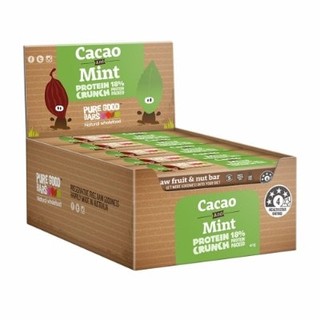
There is one major industry that is constantly popular across the globe. This is the nutrition industry. People are always seeking the latest diet or supplement that will help them to achieve their fitness goals. One of the popular items of fitness nutrition which is bound to be popular in 2017 is Paleo bars. These are nutritious bars that are made of ingredients which mimic the diet of early human beings of the Paleolitic period of human existence some 15,000 years ago. Paleo bars can be an amazing trendy product to sell online in 2017 and make a tidy profit.

Wooden bezel watches
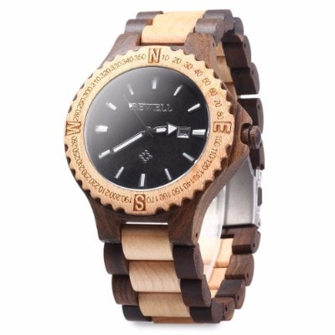
Keeping with the natural theme, there are also some wooden bezel watches that are making waves online. The idea for watches with wooden bezels has been floating around the Internet for some time. However, it has only recently really caught on. They are available in various designs and some even have carved designs on the wooden bezels. They are bound to be a big hit product you can sell online for a profit this year.

Leggings

This is a fashion item that every lady must have in their closet. Leggings are very helpful when you want something light and comfortable to wear on its own or under a dress. There has been massive Internet chatter over leggings. This is due to the new series of these items of clothing that have beautiful patterns and bold designs on them. The demand for leggings online is predicted to be steady throughout 2017.
Suggested Reading : 10 Sales Techniques That Every Entrepreneur Needs to Know

Rechargeable lighters
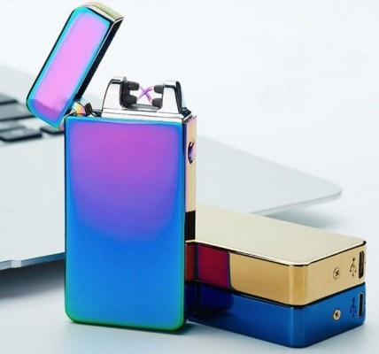
Enjoying a smoke has been transformed by technology. Rechargeable lighters now occupy the same niche as e-cigarettes and vapes. These lighters have no flame, no fuel and receive their power from lithium ion batteries. These are charged using independent charging docks or even USB cords. They use an electrically heated coil to produce the heat necessary to light up your cigarettes or cigars. These interesting devices are trending online and you can sell them for a profit in 2017.

Dad hats
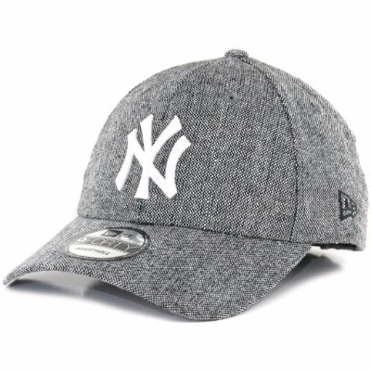
One of the latest fashion trends in the world today is dad hats. They were fabulous in the 1990's but then fell out of favor. However, they have made a tremendous comeback. Luxury brands have taken the dad hat and made it an iconic, must-have, mainstream fashion piece. They are currently available in many types of fabrics and can even be printed. Therefore, you can make a profit by selling dad hats on the Internet in 2017.

Fitness watches with smart features
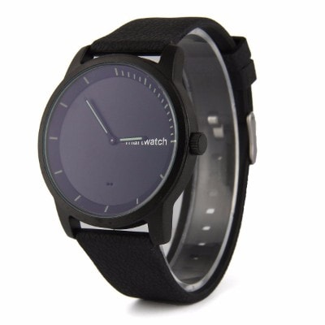
Today, there are many types of wearable technology. Some of the most popular ones are fitness watches. According to studies, 40% of consumers in the United States are willing to buy a smart watch. Half of these are interested in smart fitness watches. Big brands such as Fitbit and Apple have taken advantage of this popularity. Thus, you can find so many of these in the electronics stores and promotional material. You can make a good profit by selling these devices on the Internet in 2017.

Electronic cigarettes
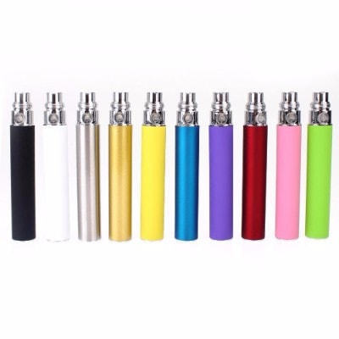
Known simply as e-cigarettes, they are currently enjoying tremendous fame online. They are a self-contained device that you can use to vape. This is to inhale vapor that contains flavored nicotine. It is battery-powered and is quickly replacing the cigarette. E-cigarettes are gaining massive popularity and were even featured in an article in Forbes Magazine. Due to the growing acceptance of electronic cigarettes, they are destined to be a trendy product for online shoppers in 2017.

E-liquid

E-cigarettes and e-liquid go hand in hand. One of the most important parts of an e-cigarette is the e-liquid that holds the flavor and the nicotine stimulant. This liquid is available in various capacities and flavors too. People even have the option to order ingredients and mix up their own e-liquid flavors. E-liquids are bound to enjoy the same popularity online as e-cigarettes in 2017. Thus, they are a good product to sell online for a profit.

The Important Take Away
On the Internet, you can reach buyers from other countries across the world. If you are selling a product that is trending favorably, you are bound to make some revenue and enjoy tidy profits. The items indicated above are great to sell online in 2017. Are you planning to engage in some e-commerce? These are the products to sell and make a fortune.
Finally, the best shop builder we recommend is Shopify. It doesn’t matter if you are launching a new online store, or bringing an offline store to the net, Shopify will help you save a lot of time so you can focus on the most important aspects of your business, their technology, customer service and the variety of ecommerce solutions they offer are simply unmatched.

