CPT 203: HTML and CSS  
Marcie Sangaline  
Web Project

1.

* Topic
  + Company website / Local café website
* Purpose
  + A website dedicated to a pretend café / restaurant
* Goals:
  + Shows visitors a menu
  + Detail location information
  + Displays contact information
  + A gallery of images
* What needs to happen:
  + Logo
  + Easy navigation
  + Image gallery
  + Menu creation
* Target Audience
  + College students, young adults, busy adult.
* Opportunity/Issue Website is Addressing
  + Initial web presence for a company
* Type of content included:
  + Images
  + GIFs
  + Text
  + Menu
* Similar websites:
  + <http://lilacpatisserie.com/>
  + <https://www.perennial.cafe/>

2. 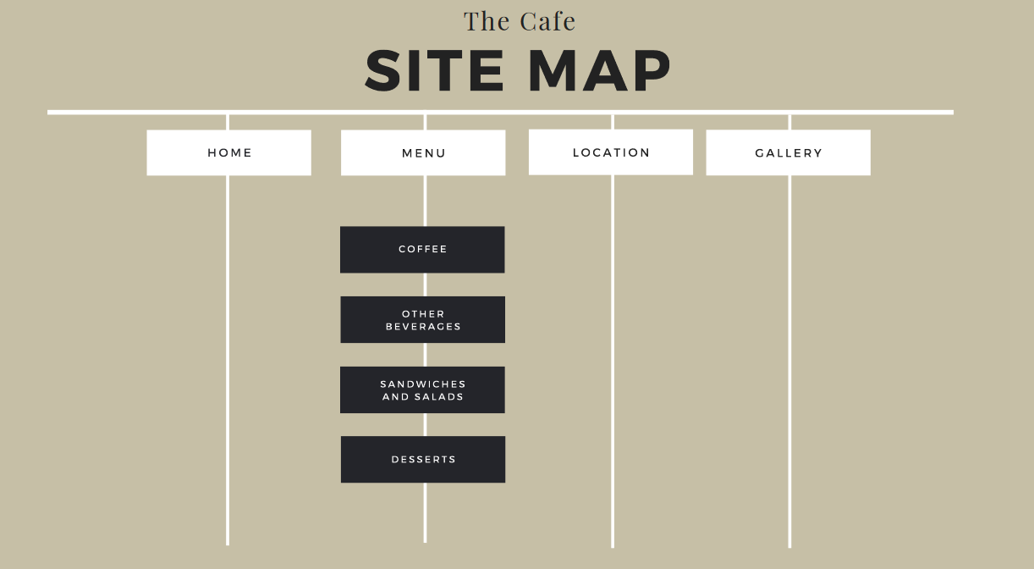

3.

