CASE STUDY REPORT
Waste Management, E-Waste and Circular Economy:
10 Case Studies

Prepared for Third Year Engineering / TE MSE Academic Submission

Field | Details
Student Name | Sanskar Vinayak Jadhav
Roll No. | 24102B0042
Course | TE (Case Studies)
Class / Division | B
Faculty | Aniket kundu
Submission Date | 04/09/2026

This report examines ten international and industry case studies across municipal waste, food waste, packaging, plastics, e-waste, product design, procurement, repair, reuse and circular manufacturing.

1. INTRODUCTION

1.1 Waste Management
Waste management is the organized prevention, collection, segregation, transport, recovery, treatment and final disposal of waste. Modern systems increasingly treat waste as a resource-management problem rather than only a sanitation problem. UNEP notes that the growing volume and complexity of waste create risks to ecosystems and health, while poorly managed waste can contaminate air, water and soil [1].

1.2 The E-Waste Challenge
Electrical and electronic equipment creates a distinctive waste stream because it contains valuable metals, plastics, glass and other recoverable materials together with hazardous substances. The Global E-waste Monitor 2024 reported 62 billion kg of e-waste generated globally in 2022, with only 22.3% documented as formally collected and recycled in an environmentally sound manner [2].

1.3 Circular Economy
A circular economy seeks to keep products, components and materials in productive use for as long as possible while reducing virgin-resource dependence and waste generation. UNEP describes circularity through reuse, remanufacture, recycling and recovery, with waste and emissions minimized [3].

1.4 Why International Case Studies Matter
The ten cases use different combinations of regulation, pricing, infrastructure, public participation, producer responsibility, technology, procurement and product design. Comparison reveals that no single model is universal.

1.5 Purpose of Comparing with India
India has a formal policy framework including the Solid Waste Management Rules, 2016 and E-Waste (Management) Rules, 2022. The SWM Rules require waste generators to segregate waste and hand it to municipal workers or authorized waste pickers [4]. The 2022 E-Waste Rules came into force on 1 April 2023 and strengthened EPR and digital compliance [5]. The purpose of this report is to identify mechanisms that can realistically complement India’s existing institutions and informal recovery economy.
Dimension | Why it matters | Examples
Economic incentives | Changes the cost/value of disposal and recovery | Taiwan, South Korea
Producer responsibility | Moves end-of-life responsibility upstream | Germany, Fairphone
Public participation | Determines sorting quality | Taiwan, South Korea, San Francisco
Infrastructure | Makes recovery physically possible | Germany, Sweden, South Korea
Circular design | Prevents waste through longer life | Fairphone, Interface, Patagonia
Government purchasing | Creates demand for circular supply | Netherlands

Data note: figures in this report are taken from the cited official or institutional sources. Historical figures and derived percentages are identified as such; no statistics have been invented to populate charts.

CASE STUDY 1: Taiwan – Pay-As-You-Throw Waste Management and Recycling System
Region/Country: Taiwan Theme: PAYT, source separation, recycling incentives Key Focus: Unit-based pricing, source separation and the Four-in-One recycling framework.

1. Executive Summary
Taiwan’s waste-management experience combines an economic incentive with mandatory sorting and an organized recycling network. Taipei introduced a per-bag trash collection fee in 2000: households purchase designated bags for residual waste, while recyclables are handled through separate channels. Taiwan’s Four-in-One Resource Recycling Plan links community residents, local governments, recycling enterprises and a recycling fund. Mandatory sorting began nationally in 2005, separating resources, kitchen waste and residual garbage [1].

2. Background
Taiwan faced pressure from dense urban development, limited land and growing waste-treatment needs. Taipei changed the household incentive structure by making residual disposal a visible user cost. The World Bank describes the policy as a volume-based PAYT system based on the polluter-pays principle, with recyclable materials exempt from the designated-bag charge [2]. Research has also documented changes in municipal waste composition after PAYT and kitchen-waste recycling policies [3].

3. Strategy / Initiative
- Designated bags create a direct price signal for residual waste.
- Recyclables are collected through separate channels, making correct sorting financially preferable.
- The Four-in-One framework coordinates residents, local government, recyclers and the recycling fund.
- Mandatory household sorting separates resources, kitchen waste and residual garbage.
- Collection schedules and enforcement make the system predictable.

4. Implementation / Operational Model
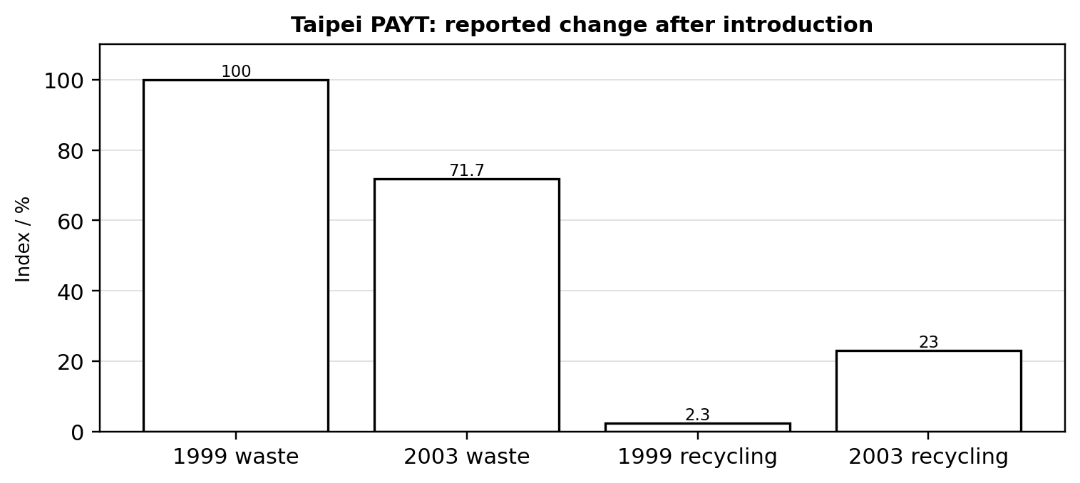
Figure 1. Taipei PAYT: reported change in waste generation and recycling after introduction. Source/derivation: cited case sources.
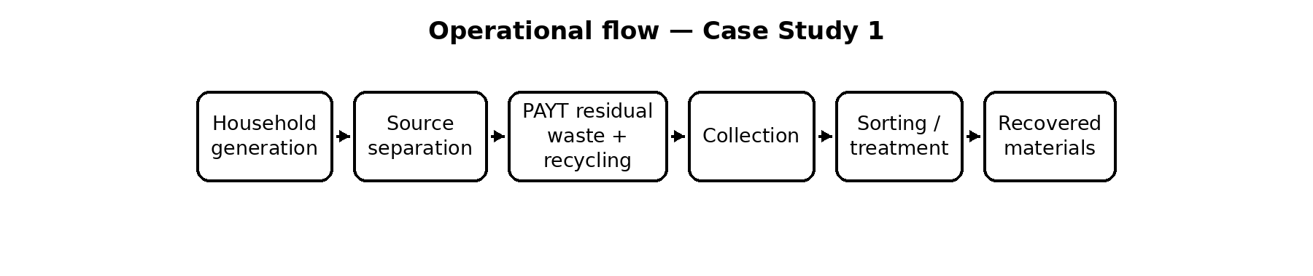
Figure 11. Simplified operational model derived from the cited system descriptions.

5. Impact and Results
Indicator | Data / Result | Significance
PAYT launch | Taipei implemented the per-bag fee in 2000 | Created a direct user-pays incentive
Waste reduction | Reported 28.3% lower waste production in 2003 than 1999 | Rapid source-reduction effect
Recycling | Reported increase from 2.3% to 23% by 2003 | Large improvement in source separation
Long-term claim | Taipei reported 65% lower household waste and recycling above 66% in a 2025 statement | Shows continued policy effect; city-reported

6. Visual Evidence
Figure 1 shows the reported reduction in waste generation and the increase in recycling associated with Taipei’s PAYT system after introduction.

7. SWOT Analysis
Strengths | Weaknesses
Clear economic incentive  • Strong source separation  • Integrated institutions  • High public visibility | Requires reliable collection  • Illegal-dumping risk if enforcement is weak  • Pricing can be politically sensitive  • Depends on disciplined collection

Opportunities | Threats
Digital collection tracking  • Repair/reuse channels  • Better material markets  • Adaptation to other cities | Fee evasion  • Contamination  • Changing consumption  • Incineration capacity masking prevention

8. Comparison with India
Parameter | Taiwan / Model | India / Benchmark
Policy | PAYT + mandatory sorting | SWM Rules 2016 + local charges/EPR
Collection | Separated scheduled streams | Varies by ULB
Segregation | Strong household separation | Mandated but inconsistent
Informal sector | Limited formal role | Major recovery role
Lesson | Price signal + reliable service | Combine incentives with inclusion

9. Lessons for India
- Pilot unit-based residual-waste charging where collection is reliable.
- Keep segregated recyclables convenient and inexpensive.
- Integrate waste pickers rather than displacing them.
- Publish ward-level waste and contamination indicators.

10. Recommendations
1. Pilot PAYT in dense urban wards after minimum service standards are met.
2. Use standardized bags/tags or digital billing with anti-dumping safeguards.
3. Provide predictable recyclable and food-waste collection.
4. Link informal collectors and material-recovery facilities to the formal chain.

11. Conclusion
Taiwan shows that waste reduction becomes durable when residual disposal has a visible cost and recycling is convenient. The transferable lesson for India is the combination of incentives, reliable collection and institutional coordination—not the designated bag itself.

12. References
- [1] Taiwan Ministry of Environment. Resource Recycling / Four-in-One. https://www.moenv.gov.tw/en/env-affairs/resource-circulation/resource-recycling/resource-recycling/3147.html
- [2] World Bank. Bridging the Gap in Solid Waste Management. https://documents1.worldbank.org/curated/en/459431622213523067/pdf/Bridging-the-Gap-in-Solid-Waste-Management-Governance-Requirements-for-Results.pdf
- [3] Chang et al.. Change in MSW characteristics under recent management strategies in Taiwan. https://pubmed.ncbi.nlm.nih.gov/18164952/

CASE STUDY 2: South Korea – Food Waste Separation, Collection and Recycling System
Region/Country: Republic of Korea Theme: Food-waste PAYT, RFID measurement, recycling Key Focus: RFID-enabled user charging, source separation and food-waste resource recovery.

1. Executive Summary
South Korea treats food waste as a separately managed resource stream. A volume-based food-waste fee was implemented nationally in 2013, with RFID weighing providing precise measurement in many apartment complexes. K-eco operates the central RFID-based management system, while local governments install equipment and manage fees [1].

2. Background
Dense housing and high food-waste volumes made odor, collection and treatment important policy issues. The Ministry of Environment explains that RFID identifies the user, weighs the waste and sends discharge information to a central system for fee calculation [2]. The sixth national waste survey reported 310.9 g of food waste per person per day, down from 368 g in the earlier survey [3].

3. Strategy / Initiative
- Separate food waste at source.
- Charge according to the amount discarded.
- Use RFID tags/cards and weighing equipment.
- Transmit weight and user data to a central system.
- Send separated food waste to permitted resource-recovery treatment.

4. Implementation / Operational Model
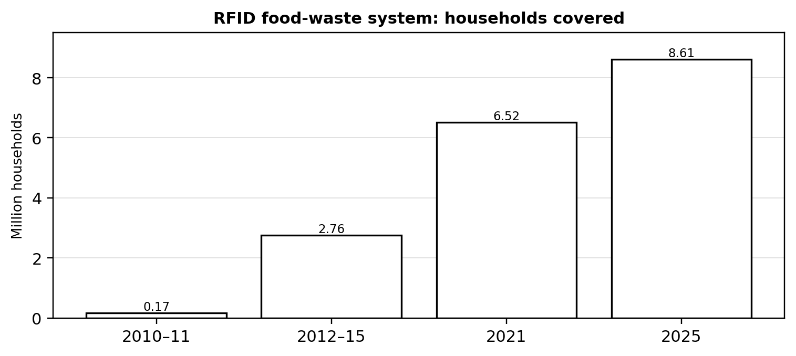
Figure 2. RFID food-waste system: growth in households covered. Source/derivation: cited case sources.
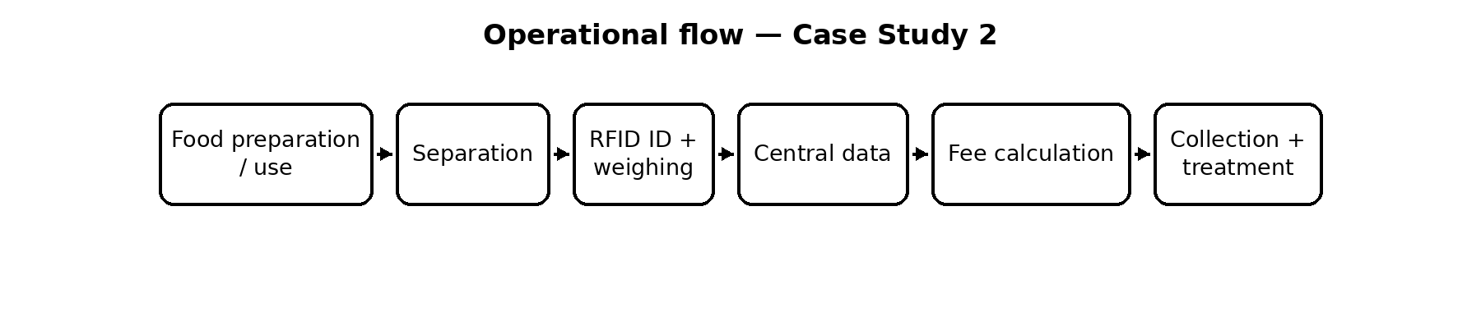
Figure 12. Simplified operational model derived from the cited system descriptions.

5. Impact and Results
Indicator | Data / Result | Significance
RFID coverage | 186 local governments and about 8.61 million apartment households by 2025 | National-scale digital infrastructure
RFID equipment | 151,934 devices in cumulative 2025 figures | Extensive physical network
Food waste | 310.9 g/person/day in sixth survey | 15.5% lower than earlier 368 g figure
Separation | Government material reports separated emission rates above 90% since 2006 | Strong source-separation culture

6. Visual Evidence
Figure 2 shows the expansion of household coverage by the RFID-based food-waste management system, illustrating the scale-up of digital measurement.

7. SWOT Analysis
Strengths | Weaknesses
Precise user charging  • Digital traceability  • High-density housing suits RFID  • Strong treatment infrastructure | Capital and maintenance cost  • Uneven convenience across housing types  • Contamination affects treatment  • Requires participation

Opportunities | Threats
Smart-bin analytics  • Anaerobic digestion  • Dynamic fees  • Food-loss prevention | Equipment failure  • Data/privacy concerns  • Contaminated feedstock  • Treatment over prevention

8. Comparison with India
Parameter | Republic of Korea / Model | India / Benchmark
Measurement | RFID weighing | Mostly non-digital household collection
Separation | Highly institutionalized | Varies widely
Treatment | Large resource-recovery network | Capacity uneven
Data | Central records | Municipal quality varies
Lesson | Measure high-density streams | Pilot in apartments/campuses

9. Lessons for India
- Measure food waste where density justifies digital equipment.
- Use user charges to reward prevention.
- Match treatment capacity to verified segregated feedstock.
- Use data to compare wards and detect leakage.

10. Recommendations
1. Pilot RFID food-waste charging in large apartments and campuses.
2. Integrate data with municipal dashboards while protecting privacy.
3. Use performance contracts for treatment plants.
4. Promote food donation and source reduction before treatment.

11. Conclusion
South Korea shows how a waste stream can become measurable, chargeable and recoverable when technology is integrated into everyday collection. India can adopt the principle selectively where density and service quality justify the investment.

12. References
- [1] Korea Environment Corporation. RFID-Based Food Wastes Management System. https://www.keco.or.kr/en/lay1/S295T387C404/contents.do
- [2] Republic of Korea Ministry of Environment. Volume-rate food-waste disposal guidance. https://www.me.go.kr/home/web/board/read.do?boardCategoryId=&boardId=184785&boardMasterId=39&decorator=&maxIndexPages=10&maxPageItems=10&menuId=&orgCd=&pagerOffset=7540&searchKey=&searchValue=
- [3] Republic of Korea Ministry of Environment. Sixth National Waste Statistical Survey. https://me.go.kr/eng/web/board/read.do?boardId=1599540&boardMasterId=522&menuId=461

CASE STUDY 3: Germany – Packaging Waste Management and Extended Producer Responsibility
Region/Country: Germany Theme: Packaging EPR, system participation, digital registration Key Focus: Producer financing, packaging collection systems and auditable data reporting.

1. Executive Summary
Germany has an institutionalized packaging-waste system in which producers finance recovery of relevant packaging. The LUCID Packaging Register provides registration and data reporting, while system operators organize collection, sorting and recycling. Since 12 August 2026, the EU Packaging and Packaging Waste Regulation and Germany’s Packaging Law Implementation Act have replaced the previous VerpackG framework, while registration, system participation and reporting remain core obligations [1].

2. Background
Germany’s packaging policy evolved toward stronger producer accountability and data controls. The German Environment Agency reports 17.9 million tonnes of packaging waste in 2023, of which 69.4% was recycled and 97.1% recovered in total [2]. The current framework also requires matching volume reports to the LUCID register and system operator.

3. Strategy / Initiative
- Register relevant producers in LUCID.
- Finance packaging recycling through system participation.
- Report material types and masses to the system and LUCID.
- Use system operators for collection, sorting and recycling.
- Require audited completeness declarations for high-volume producers.

4. Implementation / Operational Model
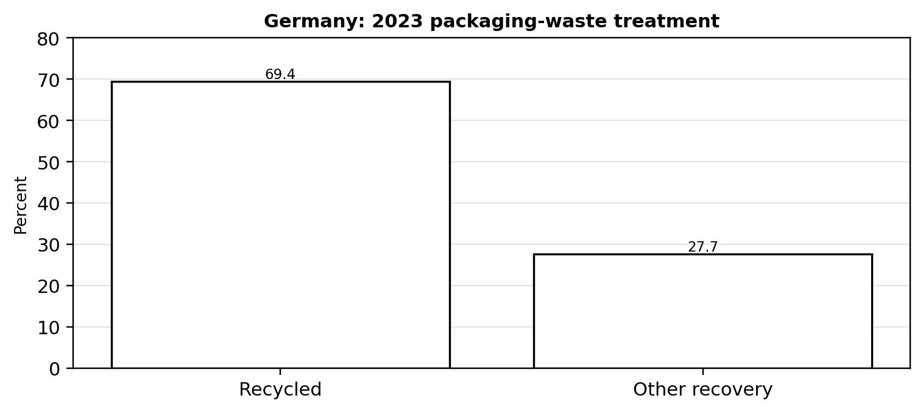
Figure 3. Germany: 2023 packaging-waste treatment outcomes. Source/derivation: cited case sources.
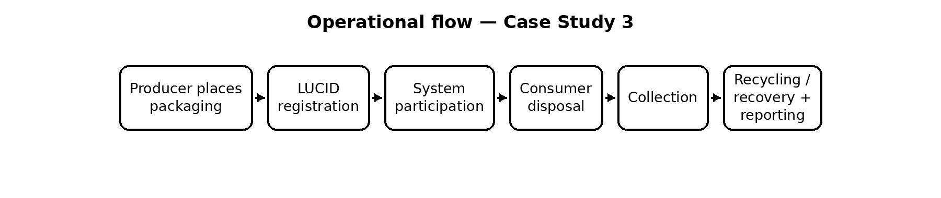
Figure 13. Simplified operational model derived from the cited system descriptions.

5. Impact and Results
Indicator | Data / Result | Significance
Packaging waste | 17.9 Mt in 2023 | Large national material flow
Recycling | 69.4% in 2023 | Majority recycled
Total recovery | 97.1% in 2023 | Very high overall recovery
Data control | LUCID + system reporting | Improves accountability and reconciliation

6. Visual Evidence
Figure 3 shows Germany’s 2023 packaging-waste treatment outcomes, highlighting the large share reported as recycled and the remaining recovery stream.

7. SWOT Analysis
Strengths | Weaknesses
Clear producer financing  • Central register  • Auditable data  • Large infrastructure | Administrative complexity  • Small-firm compliance burden  • Variable recycling quality  • Packaging volume remains high

Opportunities | Threats
Design-for-recycling incentives  • Reuse systems  • Digital material passports  • Higher-quality recyclates | Free-riding  • Complex multi-material packs  • E-commerce growth  • Recyclate market volatility

8. Comparison with India
Parameter | Germany / Model | India / Benchmark
EPR | Producer financing | EPR for packaging/e-waste
Data | LUCID reconciliation | Portal-based compliance
Collection | Established systems | Formal + informal channels
Enforcement | Registration/compliance link | State implementation varies
Lesson | Mass-balance accountability | Strengthen verification

9. Lessons for India
- Make producer registration and material-volume reporting consistent.
- Reconcile producer reports with recycler output.
- Reward packaging redesign and reuse, not only recycling.
- Publish aggregated data for accountability.

10. Recommendations
1. Strengthen mass-balance reconciliation.
2. Use standardized digital identifiers for materials.
3. Audit high-risk producers and waste streams.
4. Differentiate EPR fees by recyclability and circular design.

11. Conclusion
Germany demonstrates that EPR becomes stronger when responsibility is supported by registration, financing, data reconciliation and enforceable consequences. The transferable lesson is the accountability architecture rather than direct replication of German collection infrastructure.

12. References
- [1] Central Agency Packaging Register. System participation; PPWR/VerpackDG update. https://www.verpackungsregister.org/en/system-participation-data-reporting/system-participation
- [2] German Environment Agency. Packaging waste statistics. https://www.umweltbundesamt.de/daten/umweltzustand-trends/ressourcen-abfall/verwertung-entsorgung-ausgewaehlter-abfallarten/verpackungsabfaelle
- [3] ZSVR. Data reporting. https://www.verpackungsregister.org/en/system-participation-data-reporting/data-reporting

CASE STUDY 4: Sweden – Waste-to-Energy and Municipal Waste Management
Region/Country: Sweden Theme: Residual waste, energy recovery, municipal governance Key Focus: Integration of source separation, residual treatment and district heating.

1. Executive Summary
Sweden combines source separation and material recycling with a large waste-to-energy sector for residual waste. Municipalities are responsible for collection and treatment of household-type waste, while producer-responsibility streams operate alongside municipal services [1]. Waste-to-energy plants supply district heating and electricity, making residual waste part of the energy system, but the model also raises the need to avoid incinerating materials that could be reused or recycled.

2. Background
Swedish municipalities organize local waste services through regulations and waste plans. Food waste is generally sent to anaerobic digestion, garden waste is commonly composted, and residual waste is largely incinerated. In 2024, 4.5 million tonnes of municipal waste were generated and 47% was materially recycled [2]. Avfall Sverige reports 6.6 million tonnes of waste entering energy-recovery plants and 20 TWh of energy recovered in 2024 [3].

3. Strategy / Initiative
- Assign clear municipal responsibility.
- Use source separation for food, packaging, bulky and hazardous fractions.
- Direct organic waste to biological treatment.
- Use WtE for residual waste unsuitable for higher-value recovery.
- Integrate WtE with district heating.

4. Implementation / Operational Model
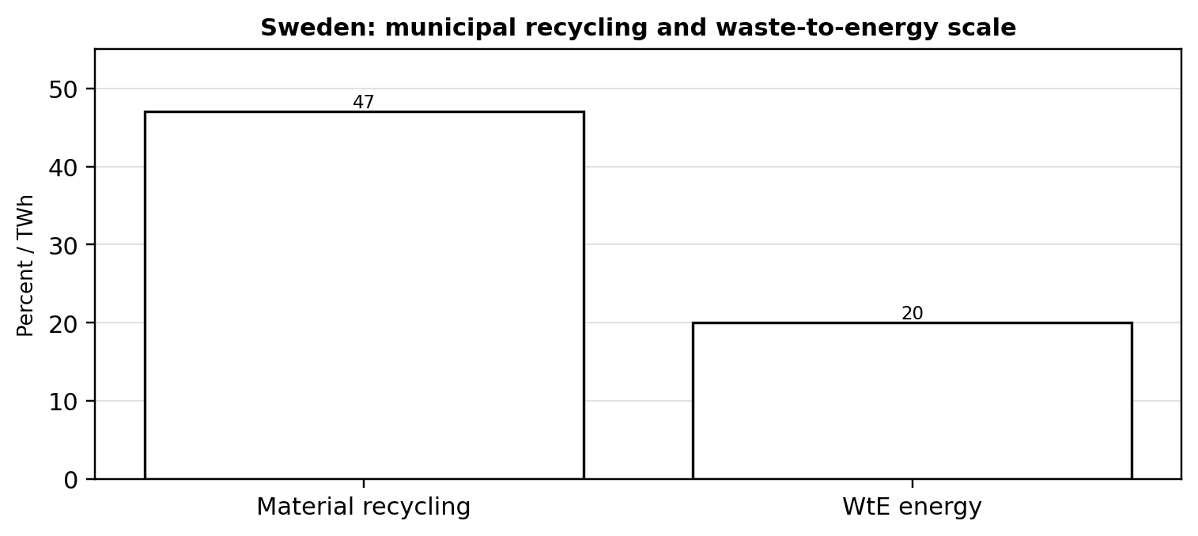
Figure 4. Sweden: material recycling and energy recovered from waste in 2024. Source/derivation: cited case sources.
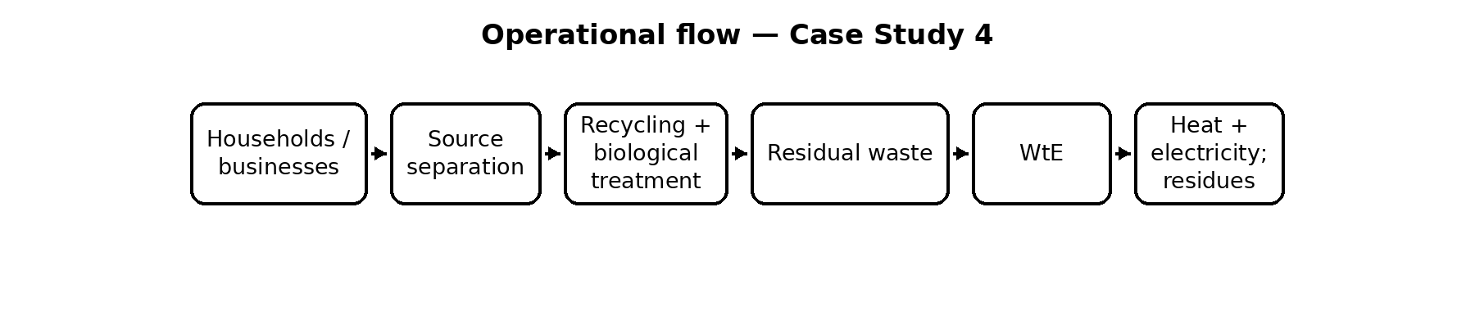
Figure 14. Simplified operational model derived from the cited system descriptions.

5. Impact and Results
Indicator | Data / Result | Significance
Municipal waste | 4.5 Mt in 2024 | 428 kg/person
Material recycling | 47% in 2024 | Below 55% Swedish/EU 2025 milestone
WtE input | 6.6 Mt in 2024 | Household, commercial and industrial waste
Energy recovered | 20 TWh in 2024 | 17.6 TWh heat + 2.4 TWh electricity

6. Visual Evidence
Figure 4 compares the reported 2024 material-recycling share with energy recovered through Sweden’s waste-to-energy system.

7. SWOT Analysis
Strengths | Weaknesses
Reliable municipal responsibility  • Strong source separation  • District-heating integration  • High treatment standards | WtE capacity can reduce prevention pressure  • Capital intensive  • Residual ash remains  • Material recycling below 2025 target

Opportunities | Threats
Better pre-sorting  • Carbon capture  • Reuse/repair  • Low-carbon heat | Fossil plastics  • Imported waste  • Incineration lock-in  • Competition with recycling

8. Comparison with India
Parameter | Sweden / Model | India / Benchmark
Residual treatment | WtE after sorting | WtE exists; feedstock quality varies
Organic waste | Separate biological treatment | Composting/biogas expanding
Energy | District heating integration | Heat demand differs by city
Hierarchy | Residual WtE | Prevention/recycling should remain higher
Lesson | System integration | Avoid mixed-waste feedstock

9. Lessons for India
- Municipal responsibility needs stable financing.
- Residual waste should be post-segregation material.
- Organic waste should be treated separately.
- WtE is most useful where residual waste and energy demand both exist.

10. Recommendations
1. Require source-segregation records before WtE acceptance.
2. Prioritize composting/anaerobic digestion for wet waste.
3. Use independent emissions and residue monitoring.
4. Build material-recovery capacity before expanding incineration.

11. Conclusion
Sweden illustrates how residual waste can support energy infrastructure, but it is not evidence that incineration should replace recycling. Its strongest lesson is integration across the waste hierarchy.

12. References
- [1] Swedish Environmental Protection Agency. Municipal waste management in Sweden. https://www.naturvardsverket.se/en/topics/waste/municipal-waste-management-in-sweden/
- [2] Swedish Environmental Protection Agency. Municipal waste statistics 2024. https://www.naturvardsverket.se/data-och-statistik/avfall/kommunalt-avfall/?q=avfall
- [3] Avfall Sverige. Swedish Waste Management 2024. https://www.avfallsverige.se/media/si4iodt5/swedish-waste-management-2024.pdf

CASE STUDY 5: San Francisco, USA – Zero Waste Strategy
Region/Country: San Francisco, California, USA Theme: Mandatory separation, composting, zero-waste governance Key Focus: Mandatory three-stream separation, composting and compliance systems.

1. Executive Summary
San Francisco’s zero-waste strategy is built around mandatory separation of recyclables, compostables and trash, supported by collection infrastructure, education, commercial requirements and product restrictions. The Mandatory Recycling and Composting Ordinance was implemented in 2009, followed by additional measures for single-use products, food recovery and large-generator compliance [1].

2. Background
The city had large-scale food-scrap collection before the 2009 ordinance and then institutionalized mandatory recycling and composting for residents and businesses. The Environment Department states that all residents and businesses must separate recyclables, compostables and trash [2]. Large refuse generators can be audited under a later compliance law [3]. A 2023 rate application reported 40.1% actual diversion for rate year 2022 [4].

3. Strategy / Initiative
- Mandatory three-stream separation.
- Citywide compost collection for food and plant material.
- Collection services supported by operational oversight.
- Education and technical assistance.
- Audits and Zero Waste Facilitators for persistent contamination.

4. Implementation / Operational Model
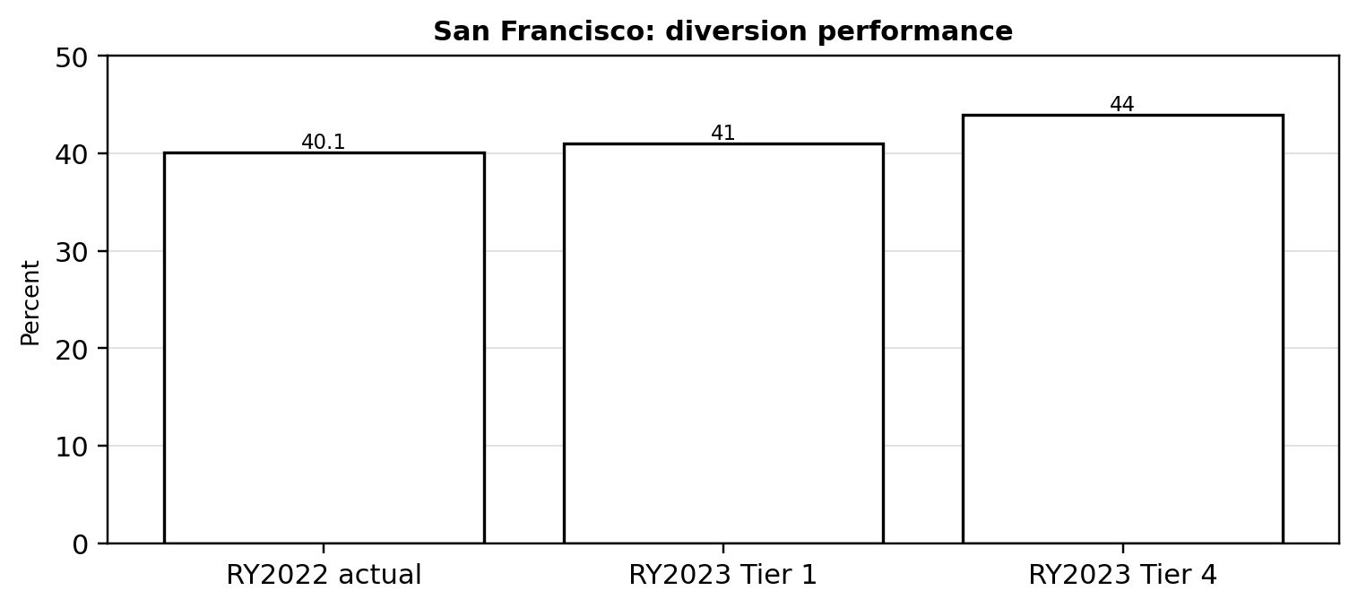
Figure 5. San Francisco: reported diversion performance across cited rate-year measures. Source/derivation: cited case sources.
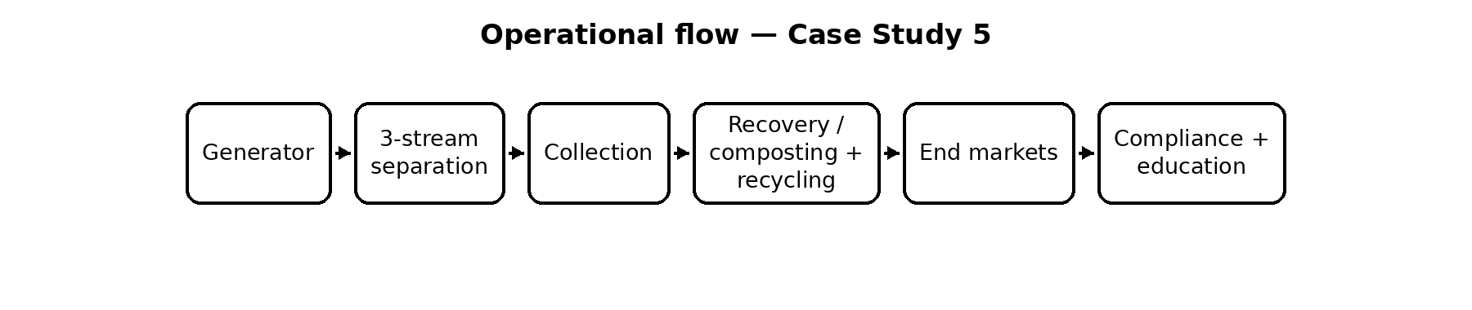
Figure 15. Simplified operational model derived from the cited system descriptions.

5. Impact and Results
Indicator | Data / Result | Significance
Mandatory ordinance | Implemented in 2009 | Compulsory source separation
Service compliance | City reports 99% property service compliance | Broad service coverage
Diversion | 40.1% in rate year 2022 | Progress but large gap to zero waste
Food recovery | Mandatory edible-food recovery for large generators from 2022 | Moves policy upstream

6. Visual Evidence
Figure 5 shows reported San Francisco diversion performance across the cited rate-year measures, illustrating progress under the city’s separation and recovery system.

7. SWOT Analysis
Strengths | Weaknesses
Mandatory participation  • Integrated composting  • Strong communication  • Commercial enforcement | Contamination persists  • Apartment chutes complicate sorting  • Diversion below ambition  • Collection contracts matter

Opportunities | Threats
Repair/reuse expansion  • Food recovery  • Better building design  • Data-driven contamination control | Consumption growth  • Misinformation  • Service cost  • Recycling-market changes

8. Comparison with India
Parameter | San Francisco, California, USA / Model | India / Benchmark
Source separation | Mandatory 3-stream | Segregation mandated but variable
Composting | Citywide organics | Wet waste systems vary
Enforcement | Commercial audits | ULB enforcement varies
Metrics | Diversion measured | City-level data inconsistent
Lesson | Mandate + infrastructure | Guarantee separate collection

9. Lessons for India
- Mandates work when infrastructure exists.
- Organics collection can be a major diversion route.
- Large generators need stronger auditing.
- Targets need measurable interim indicators.

10. Recommendations
1. Adopt mandatory segregation with service guarantees.
2. Audit large commercial and institutional generators.
3. Expand wet-waste treatment before stricter enforcement.
4. Publish ward-level diversion and contamination results.

11. Conclusion
San Francisco demonstrates both the power and limits of mandatory source separation. Regulation can shift citywide behavior, but measured diversion shows that prevention, reuse and material-market quality remain essential.

12. References
- [1] San Francisco Environment Department. Zero Waste policy timeline. https://www.sfenvironment.org/zero-waste
- [2] San Francisco Environment Department. Recycling and composting FAQs. https://www.sfenvironment.org/recycling-composting-faqs
- [3] San Francisco Environment Department. Refuse Separation Law. https://www.sfenvironment.org/refuse-separation-law-large-refuse-generators
- [4] City and County of San Francisco. 2023 Rate Application. https://www.sf.gov/sites/default/files/2023-03/2023%20Rate%20Application%20-%20Narrative%20Summary.pdf

CASE STUDY 6: Rwanda – National Plastic Bag Ban and Plastic Waste Management
Region/Country: Rwanda Theme: Plastic restriction, enforcement, alternatives Key Focus: National prohibition, coordinated enforcement and alternative packaging.

1. Executive Summary
Rwanda is a widely studied example of strict national action against plastic carry bags. The original ban was introduced in 2008 after concerns about litter, blocked drainage and impacts on agriculture and water. Law No. 17/2019 expanded the policy to plastic carry bags and a broader set of single-use plastic items, with limited authorization pathways and collection/recycling duties [1].

2. Background
UNEP reports that Rwanda’s policy followed concerns that plastic bags clogged drainage systems, affected agriculture and contaminated water [2]. The 2019 law prohibits manufacturing, importation, use and sale of plastic carry bags and single-use plastic items subject to specified authorizations. Rwanda’s environmental authority continues to administer authorization for exceptional uses where alternatives are unavailable or product quality would otherwise be affected [3].

3. Strategy / Initiative
- National legal prohibition rather than voluntary reduction alone.
- Customs, police and environmental authorities participate in enforcement.
- Limited exceptions require authorization.
- Relevant businesses have collection and segregation duties.
- Reusable/compostable alternatives are permitted under defined conditions.

4. Implementation / Operational Model
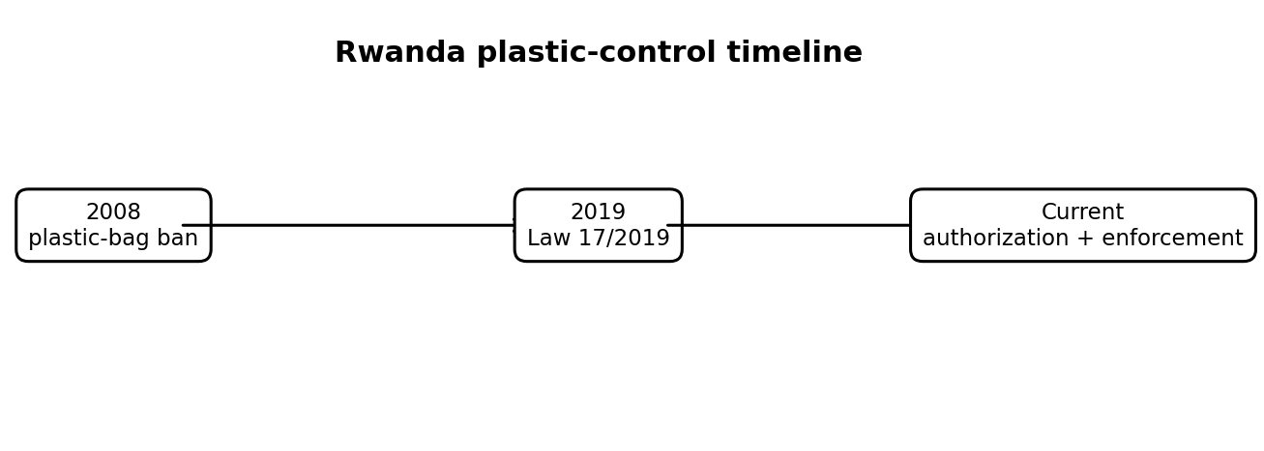
Figure 6. Rwanda: evolution of the national plastic-control framework. Source/derivation: cited case sources.
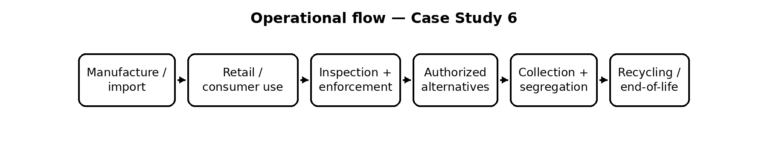
Figure 16. Simplified operational model derived from the cited system descriptions.

5. Impact and Results
Indicator | Data / Result | Significance
2008 ban | National plastic-bag ban introduced | Clear national policy signal
2019 law | Expanded to plastic carry bags and single-use plastic items | Broader scope
Enforcement | 2016 operation seized 435,000 banned bags | Evidence of active enforcement, not a compliance rate
Circular economy | UNEP reports Rwanda emphasizes circular economy and recycling capacity | Links restriction to broader waste policy

6. Visual Evidence
Figure 6 traces the evolution of Rwanda’s plastic-control framework from the 2008 bag ban through the 2019 law to the current authorization and enforcement approach.

7. SWOT Analysis
Strengths | Weaknesses
Clear rule  • Strong enforcement institutions  • High visibility  • National consistency | Alternatives can be costly  • Black-market risk  • MSME burden  • Recycling capacity still needed

Opportunities | Threats
Reusable-packaging markets  • Local alternatives  • EPR  • Circular procurement | Cross-border smuggling  • Substitution  • Remote enforcement  • Unintended social costs

8. Comparison with India
Parameter | Rwanda / Model | India / Benchmark
Plastic policy | National prohibition with exceptions | Specified SUP restrictions
Enforcement | Police/customs/REMA | Multiple authorities
Alternatives | Reusable/compostable options | Alternative market developing
Scale | Smaller population | India much larger/federal
Lesson | Clarity + alternatives | Phase and measure restrictions

9. Lessons for India
- Policy clarity simplifies compliance.
- Enforcement must be coordinated.
- Restrictions need viable alternatives.
- Measure substitution and leakage, not only banned products.

10. Recommendations
1. Phase restrictions on high-litter products.
2. Support standards and markets for reusable alternatives.
3. Combine customs, inspection and environmental data.
4. Measure plastic leakage in drains, rivers and public spaces.

11. Conclusion
Rwanda shows that strong regulation can change everyday material use when rules are clear and consistently enforced. For India, the transferable lesson is coordinated enforcement plus alternatives, not a simple copy of a national ban.

12. References
- [1] Rwanda Environment Management Authority. Law No. 17/2019. https://www.rema.gov.rw/index.php?eID=dumpFile&f=137937&t=f&token=de51c32ae154c73f32bd7e826b4d7074813b233f
- [2] UNEP. Clean Seas – Rwanda. https://www.unep.org/beatpollution/clean-seas
- [3] REMA. Authorization for single-use plastics and carry bags. https://www.rema.gov.rw/services/authorization-to-single-use-plastics-and-plastic-carry-bags
- [4] Rwanda National Police. 2016 seizure operation. https://police.gov.rw/media/news-detail/news/rnp-rema-operation-seize-435-000-pieces-of-banned-plastic-bags/

CASE STUDY 7: Netherlands – Circular Procurement and Circular Economy Policy
Region/Country: Netherlands Theme: Circular procurement, public purchasing, national policy Key Focus: Using public purchasing power to create demand for circular products and services.

1. Executive Summary
The Netherlands treats government purchasing as a market-shaping instrument for circularity. National policy aims for a fully circular economy by 2050 and a 50% reduction in primary abiotic raw-material use by 2030. The National Circular Economy Programme identifies public procurement as a major lever because public authorities collectively spend tens of billions of euros each year [1–3].

2. Background
The Netherlands was an early adopter of national circular-economy policy. The 2023–2030 programme builds on transition agendas for consumer goods, plastics, construction, manufacturing and biomass/food. The programme notes that all ministries signed the 2022–2025 Manifest for Socially Responsible Commissioning and Procurement and identifies roughly €85 billion annual public procurement, including about €13 billion by central government, as a potential market lever [3]. PBL has also cautioned that the overall transition has not yet accelerated sufficiently [4].

3. Strategy / Initiative
- Specify circular performance in tenders.
- Use life-cycle costing rather than only purchase price.
- Require repair, refurbishment, take-back or reuse where suitable.
- Create demand for secondary materials.
- Coordinate procurement across government.

4. Implementation / Operational Model
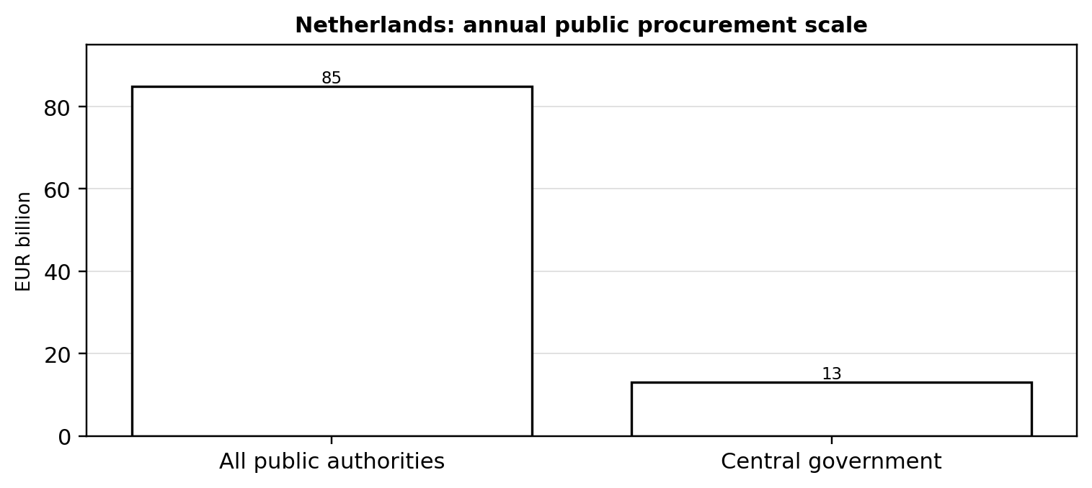
Figure 7. Netherlands: annual public-procurement scale relevant to circular procurement. Source/derivation: cited case sources.
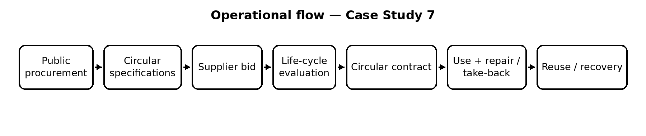
Figure 17. Simplified operational model derived from the cited system descriptions.

5. Impact and Results
Indicator | Data / Result | Significance
2050 goal | Fully circular economy | Long-term direction
2030 target | Halve primary abiotic raw-material use | Resource-use milestone
Procurement scale | About €85B/year public authorities; €13B central government | Market-shaping potential
Progress assessment | PBL 2023 found no clear acceleration | Shows policy needs stronger implementation

6. Visual Evidence
Figure 7 shows the reported annual public-procurement scale relevant to the Netherlands’ circular procurement approach.

7. SWOT Analysis
Strengths | Weaknesses
Large purchasing power  • Cross-sector influence  • Life-cycle perspective  • Policy coordination | Tender complexity  • Limited circular supply  • Verification difficulty  • Upfront price concerns

Opportunities | Threats
Circular construction  • Product-as-a-service  • Repair markets  • Secondary-material demand | Greenwashing  • Weak supplier competition  • Short-term budgeting  • Unverified circular claims

8. Comparison with India
Parameter | Netherlands / Model | India / Benchmark
Policy lever | Circular procurement | Green/public procurement emerging
Demand | Government as lead customer | Large procurement market
Measurement | National CE monitoring | Monitoring fragmented
Supply | Circular products expanding | Market maturity uneven
Lesson | Use purchasing power | Create verified criteria

9. Lessons for India
- Government can be a lead customer.
- Circular tender criteria must be measurable.
- Life-cycle cost can outperform upfront-price thinking.
- Contracts should define take-back and repair.

10. Recommendations
1. Introduce circular procurement criteria in selected high-volume categories.
2. Use life-cycle costing for electronics, furniture, vehicles and construction.
3. Require repairability and take-back where feasible.
4. Create a verified catalogue of circular products and suppliers.

11. Conclusion
The Dutch case shows that circularity can be embedded in the purchasing decisions that shape markets. For India, circular procurement can complement EPR and waste policy by creating demand for repairable, reusable and recycled products.

12. References
- [1] Government of the Netherlands. Circular economy by 2050. https://www.government.nl/themes/economy/sustainable-economy/circular-economy-by-2050
- [2] Government of the Netherlands. National Circular Economy Programme 2023–2030. https://www.government.nl/documents/2023/09/27/national-circular-economy-programme-2023-2030
- [3] Government of the Netherlands. NPCE circular procurement section. https://www.government.nl/binaries/government/documenten/reports/2023/09/27/national-circular-economy-programme-2023-2030/NPCE%2BCirculaire%2BEconomie%2Brapport%2BEngels.pdf
- [4] PBL Netherlands Environmental Assessment Agency. Integral Circular Economy Report 2023. https://www.pbl.nl/en/publications/integral-circular-economy-report-2023-assessment-for-the-netherlands

CASE STUDY 8: Fairphone – Modular, Repairable and Ethical Electronics
Region/Country: Netherlands / global electronics market Theme: Modularity, repairability, longevity, responsible materials Key Focus: Designing electronics for repair, long life, material responsibility and take-back.

1. Executive Summary
Fairphone is a product-design and business-model case in which circularity is built into electronics from the beginning. The company emphasizes modular hardware, replaceable components, long software support, spare parts and responsible materials. The Fairphone Gen. 6 has 12 user-replaceable modules, a five-year warranty, support to 2033 and a 10/10 iFixit repairability score [1–3]. Its 2025 impact reporting records 30 tonnes of e-waste collected and 97% of products placed on the market as 100% e-waste neutral [4].

2. Background
Smartphones contain valuable and resource-intensive materials, while premature replacement increases environmental impact. Fairphone therefore focuses on keeping devices in use. Its Fairphone 5 also received 10/10 from iFixit and was designed around modularity and long software support [5]. The current Gen. 6 continues this approach through replaceable batteries, display and other modules.

3. Strategy / Initiative
- Design key components for user/service replacement.
- Provide spare parts and repair guides.
- Extend software support.
- Use fair and recycled materials where feasible.
- Operate take-back and e-waste-neutrality programmes.

4. Implementation / Operational Model
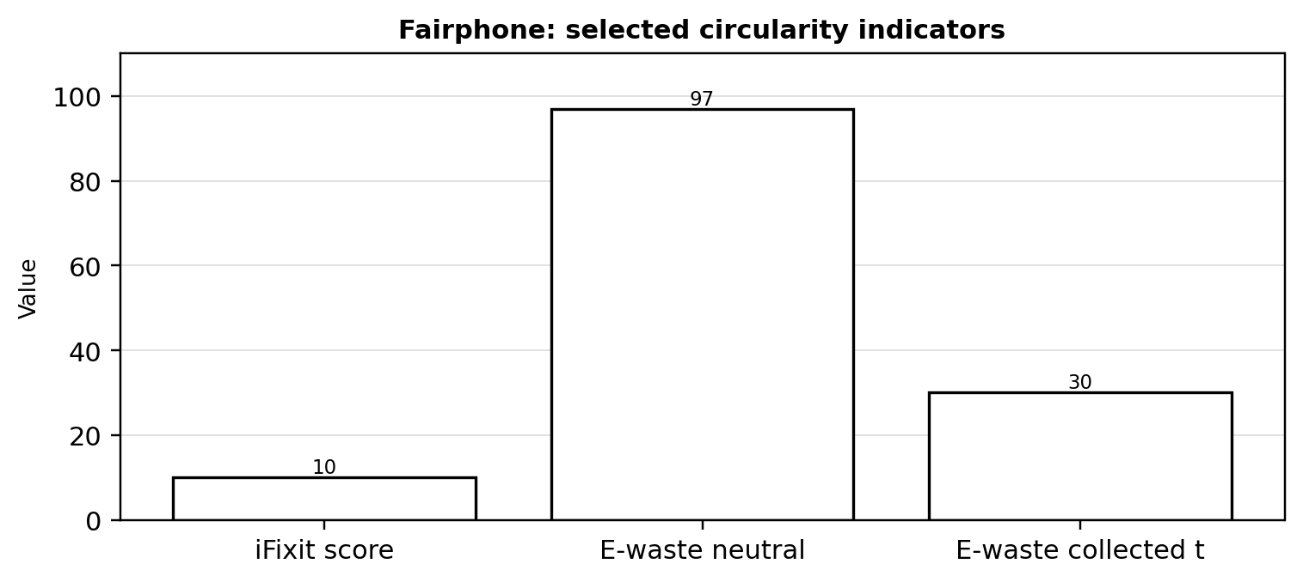
Figure 8. Fairphone: selected circularity and repairability indicators. Source/derivation: cited case sources.
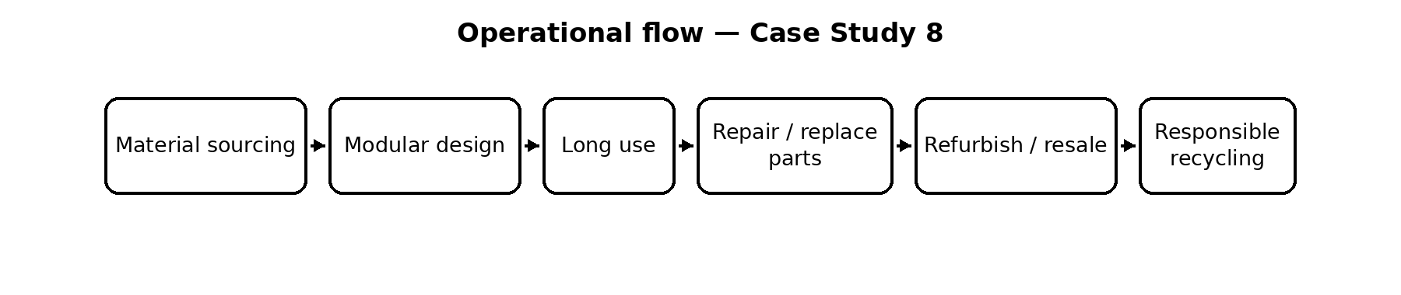
Figure 18. Simplified operational model derived from the cited system descriptions.

5. Impact and Results
Indicator | Data / Result | Significance
Repairability | Gen. 6: 10/10 iFixit | Highest possible score
Replaceable parts | 12 user-replaceable modules | Component-level repair
Support | To 2033 | Longer functional life
E-waste 2025 | 30 metric tonnes collected | Responsible end-of-life
E-waste neutrality | 97% of products placed on market were 100% neutral | Progress toward full coverage

6. Visual Evidence
Figure 8 summarizes selected Fairphone circularity indicators, highlighting repairability, replaceable components and product-life extension.

7. SWOT Analysis
Strengths | Weaknesses
Repairable architecture  • Long software support  • Impact reporting  • Responsible sourcing | Higher complexity/cost  • Small market share  • Supply constraints  • Repair depends on users

Opportunities | Threats
Right-to-repair  • Refurbished markets  • Enterprise procurement  • Industry influence | Obsolescence pressure  • Price competition  • Supplier constraints  • Sealed-device preferences

8. Comparison with India
Parameter | Netherlands / global electronics market / Model | India / Benchmark
Design | Modular + repairable | Most electronics less repairable
Longevity | Long support | Support varies
E-waste | Take-back/neutrality | EPR 2022
Repair | Manufacturer + DIY | Large informal repair sector
Lesson | Design + repair | Combine brand + local ecosystem

9. Lessons for India
- Product design is waste prevention.
- Repairability needs parts and instructions.
- Software support is part of circularity.
- Take-back complements repair and refurbishment.

10. Recommendations
1. Add repairability and spare-part criteria to electronics procurement.
2. Encourage replaceable batteries/modules where technically feasible.
3. Require support periods and repair information.
4. Partner manufacturers with India’s repair ecosystem.

11. Conclusion
Fairphone shows that circularity can begin at the design stage. Its importance is less about market share and more about demonstrating a commercially viable direction for longer-lasting electronics.

12. References
- [1] Fairphone. The Fairphone Gen. 6. https://www.fairphone.com/the-fairphone-gen-6
- [2] Fairphone. Circular operations – Impact Report 2025. https://www.fairphone.com/wp-content/uploads/2026/04/Fairphone-Impact_Report-2025.pdf
- [3] Fairphone. Resources and policies. https://www.fairphone.com/hub/en/resources-policies/
- [4] Fairphone. Impact Report 2025 highlights. https://www.fairphone.com/impact-report
- [5] Fairphone. Fairphone 5 10/10 iFixit release. https://www.fairphone.com/wp-content/uploads/2023/12/Press_Release_Fairphone5_iFixit.pdf

CASE STUDY 9: Interface – Circular Economy and Recycled Carpet Manufacturing
Region/Country: Global flooring company Theme: Circular product design, recycled inputs, take-back Key Focus: Modular carpet, recycled inputs and the ReEntry take-back loop.

1. Executive Summary
Interface applies circular-economy principles to flooring through modular design, recycled/bio-based inputs and the ReEntry take-back programme. ReEntry was created in 1995 and routes used flooring toward reuse, recycling or recovery. Interface reports 84.5 million pounds of post-consumer carpet collected since 2016, with 12% reused, 56% recycled in Interface processes, 3% recycled by others and 29% sent to waste-to-energy [1]. Its 2025 impact reporting states that 51% of flooring-product materials were recycled, bio-based or captured-carbon materials [2].

2. Background
Carpet is difficult to recover because it combines fibers, backing and other materials. Interface addresses this by making carpet modular, enabling selective replacement, and by creating a reverse flow for used products. ReEntry assesses returned flooring and chooses the highest practical recovery route [3].

3. Strategy / Initiative
- Use modular tiles to reduce installation waste and enable selective replacement.
- Increase recycled, bio-based and captured-carbon inputs.
- Operate ReEntry take-back.
- Prioritize direct reuse where practical.
- Recycle returned carpet into new flooring or other materials.

4. Implementation / Operational Model
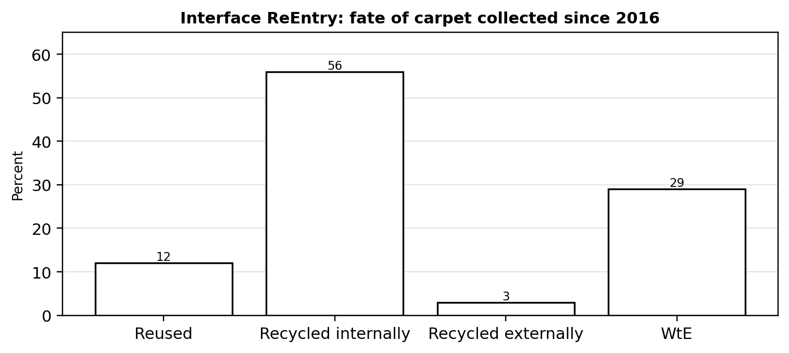
Figure 9. Interface ReEntry: fate of carpet collected since 2016. Source/derivation: cited case sources.
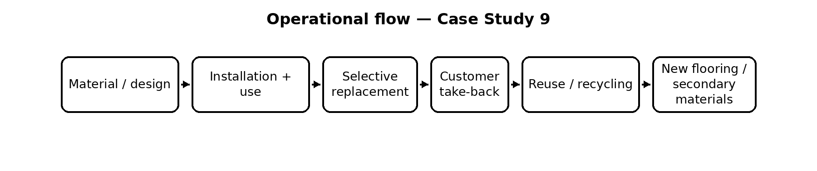
Figure 19. Simplified operational model derived from the cited system descriptions.

5. Impact and Results
Indicator | Data / Result | Significance
ReEntry | Created in 1995 | Long-running take-back system
Collected since 2016 | 84.5 million lb | Large reverse-material flow
Reuse | 12% | Highest-value life-extension route
Recycling | 59% combined internal/external | Majority returned to material use
2025 inputs | 51% recycled/bio-based/captured carbon | Circularity extends upstream

6. Visual Evidence
Figure 9 shows the reported fate of carpet collected through Interface’s ReEntry system since 2016, illustrating the role of take-back and material recovery.

7. SWOT Analysis
Strengths | Weaknesses
Design + take-back integration  • Long-running ReEntry  • High recycled input  • Measured impacts | Complex separation  • Reverse logistics  • Not every product recyclable  • Industrial scale needed

Opportunities | Threats
Design for disassembly  • Material passports  • Closed-loop recycling  • Service models | Contamination  • Transport impacts  • Material supply volatility  • Renovation cycles

8. Comparison with India
Parameter | Global flooring company / Model | India / Benchmark
Design | Modular tiles | Less common
Take-back | ReEntry | Fragmented
Material input | High recycled/bio-based share | Markets developing
Measurement | Corporate reporting | Project reporting varies
Lesson | Close loop | Build reverse logistics

9. Lessons for India
- Modularity reduces installation and replacement waste.
- Take-back is stronger when products are designed for recovery.
- Reuse should precede recycling where practical.
- Recycled-content demand creates a market for recovered materials.

10. Recommendations
1. Promote modular flooring in public projects.
2. Add take-back clauses to high-volume product contracts.
3. Create recycled-content and material-disclosure standards.
4. Build reverse logistics between manufacturers, contractors and recyclers.

11. Conclusion
Interface shows how design, material sourcing and end-of-life logistics can be operated as one circular system. The key lesson is that circularity is an operational architecture, not a single recycling step.

12. References
- [1] Interface. 2024 Impact Report – ReEntry results. https://prd-sites.interface.com/content/dam/interfaceinc/interface/sustainability/global/esg/esg-report/2024%20Impact%20Report-June%2020_FINAL.pdf
- [2] Interface. 2025 Impact Report. https://www.interface.com/US/en-US/sustainability/interface-impact-report.html
- [3] Interface. ReEntry programme. https://www.interface.com/GB/en-GB/sustainability/recycling.html

CASE STUDY 10: Patagonia – Product Repair, Reuse and Circular Business Practices
Region/Country: United States / global apparel market Theme: Repair, resale, trade-in, recycling, product longevity Key Focus: Repair, trade-in, resale and responsible recycling as a product-life-extension model.

1. Executive Summary
Patagonia’s Worn Wear programme treats used clothing as an asset that can continue generating value. The programme began in 2012 and evolved from clothing swaps into repair events, resale and trade-in. Customers can return eligible used gear for credit; products that cannot be resold can be returned for recycling or another responsible end-of-life route [1–2]. Patagonia’s FY2019 report recorded over 56,000 garments repaired at its Reno Service Center and over 67,000 garments taken in by retail stores for trade-in [3].

2. Background
Apparel waste is influenced by short product lives, changing preferences and difficult textile recycling. Patagonia’s approach starts with durability and repair, then adds resale and trade-in. The current Worn Wear programme provides used gear with another route to market and publishes repair/care guidance [1–2].

3. Strategy / Initiative
- Design and sell durable products.
- Provide repair and DIY guidance.
- Repair damaged products instead of replacing them.
- Accept eligible used products for trade-in and resale.
- Recycle products at end of useful life when reuse is no longer viable.

4. Implementation / Operational Model
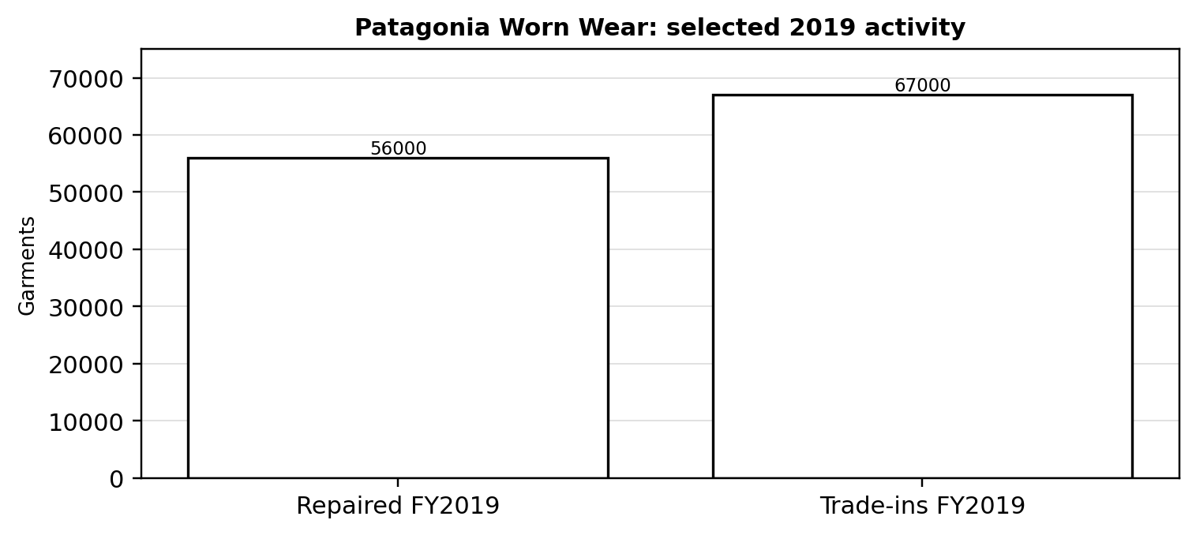
Figure 10. Patagonia Worn Wear: selected 2019 repair and trade-in activity. Source/derivation: cited case sources.
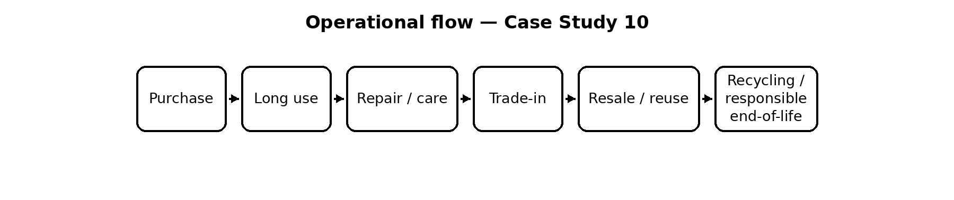
Figure 20. Simplified operational model derived from the cited system descriptions.

5. Impact and Results
Indicator | Data / Result | Significance
Programme start | Worn Wear launched in 2012 | Dedicated product-life-extension channel
FY2019 repairs | Over 56,000 garments repaired at Reno | Repair at operational scale
FY2019 trade-ins | Over 67,000 garments taken in by retail stores | Reverse flow for resale
Current trade-in | Eligible used gear returned for credit | Economic incentive for reuse
End-of-life | Patagonia accepts products for recycling | Responsibility beyond first owner

6. Visual Evidence
Figure 10 summarizes selected 2019 Worn Wear activity, showing the operational scale of Patagonia’s repair and trade-in approach.

7. SWOT Analysis
Strengths | Weaknesses
Durability positioning  • Repair network  • Resale channel  • Customer loyalty | Premium pricing  • Trade-in eligibility limits  • Textile recycling difficulty  • Still sells new products

Table 11. Cross-Case Comparison — Cases 1–5 25
Opportunities | Threats
Scale resale  • Repair services  • Fiber-to-fiber recycling  • Product-as-a-service | Fast fashion  • Overconsumption  • Blended textiles  • Logistics emissions
Table 12. Cross-Case Comparison — Cases 6–10 25
Opportunities | Threats

8. Comparison with India
Parameter | United States / global apparel market / Model | India / Benchmark
Repair | Brand-supported | Strong informal repair
Reuse | Branded resale | Large informal second-hand market
Take-back | Trade-in/recycling | Varies by producer
Business model | Durability + resale | Mostly linear apparel
Lesson | Formalize existing repair | Combine brands + local enterprises

9. Lessons for India
- Repair is a circular business activity.
- Resale creates a second revenue stream.
- Take-back works better with incentives.
- Reuse should generally precede recycling.

10. Recommendations
1. Encourage branded repair and take-back.
2. Develop durability and repairability standards.
3. Partner manufacturers with local repair enterprises.
4. Create sorting systems prioritizing resale and reuse.

11. Conclusion
Patagonia demonstrates that circularity can be embedded in customer relationships and revenue models. Repair, resale and trade-in keep products useful longer, while recycling becomes a later-stage response.

12. References
- [1] Patagonia Worn Wear. Programme FAQ. https://wornwear.patagonia.com/pages/faq
- [2] Patagonia Worn Wear. Trade-in programme. https://wornwear.patagonia.com/pages/trade-it-in
- [3] Patagonia. FY2019 Benefit Corporation Report. https://www.patagonia.com/on/demandware.static/-/Library-Sites-PatagoniaShared/default/dwf14ad70c/PDF-US/PAT_2019_BCorp_Report.pdf
- [4] Patagonia. Worn Wear recycling. https://www.patagonia.com/wornwear-recycling-scroller.html

7. CROSS-CASE COMPARISON
Case | Country | Main Problem | Main Strategy | Stakeholders | Circular Approach | Strength | Limitation | Lesson for India
Taiwan PAYT | Taiwan | Residual waste | User-pays + sorting | Households, city, recyclers | Reduce + recycle | Strong incentive | Needs reliable service | Make disposal cost visible
South Korea food waste | Republic of Korea | Food waste | RFID + PAYT | Households, municipalities, K-eco | Resource recovery | Precise measurement | Technology cost | Digitalize high-density streams
Germany packaging EPR | Germany | Packaging | Producer financing + data | Producers, systems, ZSVR | EPR + recycling | Accountability | Complexity | Verify mass flows
Sweden WtE | Sweden | Residual municipal waste | Recycling + WtE | Municipalities, operators, energy sector | Recovery + energy | Integrated infrastructure | WtE lock-in risk | Treat only residuals
San Francisco zero waste | USA | Municipal waste | Mandatory separation + composting | City, residents, businesses | Reuse/recycle/compost | Mandatory participation | Diversion incomplete | Infrastructure must match mandates
Rwanda plastics | Rwanda | Plastic bags/SUP | Ban + enforcement | Government, police, customs | Prevention + reuse | Policy clarity | Alternative supply/smuggling | Pair bans with alternatives
Netherlands procurement | Netherlands | Resource use | Circular procurement | Government, suppliers | Demand-side circularity | Market leverage | Supply maturity | Government as lead customer
Fairphone | Netherlands/global | Electronics | Modular repairability | Brand, users, repairers | Longevity + repair | High repairability | Small scale | Design out obsolescence
Interface | Global | Carpet/flooring | ReEntry + recycled inputs | Brand, customers, recyclers | Closed-loop materials | Integrated system | Reverse logistics | Design + take-back
Patagonia | USA/global | Apparel | Repair + resale + trade-in | Brand, customers, repairers | Life extension + reuse | Customer channel | Textile complexity | Measure years of use

8. KEY LEARNINGS FOR INDIA

8.1 Source Segregation
Taiwan, South Korea and San Francisco show that segregation works when collection, incentives and enforcement align. India should not require separation without separate collection.

8.2 Producer Responsibility
Germany and Fairphone show regulatory and product-level responsibility. India can strengthen EPR by linking obligations to verified physical recovery and circular design.

8.3 Consumer Participation
Economic incentives, mandatory rules and convenience must reinforce one another.

8.4 Recycling Infrastructure
Targets cannot substitute for material-recovery, composting, digestion, repair, refurbishing and high-quality recycling capacity.

8.5 Informal-Sector Integration
India should formalize and improve safety, payment and access for waste pickers and repair/reuse workers rather than displacing them.

8.6 Repair and Reuse
Fairphone and Patagonia show that product-life extension prevents waste before it is generated.

8.7 Circular Product Design
Interface and Fairphone show that design determines end-of-life options; EPR and procurement can reward modularity and repairability.

8.8 Economic Incentives
Taiwan, South Korea and Germany use different economic mechanisms; India can pilot user charges, differentiated EPR fees and procurement incentives.

8.9 Digital Tracking
RFID and LUCID illustrate how digital records improve accountability; India can strengthen mass-balance, geo-tagged and audited records.

8.10 Policy Enforcement
Rwanda and San Francisco show that clear rules need inspection, education and operational capacity.

9. FINAL CONCLUSION
The ten cases collectively show that waste management and circular economy policy are moving from a disposal-centered model toward a life-cycle model. Taiwan and South Korea demonstrate measurable user incentives; Germany shows how producer responsibility becomes stronger through registration, financing and data reconciliation; Sweden integrates residual treatment with energy systems; San Francisco institutionalizes source separation and organics collection; Rwanda demonstrates the power and limitations of strict material restrictions; the Netherlands uses public purchasing to create demand; and Fairphone, Interface and Patagonia demonstrate circularity through design, repair, take-back, resale and material recovery.
For India, no single foreign model should be copied wholesale. A practical strategy is a hybrid: reliable source segregation and collection; verified EPR; integration of waste pickers and repair workers; stronger recycling and organic-waste infrastructure; circular public procurement; repair and reuse; and digital tracking of high-risk streams. Success should be measured not only by tonnes collected or certificates issued, but by how much product and material value is actually retained in productive use.
Circular economy is therefore not a single technology. It is a coordinated system of policy, economics, product design, infrastructure, information and behavior. The strongest cases align these elements so that environmentally preferable actions are practical, visible and economically viable.

10. REVISION SHEET
Table 13. Detailed Revision Sheet 26
Case | Country | Core problem | Main strategy | Key organization | Important statistic | Strength | Weakness | Keywords
Taiwan PAYT | Taiwan | Residual waste | Per-bag fee + sorting | Four-in-One | 28.3% waste reduction by 2003; recycling 2.3%→23% | Incentive | Service dependence | PAYT, sorting, user-pays
South Korea food waste | Korea | Food waste | RFID + PAYT | K-eco | 8.61M households covered by 2025 | Measurement | Technology cost | RFID, food waste, data
Germany EPR | Germany | Packaging | Producer financing + LUCID | ZSVR | 17.9 Mt; 69.4% recycled in 2023 | Accountability | Complexity | EPR, LUCID, audit
Sweden WtE | Sweden | Residuals | Recycling + WtE | Municipalities | 4.5 Mt municipal waste; 47% recycling; 20 TWh energy | Integration | Lock-in risk | WtE, district heat
San Francisco | USA | Municipal waste | Mandatory 3-stream | SFE | 40.1% diversion RY2022 | Participation | Diversion gap | Zero waste, compost
Rwanda | Rwanda | Plastic bags/SUP | Ban + enforcement | REMA | 2008 ban; 2019 expanded law | Clarity | Smuggling/alternatives | Plastic ban, enforcement
Netherlands | Netherlands | Resource use | Circular procurement | Government | €85B public procurement scale | Market leverage | Supply maturity | Procurement, life cycle
Fairphone | Netherlands/global | Electronics | Modular repair | Fairphone | 10/10 repairability; 30 t e-waste 2025 | Longevity | Small scale | Repair, modular, e-waste
Interface | Global | Carpet | ReEntry + recycled inputs | Interface | 84.5M lb collected since 2016 | Closed loop | Reverse logistics | ReEntry, take-back
Patagonia | USA/global | Apparel | Repair + resale | Patagonia/Worn Wear | 56k repairs; 67k trade-ins FY2019 | Life extension | Textile complexity | Worn Wear, repair

10 CASE STUDIES AT A GLANCE
Table 14. 10 Case Studies at a Glance 27
Case | Signature mechanism | One-line memory aid
Taiwan | PAYT | Make residual disposal visible and costly
South Korea | RFID food waste | Measure and charge the stream
Germany | Packaging EPR | Tie producer responsibility to data
Sweden | Waste-to-energy | Treat only residuals and recover energy
San Francisco | Zero waste | Mandate separation + composting
Rwanda | Plastic ban | Clear rules + enforcement + alternatives
Netherlands | Circular procurement | Government as lead customer
Fairphone | Modular electronics | Repair instead of replace
Interface | ReEntry | Design + recycled inputs + take-back
Patagonia | Worn Wear | Repair + resale + trade-in
• Patagonia — repair, trade-in and resale keep products in use longer before recycling.
• Interface — design, take-back and material recovery connect product use with circular flooring flows.
• Fairphone — modularity, repairability, replaceable parts and longer support extend electronics life.
• Netherlands — circular procurement creates demand through purchasing specifications and life-cycle thinking.
• Rwanda — strong plastic controls depend on clear rules, enforcement and viable alternatives.
• San Francisco — mandatory three-stream separation works with collection, composting, education and compliance.
• Sweden — recycle and biologically treat higher-value streams before using WtE for suitable residual waste.
• Germany — EPR is strengthened by registration, producer financing and auditable data reconciliation.
• South Korea — RFID measures food waste and links user charging with centralized records.
• Taiwan — PAYT makes residual disposal visible and costly; sorting and reliable collection reinforce recycling.

END OF REPORT

