Explosions

**What is an explosion?**

A chemical or nuclear reaction that causes a fuel or gas to suddenly increase in volume and release energy.

Example:

bamboo shoots

if you heat up bamboo, air inside the segments expands, pressure builds up, with no where to go, it breaks the bamboo

Heat makes things expand, or introducing more gas. But a chemical reaction can introduce both heat and gas.

**Chemical Explosives**

involves a rapid and violent oxidation reaction that produces large amounts of hot gas in a very short amount of time. The concentrated gas fills up available space, applies overwhelming pressure anything caught in it's way

For any explosion, you need three things: fuels, oxygen, and means of ignition

Gun powder

Brings oxygen and fuels together

Dynamite

Bullets

TNT

detonator

http://www.youtube.com/watch?v=Xu1SRM3WAys

http://www.youtube.com/watch?v=01pjt_K-94M

**The Goal**

http://www.youtube.com/watch?v=dNzpAziju5k

explosion simulator

research different types of dynamites

bar: particle explosion

bar: gravity

Smoke

email Tracy's about plan

**Make a particle explosion effect**

http://www.gamedev.net/page/resources/_/creative/visual-arts/make-a-particle-explosion-effect-r2701

**Remove white background of a picture**

http://acedar.blogspot.com/2008/01/gimp-tutorial-removing-white.html

**in case you lost your layer tool box: ctrl + L**

http://registry.gimp.org/node/6720

http://3dgep.com/?p=1057

different particle systems

http://prideout.net/blog/

Homemade 3D FPS game

http://abdullahakay.blogspot.com/2009/06/deneme.html

The trajectory of fire and smoke (last few seconds)

http://www.youtube.com/watch?v=lNMfEyFFNHw

**Explosions and Shattering**

http://graphics.stanford.edu/courses/cs348c-95-fall/projects/engle_rosso/cs348c.html

**[All Papers related to Real-Time Fluid Dynamics for Games]**

1. [Real-Time Fluid Dynamics for Games](http://www.gamerendering.com/2008/09/26/real-time-fluid-dynamics-for-games/)

http://www.dgp.toronto.edu/people/stam/reality/Research/pdf/GDC03.pdf

**mathematics explained**

http://www.dgp.toronto.edu/people/stam/reality/Research/pdf/ns.pdf

**Explanation for Stam's paper**

**Chapter 38. Fast Fluid Dynamics Simulation on the GPU (to explain some of the math)**

http://http.developer.nvidia.com/GPUGems/gpugems_ch38.html

**Interacting with Smoke and Fire in Real Time (provides explanation for Stam's Advection)**

http://www.dgp.toronto.edu/people/stam/reality/Research/pdf/SmokeAndFire.pdf

**Practical Fluid Dynamics (provides explanation for Stam's Advection)**

http://www.gamasutra.com/view/feature/129972/practical_fluid_dynamics_part_1.php?print=1

**More explanations in online PPT form**

http://www.dgp.toronto.edu/people/stam/reality/Talks/FluidsTalk/FluidsTalk_files/v3_document.htm

**3. Continuation for the *Real-Time Fluid Dynamics for Games***

https://mikeash.com/pyblog/fluid-simulation-for-dummies.html

**4. Real Time Fluids**

http://developer.download.nvidia.com/presentations/2007/gdc/RealTimeFluids.pdf

**5. Real-time 3D Fluid Dynamics**

http://www.mat.ucsb.edu/~wakefield/594cm/assignment.htm

**Fluid Simulation for Video Games From Intel**

http://software.intel.com/en-us/articles/fluid-simulation-for-video-games-part-1

**Efficient Simulation of Fluid Dynamics in a 3D Game Engine**

http://www.nada.kth.se/utbildning/grukth/exjobb/rapportlistor/2007/rapporter07/bongart_robert_07018.pdf

**Fluid simulations**

https://www.iit.edu/arc/workshops/pdfs/Navier_Stokes.pdf

**Fluid Dynamics and the Navier-Stokes Equation**

http://www.cs.umd.edu/~mount/Indep/Steven_Dobek/dobek-stable-fluid-final-2012.pdf

1. Eulerian grid-based methods,

2. [smoothed particle hydrodynamics (SPH)](http://en.wikipedia.org/wiki/Smoothed_particle_hydrodynamics) methods,

3. vorticity-based methods

4. [Lattice Boltzmann methods](http://en.wikipedia.org/wiki/Lattice_Boltzmann_methods)

1. we assume temperature

**Rendering**

**Volume Rendering Technique**

http://http.developer.nvidia.com/GPUGems/gpugems_ch39.html

voxel -> volume elements

pixel -> picture elements

texel -> texture elements

**Texture based rendering**

**Volume ray-casting (not the same as ray-casting)**

http://graphicsrunner.blogspot.com/2009/01/volume-rendering-101.html

**compiling MFC code**

http://www.codeproject.com/Articles/30439/How-to-compile-MFC-code-in-Visual-C-Express

Raw data and pictures to test volume Renering

http://www9.informatik.uni-erlangen.de/External/vollib/

Project 2D projection of a 3D discretely sample data set

# [volume rendering (using glsl) with ray casting algorithm](http://stackoverflow.com/questions/9482572/volume-rendering-using-glsl-with-ray-casting-algorithm)

http://stackoverflow.com/questions/9482572/volume-rendering-using-glsl-with-ray-casting-algorithm

## Chapter 30. Real-Time Simulation and Rendering of 3D Fluids

http://http.developer.nvidia.com/GPUGems3/gpugems3_ch30.html

**real-time_explosions_based_on_fluid_dynamics**

http://jesper.taxboel.dk/showoff/master/real-time_explosions_based_on_fluid_dynamics.pdf

**Bloom Shader**

http://devmaster.net/posts/3100/shader-effects-glow-and-bloom

**Water Rendering and Simulation**

http://vterrain.org/Water/

**Real Time FLuids**

http://developer.download.nvidia.com/presentations/2007/gdc/RealTimeFluids.pdf

**Real-time explosions based on fluid dynamics**

http://jesper.taxboel.dk/showoff/master/real-time_explosions_based_on_fluid_dynamics.pdf

1. shock wave

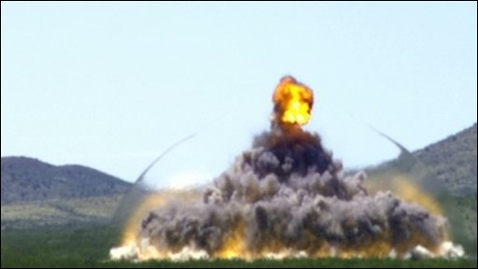

travels faster than speed of sound

2. flying shards

3. Explosion

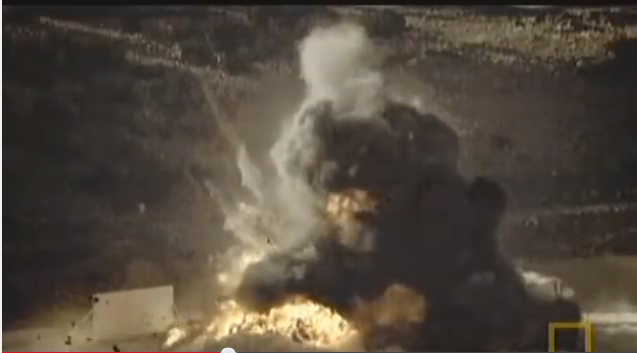

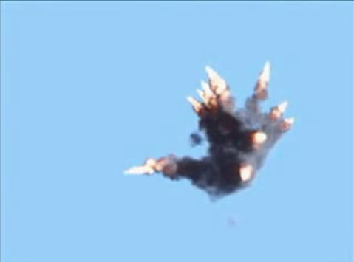

Terms in Navier-Stokes Equation

**Advection**

The velocity of a fluid causes the fluid to transport objects, densities, and other quantities along the flow.