Simple document

library(tidyverse)

I’m an R Markdown document!

# Section 1

Here’s a **code chunk** that samples from a *normal distribution*:

samp = rnorm(100)  
length(samp)

## [1] 100

# Section 2

I can take the mean of the sample, too! The mean is 0.0024633.

# Section 3

This is going to be a plot! Frist I generate a dataframe, then use ggplot to make a scatterplot.

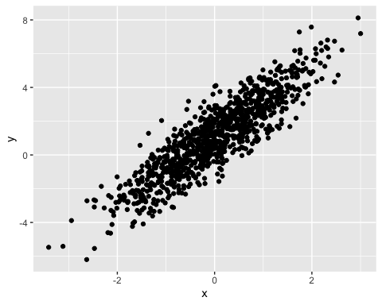

## Plot for learning assessment

library(tidyverse)  
plot_df =  
 tibble(  
 x = rnorm(n=500, mean=1),  
 logVar = x > 0,  
 abs_normal = abs(x)  
 )  
ggplot(plot_df, aes(x=abs_normal)) + geom_histogram()

## `stat_bin()` using `bins = 30`. Pick better value with `binwidth`.

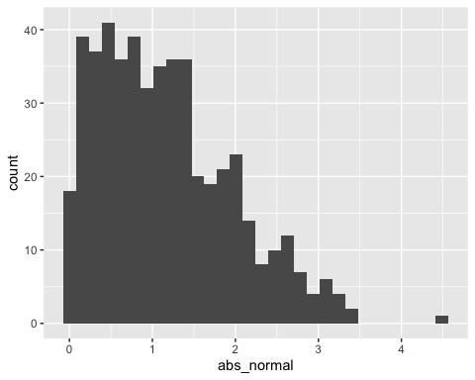

median_samp = median(pull(plot_df, x))

# Section 4

Cheat Sheet for Text Formatting

## Text formatting

*italic* or *italic* **bold** or **bold** code superscript2 and subscript2

## Headings

# 1st Level Header

## 2nd Level Header

### 3rd Level Header

## Lists

* Bulleted list item 1
* Item 2
  + Item 2a
  + Item 2b

1. Numbered list item 1
2. Item 2. The numbers are incremented automatically in the output.

## Tables

| First Header | Second Header |
| --- | --- |
| Content Cell | Content Cell |
| Content Cell | Content Cell |