
(DIGITAL IMAGE PROCESSING LAB)
LAB 06

NAME: MAFAZA BATOOL
REG ID: 235149
CLASS: BSCS-F23
SUBMITTED TO: Mr GHULAM ALI
DATE: 3/04/2026

- OBJECTIVE
The objective of this project is to design and implement a smart image enhancement system using MATLAB. The system integrates various digital image processing techniques such as sampling, quantization, geometric transformations, intensity transformations, and histogram processing to improve the visual quality of low-quality images. Additionally, the system provides analytical insights and a graphical user interface (GUI) for interactive processing.

- METHODOLOGY (PHASE-WISE)
- Phase 1: Image Acquisition & Analysis
The input image is loaded using the GUI.
RGB image is converted into grayscale.
Basic properties such as resolution, data type, and pixel values are analyzed.
A small portion of the image matrix is examined.
- Phase 2: Sampling & Quantization
The image is resized to different scales (0.25x, 0.5x, 1x, 1.5x, 2x).
Bit-depth reduction is applied (8-bit, 4-bit, 2-bit).
Visual quality is compared to observe degradation.

- Phase 3: Geometric Transformations
Rotation is applied at different angles (30°, 45°, 60°, etc.).
Translation and shearing transformations are performed.
Inverse transformations are applied to restore the original image.

- Phase 4: Intensity Transformations
Negative transformation highlights details.
Log transformation enhances dark regions.
Gamma correction (γ = 0.5 and γ = 1.5) adjusts brightness.

- Phase 5: Histogram Processing
Histogram of the original image is plotted.
Histogram equalization is applied.
Contrast improvement is analyzed using standard deviation.

- Phase 6: Final Integrated System
A complete enhancement pipeline is developed:
Gamma correction
Histogram equalization
Log transformation
Image sharpening
The final enhanced image is displayed and saved.

- CODE SNIPPETS
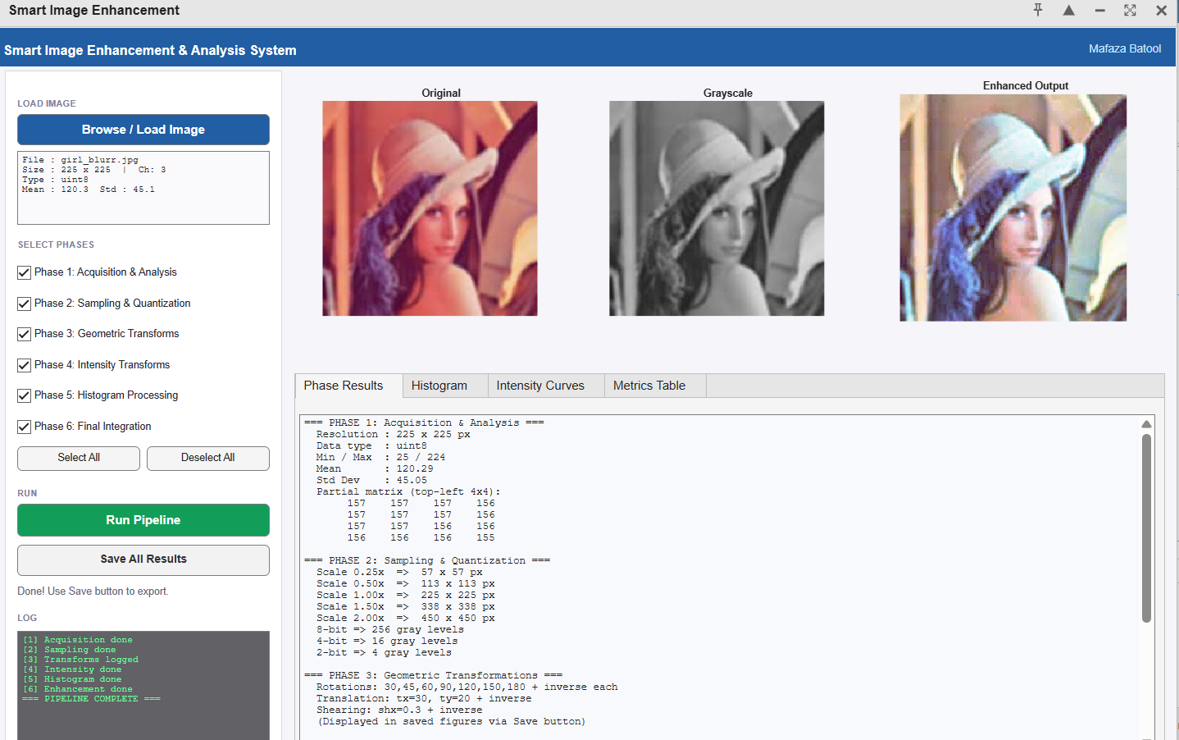

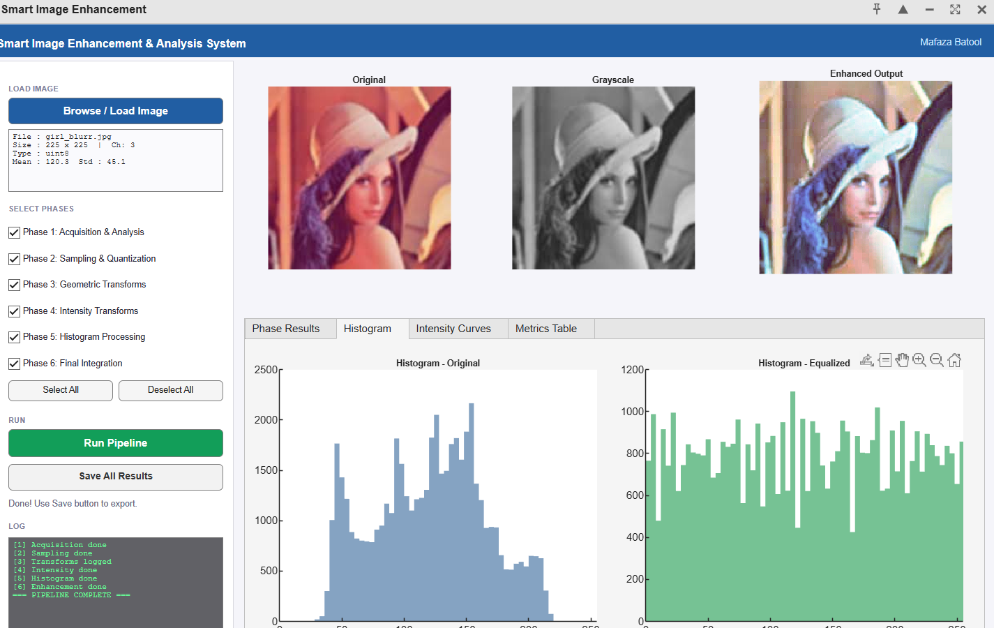
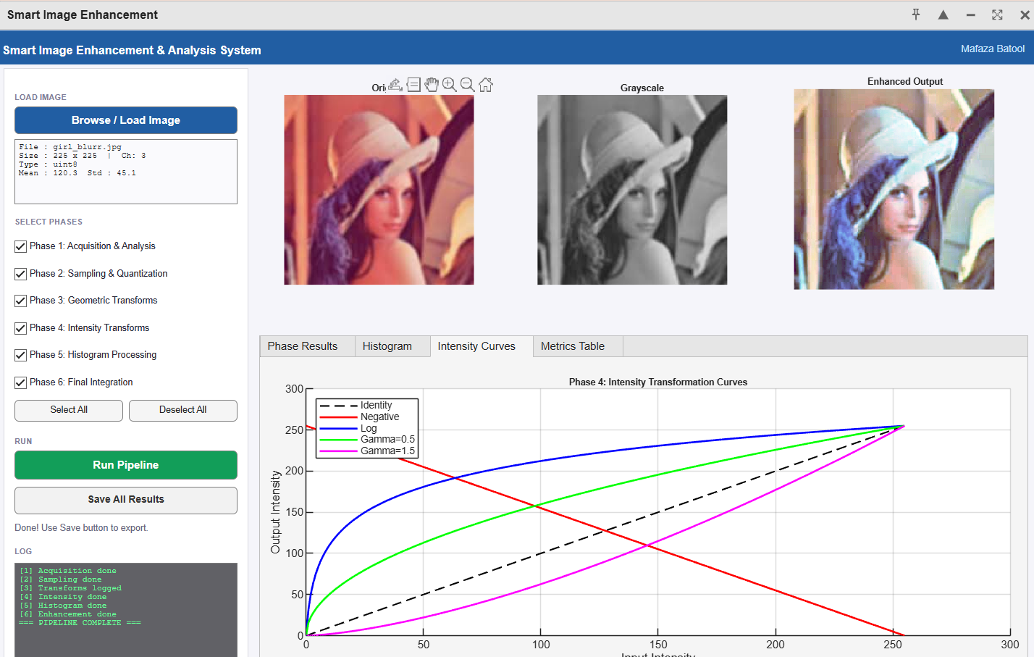
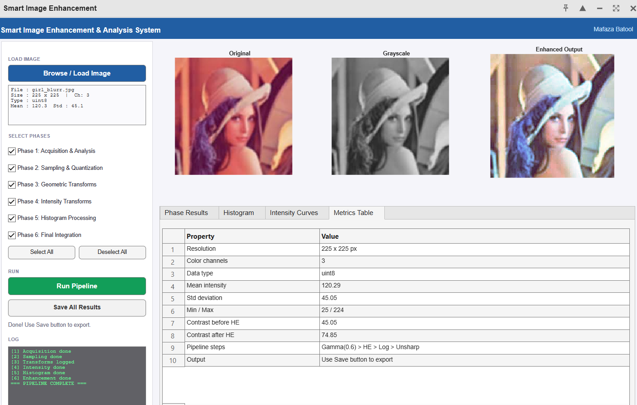

- OBSERVATIONS & ANALYSIS
- Downsampling reduces image clarity and detail.
- Upsampling increases size but may introduce pixelation.
- Quantization reduces intensity levels, causing loss of information.
- Gamma correction with γ < 1 improves brightness.
- Log transformation enhances darker regions.
- Histogram equalization significantly improves contrast by redistributing intensity values.
- Geometric transformations change spatial arrangement but can be reversed using inverse operations.

- . FINAL CONCLUSION
The developed system successfully enhances low-quality images using a combination of image processing techniques. The integration of gamma correction and histogram equalization provides significant improvement in brightness and contrast. The GUI-based implementation allows interactive analysis and demonstrates practical understanding of digital image processing concepts.

- QUESTION/ANSWERS
1. Why does histogram equalization improve contrast?
Histogram equalization improves contrast by redistributing pixel intensity values across the full range (0–255), making dark areas brighter and bright areas more distinguishable.

2. How does gamma affect brightness?
γ < 1 → increases brightness
γ > 1 → decreases brightness

3. What is the effect of quantization on image quality?
Quantization reduces the number of intensity levels, which leads to loss of detail and introduces distortion in the image.

4. Which transformation is reversible and why?
Geometric transformations such as rotation and translation are reversible because their inverse transformations can restore the original image.

5. How do transformations affect spatial structure?
Transformations change the position, orientation, and shape of image pixels, altering the spatial arrangement of the image.

GITHUB LINK:
https://github.com/mafazabatool0-leo/Image-Enhancement-System-App

LINKED LINK:
https://www.linkedin.com/feed/update/urn:li:share:7445793931763703809/

