### BM327 Microbiology Semester 2 – Lab 1 Handout

### TASK 1: Prepare bacterial cultures

Working in a group of **four**, you will be preparing 5 bacterial cultures, which you will need in the next laboratory session. As a group, you will need 12 nutrient agar plates and will pour these following Protocol 1.1 You will use 8 of these plates to plate out serial dilutions of 4 different bacterial cultures (Protocol 1.2), and 4 to streak a bacterial culture for single colonies (Protocol 1.3). (Each student should prepare and plate out serial dilutions of 1 bacterial culture, and prepare one streak plate.)

#### Protocol 1. : Preparation of nutrient agar plates.

1. Label an empty Petri dish on the bottom with “nutrient agar” or “NA”. Be sure to label the bottom of the plate, and to write around the circumference (not across the centre of the plate).

2. Using aseptic technique, pour the nutrient agar plate using the molten nutrient agar provided. Pour slowly and try to avoid bubbles. Fill the plate approximately halfway with the molten agar.

3. Leave the plates untouched on your bench for ~15 min or until the agar has fully solidified. Plates will cool and solidify more quickly if placed in a single layer (not stacked).

#### Protocol 1.: Serial dilutions and plating for single colonies

1. Make appropriate dilutions of the original bacterial culture to bring the anticipated concentrations of microorganisms within the range required to obtain single colonies (in this case, dilute to 10-4).

Make sure to work aseptically and follow good lab practice when preparing your serial dilutions:

* Change pipette tips in between each dilution
* Pipette carefully and accurately, making sure not to transfer any excess liquid on the pipette tip from one dilution to another
* Mix each culture/dilution thoroughly before removing a sample, to ensure that you are collecting a representative sample. Be especially careful to mix the culture before taking the first sample, as microbial cells commonly settle to the bottom of the culture tube.
* Label tubes carefully (writing on the side of the glass universal/bottle, not on the lid); do not mix up your dilutions.

1. Plate out your serial dilutions as follows. Note that when you are working from more-dilute to more-concentrated dilutions, you can reuse the same spreader (provided that you have not contaminated it between plates, e.g. by contact with the lab bench or other non-sterile objects.)
   1. Using a pipette, transfer 0.1 mL of the **10-4 dilution** to the agar plate. Spread the liquid evenly over the surface of a nutrient agar plate, being sure to cover the entire surface**.** Allow the suspension to be absorbed into the surface to the plate.
   2. Repeat step 2, using 0.1 mL of the **10-3 dilution** and a fresh nutrient agar plate.
   3. When the plates are dry, invert them so that they can be incubated at 37 °C for 24 - 72 hours. Follow instructor directions on how to label your group’s plates with a post-it note.

#### Competency: Preparing a streak plate

One of the key skills that you must develop as a microbiologist is to be able to streak microbial cultures to single colonies (Figure 1). (This is also a required skill if you wish to work in many other life science disciplines as it is essential for everyday procedures such as DNA cloning.)

To achieve single colonies on a streak plate, you must essentially perform a serial dilution using a platinum inoculating loop: on each sector of the loop, you will drag successively fewer bacterial cells across the surface of the agar. The loop is sterilised between sectors using the Bunsen burner, which kills any excess bacteria, and is then touched to the previous sector briefly to pick up a smaller number of bacteria. An isolated, individual cell will grow up to form a single colony after the plate has been incubated.

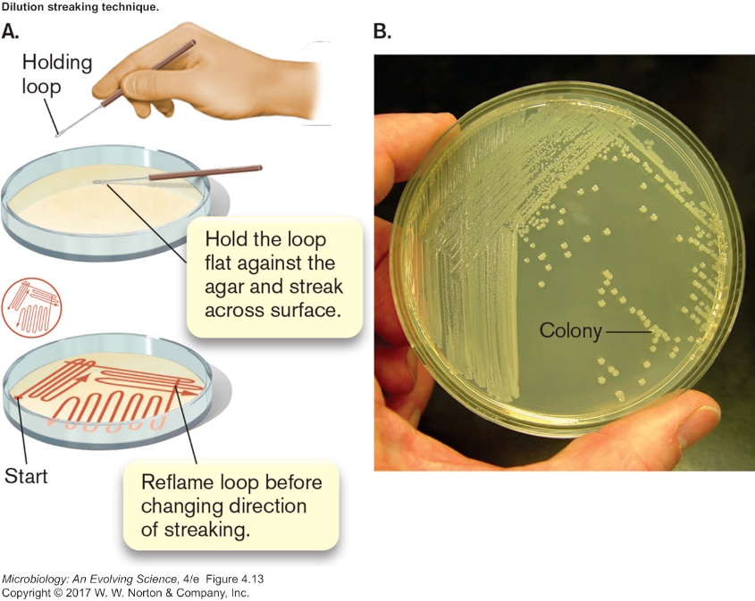

Figure 1. Streaking for single colonies.

**Before** preparing your first streak plate, use the template provided in Figure 2 to sketch a plan for how you will streak the inoculating loop across your plate. Use arrows to indicate the direction you will streak the loop, and numbers to indicate the different sectors.

Figure 2. Template for planning a streak plate.

#### Protocol 1.: Streaking for single colonies

1. Flame a loop, let it cool slightly and then touch it to the bacterial colony you have chosen to streak on a new plate.
2. Pick up the bottom of the new plate (leaving the lid on the bench) with your other hand, turn it over and gently streak the loop back and forth over a small area of the plate. Use light pressure so you don’t gouge the agar.
3. Return the plate to its lid so as to protect it from contaminants in the air while you re-flame the loop. Allow the loop to cool.
4. Pick up the plate again and touch the cooled loop onto an area of the agar that has not previously been streaked. (This step helps to quench the heat from the loop and so prevents it from killing any bacteria it subsequently comes into contact with.)
5. Drag the loop once through the previous streaked area and streak it out across a new area of agar. As the loop drags across the previous streak it will pick up some bacteria and distribute them across the new area of agar.
6. Repeat steps 4 - 5 two or three times as necessary to cover the entire surface of the plate (See Figure 1 and your completed streak plate template).

### TASK 1: Plasmid profiling of strains

Working in a group of four, you will isolate plasmid DNA from 4 strains of *E. coli* (Protocol 1.4), and analyse this DNA by agarose gel electrophoresis (Protocol 1.5 – the results (photograph of your gel) will be posted for you on MyPlace.

#### Protocol 1.: Isolation of plasmid DNA

1. Transfer 1.0 ml of your *E. coli* culture to a labelled microcentrifuge tube.
2. Spin for two minutes at 14,000 rpm in a microcentrifuge, making certain that the tube is correctly balanced (check with a demonstrator).
3. Discard the supernatant carefully by pipetting and add another 1.0 ml of your *E. coli* culture. Centrifuge the cells again as in step 2.
4. Follow the Promega Wizard Plus miniprep protocol provided (starting from step 2.)

#### Protocol 1. : Gel electrophoresis to analyse plasmid profiles.

1. [*Note: this step has been performed for you.*]Prepare 1% agarose gel. Add 1g of agarose to a glass flask. Add 100 ml 1X TAE buffer. Heat agarose in a microwave till agarose is completely dissolved in the buffer. Wait for agarose to cool down to about 50˚C. Add GelRed.
2. Prepare a gel tray by taping off both ends securely and placing a comb in the desired position. Pour the agarose into the gel tray and allow this to sit undisturbed until the agarose has set.
3. When the agarose has completely set, remove the tape and place the gel into an agarose tank. [Note: ensure the gel is oriented correctly, such that the DNA samples will not run off the gel.] Fill the tank with 1X TAE buffer. Remove the comb.
4. Load the samples as follows:
   1. Mix 16 µl of your plasmid DNA with 4 µl of 5X loading buffer and load this into one well of the agarose gel. Pipet slowly and carefully, avoiding bubbles. Do not overload the well.
   2. Repeat this for your remaining samples, making sure to keep track of which sample is loaded in which lane.
   3. Load 5 µl of the provided DNA ladder.
5. When your gel is ready to run, place the cover on the tank, and check with a demonstrator to confirm that you have set it up correctly. Set the powerpack up to perform electrophoresis at 100 V for 50 minutes.