## Introduction: Identification of microorganisms by macroscopic characterisation

*Bacterial colonies on solid media*

Under certain culture conditions, bacteria may show different characteristics of growth which might be useful in their description and identification (Figure 4). You have previously inoculated a number of nutrient agar plates with 5 different bacterial species (TASK1A) and these were incubated for you for 24 hours at 37ºC. Examine the colonies, ensuring that you are examining **well-separated, individual colonies** (Protocol 2.1)**.** Record your descriptions of the colonies in Table 1. Use of a hand lens will allow you to observe individual colonies in greater detail and a ruler will be useful in providing accurate colony size measurements.

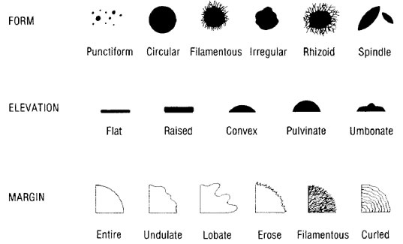

Figure 4. Bacterial colony morphology descriptors.

### TASK 2A: Observation of macroscopic characteristics

You should work individually to complete this task (make independent observations of each plate), though you may wish to compare your results with your neighbours.

#### Protocol 2.1: Observation of bacterial colony morphology

1. Measure the diameter of a representative colony in millimetres.
2. Describe the pigmentation (distinguishing between pigmented colonies and those secreting diffusible pigments) and record in Table 1.
3. Describe the form, elevation, and margin of a representative colony (using the correct terminology as indicated in Figure 4). Also indicate whether the colonies are smooth (shiny glistening surface), rough (dull, bumpy, granular, or matte surface), or mucoid (slimy or gummy appearance) and record in Table 1.
4. Record the opacity of the colonies (transparent, translucent, or opaque) in Table 1.

Table 1. Macroscopic characteristics of the colonies of typical bacteria grown on nutrient agar.

|  |  |  |  |  |
| --- | --- | --- | --- | --- |
| **Bacterial species** | Characteristic | | | |
|  | Size range (mm) | Shape | Colour | Odour |
| ***Escherichia coli*** |  |  |  |  |
| ***Staphylococcus aureus*** |  |  |  |  |
| ***Bacillus cereus*** |  |  |  |  |
| ***Proteus* species** |  |  |  |  |
| ***Pseudomonas aeruginosa*** |  |  |  |  |

### Competency check: streak plate.

One of the lecturers will assess your streak plate for competency according to the following criteria:

Streak plate competency check 1:

* Well-streaked plate, with several well-separated and distinct individual colonies
* Streaking technique needs improvement: does not make good use of the space available on the plate
* Streaking technique needs improvement: no/few single colonies obtained
* Streaking technique needs improvement: probable faults in aseptic technique
* Streaking technique needs improvement: other ________________________

Labelling technique:

* Clear, legible, complete label
* Labelling is illegible/unclear
* Label placed incorrectly: _____________________
* Label is missing key information: ___________________

You should use the feedback provided by the lecturer on your streak plate to improve your technique. You will be given several more opportunities to pass the streak plate competency test over the course of this module.

***Fungal colonies on solid media***

You are supplied with a culture of a yeast (unicellular fungus) and moulds (multicellular fungi) that has been grown on the surface of Sabouraud/dextrose agar plates for 72 hours at 25°C. Examine the colonies and record your descriptions in Table 2.

Table 2. Macroscopic characteristics of the colonies of fungi grown on nutrient agar.

|  |  |  |  |
| --- | --- | --- | --- |
| **Characteristic** | **Microorganism** | | |
|  | ***Saccharomyces cerevisiae*** | ***Penicillium notatum*** | ***Aspergillus niger*** |
| Size range (mm) |  |  |  |
| Shape |  |  |  |
| Colour |  |  |  |

### Discussion questions: macroscopic observations

Identification of microorganisms by microscopic characterisation

## Introduction: Gram staining and microscopy

The individual cells of typical bacteria are very small. To be seen clearly, they must be fixed to a glass slide, stained, and then examined using a microscope fitted with an oil-immersion lens (x100) which is capable of producing an overall magnification of at least x1000. (Note that the total magnification is the product of the objective and the ocular lenses – e.g., for many commonly used light microscopes, objective magnification (x100) * ocular magnification (x10) = x1000 magnification.) The most common staining technique employed in microbiology is the Gram stain since it allows visualisation of the test bacterium under a light microscope and it is a discriminatory stain (i.e. it contributes to the identification of a microorganism, particularly when the information provided is used in conjunction with the macroscopic characteristics). The size, shape, and arrangement of the cells (Figure 3) can also be helpful in bacterial identification (i.e. with the use of a dichotomous key).

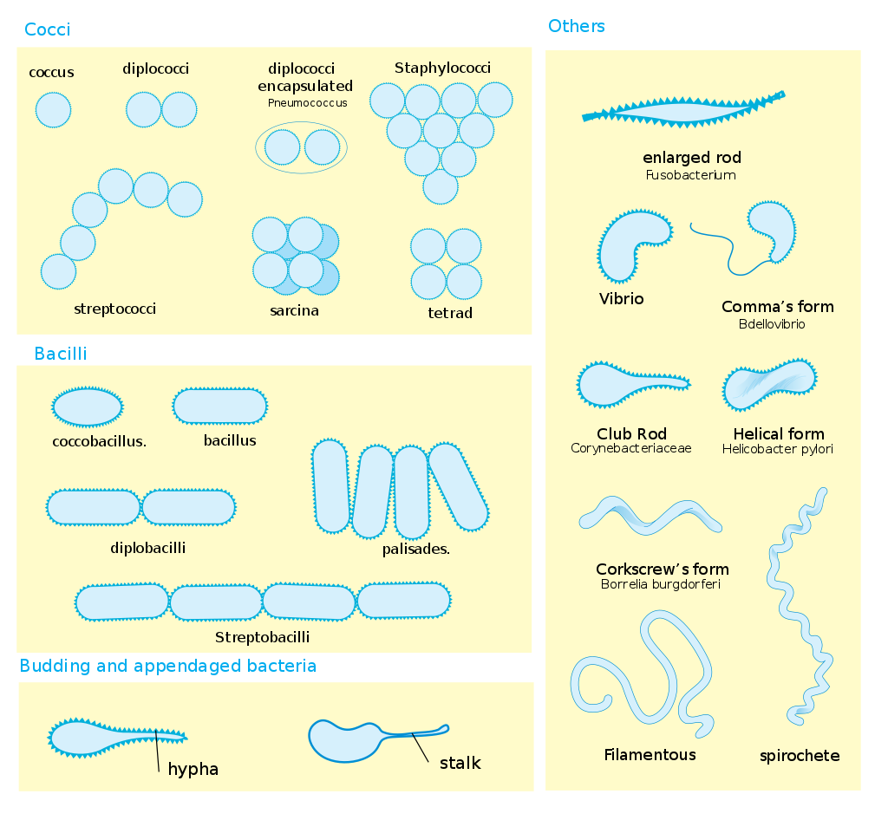

Figure 5. Bacterial cell shapes

**Correct use of a microscope**

Bacteria are much smaller than anything else you will have looked at under a microscope; most bacterial cells are approximately 1-3 m long. Optimal set up of the microscope is therefore essential.

Please note that you should **not** wear gloves while working with a microscope: you do not want to inadvertently transfer staining reagents onto it.

Begin by placing a slide onto the stage and aligning the **lowest power objective** (usually the 10X objective) over it.

1. Raise the stage using the coarse focusing knob so that the slide is about 5 mm away from the objective.

2. Bring the slide into focus as best you can, first using the **coarse focusing** knob and then the **fine focusing** knob. You will be slowly lowering the stage so as to increase the distance between the slide and objective.

3. Once you have focussed as best you can using this objective, you should move on to the next highest power objective.

Often the plane of focus is extremely narrow, so that small, faint objects like stained bacteria may be easily missed as the focus passes through the plane. Thus, a good technique is to constantly move the focus up and down while also slowly moving the slide up/down or left/right on the stage. In this way, objects that flash in and out of focus tend to be more easily noticed by the eye.

At any point while using the microscope, you may wish to:

Adjust the “**interocular separation**” of the eyepieces so that they are comfortably aligned with your eyes.

Adjust the lamp voltage at any time when using a microscope in order to get a comfortable level of light.

**Use of oil with the microscope:**

* The 100x objective is designed to be used with oil (it will have “oil” explicitly written on it), whereas the other objectives are not.
* **Never** use oil with any objective other than the 100x lens. Once you have added oil to your sample, **never** return to using a smaller magnification objective!
* Only a small drop of oil is needed – do not use too much. 
* When you have found your focus and optimised set-up with the 40x objective, swing the objectives half-way between the 40x and 100x. **DO NOT** move the stage or change the focus as you do this! The gently add a very small drop of oil onto the spot of light you can see in your sample. Gently swing the 100x objective into place.
* You will most likely have to adjust the focus a little, but only use the fine adjustment at this stage. Ask for help if you have trouble finding the focus. Under no circumstances go back to the 40x, as it does not tolerate getting in contact to the immersion oil.
* Residual oil will cling to the 100X objective after use, so make sure you clean it off with a **lens tissue** (specifically designed for this) – do not use any other cloth or tissue as this will damage the lens.

### TASK 2B: Observation of microscopic characteristics

#### Protocol 2.2: Preparing Gram-stained bacterial cells.

Working as a group of two, you should prepare Gram-stained slides for each of the five bacterial cultures from TASK 1A/TASK 2A (*E. coli, Staphylococcus aureus, Proteus* species, *Pseudomonas aeruginosa,* and *Bacillus cereus*).

Please note, it is advisable that you wear safety gloves when handling staining reagents. However, gloves must be removed when working near the Bunsen burner.

1. Hold a glass slide with metal forceps and flame thoroughly its upper surface using a Bunsen flame (this degreases the slide and allows even spreading of the film of bacterial cells). Allow the slide to cool. **Note**, you must take care when doing this – holding the glass slide in the flame too long can cause the glass to shatter!
2. Flame a loop until red hot and allow it to cool (hold it steady, do not move around or lay it on the bench). Once cool, place a loopful of sterile water on the upper surface of the slide. Note, do not use too much water or it will take a very long time for your slide to dry!
3. Flame the loop again and allow it to cool, then use it to pick up a speck of a bacterial colony (ideally this would be from an isolated single bacterial colony – **not** from a lawn or confluent smear). Mix this speck thoroughly into the drop of water to form a dilute milky suspension covering an area of about the size of a 20p coin (the aim is to provide a film that contains a single layer of cells. Too high a density of cells applied to the slide results in loss of detail as the cells are too closely packed together to visualise under the microscope or even too thickly packed for the stains to penetrate. The amount of culture necessary to produce a good film is learned from experience).
4. If labelling the samples on a slide using a permanent marker, use caution to ensure that the label is not destroyed during the ethanol wash.
5. Dry the film completely by warming the slide gently. Hold the slide well above the Bunsen flame.
6. Fix the film of cells to the slide by passing the lower surface of the slide through the Bunsen flame slowly twice. Allow the slide to cool.
7. Stain the film with 0.5% w/v crystal violet for 30 seconds. (Reminder – at this point you should have turned off your Bunsen burner and should be wearing gloves to work with the stains.)
8. Drain the crystal violet, rinse off the remainder with a solution of iodine (1% w/v iodinein 2% w/v potassium iodide). Cover the film with iodine for one minute.
9. Drain the iodine, rinse off the remainder with alcohol. Rock the alcohol from side to side until no more crystal violet is removed. This process should take no longer than 45 seconds.
10. Drain off the alcohol remaining and gently blot the slide dry.
11. Rinse with water.
12. Cover the film with 1% w/v safranin for 30 seconds. Wash the safranin off the slide with water and allow the slide to dry.
13. Observe your slides under the microscope, using a low power objective lens (x10) first [note: you do not need to use a coverslip]. Then, work your way up through the lenses until you reach the oil-immersion lens (x100).

To use the oil-immersion lens, only a **very small** amount of immersion oil should be used. Do not use the oil with any other lenses! Be sure to carefully clean the oil off the x100 lens when you are finished using **lens paper** only (do not use any other tissue/cloth).

1. First record your raw data (observations, e.g. colour observed, any notable features observed on the slide). Make accurate drawings of the cells of the five bacteria to show clearly the shapes of the individual cells, and the groupings of the individual cells (Table 3). Be sure to note the magnification used to observe the cells that you sketched. Then, record your interpretation of these observations (indicate whether each organism is Gram-positive or Gram-negative and its morphology – e.g., Gram-negative coccus, Gram-positive filamentous).

***Interpretation***

**Gram-positive** organisms are stained **blue/violet**.

**Gram-negative** organisms are stained **red/pink**.

Table 3. Microscopic characteristics of bacterial colonies isolated from solid nutrient agar following application of Gram stain.

|  |  |  |  |
| --- | --- | --- | --- |
| **Microorganism** | **Reaction to Gram stain** | **Sketch of cellular morphology and arrangement** | **Interpretation** |
| *Escherichia coli* |  |  |  |
| *Staphylococcus aureus* |  |  |  |
| *Proteus* species |  |  |  |
| *Bacillus cereus* |  |  |  |
| *Pseudomonas aeruginosa* |  |  |  |

### Discussion questions: microscopic observations

Do these results align with your knowledge of these five bacteria based on the literature? If you observed anything expected – what might account for your results?

Are Gram-stain reaction and cell morphology sufficient for bacterial identification in these cases, or not? What other experiments might help you to identify these bacteria?

## Introduction: Staining and microscopy of fungal cells

***Microscopic characteristics of fungi***

Moulds are multicellular fungi. They are much larger than yeasts and they do not require the use of an oil-immersion lens to be seen clearly. The characteristics of their mycelia may be seen using the microscope’s low power objective lens (x10); the characteristics of their *hyphae*, *conidiophores* and *spores* (Figure 6) may be seen using the high power lens (x40). Although no stains are required to visualise the sample, simple stains such as iodine solution or lactophenol cotton blue reagent are sometimes applied to highlight cellular morphology more clearly.

Working as a group of two, you will examine the three different fungal species provided for TASK 2A under the microscope (Protocol 2.3). Please note that you should take care when opening the Petri dishes containing the fungal cultures, as you do not want to disperse spores throughout the lab (or inhale them) – open each plate narrowly, and for the minimum amount of time required to take a sample of the culture.

Figure 6. Structures of a typical mould.

### TASK 2X:

#### Protocol 2.3: Microscopic examination of fungi.

1. Place a drop of iodine solution on the surface of a glass slide.
2. Using a flamed and cooled loop, pick up a small amount of a colony of a fungus and tease it out in the drop of iodine.
3. Place a cover slip on top of the mounted material and examine the fungi using first the low power (x10) and then the high power (x40) objective lenses of the microscope. Make accurate drawings of the three fungi showing their *mycelia*, hyphal structure (whether septate or non-septate), *conidiophores* and spores (Table 4).

Table 4. Microscopic characteristics of fungi isolated from solid nutrient agar following addition to iodine solution.

|  |  |
| --- | --- |
| Microorganism | Sketch of cellular morphology and arrangement |
| *Penicillium notatum* |  |
| *Aspergillus niger* |  |
| *Saccharomyces cerevisiae* |  |

### Discussion questions: fungal observations

### Competency check: documenting and reporting on experimental results and conclusions.

Before you leave the lab, one of the lecturers will assess your work (Table 3 and Table 4) for competency according to the following criteria:

Recording results check 1:

* Results and interpretation clearly and concisely recorded
* Poor sketch(es), lacking adequate detail
* Sketches/results illegible/unclear
* Lack of separation between results (raw data) and interpretation
* Failure to use accurate/precise terminology
* Failure to record magnification used
* Results table(s) missing key information: ___________________
* Other: ____________________________

## Introduction: Identification of microbes using selective and differential media

Macroscopic observations of bacterial colony morphology can be useful in the identification of different species, as you saw in TASK 2A. In addition to examining bacteria grown on nutrient agar, you will also find a wide range of differential and selective media used in clinical microbiology. These use the fact that different bacterial species have characteristic physiological and biochemical characteristics that can help to identify them. Selective media allow the growth of some bacteria, but not others. Differential media exploit specific chemical products of metabolism to produce visual indications of their production (e.g. by changes in colour of the colony or growth media), which can then be used to help identify the producing organism. Some media may be both selective and differential; and, in some cases, you may need to use multiple selective/differential media in combination to correctly identify an unknown organism.

In this lab, you will be using blood agar as a differential medium to identify bacteria based on their haemolytic ability (CASE STUDY 2).

**CASE STUDY 2: *Strep throat?***

Patient history: young child with a sore throat, mild fever, swollen lymph nodes, no history of previous Strep throat.

The clinician suspects that the child may have a Group A Strep (*Streptococcus pyogenes*) infection. However, many sore throats are caused by viruses instead. Before starting the child on a course of antibiotics, the clinician takes a throat swab culture and sends it to the lab for analysis.

Gram staining and microscopic observation showed the presence of a Gram-positive coccus-shaped bacterium. Your task is to identify the bacterialspecies causing this infection (TASK 2C).

### TASK 2C: Differential media - use of blood agar to differentiate bacteria based on their haemolytic activity

Blood agar plates are a differential medium used to detect haemolytic activity in different microorganisms. They are also useful for the clinical microbiologist, as this medium is enriched with mammalian blood and thus supports the growth of many nutritionally fastidious organisms. Several pathogenic bacteria can produce a haemolysin capable of lysing red blood cells, and thus a zone of lysed cells appears around these bacteria when they are grown on blood agar plates. This diagnostic test is particularly useful for the identification of *Streptococcal* species.

There are three types of haemolysis as illustrated in Figure 7. Beta haemolysis is complete haemolysis: the blood cells are lysed and a clear zone forms around the colony. In alpha haemolysis (sometimes called incomplete haemolysis), the blood cells are not actually lysed; instead, the haemoglobin is reduced to methaemoglobin, causing a greenish or brownish discoloration. Gamma haemolysis is the lack of haemolysis, with no change to the surrounding medium after bacterial growth. Note that some bacteria may produce more than one more haemolysin, and also some haemolysins are oxygen-sensitive and only function in anaerobic conditions).

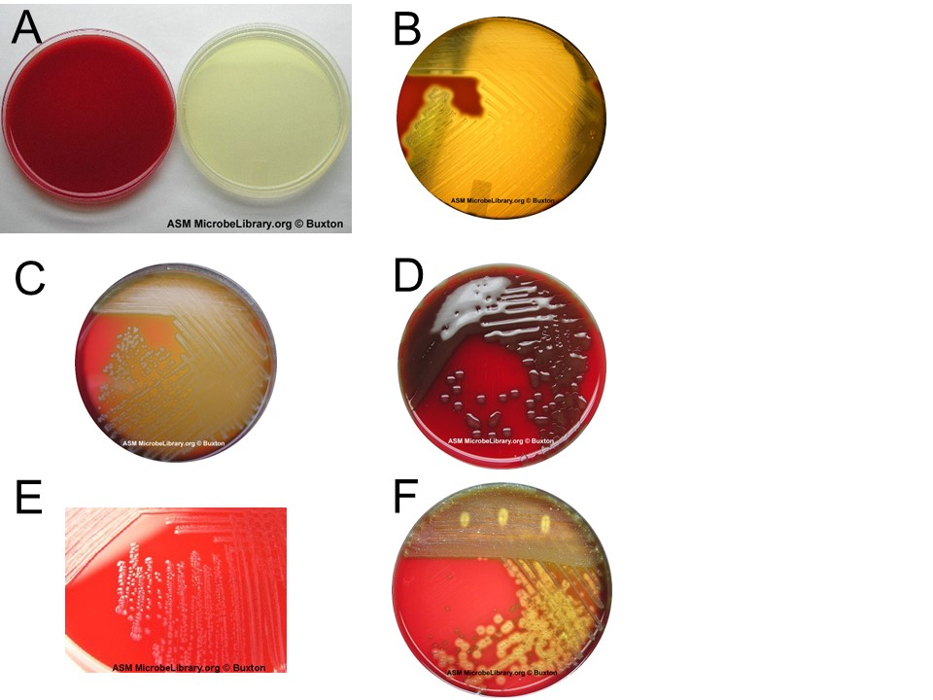

Figure 7. Analysis of haemolysis on blood agar.(**A) Uninoculated plates**. Blood agar plates made by the addition of sheep’s blood (left) to Triptic Soy Agar plates (right). **(B) Beta haemolysis**. (Streptococcus pyogenes). (**C) Alpha haemolysis** (Streptococcus species "Viridans group"). **(D) Alpha haemolysis** (encapsulated strain of Streptococcus pneumoniae). **(E) Gamma haemolysis** (Enterococcus faecalis - many strains are usually non-haemolytic after 24 hours of incubation, but eventually display weak alpha haemolysis after prolonged incubation.) **(F) Mixed culture** of normal upper respiratory flora and a beta-haemolytic Streptococcus sp. (indicating the possibility of a S. pyogenes infection).

Working as a group of four, you will be given an unknown *Streptococcus* sp.to identify based on its haemolytic activity, as well as a set of controls (strains with known alpha, beta, and gamma haemolytic activities). (Each group member should prepare one streak plate.)

#### Protocol 2.4: Streaking for single colonies on blood agar plates.

Make sure that all agar plates are clearly labelled with your name, the sample name or number, your bench number, and the date. You should label the bottom of the plate (not the top – which may become separated from the bottom!). It is best to write in a circle around the edge of the plate, so that your writing will not obscure observation of the growth on the plate.

1. Flame a loop, let it cool slightly and then touch it to the bacterial colony you have chosen to streak on a new plate.
2. Pick up the bottom of the new plate (leaving the lid on the bench) with your other hand, turn it over and gently streak the loop back and forth over a small area of the plate. Use light pressure so you don’t gouge the agar.
3. Return the plate to its lid so as to protect it from contaminants in the air while you re-flame the loop. Allow the loop to cool.
4. Pick up the plate again and touch the cooled loop onto an area of the agar that has not previously been streaked. (This step helps to quench the heat from the loop and so prevents it from killing any bacteria it subsequently comes into contact with.)
5. Drag the loop once through the previous streaked area and streak it out across a new area of agar. As the loop drags across the previous streak it will pick up some bacteria and distribute them across the new area of agar.
6. Repeat steps 4 - 5 two or three times as necessary to cover the entire surface of the plate (See Figure 2 and Protocol 1.3 from the last lab for more details).

You will record your results in Table 12 during the next laboratory session (TASK 3D).

### Discussion questions: selective and differential media

Q. What is the role of haemolysins in a bacterial infection?

Q.