### TASK 3A: Using selective and differential media for the cultivation and identification of *Escherichia, Salmonella,* and *Shigella* sp.

***MacConkey agar***

MacConkey agar is a selective differential medium that is used for primary isolation of *Enterobacteriaceae* and related enteric Gram-negative bacilli and to aid in the identification of potentially pathogenic microorganisms. Its components are listed in Table 6.

MacConkey agar is differential as it contains a sugar and the pH indicator neutral red, which can help to distinguish between bacteria which are able to metabolise the sugar, and those which cannot. It is often supplemented with lactose, but can also be supplemented with other sugars, such as sorbitol. Fermentation of the sugar produces acid, causing precipitation of the bile salts present in the medium and a change in colour due to the pH indicator. Bacteria that are not able to ferment the sugars will instead utilise the amino acids present in the medium, producing ammonia and causing the pH to increase.

Table 6. Components of MacConkey/lactose agar

|  |  |
| --- | --- |
| **Component** | **Function** |
| Peptone | Nutrient source of carbon and nitrogen |
| Polypeptone | Nutrient source of carbon and nitrogen |
| Lactose | Carbohydrate nutrient |
| Bile salts | Inhibitor of Gram-positive bacteria and some fastidious Gram-negative bacteria |
| Sodium chloride | Osmolarity adjuster |
| Agar | Solidification agent |
| Neutral red | pH indicator |
| Crystal violet | Inhibitor of Gram-positive bacteria and some fastidious Gram-negative bacteria |
| Distilled water | Water source |

Therefore, following culture on MacConkey/lactose medium, strong lactose fermenters such as *Escherichia* species will produce red colonies with a surrounding zone of precipitated bile sometimes observable. The red colour is due to the indicator changing colour in response to acid production following lactose fermentation.

Slow or weak lactose fermenters such as *Citrobacter* and *Serratia* species may appear colourless after 24 hours or slightly pink after 24 - 48 hours.

Non-lactose fermenting microorganisms such as *Proteus*, *Salmonella* and *Shigella* species, with rare exceptions produce colourless or clear transparent colonies.

Working as a group of (4?), you will be streaking your unknown (CASE STUDY 3) as well as positive and negative controls on MacConkey agar.

#### Protocol 3.1: Streaking for single colonies on MacConkey agar plates

1. Using a flamed loop, take a colony from the agar plate provided containing your unknown clinical specimen.
2. Use this to streak a MacConkey agar plate (see **Protocol 1.3** for a more detailed explanation if necessary).
3. Repeat this exercise on fresh MacConkey agar plates for the positive and negative controls (*Escherichia* and *Salmonella*).

You will record your results in Table 21 in laboratory session 4, TASK 4D.

### Discussion questions: MacConkey agar

Q.

Q.

## Introduction: Oxygen requirements for microbial growth

**CASE STUDY 4. The case of the careless clinician.**

You are working in a clinical microbiology with a friend, who has just left for holiday – leaving you to record the results from the last sample he was processing. You think he said that it was *C. diff*– or maybe *E. coli* – he was working on faecal samples earlier that morning. But you aren’t entirely sure and he isn’t answering his phone. (You need to get better friends.)

The patient can’t wait for a diagnosis until your friend gets back from his holiday, so you’d better figure it out for him. Your task is to determine whether the isolated pathogen is *Clostridium* or *E. coli* using biochemical assays (TASK 3B) and by testing whether the pathogen is an obligate or facultative anaerobe (TASK 3C).

Anaerobic conditions: A number of clinically relevant pathogens are obligate anaerobes and therefore must be cultivated anaerobically. In this laboratory, you will learn techniques for the anaerobic growth of microorganisms and perform biochemical assays to test for the presence of enzymes involved in aerobic growth. These complementary assays will help you to determine whether this clinical specimen is an anaerobe or an aerobe, and therefore aid in species identification.

### TASK 3B: Biochemical assays to identify pathogens of the intestinal tract

Working in a group of two, you should perform the catalase and oxidase tests on your unknown as well as the appropriate positive and negative controls for each test.

Catalase is an enzyme that breaks down hydrogen peroxide into oxygen and water. The enzyme is a haem protein expressed by most aerobic and facultatively anaerobic bacteria (excluding *Streptococci* species) and used to degrade any hydrogen peroxide that is generated during aerobic carbohydrate metabolism.

#### Protocol 3.2: Testing for catalase activity.

1. With a flamed loop that has been allowed to cool, transfer cells from the centre of an isolated colony onto the surface of a glass slide.
2. Add 1 or 2 drops of 3% hydrogen peroxide to the cells.
3. Observe the slide and record your results in Table 8.
4. Repeat the assay for your other samples. You should assay your positive and negative controls as well as your unknown microbe.

*Interpretation*

Rapid appearance and sustained production of gas (oxygen) bubbles is indicative of a positive test. A few tiny bubbles after 20 – 30 seconds are not considered positive.

Table 8. Catalase activity assay results

|  |  |
| --- | --- |
| **Microorganism** | **Catalase test result –**  **carefully record what you observe** |
| Positive control  (*Escherichia coli*) |  |
| Negative control  (*Streptococcus* sp.) |  |
| Your unknown |  |

### Introduction: Oxidase test

Cytochrome oxidase is a haemprotein enzyme that is involved in the terminal chain of aerobic respiration by transferring electrons (hydrogen) to oxygen, to form water. It is possessed by aerobic and facultative anaerobic microorganisms. The test is helpful in screening Enterobacteriaceae (all negative), *Pseudomonas* (positive) or *Neisseria* (positive) species. The oxidase test uses a dye that can substitute for oxygen as an electron acceptor. In the reduced state the dye is colourless. However, in the presence of cytochrome oxidase and atmospheric oxygen it becomes oxidized and converts to a coloured derivative.

### Protocol 3.3: Testing for oxidase activity.

1. Apply the oxidase strip onto an isolated colony.
2. Record any colour changes in Table 9.
3. Repeat the assay for your other samples. You should assay your positive and negative controls as well as your unknown microbe.

*Interpretation*

If the test microorganism is oxidase-positive, then an intense deep blue colour will develop within seconds.

Table 9. Oxidase activity assay results.

|  |  |
| --- | --- |
| **Microorganism** | **Oxidase test result –**  **carefully record what you observe** |
| Positive control  (*Pseudomonas aeruginosa)* |  |
| Negative control  (*Escherichia coli*) |  |
| Your unknown |  |

Summarize your observations and interpretations in Table 10. What can you conclude about your unknown organism?

Table 10. Catalase test and oxidase test observations and results

|  |  |  |
| --- | --- | --- |
| Biochemical test | Observation | Positive or negative? |
| Catalase production |  |  |
| Oxidase production |  |  |

### Discussion questions: catalase and oxidase assays

Q.

Q.

### TASK 3C: Determining whether the unknown microorganism requires oxygen for growth

There are a number of different techniques used in microbiology laboratories for achieving anaerobic conditions to permit the growth of different microbes. In this lab, you will use two different techniques: use of thioglycollate medium and use of an anaerobic jar. Working as a group of 4(??), you will inoculate your unknown microorganism and appropriate control organisms in thioglycollate medium and you will streak these on blood agar plates that will be incubated ± O2.

#### Introduction: Thioglycollate medium

This medium (Table 11) contains a reducing agent, sodium thioglycollate, that binds to and consumes O2 and thus maintains a low oxygen tension in the medium. The medium also contains a redox indicator, resazurin, which turns pink in an oxidized environment. It is essential to use fresh thioglycollate medium (as indicated by the absence of pink colour). Growth of organisms in thioglycollate medium will depend on their oxygen requirements, as illustrated in Figure 7.

Table 11. Components in fluid thioglycollate medium

|  |  |
| --- | --- |
| **Component** | **Function** |
| Tryptone | Nutrient source of carbon and nitrogen |
| L-Cystine | Nutrient source of carbon and nitrogen |
| Glucose | Carbohydrate nutrient |
| Yeast extract | Nutrient source/growth enhancer |
| Sodium chloride | Osmolarity adjuster |
| Agar | A small amount of agar is added to impede O2 diffusion into the medium |
| Sodium thioglycollate | Reducing agent that removes molecular O2 from the medium |
| Resazurin | Redox indicator that is colourless when reduced and turns pink when oxidized |
| Distilled water | Water source |

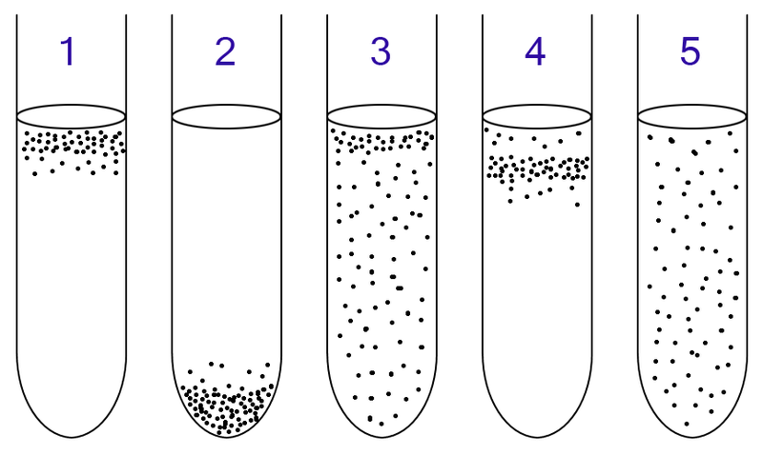

Figure 9. : Growth of microorganisms with different oxygen requirements. 1) Aerobic organisms will grow at the surface, where the [O2] is highest. (2) Obligate anaerobes will grow at the bottom of the culture tube, where the [O2] is lowest. (3) Facultative anaerobes will grow throughout the tube, but exhibit more growth near the top (because they preferentially use aerobic respiration, which generates more ATP than anaerobic respiration or fermentation). (4) Microaerophiles grow near the surface, as they require O2 for growth (they cannot grow anaerobically), but are inhibited by high [O2]. (5) Aerotolerant organisms grow throughout the tube: they do not use O2 as an electron acceptor, but produce catalase and/or other enzymes for the detoxification of reactive oxygen species and are therefore not killed in the presence of O2.

#### Protocol 3.4: Anaerobic growth of microorganisms using fluid thioglycollate medium.

1. Label the culture tube with your name, today’s date, and the name of the inoculum.
2. Flame your inoculating loop. It is important to sterilize the entire platinum wire.
3. Lift the lid of the Petri dish slightly.
4. Cool the loop on an empty area of agar. (If it is too hot, you will kill the bacteria in the colony you choose.)
5. Gently pick up a single colony with the loop.
6. Close the lid of the Petri dish.
7. Using good aseptic technique, open the culture tube containing thioglycollate medium.
8. Put your loop into the broth and shake it gently. Be sure to innoculate the depths of the culture media.
9. Close the culture tube. Flame your loop before setting it down.
10. Repeat the procedure for each sample; you should inoculate your controls (*E. coli* and *Clostridium*)as well as your unknown organism into thioglycollate medium. Incubate the cultures at 37°C overnight.

You will record your results in Table 22 in laboratory session 4 (TASK 4D).

#### Introduction: The GasPak/Anaerobic jar technique

This system uses a sealed jar and a GasPak, which generates carbon dioxide and hydrogen; a palladium catalyst in the jar combines the hydrogen with oxygen (generating water); this then creates an anaerobic atmosphere in the jar (Figure 8). An indicator strip is used to verify that anaerobic conditions have been established: it contains methylene blue, which becomes colourless in the absence of oxygen.

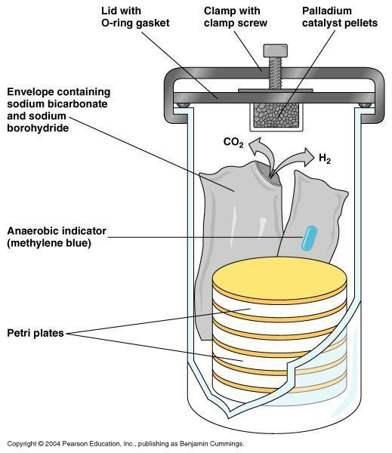

Figure 10. Anaerobic jar and Gas-Pak system

You will streak two agar plates; one will be incubated aerobically; the other, anaerobically. Each plate should be divided in half (use a marker-pen to draw a line on the base of the plate). You will inoculate one half of each plate with your unknown organism and one half with *Clostridium* as a control. As *Clostridium* will only grow anaerobically, its growth in this experiment will confirm that anaerobic conditions were achieved in the jar with the Gas-Pak.

#### Protocol 3.5: Anaerobic growth of microorganisms using the Gas-Pak system.

1. Label the base of the agar plate with your group name, today’s date, and label each plate +O2 or -O2 as appropriate.
2. Using a flamed loop and proper aseptic technique, take a colony from the agar plate provided containing your unknown clinical specimen.
3. Use this to streak for single colonies on half of each of your two stiff blood agar plates.
4. Repeat steps 2 - 3 for your control (*Clostridium*).
5. Keep one plate on your bench for incubation +O2 at 31°C for 48 - 72 hours. Deposit the other plate in the anaerobic jar for incubation -O2 at 31°C for 48 - 72 hours.

You will record your results in Table 23 in laboratory session 4 (TASK 4D).

### Discussion questions: oxygen and microbial growth

Q.

Q.

Q.

### TASK 3D: Analysing blood agar plates (from TASK 2C)

Observe your blood agar plates from TASK 2C. You should hold the plate up to the light to best observe any haemolysis (with transmitted light coming through the plate).

Record the results in Table 12 below. If needed, refer back to Figure 2 for the appropriate colony morphology descriptors.

Table 12. Observation of haemolysis on blood agar plates.

|  |  |
| --- | --- |
| Microorganism | Colony morphology and haemolysis – carefully record what you observe |
| Alpha-haemolytic strain |  |
| Beta-haemolytic strain |  |
| Gamma-haemolytic strain |  |
| Your unknown |  |

### Competency check: streak plate.

One of the lecturers will assess your streak plate for competency according to the following criteria:

Streak plate competency check 2:

* Well-streaked plate, with several well-separated and distinct individual colonies
* Streaking technique needs improvement: does not make good use of the space available on the plate
* Streaking technique needs improvement: no/few single colonies obtained
* Streaking technique needs improvement: probable faults in aseptic technique
* Streaking technique needs improvement: other ________________________

Labelling technique:

* Clear, legible, complete label
* Labelling is illegible/unclear
* Label placed incorrectly: _____________________
* Label is missing key information: ___________________

You should use the feedback provided by the lecturer on your streak plate to improve your technique. You will be given several more opportunities to pass the streak plate competency test over the course of this module.

### Discussion questions: blood agar results

Q. What conclusions can you make based on your results (Table 12?

. What further experiments could you perform to definitively identify the pathogen?

Q. What further experiments could you perform that would enable you to recommend a clinical treatment?

### TASK 3E: *Staphylococcus aureus* inoculation on mannitol salt agar

Mannitol salt agar (MSA) (Table 13) is a selective differential medium that is used for primary isolation and identification of potentially pathogenic *Staphylococcus* *aureus* from non-pathogenic commensal microorganisms from the genus *Micrococcus*. MSA contains a relatively high sodium chloride content of 7.5% (w/v) which allows selection for microorganisms that can tolerate this level of sodium chloride. This makes the test selective. In addition, it contains mannitol and an indicator, phenol red. If a microorganism can ferment the mannitol, acid will be produced and the indicator will turn from red to yellow in response to the pH drop. This makes the test differential.

Table 13. Components of Mannitol Salt Agar (MSA)

|  |  |
| --- | --- |
| **Component** | **Function** |
| Beef extract | Nutrient source of carbon and nitrogen |
| Peptone | Nutrient source of carbon and nitrogen |
| Mannitol | Carbohydrate nutrient |
| Phenol red | pH indicator |
| Sodium chloride | Osmolarity adjuster |
| Agar | Solidifying agent |
| Distilled water | Water source |

*Staphylococcus aureus* grows on MSA and ferments mannitol, turning the plate yellow. Microorganisms such as *Staphylococcus epidermis* although capable of growth on MSA, do not ferment mannitol. Members of the genus *Micrococcus* (e.g. *Micrococcus luteus*) cannot grow on MSA.

Working as a group of (2 or 4?), you will streak your unknown organism on MSA.

#### Protocol 3.6: Streaking for single colonies on MSA agar.

1. Using a flamed loop, take a colony from the agar plate provided containing your unknown clinical specimen.
2. Use this to streak a Mannitol Salt Agar plate (see Protocol 1.3 for a more detailed explanation if necessary).
3. Place in storage container for incubation at 31°C for 48 - 72 hours.
4. You will record your results in Table 15 in the next laboratory session (TASK 4A).

### Discussion questions: Mannitol Salt Agar

Q.

Q.