# Additional Writing exercise 06: Figure Narrative

## Dr. Morgan Feeney, AY 2024-25

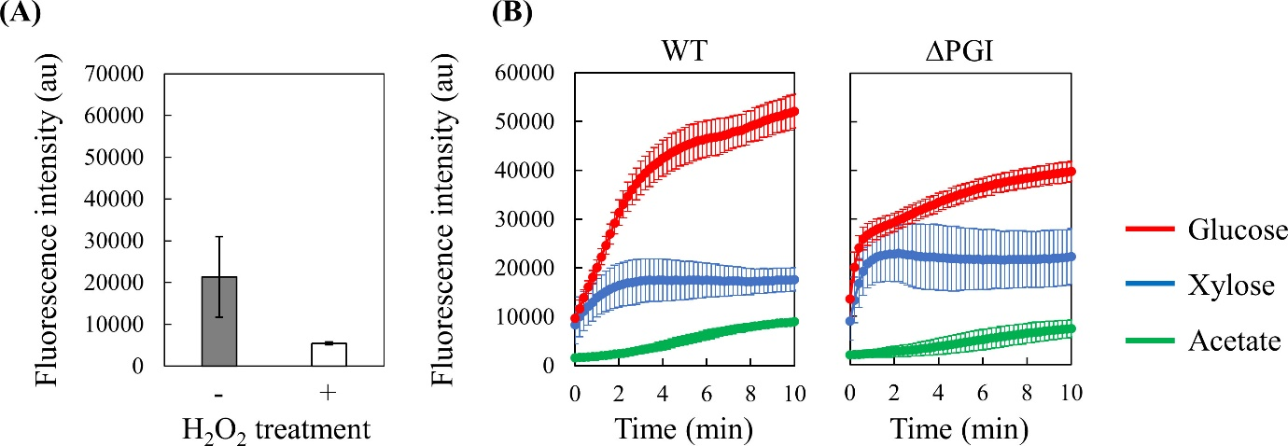

**Fig 2** Perturbation analyses of starved *E. coli* cells. (**A**) NADPH depletion by H2O2 treatment (**B**) Time courses of mBFP fluorescence intensity of WT and ΔPGI strains under glucose, xylose, and acetate conditions. Error bars represent standard deviations from triplicate experiments using cells obtained from different pre-cultures.

[Reproduced from: Ueno K, Sawada S, Ishibashi M, Kanda Y, Shimizu H, Toya Y. 2024. Identification of a novel NADPH generation reaction in the pentose phosphate pathway in *Escherichia coli* using mBFP. J Bacteriol 206:e00276-24.

<https://doi.org/10.1128/jb.00276-24>]

1. How would you describe the results presented in this figure?
2. Compare your description with the authors’.