# Writing exercise S08: Model Figures

## Dr. Morgan Feeney, AY 2024-25

Model figures can help to clarify complicated concepts and using them in your thesis can be very helpful: they help to make sure your reader “is on the same page” as you and has the same understanding of your system/topic. They can also be quite helpful in terms of word count – a picture is worth a thousand words, after all!

However, consider the figure below (or any textbook figure showing the functioning of the *Escherichia coli lac* operon.

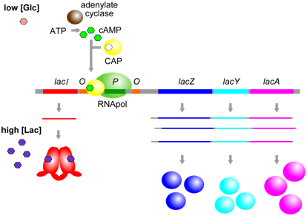

Figure 12.1.612.1.6: When glucose [Glc] and lactose [Lac] are both high, the lac operon is transcribed at a moderate level, because CAP (in the absence of cAMP) is unable to bind to its corresponding cis-element (yellow) and therefore cannot help to stabilize binding of RNApol at the promoter. Alternatively, when [Glc] is low, and [Lac] is high, CAP and cAMP can bind near the promoter and increase further the transcription of the lac operon. (Origianl-Deyholos-CC:AN) [From: Biology LibreTexts]

### Exercise A.

Analyse the figure and ask yourself:

1. What is the figure showing?
2. What is wrong with it?
3. How can it be improved?

Consider also the four model figures shown below: although they all depict the same regulatory system, they are remarkably different (because of the increased understanding of the system and/or because the authors of the different papers were choosing to focus on different aspects of the system.)

Figure 2. Models of the SigR-RsrA system from *Streptomyces*. Reproduced from A) Kang et al 1999, B) Rajasekar et al 2016, C) Feeney et al 2017, D) Park et al 2019.

### Discussion Questions

1. Which figure do you prefer, and why?
2. What are the positives and negatives of each? In which context would you choose to use each of them?
3. How might these figures be improved/how else might you illustrate this system?

### Exercise B.

Draw a model figure illustrating the system you are working on in your project. (You may wish to create two versions – one for your written thesis and one for your presentation.)

Consider this model figure critically: does it contain everything your reader (or audience) needs to know to understand the system? Does it contain anything extraneous/irrelevant to the point you wish to make? How can it be improved?

### References

Kang JG, Paget MS, Seok YJ, et al. RsrA, an anti-sigma factor regulated by redox change. *EMBO J*. 1999;18(15):4292-4298. doi:10.1093/emboj/18.15.4292

Rajasekar KV, Zdanowski K, Yan J, et al. The anti-sigma factor RsrA responds to oxidative stress by reburying its hydrophobic core. *Nat Commun*. 2016;7:12194. Published 2016 Jul 19. doi:10.1038/ncomms12194

Feeney MA, Chandra G, Findlay KC, Paget MSB, Buttner MJ. Translational Control of the SigR-Directed Oxidative Stress Response in *Streptomyces* via IF3-Mediated Repression of a Noncanonical GTC Start Codon. *mBio*. 2017;8(3):e00815-17. Published 2017 Jun 13. doi:10.1128/mBio.00815-17

Park JH, Lee JH, Roe JH. SigR, a hub of multilayered regulation of redox and antibiotic stress responses. *Mol Microbiol*. 2019;112(2):420-431. doi:10.1111/mmi.14341