Department of Computing
CS: Data Structures and Algorithms
Class: BSCS-15E

Lab 03
Structures and Pointers
Dynamic Memory Allocation
CLO 2: Solve a given real time problem by applying appropriate data structure and algorithm.
CLO 3: Practice programs using the latest IDEs ensuring testing, documentation and packaging of programs as per standards practices applicable to the software industry.
Date:22nd Septemeber 2026
Duration: 3 hours
Instructor: Sara Tariq Sheikh
Lab Engineer: Urooj Akmal

Introduction
This lab introduces student records using structures, pointers, and dynamic memory allocation in C++. You will create, access, update, and release a record, then combine these skills in a simple menu-driven application. Complete the six tasks in order. These skills prepare you for linked lists in a later lab.

Objectives
• Explain structures, structure pointers, and member access using the dot and arrow operators (CLO 1).
• Describe dynamic allocation, memory release, and the purpose of nullptr (CLO 1).
• Use pointer parameters to display and update records through functions (CLO 2).
• Develop a student record application with appropriate pointer checks and memory cleanup (CLO 2).

Tools and Software Requirements
Use a C++ compiler or IDE supporting C++11 or later. Write each task in a separate .cpp file that compiles and runs independently. Use <iostream> and <string>. Assume valid numeric input, marks from 0 to 100, and successful memory allocation. Allow names containing spaces using getline(cin >> ws, name).

Structures and Structure Pointers
A structure groups related fields into one record. Use the dot operator with a structure variable and the arrow operator with a pointer to that structure. Use this definition in each task:
struct Student {
int rollNo;
string name;
float marks;
};
For Student s; and Student* p = &s;, s.marks and p->marks access the same field. Do not use delete on a pointer to an ordinary local variable.

Dynamic Memory and Pointer Parameters
Student* p = new Student{}; creates one dynamically allocated record. Check that a pointer is not nullptr before accessing its fields. Release this single record with delete p; and then set p = nullptr;. Do not access a deleted record. A function receiving Student* can modify the record; const Student* prevents modification through that pointer.

Lab Tasks
Suggested timing: guided review 20 minutes; Tasks 1–6 take 15, 20, 20, 25, 20, and 45 minutes respectively; checking and submission 15 minutes.

Task 1 Creating a structure
Define the Student structure. Declare one student variable, input its roll number, full name, and marks, and display all details with clear labels.
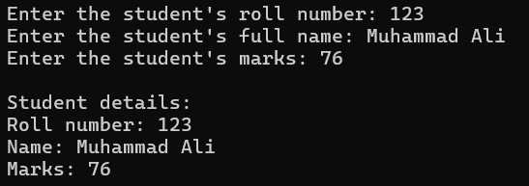
Output:

Task 2 Accessing a structure through a pointer
Create a pointer to a student variable. Input the record, then use the arrow operator (->) to display its details, update its marks with a new value entered by the user, and display the updated record.
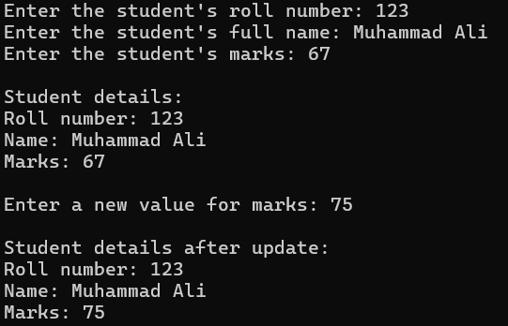
Output:

Task 3 Creating a record dynamically
Allocate one Student record using new. Input and display its details through the pointer. Release the allocated memory using delete and set the pointer to nullptr.
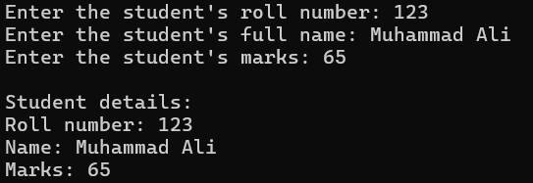
Output:

Task 4 Using functions with pointers
Create and input a dynamically allocated student record. Implement the following functions. In main(), display the record, update its marks, and display it again. Release the memory before the program ends.
void displayStudent(const Student* s);
void updateMarks(Student* s, float newMarks);

Output:
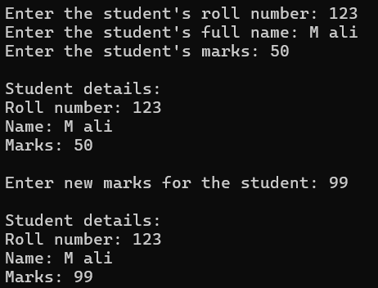

Task 5 Checking whether a record exists
Initialize a student pointer to nullptr. Write void displayIfExists(const Student* s) to display a record if it exists or print "No record available" otherwise. Call it before allocation, after allocating and entering a record, and after deleting the record and resetting the pointer to nullptr.
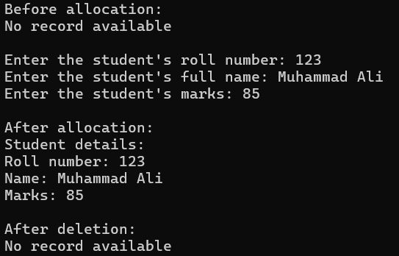
Output:

Task 6 Building a student record application
Develop a menu-driven program with options to create a record, display it, update its marks, delete it, and exit. Manage only one dynamically allocated student record. Prevent creating another record while one exists. Check for an existing record before accessing or deleting it, reset the pointer after deletion, and release any remaining allocation before exiting. Repeat the menu until Exit is selected and handle invalid menu choices. Reuse your earlier functions where appropriate.
Check your application by trying Display before Create, Create twice, Update, Delete, Display after Delete, and Create followed by Exit. Verify the results during the lab; no written test report is required.

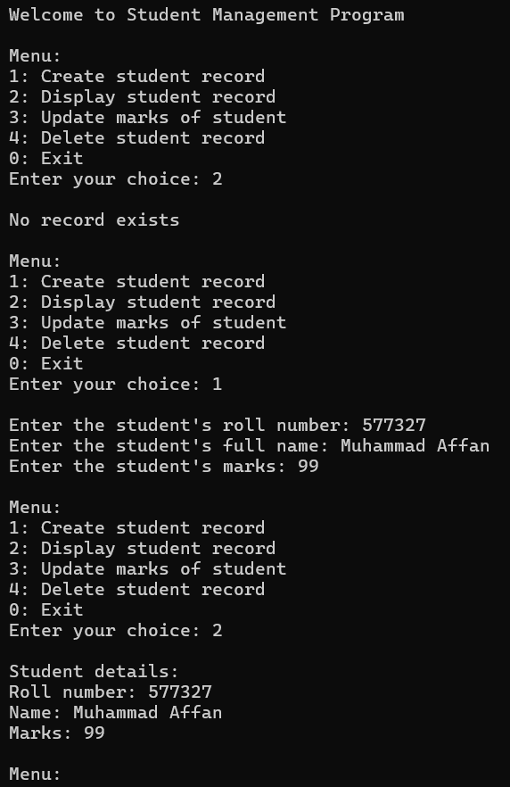
Output:
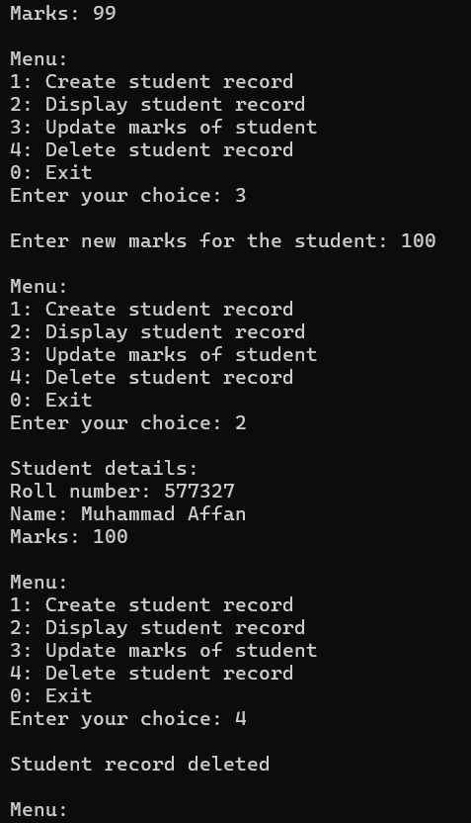

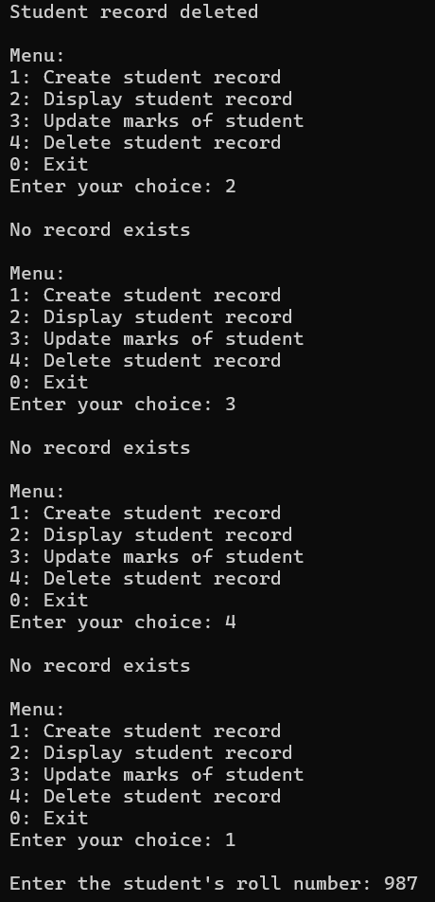

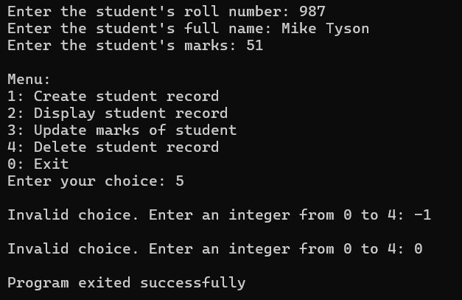

Github link: https://github.com/maffanbscs25seecs-crypto/DSA-lab3

Deliverables
Submit Q1.cpp through Q6.cpp. Each file must compile and run independently. Add your name, registration number, and section as a comment at the top of each file. Choose either submission option below:
Option 1: Git repository
Push the six .cpp files to a Git repository (for example, GitHub) and submit the repository link on LMS. Ensure the instructor can access the repository.
Option 2: ZIP upload
Place the six .cpp files in one ZIP file named RollNo_Lab03_Structures.zip and upload it to LMS.
No separate report, screenshots, Word/PDF submission, or compiled executable files are required. Be prepared to run and explain your own programs during the lab.
Academic integrity: Discuss ideas, but type, run, and explain your own programs. Acknowledge any external code or explanations in source-code comments.

Lab Rubrics
Total: 10 marks.
Conceptual understanding will be checked through a short viva or demonstration; no written explanations are required.
Criterion | CLO | Marks | Evidence expected
Structures and pointers | 1 | 2 | Explains fields, dot/arrow access, and pointer parameters.
Memory understanding | 1 | 1 | Explains new, delete, nullptr, and checks before access.
Record creation and access | 2 | 2 | Tasks 1–3: correct input, display, pointer use, and cleanup.
Functions and pointer checks | 2 | 2 | Tasks 4–5: correct display, update, and missing-record handling.
Student record application | 2 | 3 | Task 6: working menu and operations (2); existence checks and cleanup (1).

Reference
Goodrich, M. T., Tamassia, R., & Mount, D. M. (2011). Data Structures and Algorithms in C++ (2nd ed.). Wiley. Review the introductory C++ material on structures, pointers, and dynamic memory allocation.

