Frances Gliane

VBA Homework

Screen shot – 2016

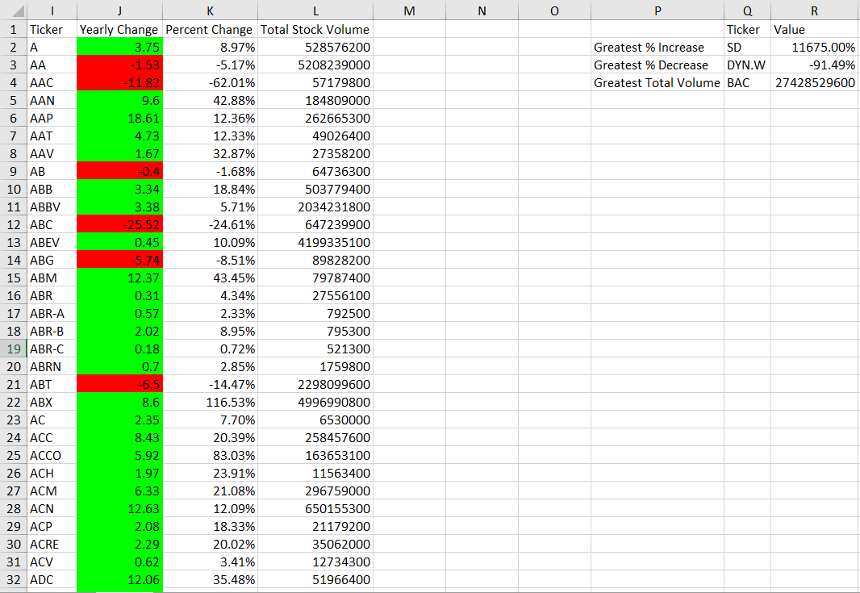

Screenshot – 2015

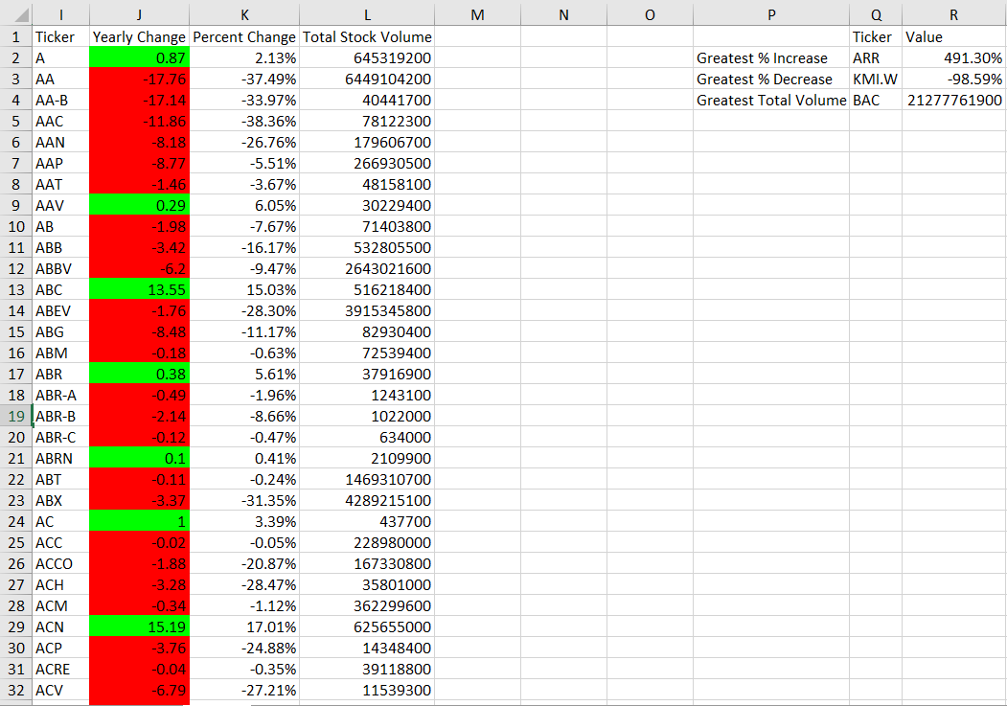

Screenshot – 2014

