**Initial:**

|  |  |  |  |
| --- | --- | --- | --- |
| Number | Task Name | Length  [Hours or Days] | Predecessor |
| 1 | Fix While Loop | 1 |  |
| 2 | Update Options Form | 0.5 | 1 |
| 3 | Easter Egg | 1 |  |
| 4 | Test | 1 | 2 |

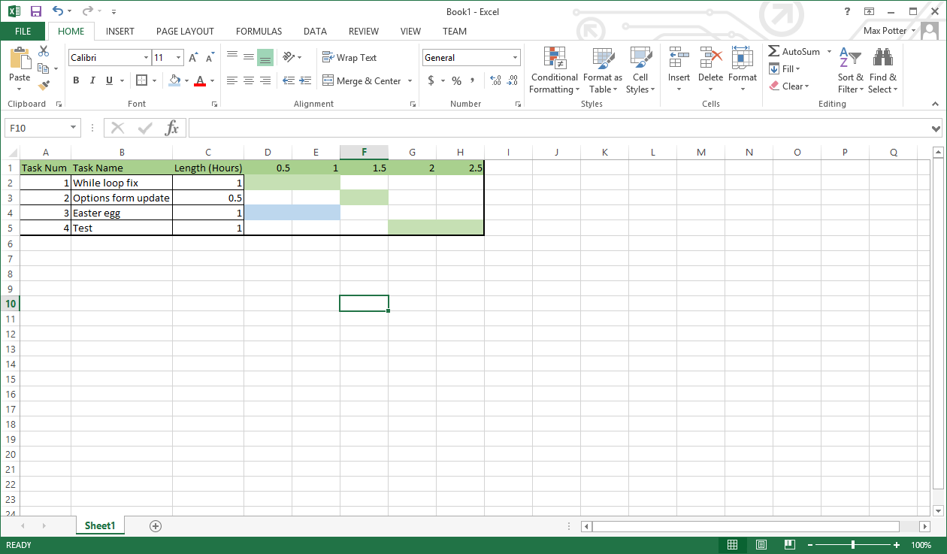

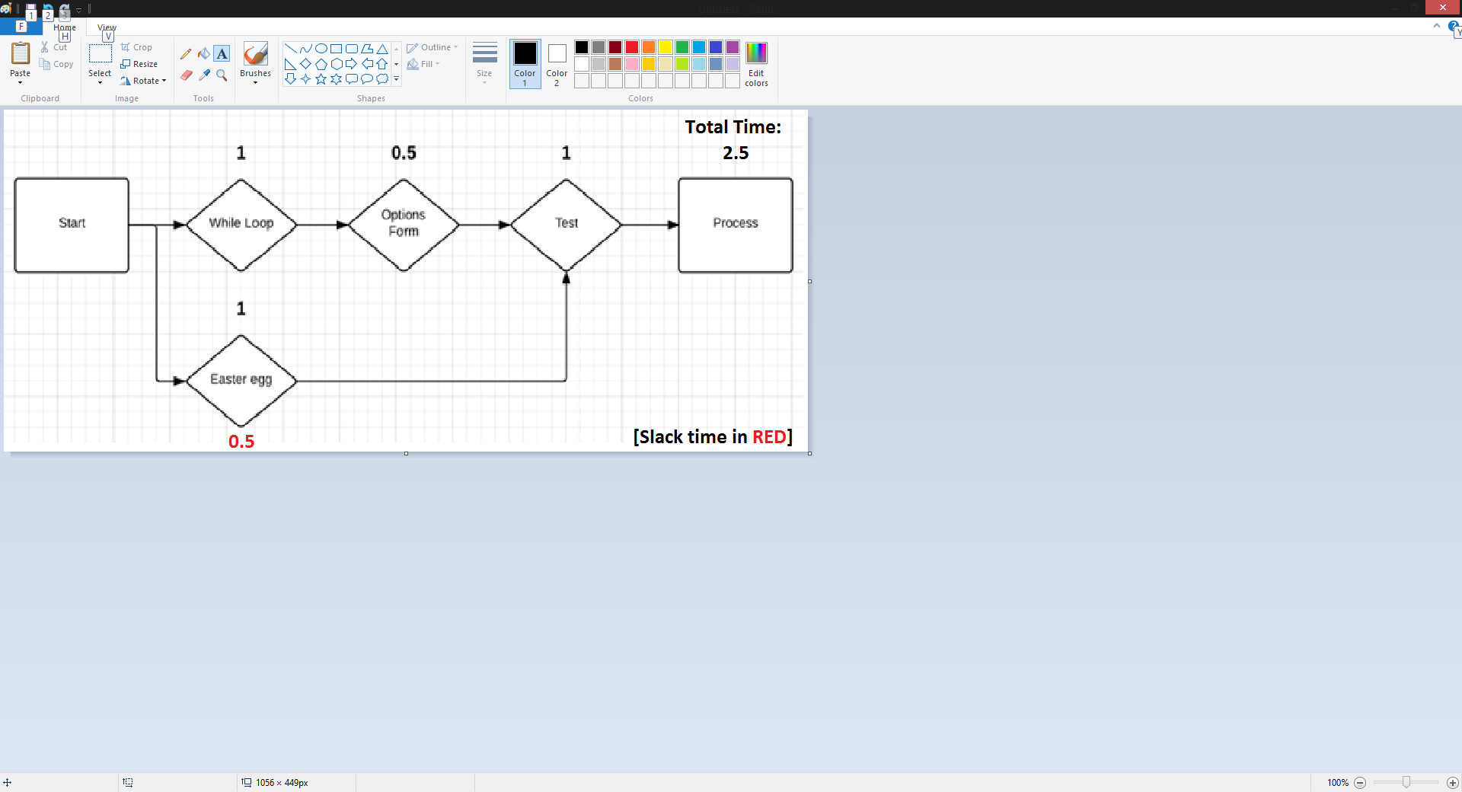

**Updated:**

|  |  |  |  |
| --- | --- | --- | --- |
| Number | Task Name | Length  [Hours or Days] | Predecessor |
| 1 | Fix While Loop | 1.5 |  |
| 2 | Update Options Form | 1 | 1 |
| 3 | Easter Egg | 2 |  |
| 4 | Test | 0.5 | 2 |

