docdoom’s   
Backup Manager for ComicRack

The Manual v1

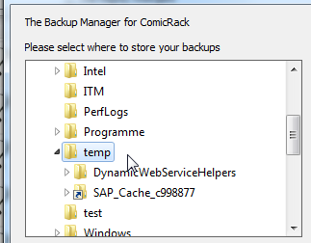covering CR Backup Manager up to Version 1.0



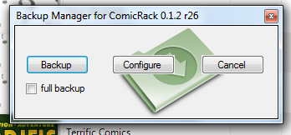

Contents

Purpose 3

Known Limitations 3

Installation 4

Usage 5

Setting up the configuration 5

Running a normal backup 5

Running a full backup 6

Restoring a normal backup 7

# Purpose

The eComic reader and organizer ComicRack provides no tool for automatic backups of the library. The Backup Manager plugin for ComicRack was written to save your data automaticall on a regular basis or manually in a very easy way.

# Known Limitations

The Backup Manager provides two backup modes:

“normal” – it saves the ComicDB.xml file in the %appdata%\roaming\cyo\comicrack folder as well as the custom thumbnails. This mode runs at each start of ComicRack but can be run manually as well.

“full” – it saves the complete content of %appdata%\roaming\cyo\comicrack including subfolders as well as the custom thumbnails.

* At the moment the Backup Manager will **not** save your ComicDB.xml if it is not located in the folder %appdata%\roaming\cyo\comicrack.
* With ComicRack 0.9.164 and higher you can use shared SQL servers as data sources for your library instead of the ComicDB.xml file (currently MySQL and MS SQL). If you use these server back ends for your library the normal backup mode of the Backup Manager does not make sense. In this case you should use the database backup features in MySQL and MS SQL, resp.

# Installation

Download the latest version of the Backup Manager from [here](http://code.google.com/p/cr-backup-manager/downloads/list). In ComicRack then select “Edit -> Preferences -> Scripts”. Click on “Install” and select the file you just downloaded. You have to restart ComicRack afterwards.

**Important:** if you install the Backup Manager plugin over a previous version please **don’t remove the older version** (selecting “Edit -> Preferences -> Scripts -> CR Backup Manager -> Remove”). Otherwise you will lose your previous self-defined setting for the Backup Manager.

**So, don’t ever:**

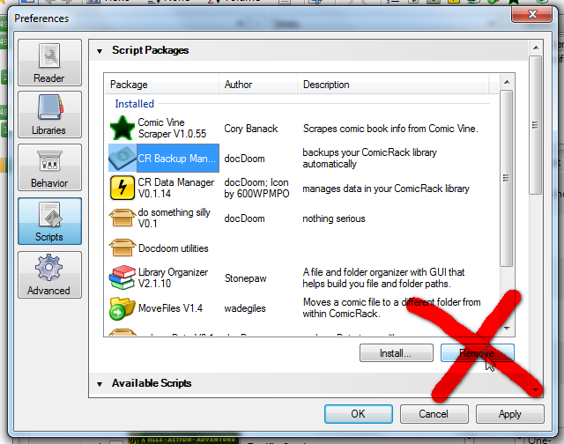

Just install the newer version over the old one and you will be fine:

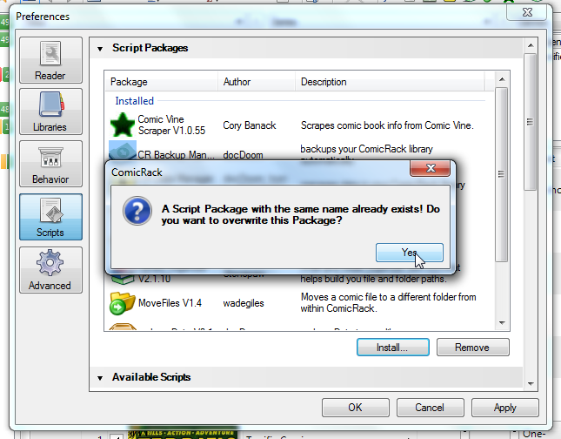

# Usage

## Setting up the configuration

If you have not used the Backup Manager before it will ask you with the next start of ComicRack where your backup files shall be stored:



Select the folder where you would like to store your future backups and click “Ok”.

You can also cancel the folder browser dialog and select the folder afterwards: just start the Backup Manager from the context menu in the library browser or from the toolbar in ComicRack (the icon of the Backup Manager is the little green folder symbol):



On the next dialog click on „Configure“ and select the folder to store your backups.

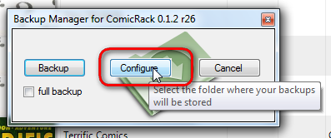

## Running a normal backup

Each time you start ComicRack the Backup Manager will backup your library file („ComicDB.xml“) and your custom thumbnails as a Zip-file to the folder you selected in chapter above.

If you want to run the Backup Manager, just click on the Backup Manager icon on the ComicRack toolbar:



After that click on “Backup” on the next dialog. That’s all.

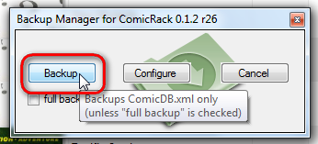

Once the backup is finished a dialog will tell you so:

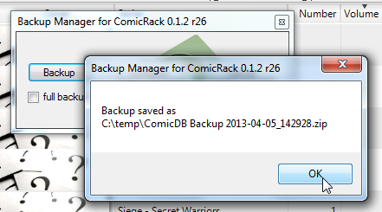

## Running a full backup

Sometimes you might want to save your complete personal ComicRack data including scripts etc. In this case you can select the “full backup” option on the Backup Manager main dialog und click on “Backup”:

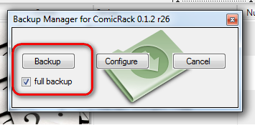

The full backup will save a copy of all of your files and folders in the folder %appdata%\roaming\cyo\comicrack and the custom thumbnails folder as well.

## Restoring a normal backup

To restore a normal backup you use the built-in ComicRack restore function. In ComicRack select: “Edit -> Preferences”. In the Preferences dialog select “Advanced” and click on “Restore Database”:

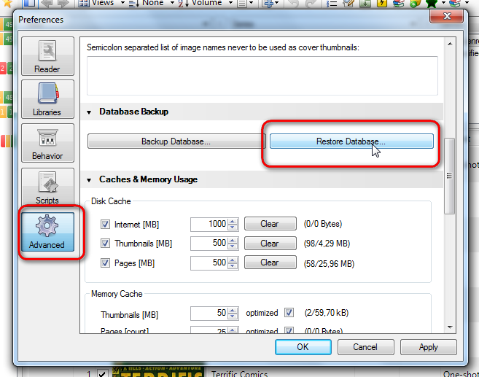

Then select the file with the backup you want to restore:

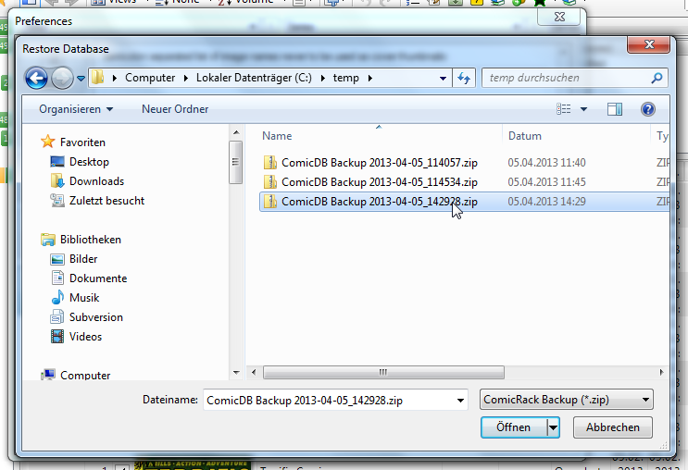

Finally, click on “Open” and ComicRack will restore your library file and custom thumbnails from that backup. That’s all, folks! Afterwards you have to restart ComicRack.

**Please note:** This will work only with a “normal” backup. The structure of the “full backup” is completely different. If you want to restore a full backup you have to unzip the full backup file manually and restore the files to the original location.