**Database System Logical and Physical Design**

**for**

**Library DB application**

**Version 1.0 approved**

**Prepared by Anvar Muminov U1510052 (004)**

**Maftuna Sharabbaeva U151067* (004)**

**Kamola Samigova U1510077 (004)**

**“Mysterious Library”**

**12.04.2018**

***Copyright © 2017 by Alessandro Agostini. Permission is granted to use, modify, and distribute this document.***

***Logical and Physical Database Design for <Project>*** ***Page ii***

|  |  |  |  |  |
| --- | --- | --- | --- | --- |
| **Table of Contents** | | | **1** |  |
| **1** | **Introduction..............................................................................................................................** | |  |
| **2** | **Logical Database Design .........................................................................................................** | | **1** |  |
|  | 2.1 | Summary of Conceptual Design – ER/EER-Diagram(s)................................................................. | 1 |  |
| **3** | 2.2 | Logical Schemas in *ER-Win*: Logical Diagram............................................................................... | 1 |  |
| **Physical Database Design........................................................................................................** | | **1** |  |
|  | 3.1 | Physical Schemas (“tables”) in *ER-Win*: Physical Diagram............................................................ | 1 |  |

**Revision History**

|  |  |  |  |
| --- | --- | --- | --- |
| **Name** | **Date** | **Reason For Changes** | **Version** |
| Maftuna Sharabbaeva | 12.04.2018 | To make more complex database | 1.0 |
| Kamola Samigova | 12.04.2018 | To maintain security | 1.0 |
| Anvar Muminov | 12.04.2018 | To make interface be simple | 1.0 |

***Software Design Specification for Library DB application*** ***Page 1***

**1 Introduction**

* *Here briefly summarize the project, give a context, so that what follows in the next sections has a proper – although brief - introduction.>*

**2 Logical Database Design**

* *Here make the necessary premises on notation and terminology that you are going to use successively in your logical design.>*

**2.1** **Summary of Conceptual Design – ER/EER-Diagram(s)**

* 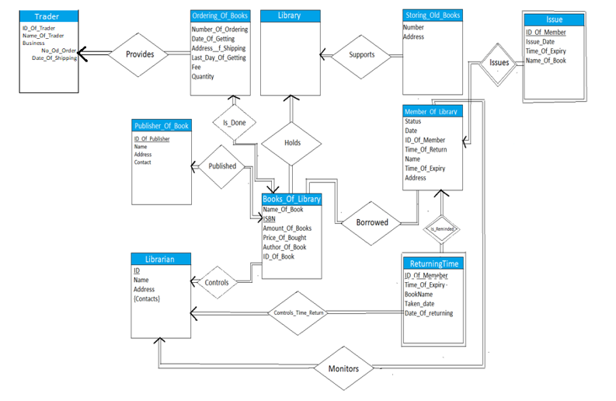*Here insert* ***exactly the same conceptual ER/EER-diagram*** *you produced* ***in Homework 2****. The diagram is also required to be printed in format A4 (orientation Landscape for better view, if your diagram has a horizontal development) and attached to this document.>*

***Software Design Specification for Library DB application*** ***Page 2***

* **2.2** **Logical Schemas in *ER-Win*: Logical Diagram**
* *Here insert the ER-Win Logical Diagram of the conceptual diagram in the previous subsection.* ***Important****: If there are some differences in the two diagrams due to specific limitations and/or**features of ER-Win, explain the differences and why they are necessary in order to make the two diagrams equivalent, or almost equivalent, in case you think the two diagrams are not equivalent. The diagram is also required to be printed in format A4 (orientation Landscape for better view, if your diagram has a horizontal development) and attached to this document.>*

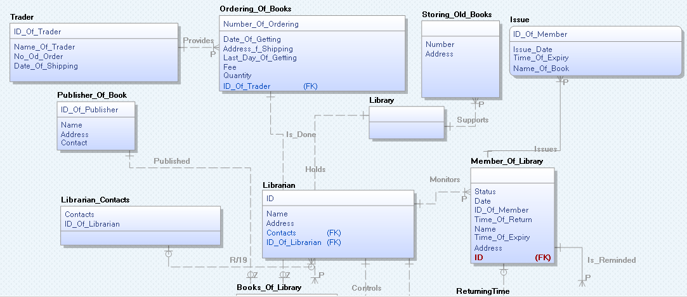

**

**3 Physical Database Design**

* *Here make the necessary premises on notation and terminology that you are going to use successively in your physical design by ER-Win.>*

**3.1** **Physical Schemas (“tables”) in *ER-Win*: Physical Diagram**

* *Here add the ER-Win Physical Diagram of the Logical Diagram you produced in the previous subsection. The diagram is required to have all the attributes’ data-types, value domains and null constraints. The diagram is also required to be printed in format A4 (orientation Landscape for better view, if your diagram has a horizontal development) and attached to this document.>*

