Lab: Unit 08 – Logical Data Modeling

# Overview

In this lab we will explore how to map draw logical models from conceptual models.

## Learning Objectives

Upon completion of the lab, you should be able to:

* Identity the components of the logical,
* Use a diagramming tool such as **draw.io** to draw relational model diagrams.
* Map conceptual models to logical model by following mapping rules and best practices.

## What you will need

To complete this lab, you will need the Draw.io tool by <https://www.diagrams.net/> You can draw your diagrams online or download the app to your computer. Follow the link to draw in the browser or download.

# Walkthrough

## Step 1: Logical Models in Draw.io

Watch this video to get started drawing logical model diagrams with the **draw.io** tool. The video will take you through the basics of setting up tables, columns annotations and foreign keys.

<https://youtu.be/CmjW3HyazRA>

Also, here is more general tutorial for how to use Draw.io here: <https://www.youtube.com/watch?v=Z0D96ZikMkc>

## Step 2: Re-Create this Logical Model

After you have completed the tutorial, try to draw this diagram by re-creating it exactly.

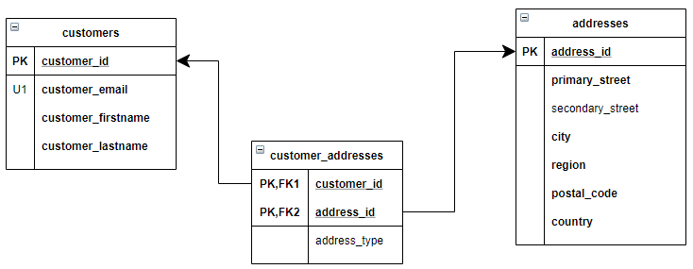

## Step 3: Re-Create a Logical Model From an ERD

Now that you are comfortable drawing a diagram, try to map this conceptual model to a logical model.   
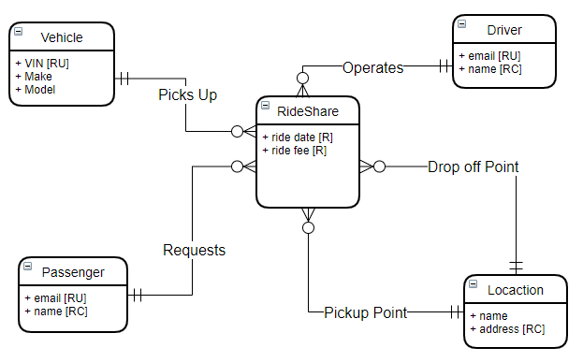

# Questions

Answer these questions using the problem set submission template. You will need to provide a screen shot for each answer. Please follow the guidelines for submitting a screenshot.

1. Provide a screenshot of your completed logical model from Walkthrough Step 2.
2. Provide a screenshot of your completed logical model from Walkthrough Step 3.
3. Map this conceptual model to a logical model.   
   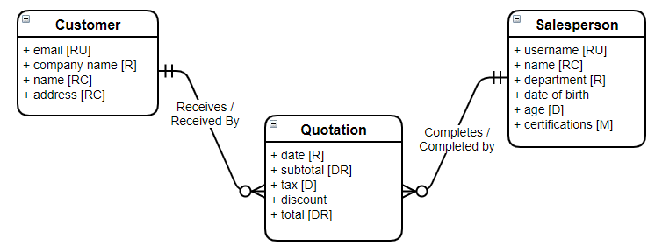
4. Map this conceptual Model to a logical Model  
   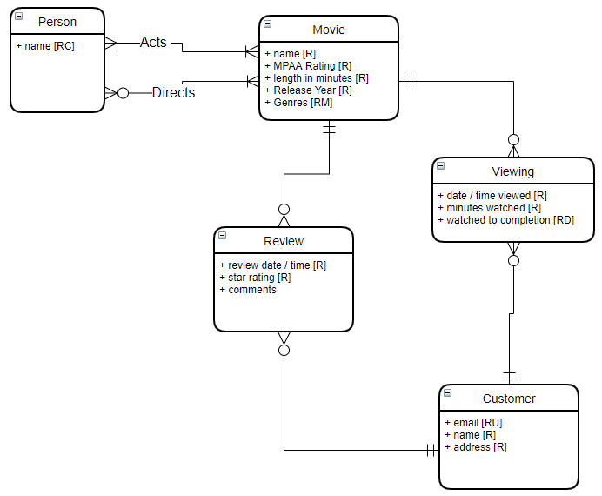
5. Map this conceptual model to a logical data model  
   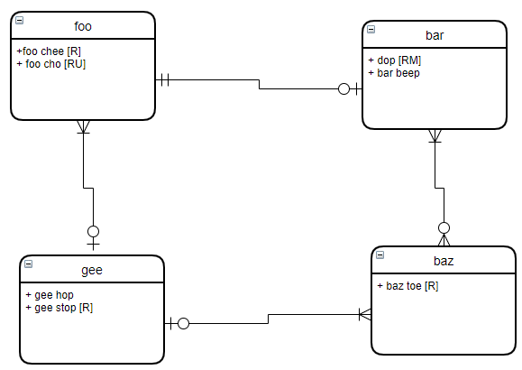
6. Write an SQL Up/Down script to create the tables, keys and constraints for the logical model you created in question 1. Create the tables first with table constraints. Then alter the tables and add the FK constraints. The down part of your script should do this in reverse.