# Azure SQL Database Setup

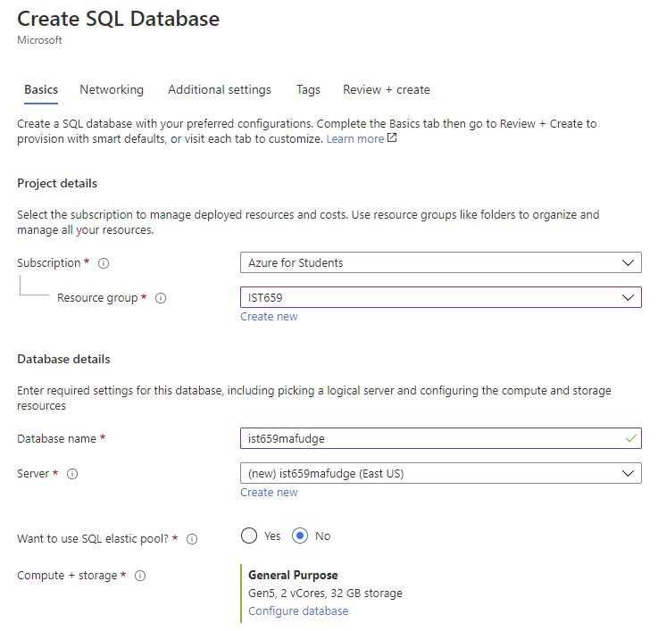

1. <https://portal.azure.com>
2. Login with [***netid*@syr.edu**](mailto:netid@syr.edu)and your SU NetID password.
3. Click **Create a resource**
4. Enter **SQL Database**
   1. Subscription:  **Azure for Students**
   2. Resource Group => Create new
      1. IST659
   3. Database name **ist659*yournetid***
   4. Server -> Create new
      1. Server name: **ist659*yournetid***
      2. Server admin login: ***yournetid***
      3. Password: <<create-your-own-password>>
      4. Location: **(US) East US**
   5. **IMPORTANT:** click Configure Database
      1. Change the **Compute Tier** from “Provisioned” to “Serverless”
      2. Should now say:  
         **General Purpose**Serverless, Gen5, 1 vCore, 32 GB storage
   6. Click **Review+Create**
5. Smoke ‘em if you got ‘em your database is being deployed! This can take 5-20 minutes.

# Connect to your Azure SQL Database from Azure Data Studio

1. Launch Azure Data Studio
2. Display the Side Bar **Ctrl** + **B**
3. Click on the **Azure** section and click **Sign Into azure**
   1. Click **Add An Account**
   2. Add your [***netid*@syr.edu**](mailto:netid@syr.edu)and SU NetID password.
4. Back in Azure Data Studio, Login!
   1. Select your Azure Account
   2. Select Azure for Students
   3. Select SQL Server
   4. Select Server **IST659*yournetid***
   5. Add your IP Address to the Firewall Exception
   6. Login with ***yournetid*** with your password from step 4.d.iii
5. Now you know you can connect to your Azure Database, its time to make a server connection.
   1. Next to servers, click **New Connection**
   2. Server: **ist659*yournetid*.database.windows.net**
   3. Authentication Type: **SQL Login**
   4. User name: ***yournetid***
   5. Password: your password from step 4.d.iii
   6. Check : “Remember Password”
   7. Select database: **IST659*yournetid***

# PowerApps

1. <https://make.powerapps.com>
2. Login with [***netid*@syr.edu**](mailto:netid@syr.edu)and your SU NetID password.
3. New Canvas App
4. Data Add the tables
   1. Sql server
5. New Screen for Fudgemart Employees – List
   1. Name the controls that matter:
      1. ScreenEmployees
      2. BrowseGalleryEmployees
      3. TextSearchBoxEmployees
      4. IconSortUpDownEmployees
      5. IconReferehEmployees
      6. LblScreenEmployees
   2. Change gallery to data source to fudgemart employees
   3. Change Gallery to show name and department
   4. Combine first and last name :  
      ThisItem.employee_firstname & " " & ThisItem.employee_lastname
   5. Get it to search: Gallery Items property  
      Search('fudgemart_employees',TextSearchBoxEmployees.Text, "employee_firstname","employee_lastname","employee_department")
   6. Get it to sort: Gallery Items Property:
6. New Blank Screen
   1. Rename to ScreenMainMenu
   2. Add Button for Employee Directory, name ButtonEmployeeDirectory
   3. On Select Action   
      Navigate(ScreenEmployees)
7. Add Back button to the ScreenEmployees
   1. Add the ChevronLeft Icxon to the top of the screen, rename IconGoBackEmployees
   2. On Select: Navigate(ScreenMainMenu)
8. On the Main menu, add a logo
   1. Upload media
   2. Add to canvas
9. Add a screen for Vacation requests
   1. New Screen => List
   2. Rename stuff VacationRequests
   3. Add the back button
   4. Set the data source to fudgemart_vacation Requests
   5. Set the fields and rename the controls
   6. Set special data
      1. LabelRequestdate.Text => Text(ThisItem.request_start_date,"[$-en-US]yyyy-mm-dd")
      2. LabelRequestNumberOfDays => ThisItem.request_number_of_days & " days"
      3. LabelEmployeeName => LookUp(fudgemart_employees,employee_id= ThisItem.request_employee_id, employee_firstname & " " & employee_lastname)
   7. Get filter to work => Search(fudgemart_vacation_requests,TextSearchBoxVacationRequests.Text, "request_name")
   8. Set Sort to work => SortByColumns(Search(fudgemart_vacation_requests,TextSearchBoxVacationRequests.Text, "request_name"),"request_name",If(SortDescending1, Descending, Ascending))
   9. Hook up Navigation back to main menu
10. Add Screen FORM to View Vacation Request => ScreenViewVacationRequest
    1. Adjust Header: back button, title edit and delete
    2. Delete the form, add a form viewer
    3. Name objects
    4. Connect the DetailFormVacationRequest.datasource = fudgemart_vacation_reqeusts
    5. Connect the DetailFormVacationRequest.item = BrowseGalleryVacationRequests.Selected
11. Connect Gallery to Details Screen
    1. Select first item in gallery.   
       OnSelect = Navigate(DetailFormVacationRequest)
12. Details screen works the visual appearance needs improvement. Let’s make it better! Cards are locked so we will need to unlock them to make some of thee changes:
    1. CardValue for Employee.Text = LookUp(fudgemart_employees,employee_id=ThisItem.request_employee_id, employee_firstname & " " & employee_lastname)
    2. CardValue for Vacation Start Date.Text = Text(ThisItem.request_start_date,"[$-en-US]yyyy-mm-dd")
    3. Card Value for Request Status.text = If(Len(ThisItem.request_approved_employee_id)=0,"Not Approved", "Approved")
13. Add another FORM screen for editing the Vacation Request
    1. Data source fudgemart_acation_requests
    2. Label = Make Vacation Request
    3. Create the dropdown for Employee:
       1. DataCardDropdownEmployee.Items = ShowColumns(AddColumns(fudgemart_employees, "employee_name", employee_firstname & " " & employee_lastname), "employee_name", "employee_id")
       2. DataCardDropDownEmployee.Value = employee_name
       3. DataCardDropDownEmployee.Default = LookUp(fudgemart_employees, employee_id= ThisItem.request_employee_id, employee_firstname & " " & employee_lastname)
       4. Request_employee_id_DataCard.Default = ThisItem.request_employee_id
       5. Request_employee_id_DataCard.Default = DataCardValueDropDownEmployee.Selected.employee_id
14. Fix Navigation
    1. ScreenEditFormRequest [X] on select = ResetForm(EditFormVacationRequest);Back()
    2. ScreenEditFormRequest Check = SubmitForm(EditFormVacationRequest);Back()
    3. EditFormVacationRequest.Item = BrowseGalleryVacationRequests.Selected
    4. ScreenVacationRequests [+] .OnSelect = NewForm(EditFormVacationRequest);Navigate(ScreenEditVacationRequest)

# On your own

ScreenVacationRequestsMenu

* Button for New Request
* Button for list Not Approved Requests
* Button for list of Approved Requests

ScreenMainMenu

* Button to open ScreenVacationRequestsMenu

ScreenEditApproveVacationRequest

* Screen to approve a vacation requerst

DetailFormVacationRequests

* Add Button to Approve a Request