The National University of Lesotho
Department of Mathematics and Computer Science
Faculty of Science and technology

CS4433: Software Engineering
Task: Phase 3 System design
‘Mafusi Motsoari
202322797

- Architecture design
  - Selected Architectural style
The Moderated Learning Management System (MLMS) uses a Layered architecture, it organizes the software into horizontal tiers or layers, where each layer has a specific responsibility and can only communicate with adjacent layers (typically top-down). This promotes separation of concerns, high maintainability, and testability. The system is structured into four primary functional layers plus the database layer:
- Presentation Layer: Manages user interaction and UI components, including the login/role menu and dedicated screens for Students, Lecturers, HoDs, and Administrators.
- Application Layer: Orchestrates business workflows and coordinates services such as authentication, role access, password hashing, course enrollment, assignment submissions, marking/moderation, and audit logging.
- Domain Layer: Houses the core domain models (e.g., users, courses, submissions, audit entries) and encapsulates enterprise business logic and rules, such as the late penalty strategy (10% deduction per day, up to a maximum of 3 days, with 0 marks awarded after 3 days).
- Persistence Layer: Manages data access abstraction through standard repositories, SQLite-specific repository implementations, and database connections.
- Database: Stores persistent application data in an SQLite database file hosted on a local PC or school LAN.
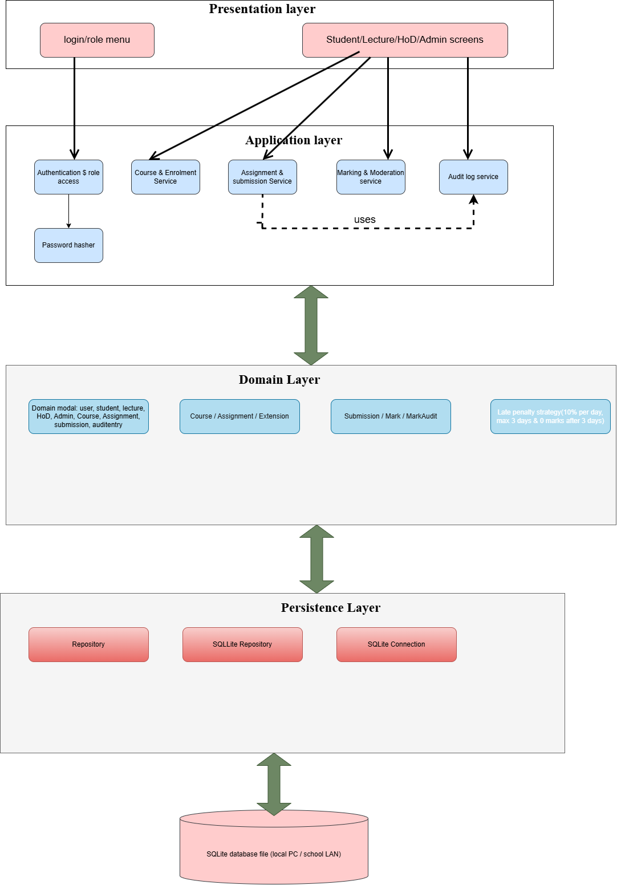
  - Alternative Architecture Considered
An alternative considered was Model–View–Controller (MVC). MVC separates an application into the Model, View and Controller components. It is useful for organising web applications and separating user interface code from application logic.
However, Layered Architecture was selected because the MLMS has several distinct responsibilities, including assignment management, marking, moderation, audit logging and database access. Four layers make these responsibilities easier to identify and explain in the system design.
MVC could still be used within the Presentation Layer, but Layered Architecture provides the overall structure for the complete MLMS.
- Class Diagram
The Learning Management System (LMS) is designed to manage users, courses, assignments, submissions, marking, moderation, and audit records. The class diagram uses object-oriented design principles to organise the system into classes with specific responsibilities. Design patterns help solve common software design problems, while SOLID principles improve maintainability, flexibility, and reusability.
  - Design Patterns
    - Service Layer Pattern
The Service Layer Pattern is represented by AuthService, SubmissionService, and MarkingService. These classes manage the main business operations of the LMS. AuthService handles authentication, SubmissionService processes assignment submissions, and MarkingService manages marking activities. This pattern separates business logic from other classes, making the system easier to maintain, test, and update.

    - Inheritance Pattern
The Inheritance Pattern is represented by the User class and its subclasses: Student, Lecturer, HoD, and Admin. The User class contains common attributes and operations shared by all users, while each subclass has its own specific responsibilities. This reduces code duplication and makes it easier to manage different user roles.
    - Composition Pattern
The Composition Pattern is used to represent the relationships between Course and Assignment, and between Assignment and Submission. A course contains assignments, while an assignment contains submissions. This pattern helps organise related objects and makes the structure of the LMS easier to understand.
    - Audit Log Pattern
The Audit Log Pattern is represented by the MarkChangeAudit class. It records important changes to student marks, including the previous mark, the new mark, the date, and the reason for the change. This pattern improves accountability and transparency by allowing authorised users to track changes to marks.

  - Application of SOLID Principles
    - Single Responsibility Principle (SRP)
The Single Responsibility Principle states that each class should have one main responsibility. In the LMS, AuthService handles authentication, SubmissionService manages submissions, and MarkingService handles marking operations. Separating these responsibilities makes the system easier to maintain and debug.
    - Open/Closed Principle (OCP)
The Open/Closed Principle states that a system should allow new functionality without requiring major changes to existing code. The LMS applies this principle through the User class hierarchy. For example, a new user role could be introduced as a subclass of User without duplicating all the common attributes and operations.
    - Liskov Substitution Principle (LSP)
The Liskov Substitution Principle states that subclasses should be usable wherever their parent class is expected. In the LMS, Student, Lecturer, HoD, and Admin inherit from User. They can share common user operations, such as account identification and authentication, while retaining their specialised responsibilities.

    - Interface Segregation Principle (ISP)
The Interface Segregation Principle states that classes should not be forced to depend on operations they do not need. In the LMS, responsibilities are separated according to user roles. For example, students submit assignments, lecturers mark submissions, HoDs moderate marks, and administrators manage users. This separation prevents unrelated responsibilities from being placed in a single class.
    - Dependency Inversion Principle (DIP)
The Dependency Inversion Principle states that system components should be designed to reduce unnecessary dependencies on specific implementations. In the LMS, authentication, submission processing, and marking are handled by separate service classes. This separation helps organise business logic independently of the main entity classes and supports future improvements to the system design.

Class Diagram
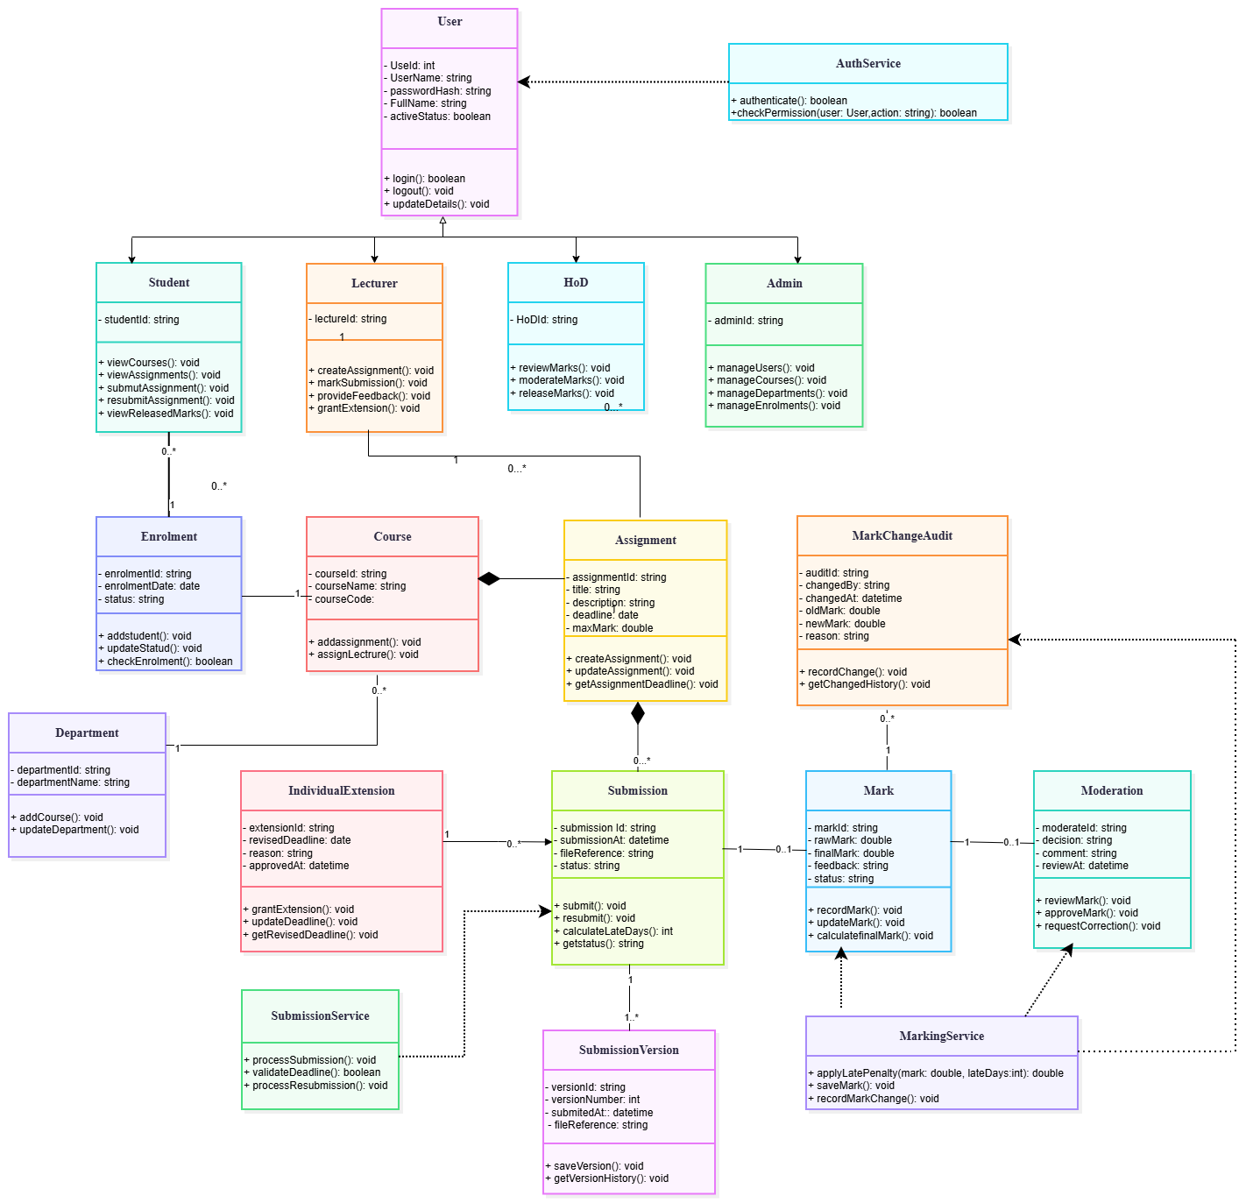

- State diagram
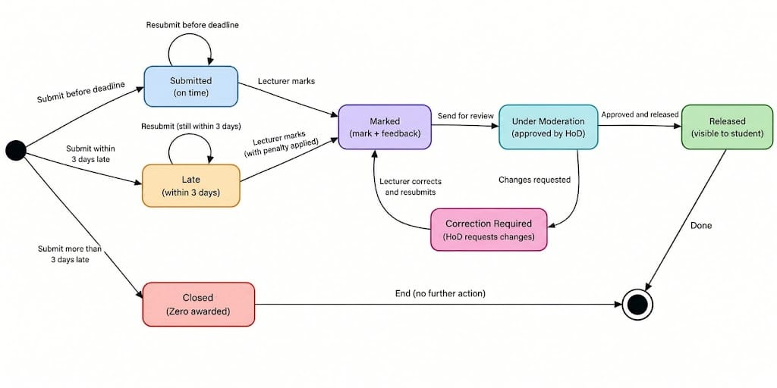

- Activity Diagram
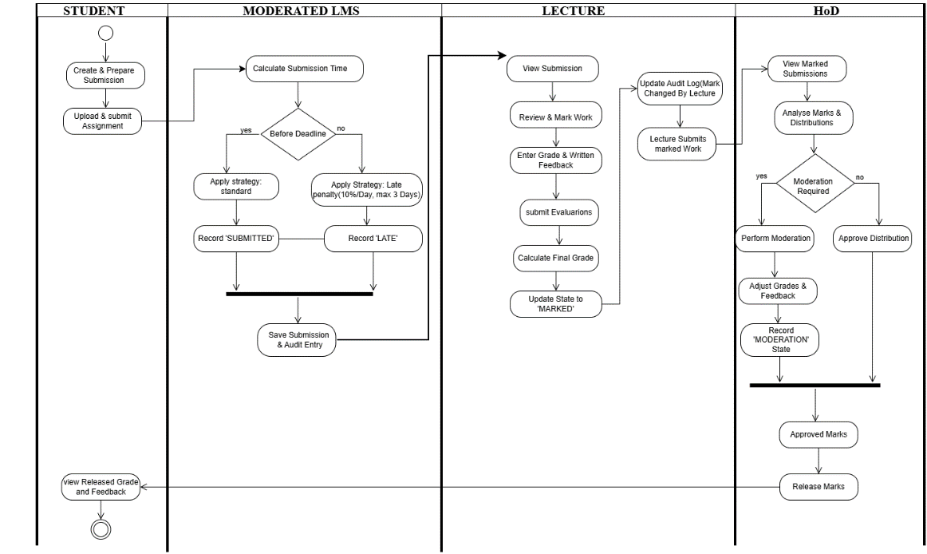

- Sequence Diagram- submit assignment
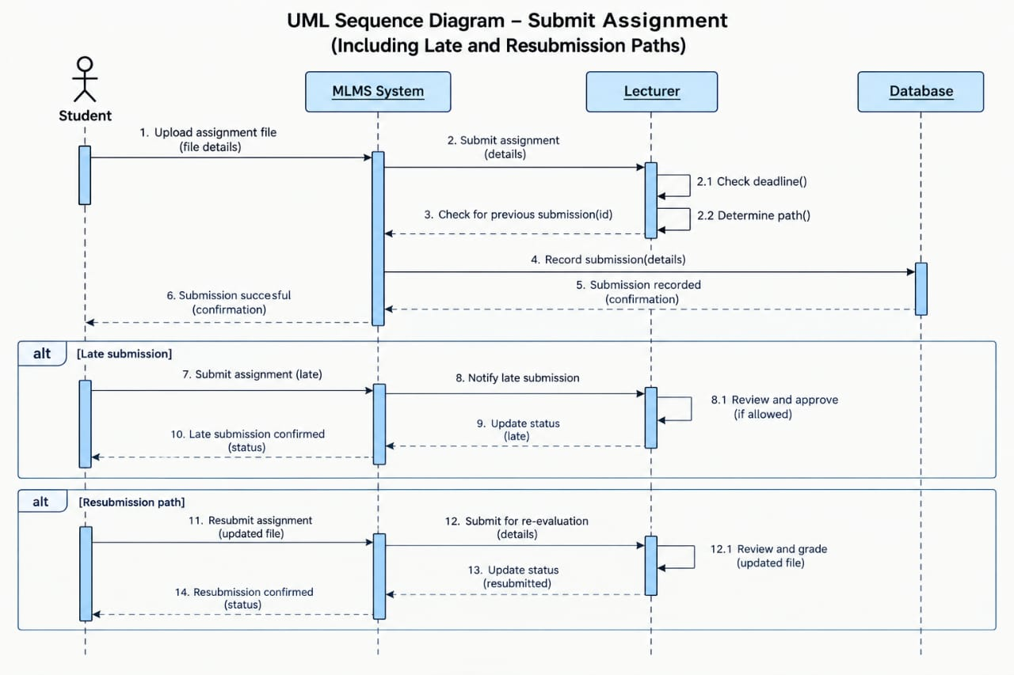

- Sequence Diagram- moderate and release marks

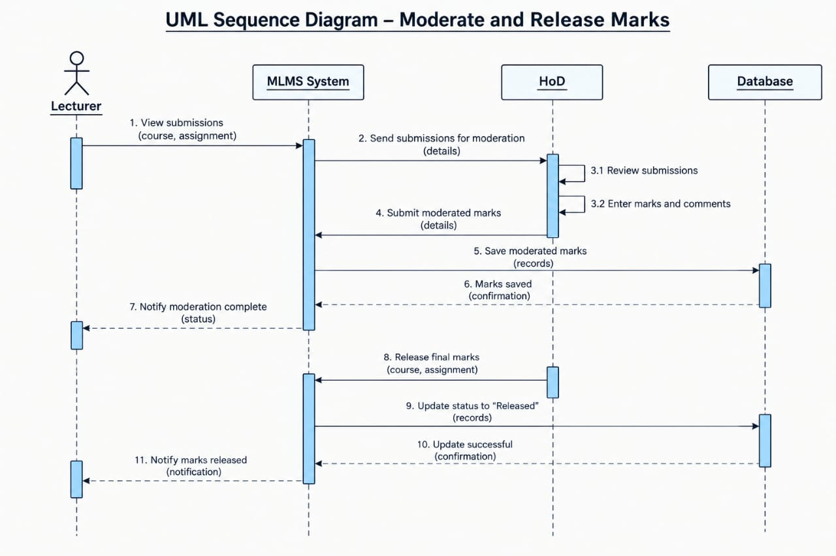

- ERD
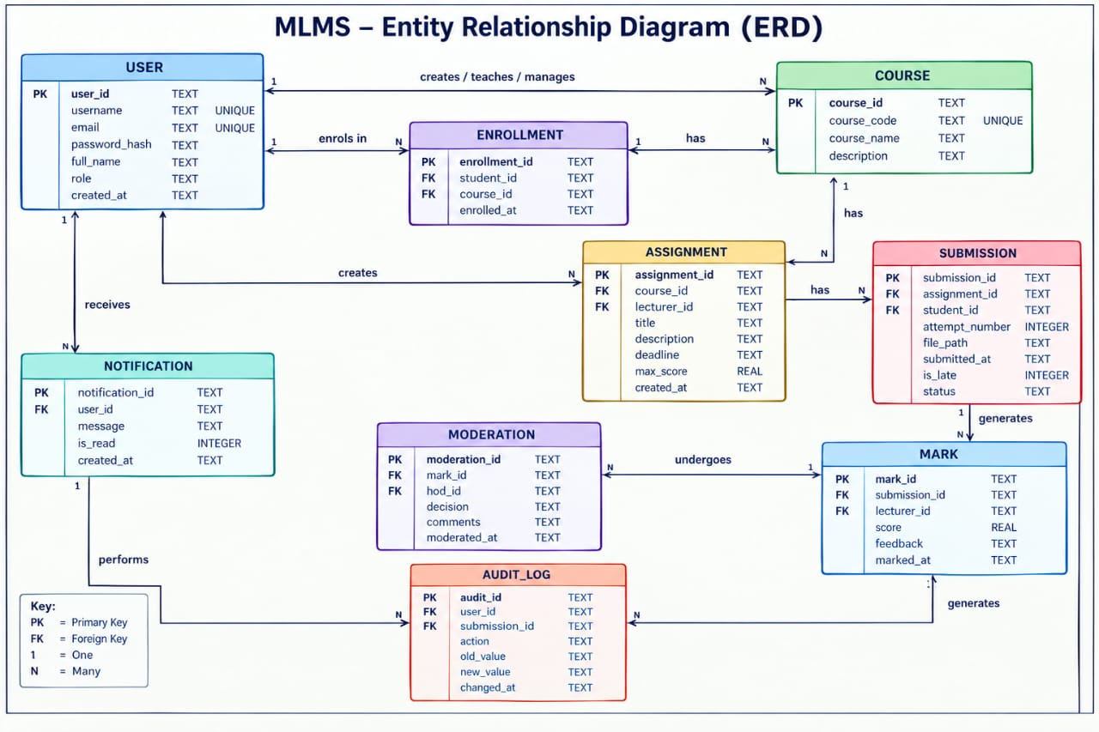

  - Data Dictionary
- Users Table
The Users table stores account details for students, lecturers, the Head of Department (HoD) and administrators.
Attribute | Data Type | Constraints | Description
user_id | INTEGER | Primary Key, AUTOINCREMENT | Unique user ID
username | TEXT | NOT NULL, UNIQUE | Username used to log in
email | TEXT | NOT NULL, UNIQUE | User's email address
password_hash | TEXT | NOT NULL | Hashed password
full_name | TEXT | NOT NULL | User's full name
role | TEXT | NOT NULL, CHECK | User role
created_at | TEXT | NOT NULL | Account creation date and time

2. Courses Table
Attribute | Data Type | Constraints | Description
course_id | INTEGER | Primary Key, AUTOINCREMENT | Unique course ID
Course_code | TEXT | NOT NULL, UNIQUE | Course code
Course_name | TEXT | NOT NULL | Name of course
description | TEXT | optional | Course description

3. Enrollments Table
The Enrollments table connects students to the courses they enroll in. Lecturers do not enroll as students.
Attribute | Data Type | Constraints | Description
enrolment_id | INTEGER | Primary Key, AUTOINCREMENT | Unique enrolment ID
student_id | TEXT | Foreign, NOT NULL | References Users.user_id
Course_id | TEXT | Foreign, NOT NULL | References Courses.course_id
enrolled_at | TEXT | NOT NULL | Date and time of enrolment

4. Assignments Table
Attribute | Data Type | Constraints | Description
assignment_id | INTEGER | Primary Key, AUTOINCREMENT | Unique enrolment ID
Course_id | TEXT | Foreign, NOT NULL | References Courses.course_id
lecturer_id | TEXT | Foreign, NOT NULL | References Users.user_id
title | TEXT | NOT NULL | Assignment title
description | TEXT | Optional | Assignment instructions
deadline | TEXT | NOT NULL | Assignment submission deadline
max_score | REAL | NOT NULL, CHECK | Maximum available marks
created_at | TEXT | NOT NULL | Date and time the assignment was created

5. Submissions Table
Attribute | Data Type | Constraints | Description
submission_id | TEXT | Primary Key, AUTOINCREMENT | Unique submission ID
assignment_id | TEXT | Foreign, NOT NULL | References Assignments.assignment_id
student_id | TEXT | NOT NULl, CHECK | References Users.user_id
attempt_number | INTEGER | NOT NULL | Submission attempt number
file_path | TEXT | NOT NULL | Location of the submitted file
submitted_at | TEXT | NOT NULL | Date and time of submission
is_late | INTEGER | NOT NULL, CHECK | 1 if late; 0 if on time
status | TEXT | NOT NULL, CHECK | Current submission status

Additional constraint: The combination of assignment_id, student_id and attempt_number must be unique. Each resubmission is stored as a new record to preserve previous attempts.
6. Marks Table
Attribute | Data Type | Constraints | Description
mark_id | TEXT | Primary Key, AUTOINCREMENT | Unique mark ID
submission_id | TEXT | Foreign, NOT NULL | References Submissions.submission_id
lecturer_id | TEXT | Foreign, NOT NULL | References Users.user_id
score | REAL | NOT NULL, CHECK | Mark awarded
feedback | TEXT | Optional | Written feedback
marked_at | TEXT | NOT NULL | Date and time the submission was marked

7. Moderations Table
Attribute | Data Type | Constraints | Description
moderation_id | TEXT | Primary Key, AUTOINCREMENT | Unique moderation ID
mark_id | TEXT | Foreign, NOT NULL | References Marks.mark_id
hod_id | TEXT | Foreign, NOT NULL | References Users.user_id
decision | TEXT | NOT NULL, CHECK | Moderation decision
comments | TEXT | Optional | HoD's comments
moderated_at | TEXT | NOT NULL | Date and time of moderation

8. Notifications Table
Attribute | Data Type | Constraints | Description
notification_id | TEXT | Primary Key, AUTOINCREMENT | Unique notification ID
user_id | TEXT | Foreign, NOT NULL | References Users.user_id
message | TEXT | NOT NULL | Notification message
is_read | INTEGER | NOT NULL, CHECK | 1 if read; 0 if unread
created_at | TEXT | NOT NULL | Date and time the notification was created

9. Audit_Log Table
Attribute | Data Type | Constraints | Description
audit_id | TEXT | Primary Key, AUTOINCREMENT | Unique audit ID
user_id | TEXT | Foreign, NOT NULL | References Users.user_id
submission_id | TEXT | Foreign Key, optional | References Submissions.submission_id
action | TEXT | NOT NULL | Action performed
old_value | TEXT | Optional | Previous value before a change
new_value | TEXT | Optional | New value after a change
changed_at | TEXT | NOT NULL | Date and time of the action

