老师,我是往届生我的本科论文找不到了,故选用选用知网上的一篇硕士论文代替.

[数据库加密系统研究 - 中国知网 (cnki.net)](https://kns.cnki.net/kcms/detail/detail.aspx?dbcode=CMFD&dbname=CMFD2012&filename=1012370944.nh&uniplatform=NZKPT&v=YQYLwr9PrF6VfjZDl8gIooMiM_XMACw7FnC70fLyYcBPOkChWqnkr3pxHWUC0Wt1)

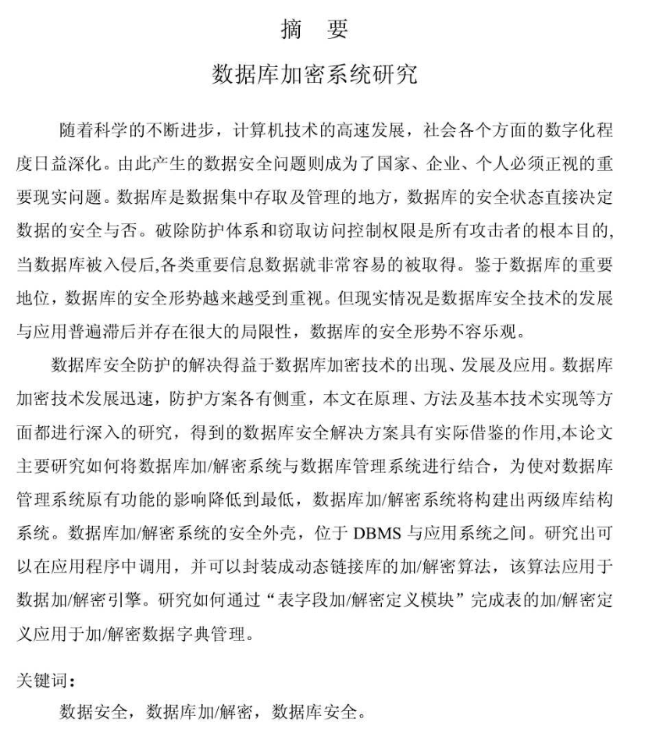

With the continuous progress of science and the rapid development of computer technology, the degree of digitalization is deepening in all aspects of society . The resulting data security problem has become an important real-world issues that countries, enterprises and individuals must deal with. The database is an organized collection of data accessed and managed, and the security status of the database directly determines the security of the data. The purposes of attackers are breaking the protection system and stealing access control .When the database is invaded, all kinds of important information and data can be easily obtained. Due to the important status of the database, the security situation of the database has been paid more attention. But the reality is that the development of database security technology generally lag behind and limitations exist. The security situation of the database is not optimistic.

The solution of database security protection benefits from the emergence, development and application of database encryption technology. The database encryption technology is developing rapidly, and the protection schemes have different emphases. This paper conducts in-depth research on the principles, methods and basic technology implementation, and the obtained database security solutions can be used for practice. This paper mainly studies how to combine encryption/decryption system with the database management system. In order to minimize the impact on the original functions of the database management system, the database encryption/decryption system will construct a two-level library structure system. The security shell of the database encryption/decryption system is located between the DBMS and the application system. An encryption/decryption algorithm that can be called in the application program and be encapsulated into a dynamic link library is developed, and the algorithm is applied to the data encryption/decryption engine. Study how to complete the definition of table encryption/decryption through "Table Field Encryption/Decryption Definition Module" and apply it to encryption/decryption data dictionary management.