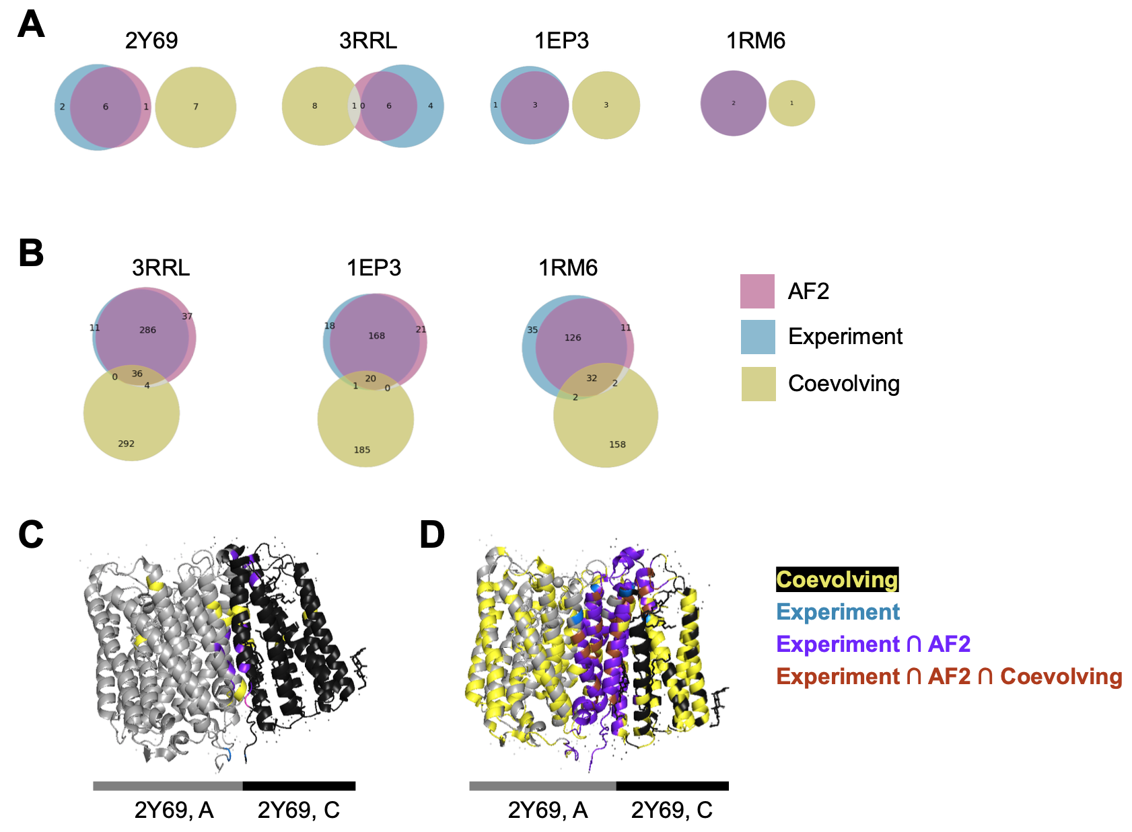

**Supplementary Figure 1.** Visual comparisons of residue pairs: Venn diagrams of residue pair sets within distance < 5Å (A) and < 10Å (B). Ribbon diagram of 2Y69 with subsets of residue pairs highlighted in different colors. AF2 = AlphaFold2

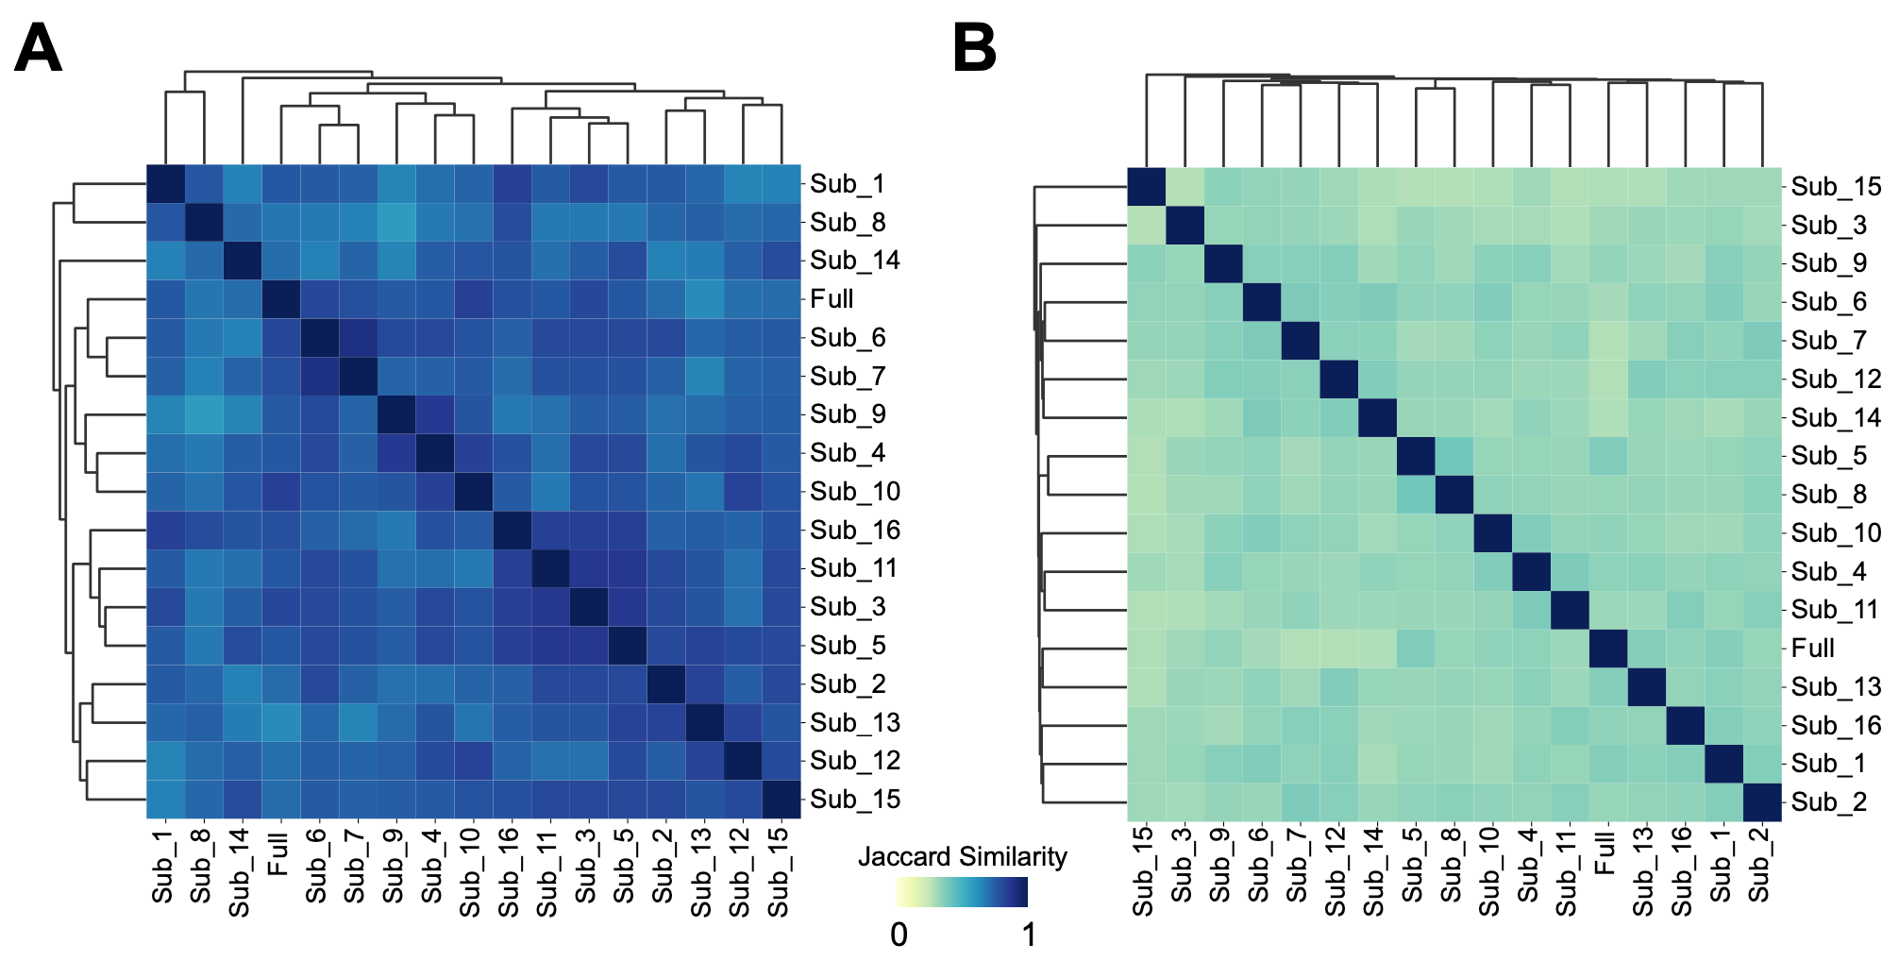

**Supplementary Figure 2.** Heatmap visualizations of Jaccard similarity scores of residue pair subsets: highly coevolving and contacting (A) and coevolving but non-contacting(B), across 16 MRF models with 50% subsampled MSAs and the full MSA of 1RM6. Sub = MRF model with a subsampled MSA; Full = full MSA.