PageRank Project Report
Name : Magahet Mendiola GID: mmendiola3

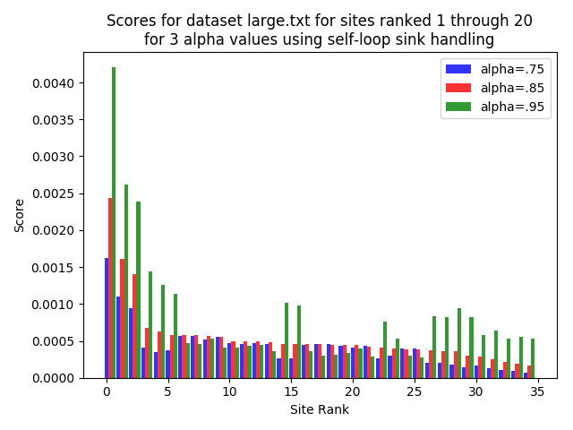
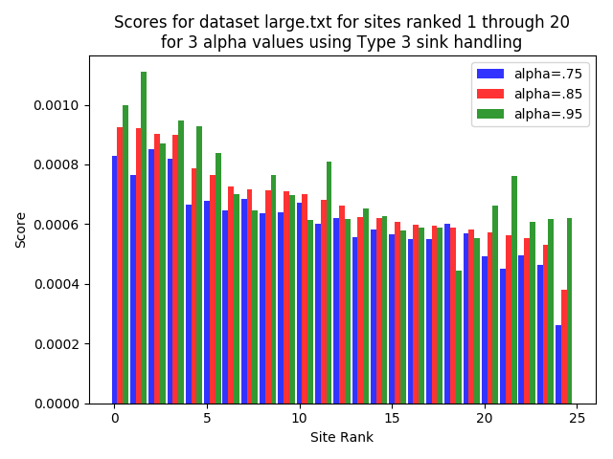
PageRank Project Report
Name : Magahet Mendiola GID: mmendiola3

Plots Discussion :

What are the results you see in the plots?
What do the values represent?
What does increasing alpha toward 1.0 mean?
Why do the results change with changing alpha?
Why does changing alpha affect the runtime?
How does the sink handling strategy impact the results and the runtime?

