 Translated from French to English - www.onlinedoctranslator.com
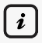
GENERAL INFORMATION = This document is a summary of the internal regulations. The internal regulations includeyour rights and obligationsto benefit from our services. The Prince de Liège center is aemergency accommodation and temporary care facility for homeless peopleThe services offered under this scheme arefree. The center's gate closes at9:30 PM. The contact number to reach the organization in case of need (delays, questions, etc.) is the02.329.05.94(home) or the0800.99.340.(Samusocial telephone triage service). Thepraise,In other words, nights spent outside the center during your stay are only permitted with the agreement of the PMS team and under certain conditions outlined in the general rules and regulations. Failure to comply with these conditions may result in the Samusocial deciding to terminate your accommodation.
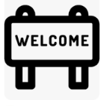
YOUR WELCOME = Upon joining the project, you will be asked to meet with asocial worker,to hand in yourMedications are available at the infirmary. The center and its facilities will be shown to you. We ask you torespect the center's rules (as outlined in the general ROI) in order to benefit from our services.
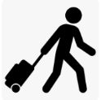
YOUR DEPARTURE= Except in exceptional circumstances, you will be informedone week in advance At the end of your stay here, you will be asked toreturn the equipment that was loaned to you by Samusocial to professionals andclean your room.THE The center can store some of your belongings for a maximum period of14 days following your departure.
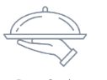
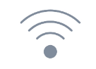
COLLECTIVE SERVICES = Several services are available to you.(Bed, meals, bathroom, television)…).It is necessary torespect the opening hoursof these servicesto gain access to it. OneWIFI connection is available (username: Samusocial Guest). The login code isS@mUfree2020. The center can provide you with aphoneand to acomputer, as part of your administrative procedures. Alocker is also available for you to secure some of your belongings. You will find all the services we offer in theoverall ROI from the center.

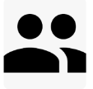
PMS SERVICES = Apsycho-medical-social team and at your disposal to assist you throughout your stay. It is expected that youcollaboratewith the latter. Therefusal to cooperateDisagreements with the social team can lead to the end of support.refusal of orientation Moving to accommodation better suited to your situation may lead to a decision to end your current accommodation. In case of risk ofcontaminationThe medical team may ask you to perform certain procedures or undergo specific treatments.Refusal of care when there is a risk of contamination.canlead to the termination of accommodation.

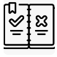
RULES FOR LIVING TOGETHER = Any form ofviolence is strictly prohibited and will be automatically sanctioned.Drug use and trafficking, theft, vandalism are prohibited. It is forbidden to consumealcoholLon site. Consumption ofcigarette is only permitted in the designated area. You are asked to respecthygienethroughout the entire building and its immediate surroundings. ItEating is only permitted in the dining hall and the loungeexceptfruits and dried foods,under the maintenance of hygiene. To avoid any risk of fire, the possession and use ofhigh-power equipmentandflammable material is strictly prohibited in the center. It is strictlyCooking in the room is prohibited.THEblunt objects (Knives, hammers, etc.) are prohibited in the center. For safety and hygiene reasons,The workers regularly make rounds of the roomsIf professionals find a dangerous object, it will be removed and returned to its owner under strict conditions regarding its removal from the facility.Pets are not allowedin the center. For hygiene reasons, the number ofluggageper beneficiary is limited to3 tubs per personOut of respect for everyone's privacy, you are asked to move around inappropriate attire in the center and its surroundings. For the sake of peace and quiet, you are askedto avoid noise disturbances from 9:00 PM onwards,and especially in your room.
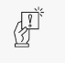
SANCTIONS = If you commit an offence against the rules set out in the general internal regulations,A sanction may be imposed on you.The list of penalties incurred for non-compliance with the ROI is included in the general ROI of the project.

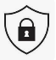
CONFIDENTIALITY = Workers, as well as students and volunteers, are required to respect theduty of confidentiality. This means that your information will only be disclosed to external partners with your consent. The PMS team is bound byprofessional secrecy. Of thecamerasare present in the centre and are filming the common areas.
THEvisits Outsiders are prohibited from entering the center and its surroundings. It is strictlyTaking a photo or video is prohibited. of another person in the center without the latter's prior consent.
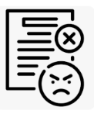
COMPLAINTS PROCEDURE = In the event of abuse committed against you by one of our professionals, volunteers, or students, Samusocial encourages you to file a complaint with thecoordination of your project. You can also send your complaint toVivalisvia their website:https://www.vivalis.brussels/fr/plainte

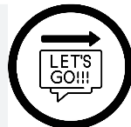
ACCESS TO ALL YOUR RIGHTS = overall ROI to be found atdisplay valves or via theQR code following :
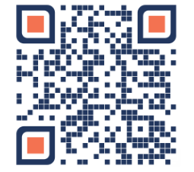

SERVICE HOURS
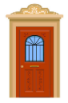
- Collective services:
- Access to the center:Closed between 9:30 PM and 6:00 AM
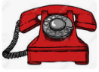
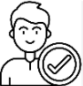
- Center phone number: 02.329.05.94 (reception) or the Samusocial dispatch center (0800.99.340)

- Room presence:Guests are expected to be in their rooms from 9:40 PM.
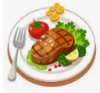
- Meal times:Breakfast: 7:30 am to 10:00 am - Lunch: 12:00 pm to 1:30 pm - Dinner: 6:00 pm to 7:30 pm
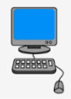
- Computer room:From 8:00am to 9:00pm, by reservation only.

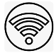
- Wifi:Username: Samusocial Guest - Password: S@mUfree2020

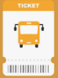
- Transport tickets:From 5pm the day before the appointment, upon presentation of proof of appointment


- Washing machine :Hours for dropping off personal belongings at reception: 07am-12pm (on the day corresponding to your floor only).

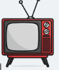
- Television: from 8:00 am to 12:00 am

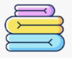
- BeddingBed linen and household linen are renewed every Saturday, while blankets are changed every two weeks.
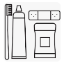
- Hygiene kit:It is possible to collect missing hygiene items every two weeks, on Saturdays and Sundays. Collection dates are posted on the notice boards in the main corridor at the building entrance.
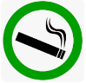
- Smoking room: You are asked to stop making noise in this area from 9:00 PM.
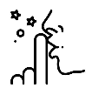
- Peace and quiet in the center:No noise disturbances are permitted between 9pm and 8am

- PMS Services:

- Educational service:The educators are available 7 days a week from 7:00 am to 6:00 pm (excluding afternoon meetings)

- Social services:24/7 on-call service outside of meetings

- Medical unit (2nd floor infirmary) - 24/7
  - 7:30-9:30medication distribution schedule
  - 11:30-12:30medication distribution schedule
  - 5:30 PM - 7:30 PMmedication distribution schedule
  - 9:30 PM - 10:30 PMmedication distribution schedule
  - 10:00-12:30wound care
Outside of these hours, the infirmary on the second floor remains available for any other requests.

- Vulnerable area (ground floor infirmary):9:00am-8:00pm – 7 days a week
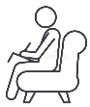
- Psychological services:
  - Morning: 9am-1pm
  - During the day and evening: 2:30 p.m. - 5 p.m.
Center Manager: Joan Medical Coordinator: Claude Social Coordinator: Laura

