Collège de Rosemont

Formation Continue

Groupe : 0283

**EVALUATION 1**

420-A34-RO Approfondissement des bases de données

Professeur : Florent Adima

29/05/2017

Nom : **Marchand Magali**

Numéro étudiant : 1699241

**PARTIE 1 : Fonctions – Procédures – Triggers**

**Énoncé 1 - 1**

CREATE OR REPLACE FUNCTION trouverEmploye (f_no_Emp IN NUMBER)

RETURN NUMBER IS

v_no_Emp NUMBER;

CURSOR c1 IS SELECT EMPLOYEE_ID FROM EMPLOYEES WHERE EMPLOYEE_ID = f_no_Emp;

BEGIN

OPEN c1;

FETCH c1 INTO v_no_Emp;

IF c1%NOTFOUND THEN

v_no_Emp := 0;

DBMS_OUTPUT.PUT_LINE('Il n y a pas d employe a ce nom');

END IF;

CLOSE c1;

RETURN v_no_Emp;

END;

**Énoncé 1 - 2**

create or replace procedure supprimerEmploye (f_no_Emp IN NUMBER) is

begin

DELETE FROM EMPLOYEES

WHERE EMPLOYEE_ID = f_no_Emp;

end;

**Énoncé 1 - 3**

create or replace procedure AJOUT_FONCT (p_id_job in VARCHAR2, p_title_job in VARCHAR2) is

begin

INSERT INTO JOBS(JOB_ID,JOB_TITLE)

values(p_id_job,p_title_job);

end;

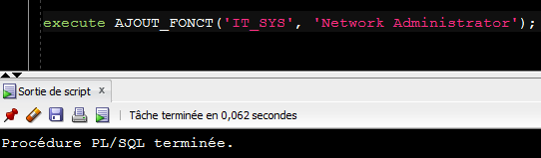



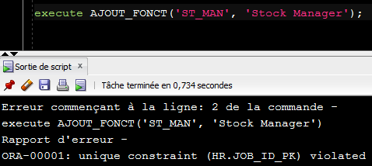

Erreur : On ne peut pas insérer ce poste car il existe déja et possède une contrainte de non duplication sur la colonne JOB_ID qui est la clé primaire de la table JOBS.

**Énoncé 1 - 4**

CREATE OR REPLACE TRIGGER unique_president

BEFORE INSERT ON EMPLOYEES

FOR EACH ROW

DECLARE

nb_pres NUMBER;

BEGIN

select count(JOB_ID) into nb_pres from EMPLOYEES where JOB_ID = 'AD_PRES';

if nb_pres = 1 then

Raise_application_error (-20222, 'Il existe deja un president dans la table des employes');

end if;

END;

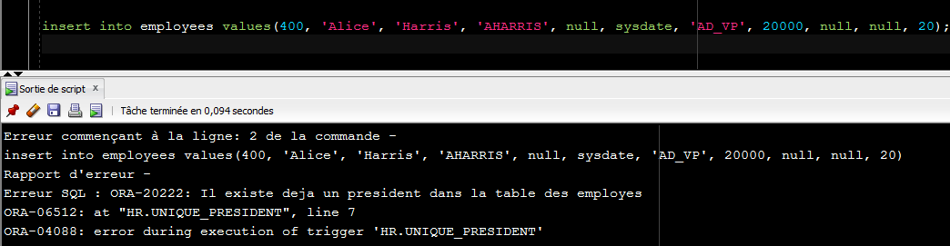

**Énoncé 2 - a**

CREATE OR REPLACE FUNCTION GET_JOB_COUNT (p_id_emp IN NUMBER)

RETURN NUMBER IS

v_nb1 NUMBER;

v_nb2 NUMBER;

v_nb3 NUMBER;

notfound_id EXCEPTION;

CURSOR c1 IS SELECT distinct JOB_ID FROM JOB_HISTORY WHERE EMPLOYEE_ID = p_id_emp;

CURSOR c2 IS SELECT JOB_ID FROM EMPLOYEES WHERE EMPLOYEE_ID = p_id_emp;

CURSOR c3 IS SELECT EMPLOYEE_ID FROM EMPLOYEES WHERE EMPLOYEE_ID = p_id_emp;

BEGIN

OPEN c1;

OPEN c2;

OPEN c3;

v_nb1 := 0;

v_nb2 := 0;

v_nb3 := 0;

WHILE c1%FOUND LOOP

v_nb1 := v_nb1 + 1;

END LOOP;

IF c1%NOTFOUND THEN

v_nb1 := 0;

END IF;

IF c2%FOUND THEN

v_nb2 := 1;

else IF c2%NOTFOUND THEN

v_nb2 := 0;

END IF;

IF c3%NOTFOUND THEN

RAISE notfound_id;

END IF;

v_nb3 := v_nb1 + v_nb2;

EXCEPTION

WHEN notfound_id THEN

raise_application_error (-20001,'Cet id employe ne se trouve pas dans la base de donnees.');

CLOSE c1;

CLOSE c2;

CLOSE c3;

RETURN v_nb3;

END;

**PARTIE 2 : Affichage d’informations et curseurs**

**Énoncé 1**

CREATE OR REPLACE PROCEDURE listeEmployes

IS

v_prenom VARCHAR2(20 BYTE);

v_nom VARCHAR2(25 BYTE);

v_salaire NUMBER(8,2);

CURSOR c1 IS SELECT FIRST_NAME, LAST_NAME, SALARY FROM EMPLOYEES

WHERE JOB_ID = 'IT_PROG';

BEGIN

OPEN c1;

WHILE c1%FOUND LOOP

FETCH c1 INTO v_prenom, v_nom, v_salaire;

DBMS_OUTPUT.PU_LINE('Employe: ' || v_prenom || 'Nom: ' || v_nom || 'Salaire: ' || v_salaire);

END LOOP;

CLOSE c1;

END;