ERRATA in HVACSIM⁺ Program Documents

Errata are for the originally printed documents.

(a) NBSIR 84-2996 HVACSIM⁺ Building Systems and Equipment
Simulation Program - Reference Manual

Page 6 "and mode 3 is required for satisfactory accuracy" should be "and mode 2 is
required for satisfactory accuracy".

Page 41 "[0.001/(kg m)]" should be "[1000 / (kg m)]".

Page 44 "[0.001/(kg-m)]" should be "[1000 / (kg-m)]".

Page 53 Add "3 C - valve stem relative position" to the output description.

Page 71 Add "6 C - valve stem relative position" to the output description.

Page 99 "[ kJ/(kg K]" should be "[W/m K]" in the parameter description.

Page 100 Add " 1 multiplier" in the parameter description.

(b) NBSIR 85-3243 HVACSIM⁺ Building Systems and Equipment
Simulation Program - Users Guide

Page 67 Delete two lines from the bottom.

Page 101 "3 1 9 28 1 5 2 4" should be "3 1 9 3 1 5 2 4".

Page 186 Add a line "1 multiplier (-)" for a parameter.

(c) NBSIR 86-3331 HVACSIM⁺ Building Systems and Equipment
Simulation Program - Building Loads Calculation

Page 23 "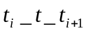 " should be "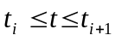".

Page 24 "cantiler" should be "cantilever".

Page 34 "where 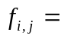 " should be "where 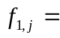 ".

Page 48 The equation (6.4) should be

 = 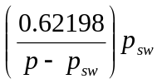 (-)

Page 61 The equation (7.18) should have bars to indicate absolute values.

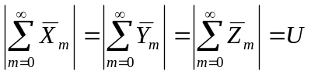
Page 63 The equation (7.26) has two equal signs. The last one should be a plus sign.

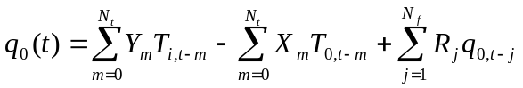

(d) NISTIR 7514 HVACSIM⁺ User’s Guide Update

Page 15 “254 megabytes of memory” should be read as “256 megabytes of memory”.

