**Employees**

Username – **user1**

Password – **P@ssword1**

User 2 – **user2**

Password – **P@ssword2**

**Admin**

Username – **admin**

Password - **Admin123!**

1. Login Screen

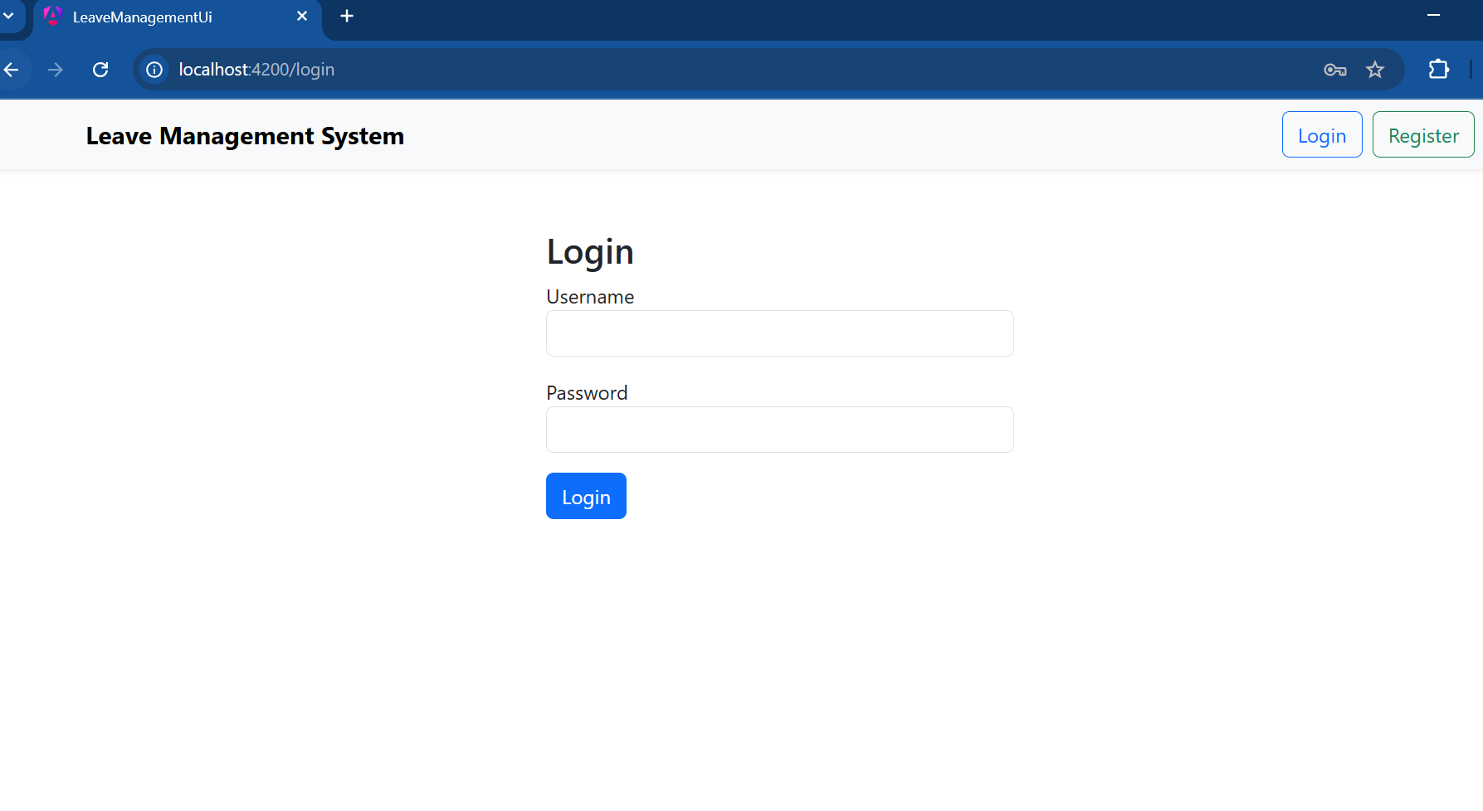

2. Register Screen

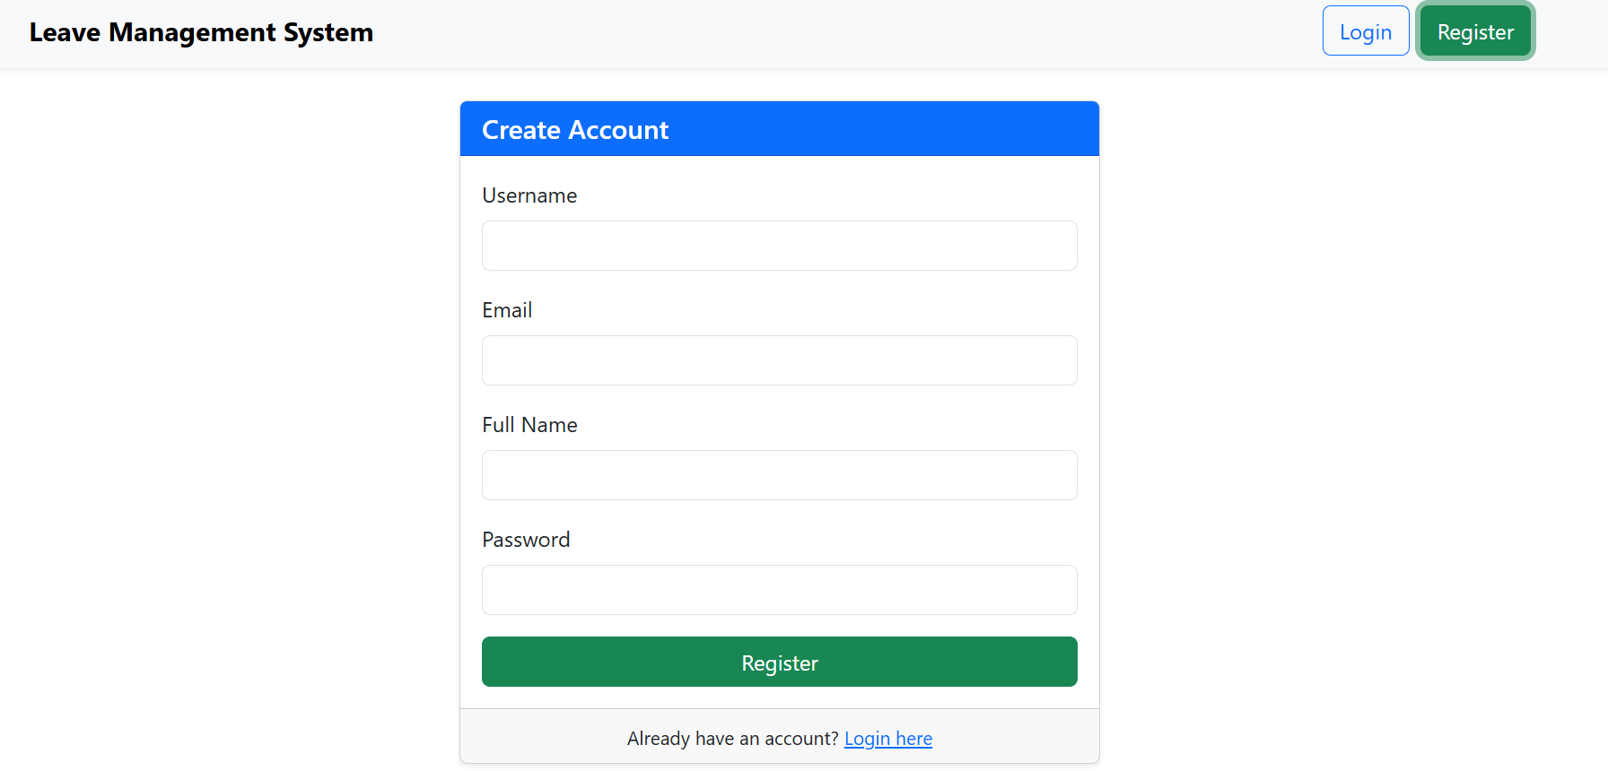

3. Employee Leave Request

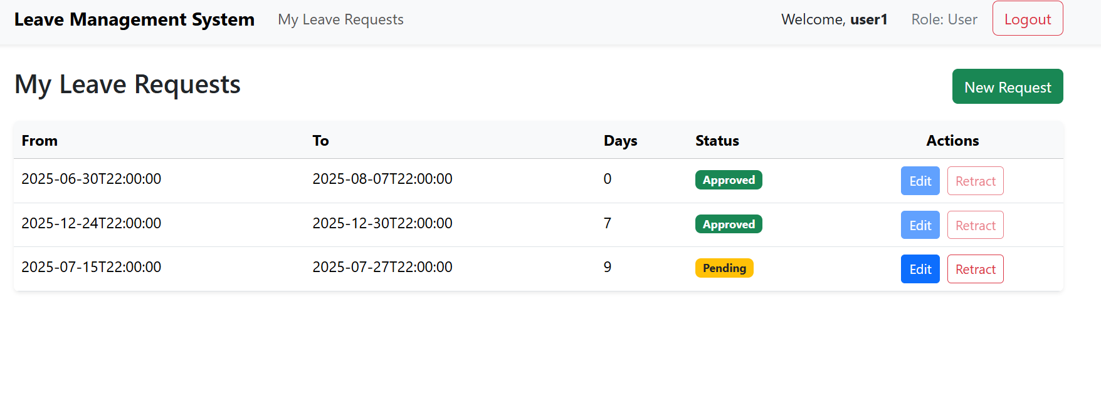

4. Submit Leave Request

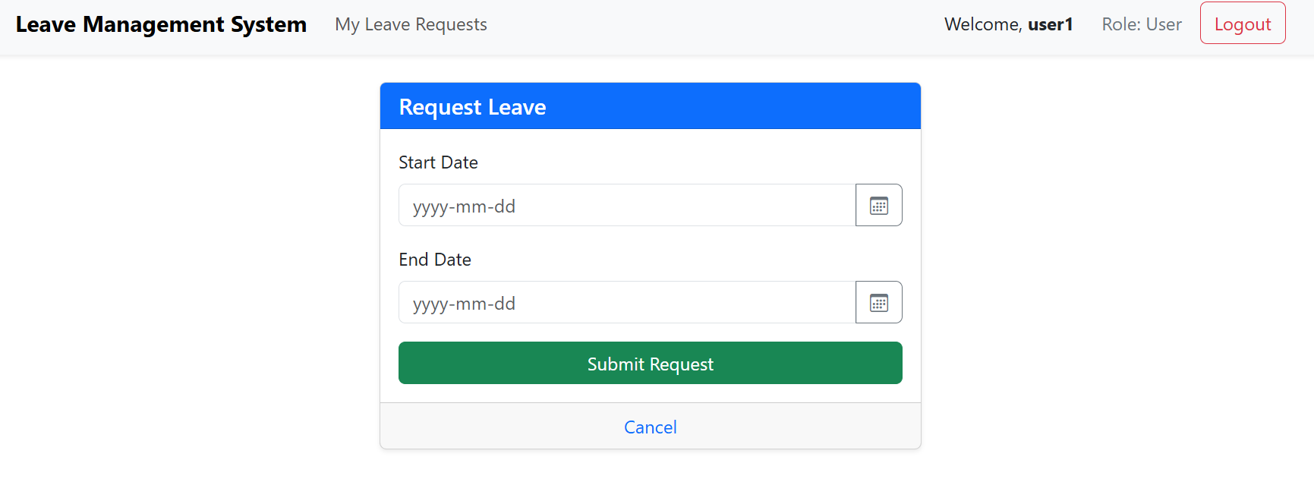

5. Team Leave Request Approval

