# Introduction

In this stage, we talk about the models and diagram that are produced during the task. This stage helps in advance improvement forms by giving diagram of the framework engineering and framework approaches. Since, we are following the waterfall model utilizing object oriented methodology, we will build up the UML (Unified Modeling Language) diagram like: activity, sequence, class and Entity Relationship (ER).

UML diagram are the method for envisioning a product program utilizing a gathering of outlines. The UML outlines are gathering of different diagram, the diagram recorded above are a portion of these.

# Types of design

There are lots of types of design which are given below:

# Structural design

Structured model is a way to deal with demonstrating and to the plan of computer based displaying system. This model is centered on depicting the outline through instantiation of various hardware components. It is worried to relating the items in the framework and how they connect with each other.

# Class diagram

It is also known as a static graph. It addresses the static point of view of an application. Class outline isn't used for envisioning, delineating and archive particular parts of a framework yet what's more to develop executable code of the item application.

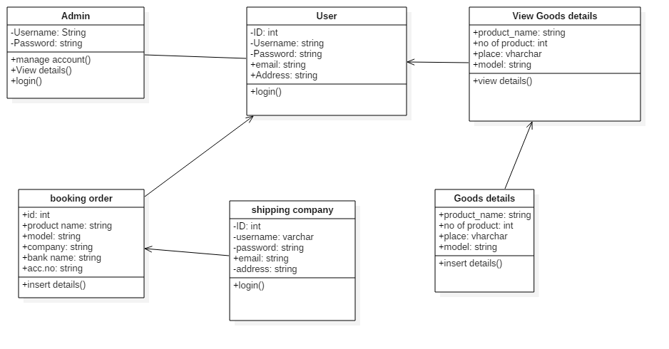

Figure 16: Class diagram for cargo management system

**Description**

The class diagram demonstrates that the client is related with each different classes as every one of the job are taken care of by the client. A client registers, login to system, refreshes profile and resets the password through client dealing with. The administrator includes new client and expels existing client by means of client taking care of. The client includes and refreshes client by means of client dealing with. The client includes, updates all the details of their product.

# Behavioral diagram

This model depicts the check shape of a system. It is also called as a dynamic model. It demonstrates the inner unique parts of a system helping the business procedure in an association. This model uniquely portrays the functionalities of the framework.

In this project, we are going to discuss two types of diagrams which are given below:

# Activity diagram

### Activity diagram demonstrate the dynamic idea of a framework by displaying the stream of control one action to another. An action speaks to an activity done on a class in a framework bringing about change in condition of the framework. It is for the most part used to display work process or business forms and inward task simply like stream diagrams. The documentations utilized as a part of this outline are describe beneath:

### **Initial Node**

It is the starting point of an activity diagram.

### **Control Flow**

It is the navigator on flow of an activity diagram.

### **Decision**

It is the node where decisions are handled.

### **Final Node**

It is the node of end for an activity diagram.

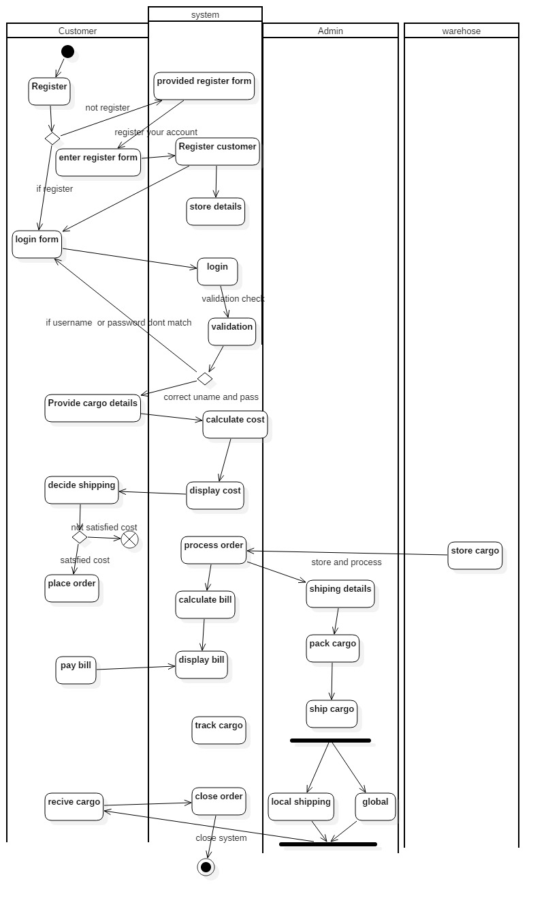

Figure 17: activity diagram

# 

# Sequence diagram

Sequence diagrams manage portraying collaborations among classes regarding of exchange if messages after some time. it executes the framework in more elevated amount helping developer to see the parts and their co-operations with each other in a framework. It speaks to the scope, life saver and objects of a framework. On review this picture, designers get information of the methods, classes and object rotating around the framework.

The sequence diagram for this assignment is demonstrated as follows:

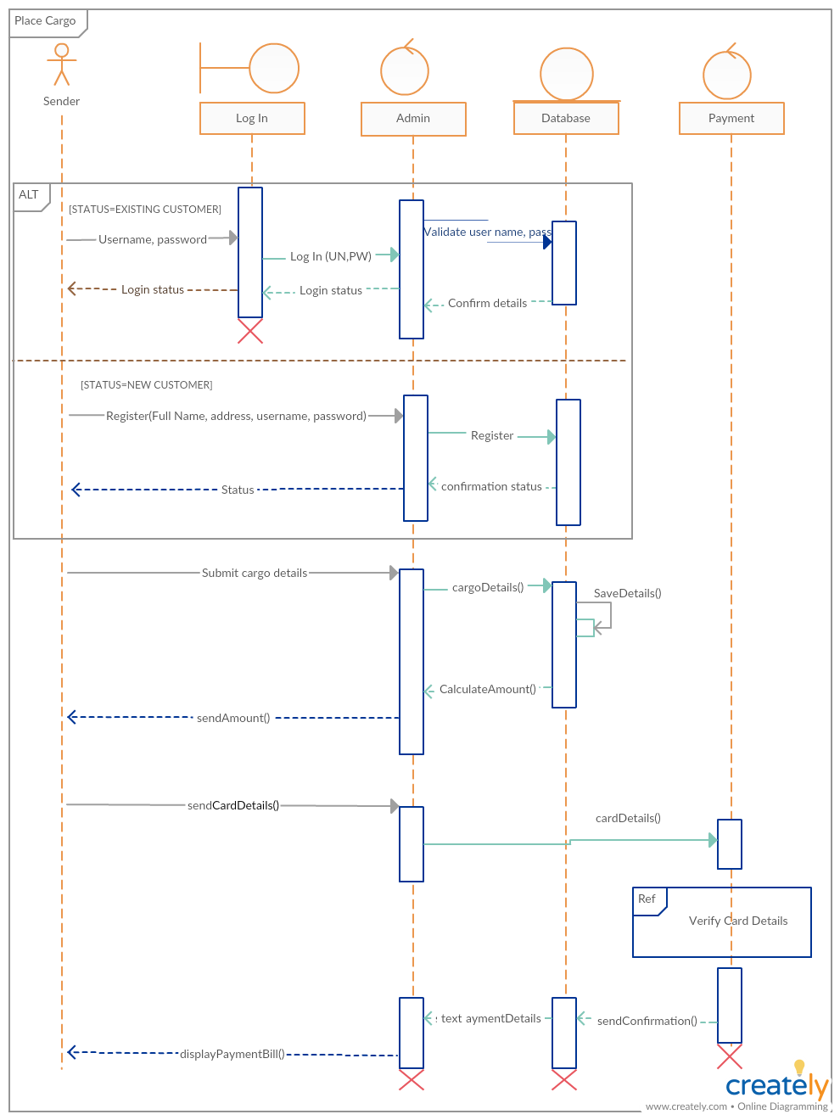

Figure 18: sequence diagram of cargo management system

# Database design

Database design is define as the association of information as indicated by a database demonstrate. The designer decides out what information must be put away and how the information components interrelate. With this data, she/he can start to fit the information to the database model

# Data dictionary

Data dictionary is define as a data on date. It consist data type, column name, keys, length etc. All the required data table is given below:

1. Table for registration

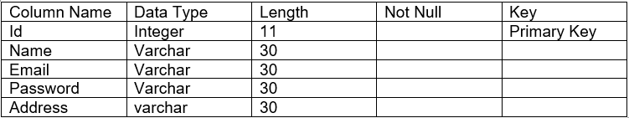

1. Table for admin

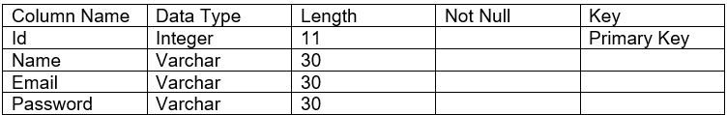

1. Table for user

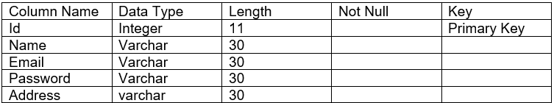

1. Sender details

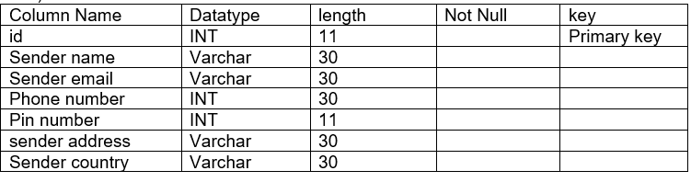

1. Receiver details

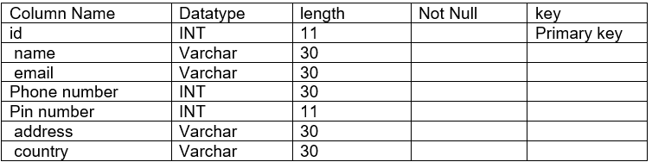

1. Cargo details

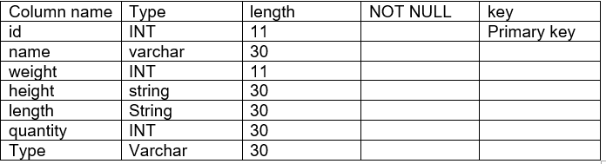

1. Payment type

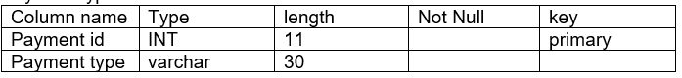

# ER Diagram

This diagram is identified with the database of a system. It demonstrates consistent connection between at least two entities. Entities are the tables of a database having properties as segments. Entities are identified with each other with various cardinalities like:

1. One to one relationship
2. One to many relationship and
3. Many to many relationship

### Entity

Entity is defined as something which has its own existence. It is a real thing and has own characteristics and identity which makes it different from others. It can be anything varying from an object to person.

### Attribute

Attributes define each entity. It shows the relationship between the entities as well as the properties also.

### Relationship

Relationship in the ER diagram can be known as the linking of the entities together. It shows the entities how they are associated with each other and they act upon each other.

## Types of Relationships

The three different types of relationships are listed and explained below:

### One-to-One Relationship

This is that type of relationship in which an attribute in a table or a row has only one matching or associated attribute in another table.

### One-to-Many Relationship

In this type of relationship, a parent record is used in multiple times in another table. In this relationship the parent record should not obtain child record. This relationship can be viewed as One-to-Many or Many-to-One depending upon the way we look at it.

### Many-to-Many relationship

In this relationship a column in the table can have numerous coordinating lines in another table. Likewise, it can be thought as two one-to-numerous relationship connected by a mediator table.

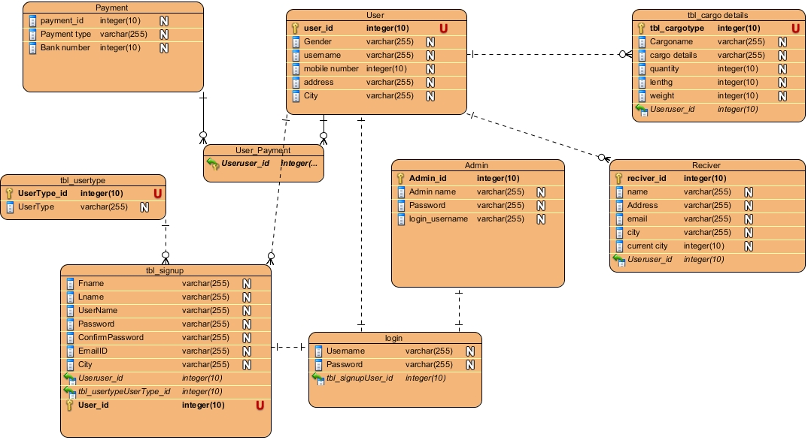

Figure 19: ER diagram of cargo management system

# UI design

The UI design for cargo management system are given below:

1. Registration page

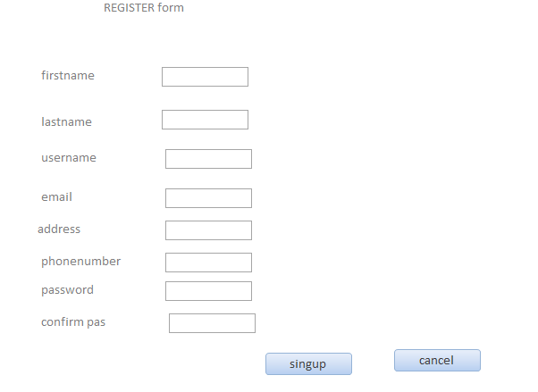

Figure 20: Registration form

In this form user can easily register their account. After register their account they can easily login inside the system.

1. Login form

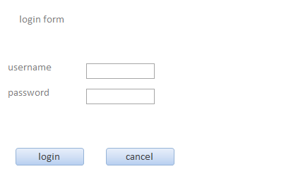

Figure 21:login form

After register user account, user can easily login inside the system.

1. Sender details

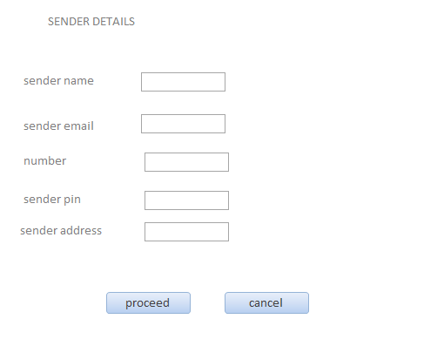

Figure 22: sender details

In this form sender needs to fill up all the details about him like name, address, phone number, current city etc.

1. Receiver details

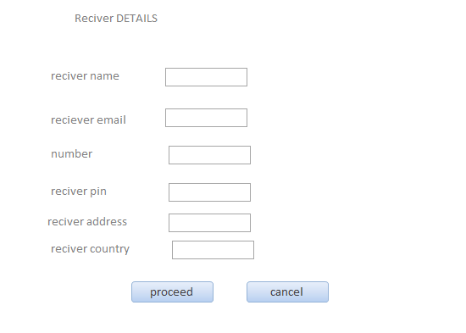

Figure 23: receiver details form

In this field user also fill up all the details about receiver like his pin number, address, email, number etc.

1. Cargo details form

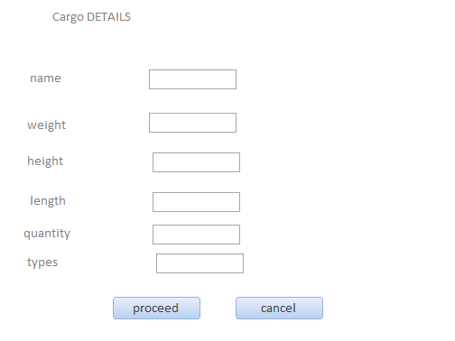

Figure 24: cargo details

In this field user need to fill up details about his good like, names, height, weight type’s quantity etc.

1. Payment types form

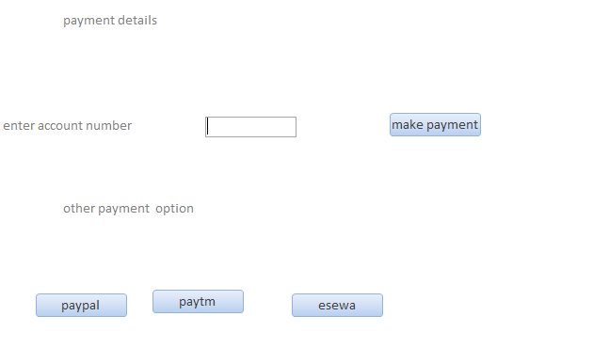

Figure 25: payment type

In this field user can easily choose the payment types.