**Project Proposal**

**On**

**Cargo Management System**

**Computing Project**

**Softwarica College of IT & E-Commerce**

**April 9, 2019**

**Submitted to: Submitted By:**

**Niman Maharjan Bibek Rana Magar**

**Computing Project 00175023**

**Module Teacher Batch 22 D**

Table of Contents

Overview 4

1. Introduction 4

2. Justification 4

3. Description of the Project 4

4. Scope 4

i. Aims 5

ii. Objectives 5

5. Development Method 5

6. Project Planning 7

a. Work Breakdown System (WBS) 7

b. Time Estimation 8

c. Milestone Time 8

Proposal: 9

Analysis 9

Design 9

Implementation 9

Testing 9

Documentation 9

d. Schedule 10

7. Other Project Activities 12

a. Risk Management 12

b. Configuration Management 14

8. Conclusion 14

Figure 1:Waterfall Model 5

Figure 2: WBS Breakdown 6

Figure 3: Scheduling 8

Figure 4: Gantt Chart 9

Figure 5: Configuration Management 11

# Overview

## Introduction

Along with the growing technology the demand of online tracing is high thus I have developed cargo management system which will be beneficial to clients and users for sending, receiving and tracing the goods imported/exported internationally. Cargo is growing in popularity as the medium of choice when it comes to shipping time sensitive goods, belongings, documents and information from one place to another. Cargo refers to the act of using an air carrier as the transport vessel for shipment purposes. The benefits of cargo are the speed and convenience of using such a service. cargo can get your shipment to its overseas destination within a day in many instances and it has become an integral and important part of the global logistics network chain.Top of Form

Bottom of Form

## Justification

I have proposed this project because, with this software even a small cargo or local cargo company can use online software with minimum cost. Currently people are using cargo services to transport materials from one place to another with in a country or outside the country. With the help of this software the client can track their cargo to know where it has reached. It is possible due to a tracking number which is generated automatically for each cargo.

## Description of the Project

The development of this new system contains the following activities, which try to automate the entire process keeping in the view of database integration approach. This system maintains user’s personal, address, and contact details. User friendliness is provided in the application with various controls provided by system rich user interface. This system makes the overall project management much easier and flexible. Various classes have been used for maintain the details of all the users and catalog. Authentication is provided for this application only registered users can access. The user’s information files can be stored in Centralized database which can be maintained by the system. This system is providing more memory for the users to maintain data.

## Scope

The scope of this system is to provide user comfortable environment of transporting products and services over the internet without the need of going physically to the destination. Cargo is one of the most use services in the current era it is reliable as well as safe to transport product from one place to another. Online cargo system helps clients to choose their pick up location and destination with the help of internet. This project provides the facility to all user to send and receives the countries. They can get the information of the cargo. System development is also considered as a process backed by IT approach. Cargo agency is considered as an expansion of business relations. It contributes a lot by providing quick and fast services. This project is for domestic as well as international.

### Aims

1. Digitalize the old postal system to digital courier system.
2. Tracking the products or goods which has been dispatched to their destination.

### Objectives

The objective of developing this project are:

1. The main objectives of this project is that it facilitate user to communicates in a faster manner in comparison of manual system. Through this system, the status of the cargo can be known easily where as in manual system it is difficult.
2. To propose all in one system that include both tracking and cargo system.
3. To develop a software solution for cargo services system that provide best service, error free.
4. To study their current information system and identify how process handle by an information technology solution.

## Development Method

A software development methodology or system development methodology in software engineering is a framework that is used to structure, plan, and control the process of developing an information system.

For this project I will be using waterfall model because it is one of the easiest developing method. There are six steps in the waterfall model they are listed below:

* Requirement Analysis
* System Design
* Implementation
* Testing
* Deployment
* Maintenance

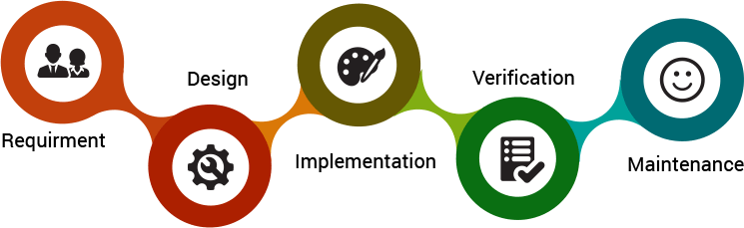

Figure 1:Waterfall Model

Reasons for using waterfall model:

1. Upfront documentation and planning stages allow for large or shifting teams to remain informed and move towards a common goal.
2. Forces structured, disciplined organization.
3. Is simple to understand, follow and arrange tasks.
4. Facilitates departmentalization and managerial control based on schedule or deadlines.
5. Reinforces good coding habits to define before design and then code.
6. Allows for early design or specification changes to be made easily.
7. Clearly defines milestones and deadlines.

I am not selecting different development methodology as a result of I will be able to not have long amount of your time for the event of the project. it's a little project that needs to be developed in an exceedingly short amount of a time. If I select, another development methodology instead of falls model than I’ll return to the step that is already completed and will bog down in this. this can have an effect on within the programming and that I won't be ready to end the project on time. So, because of this reason I’ve got not chosen different developing methodology.

## Project Planning

### Work Breakdown System (WBS)

A [work breakdown structure](https://www.matchware.com/wbs-software) (WBS) is a key project deliverable that organizes the team's work into manageable sections. The Project Management Body of Knowledge ([PMBOK](https://www.workbreakdownstructure.com/work-breakdown-structure-according-to-pmbok.php)) defines the work breakdown structure as a "deliverable oriented hierarchical decomposition of the work to be executed by the project team." The work breakdown structure visually defines the scope into manageable chunks that a project team can understand, as each level of the work breakdown structure provides further definition and detail.

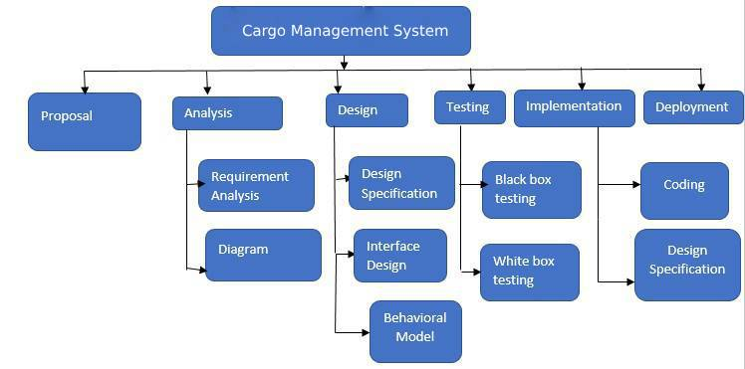

Figure 2: WBS Breakdown

### Time Estimation

Time may be a key note for the completion of this project. Everything ought to be done at intervals the time. Otherwise, the project is tousled and that I not be ready to end the project within the given time. So, I allotted the subsequent time estimation for the project.

|  |  |  |
| --- | --- | --- |
| **WBS** | **Task name** | **Days** |
| **1** | **Proposal** | **16 days** |
| 1.1 | Planning | 6 days |
| **2** | **Analysis** | **15 days** |
| 2.1 | Requirement Analysis | 10 days |
| 2.2 | Diagram | 5 days |
| **3** | **Design** | **30 days** |
| 3.1 | DesignSpecification | 10 days |
| 3.2 | Interface Design | 15 days |
| 3.3 | Behavioral Design | 5 days |
| **4** | **Implementation** | **29 days** |
| 4.1 | Coding | 24 days |
| 4.2 | Design Specification | 5 days |
| **5** | **Testing** | **15 days** |
| 5.1 | Blackbox testing | 5 days |
| 5.2 | White box testing | 10 days |
| **6** | **Documentation** | **20 days** |
|  | **Total** | **125 days** |
|  |  |  |

### Milestone Time

I have thought a number of the dates within which I’ll be doing the various elements of the project. this can be referred to as milestones. I’ll be finishing the milestones so as to complete the project in time. the subsequent table is that the indication of the milestones I’ll be achieving so as to finishing the project in time.

|  |  |  |
| --- | --- | --- |
| **S.N** | **Milestone** | **Date** |
| 1 | Proposal | 9 April, 2019 |
| 2 | Analysis | 24 April, 2019 |
| 3 | Design | 24 May, 2019 |
| 4 | Implementation | 22 June, 2019 |
| 5 | Testing | 7 July,2019 |
| 6 | Documentation | 2 August, 2019 |
|  |  |  |

## Proposal:

I allocate total 16 days for this task i.e. 5 days for Planning, 4 days for Monitoring.

## Analysis

I allocate total 15 days for this task i.e. where 10 days for requirement analysis and 5 days for diagram.

## Design

I allocate total 30 days for this task i.e. 25 days for coadding, 5 days for Interface design and 10 days for designspecification

## Implementation

I allocate total 29 days for this task i.e. 8 days for database build and 15 days for coding.

## Testing

I allocate total 15days for this task i.e.5 days for black box testing and 10 days for white box testing.

## Documentation

I allocate total 20 days for this task i.e. 12 days for user manual and 8 days for Final Report.

### Schedule

The steps are done step by step. Here, I’ll be selecting the water model thus, I’ll not be able to come back to the finished project however I’ll be solely moving ahead. So, I’ve got calculable days for the completion of the project. Below is table showing the schedule for the completion of the project.

|  |  |  |
| --- | --- | --- |
| **S. N** | **Parts** | **Days** |
| 1 | Proposal | 16 days |
| 2 | Analysis | 15 days |
| 3 | Design | 30 days |
| 4 | Implementation | 29 days |
| 5 | Testing | 15 days |
| 6 | Documentation | 20 days |

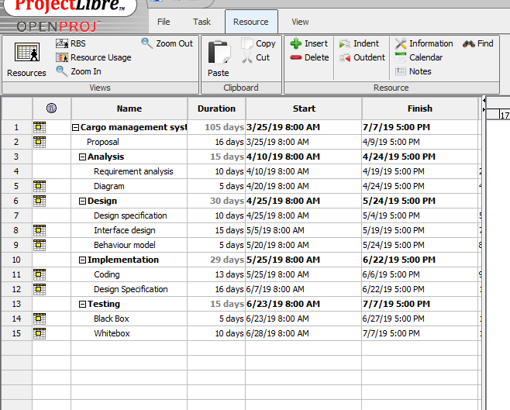

Figure 3: Scheduling

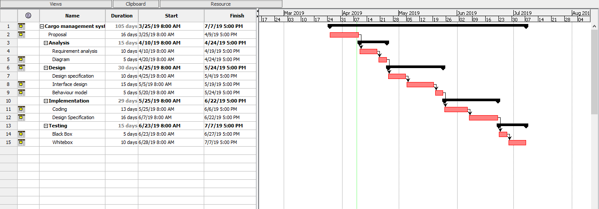

Figure 4: Gantt Chart

## Other Project Activities

### Risk Management

No application is ideal in anyways. they need their own flaws. So, my system is additionally not excellent in it however it’s reliable. however, there are a number of the risks which will be vulnerable within the future if not taken seriously. So, these risks must be prepared within the initial part for the higher output in future.

The relation formula [*Impact = Likelihood * Consequence*] is used to calculate and evaluate risk factors.

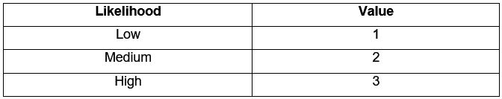

Figure 5:risk likelihood and value

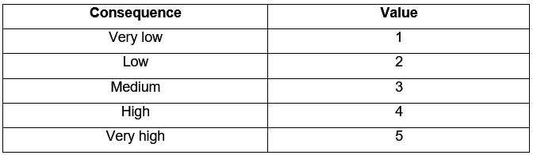

Figure 6:Consequence

I have listed some of the risks that are vulnerable from project with their impact and action:

|  |  |  |  |  |
| --- | --- | --- | --- | --- |
| Risks | Likelihood | Consequence | Impact | Action |
| Hardware failure | 3 | 4 | 12 | Data loss |
| System failure | 2 | 5 | 10 | work cannot be done |
| Too many bugs | 2 | 2 | 4 | May impact on the scheduling |
| Team changes | 2 | 2 | 4 | developers might get sick, go on vacation |

### Configuration Management

configuration Management is the method that helps to review the complete system. It ensures that any changes created in one system doesn't adversely have an effect on any of alternative systems. the appliance tracks and controls the changes in it.

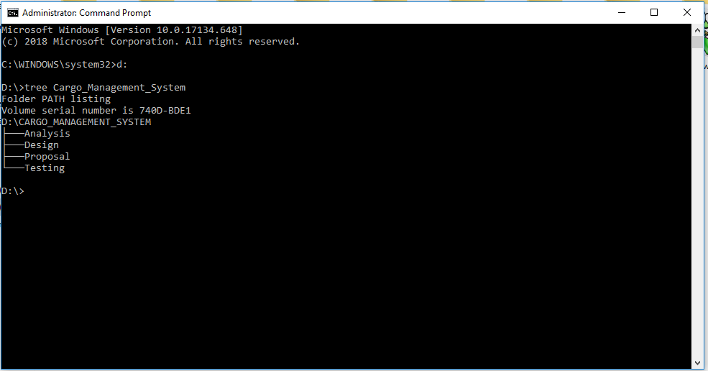

Figure 7: Configuration Management

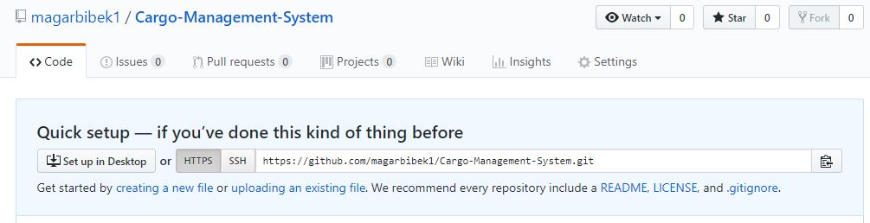

<https://github.com/magarbibek1/Cargo-Management-System>

# Conclusion

The proposed of this project on Cargo Management System is a solution to current problems regarding transaction and data recording in cargo companies. The implementation of this project reduces the over expenditure of such companies and makes economical balance.