# Testing

## Introduction

Testing is one of the import phase of making website, application or other system. Without testing we can’t say our system is user friendly or not, we cannot say how system work , how system run etc. so, if you say my system is very good without doing testing part you are absolutely wrong.

Testing is the process of finding out how well capacities of something like website application etc. With respect to, testing find out what the level of data or capacity has been picked up. In PC hardware and programming change, testing is used at enter checkpoints in the general strategy to choose if targets are being met. For example, in programming headway, thing objectives are now and again attempted symptom customer delegates. Right when the arrangement is done at the part level by the social affair of programming engineers included, and at the system level when all portions are combined. At in front of calendar or late stages, a thing or organization may in like manner be striven for usability.

## Types of testing

There are different types of testing which are listed below:

1. Unit Testing
2. System Testing
3. Acceptance testing
4. Integration Testing
5. Functional Testing
6. Performance Testing
7. Usability Testing
8. Stress Testing
9. Regression Testing
10. Beta Testing

Among them i have chosen unit testing and integration testing for my cargo management system project.

**Unit testing:**

Unit testing is one of the testing that is performed for this errand. In this, the product developer test an individual unit or social occasion of related units in every movement of the headway arrange. This testing falls under the Whitebox testing. It is done line by line in a program checking if a unit of program does what it ought to do. For this, I have attempted every unit of code while the change organize.

**Integration testing:**

Integration testing is the other testing which is I choose for this assignment. In this, a gathering of parts are joined to create a yield. The connection amongst programming and hardware is additionally tried to check if programming and equipment segments have any connection.

To experience the integration testing, a test subject is made, set its normal outcome. At that point, the outcome got in the wake of testing the subject is contrasted and the normal outcome.

The testing done in this project are shown below:

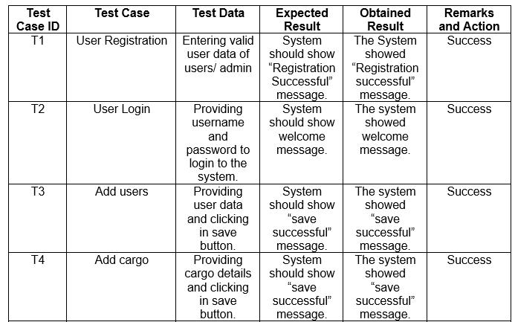

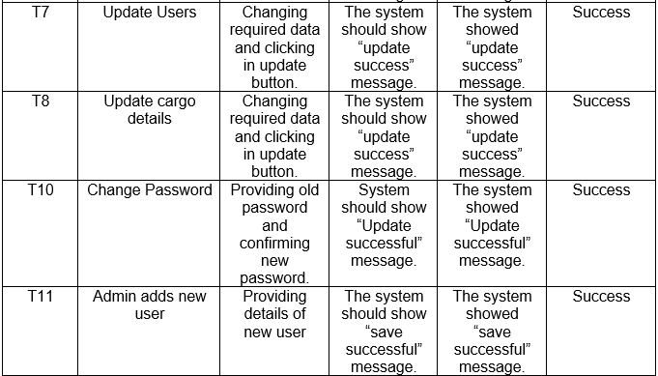

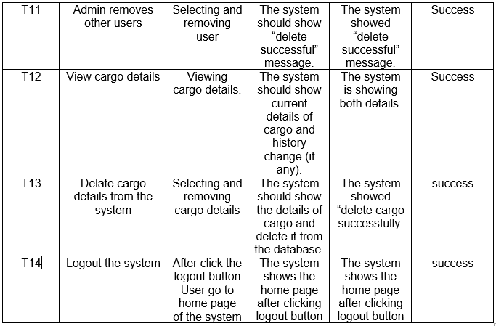

Figure 26: Integration testing