VELLORE INSTITUTE OF TECHNOLOGY
School of Computer Science and Engineering, Chennai
DUMBIT
Decision Utility for Managed Balance, Intent & Time

Software Design Document
Digital Assignment 2 — DA2 Review
Student | Naveen
Reg. No. | 23BCE1579
Course | Software Engineering
Project | DUMBIT — Cognitive Gatekeeper CLI
Tech Stack | Rust, SurrealDB, Clap, Tokio
Date | March 2026

1. Design Principles Applied
DUMBIT was designed with four core software engineering principles at its foundation. Every architectural decision was evaluated against these principles to ensure the system remains maintainable, extensible, and correct.

Principle | How DUMBIT Applies It
Abstraction | The CLI layer has no knowledge of how data is stored. It calls high-level functions like add_task() and get_today(). The SurrealDB layer has no knowledge of business rules — it only stores and retrieves records. Each layer works through a clean interface, hiding implementation details from the layers above and below it.
Modularity | The codebase is split into three distinct modules: Decision Engine (validates tasks), Business Logic (manages tasks and profiles), and Output Formatter (renders terminal output). Each module can be modified or replaced independently without affecting the others.
High Cohesion | Every module has a single, well-defined responsibility. The Decision Engine only validates — it does not store or display anything. The Output Formatter only renders — it does not compute or validate. This keeps each module focused and easy to reason about.
Low Coupling | Layers communicate strictly downward and only through defined interfaces. The CLI does not import database types directly. Replacing SurrealDB with SQLite would require changes in exactly one place: the data layer. There are no ripple effects across the codebase.

How These Principles Work Together
The four principles reinforce each other. Abstraction defines the boundaries between layers. Modularity enforces that each boundary contains exactly one concern. High Cohesion keeps each module focused on its single responsibility. Low Coupling ensures that changes within one module do not ripple outward — a new validation rule in the Decision Engine requires zero changes in the CLI or the database layer.
This structure means future features — team collaboration, calendar integration, or a web interface — can be added as new layers or modules without touching the core engine. The reliability system is entirely contained within Business Logic and can be tuned independently of how tasks are displayed or stored.

2. High-Level Architecture

Architecture Style: Layered Architecture
DUMBIT uses a classic Layered (N-Tier) Architecture with strict downward communication. The three primary layers are: User Interface (CLI), Application Logic (Decision Engine + Business Logic + Output Formatter), and Data Persistence (SurrealDB over RocksDB). A separate Deployment layer handles build and containerization concerns.

Why Layered Architecture?
- Natural fit for CLI tools: A CLI has no GUI event loop. Input arrives as a command, flows through logic, and returns a formatted result — a perfect match for a linear layered model.
- Separation of concerns: Validation logic, storage logic, and rendering logic are completely independent. A bug in output formatting cannot affect task storage.
- Testability: Each layer can be tested in isolation by mocking the layer below it. The Decision Engine can be tested with in-memory data without touching SurrealDB.
- Replaceability: The data layer (SurrealDB) is the most likely component to change as the project scales. Layered architecture makes this swap a localized change in one place.

Architecture Diagram
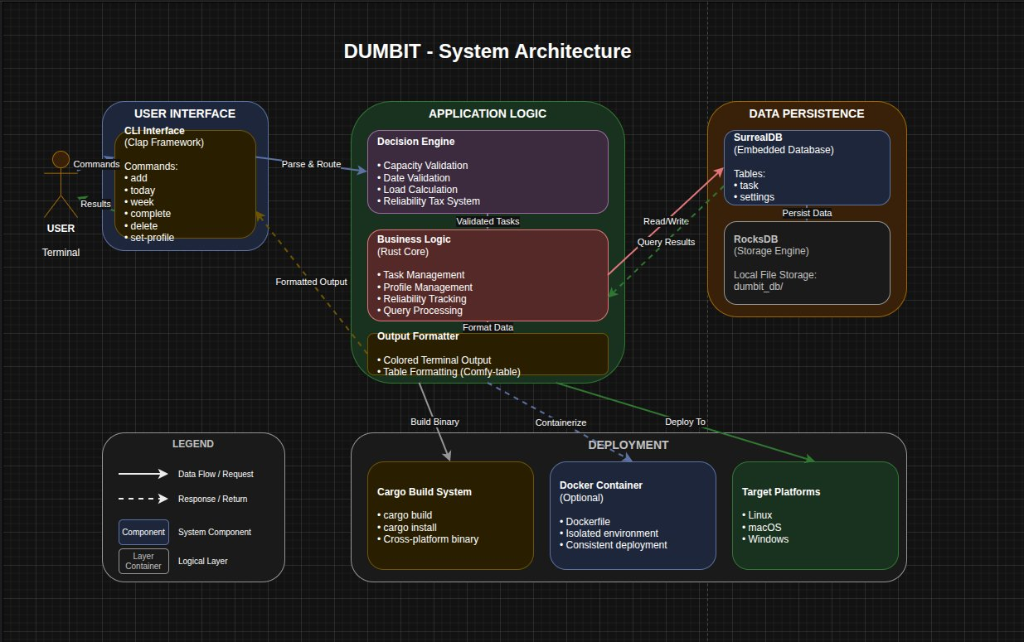
Figure 1 — DUMBIT System Architecture (Draw.io)

Layer | Components | Responsibility
User Interface | CLI (Clap Framework) | Parse commands, display results, route to application logic
Application Logic | Decision Engine, Business Logic, Formatter | Validate capacity and dates, manage tasks and profiles, format terminal output
Data Persistence | SurrealDB + RocksDB | Store and retrieve tasks and settings from local disk
Deployment | Cargo Build, Docker | Compile binary, containerize for consistent cross-platform delivery

3. User Interface Design
DUMBIT is a CLI tool — the terminal is the interface. UI design decisions focus on terminal UX: how information is structured, how feedback is communicated, and how errors are presented. The screens below represent the six primary interaction states of the tool.

CLI UX Design Decisions
- Consistent color language: Green = accepted/success, Red = rejected/error, Yellow = pending/warning, Blue = commands, Purple = headings. Applied consistently across all screens.
- Immediate, explicit feedback: Every command returns a clear ACCEPTED or REJECTED result with a specific reason. The user never has to guess why something failed.
- Capacity bars: The today and week views show visual progress bars for daily and weekly load, giving users an at-a-glance sense of remaining capacity without mental arithmetic.
- Pattern detection: The rejected view includes an automatically generated warning when multiple rejections share a cause, helping users learn from their commitment patterns.
- Structured tables: All multi-item views use aligned column tables via Comfy-table, making data scannable at a glance.
- Monospace consistency: Courier New is used throughout, matching the authentic terminal aesthetic and ensuring column alignment works correctly.

CLI Screens
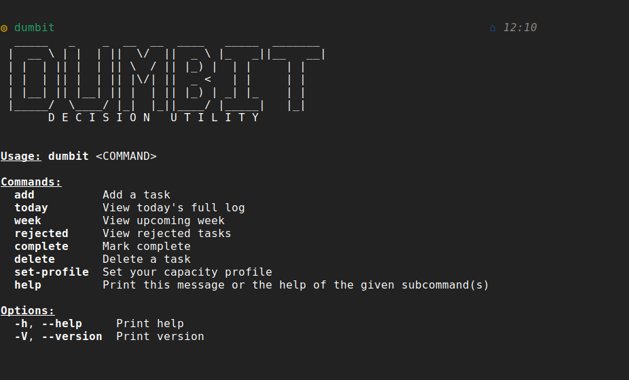 | 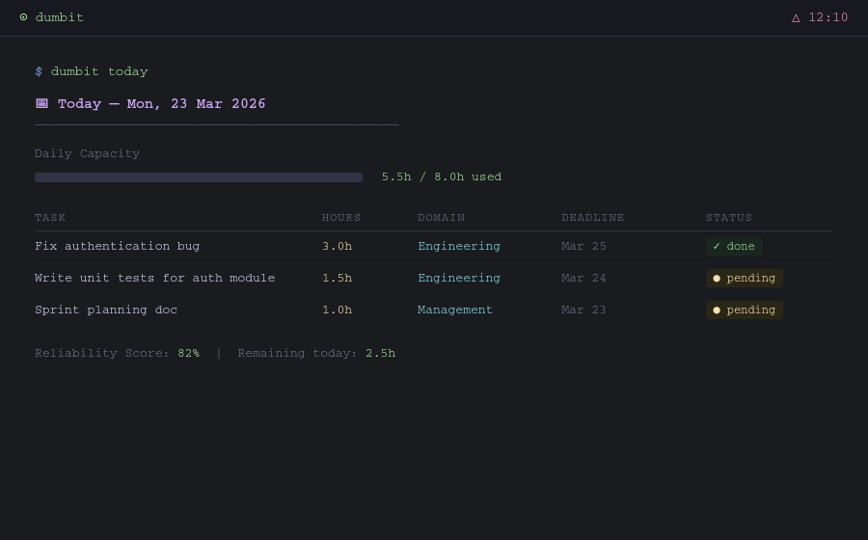
Screen 1 — Home / Help | Screen 2 — dumbit today
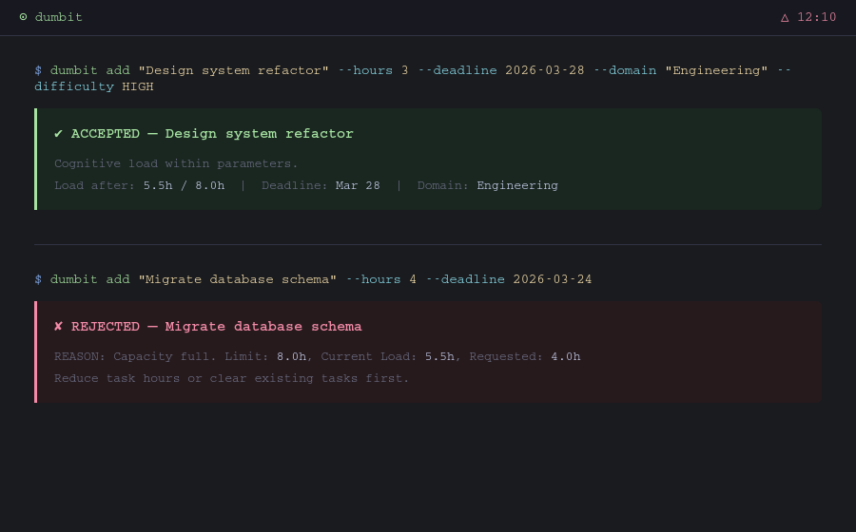 | 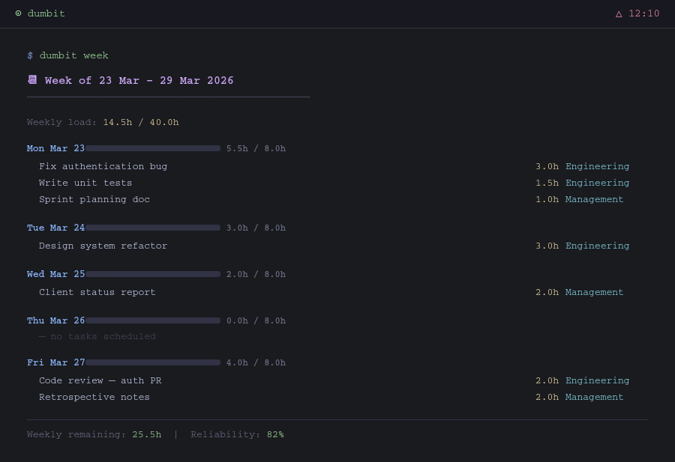
Screen 3 — Task Add (Accept & Reject) | Screen 4 — dumbit week
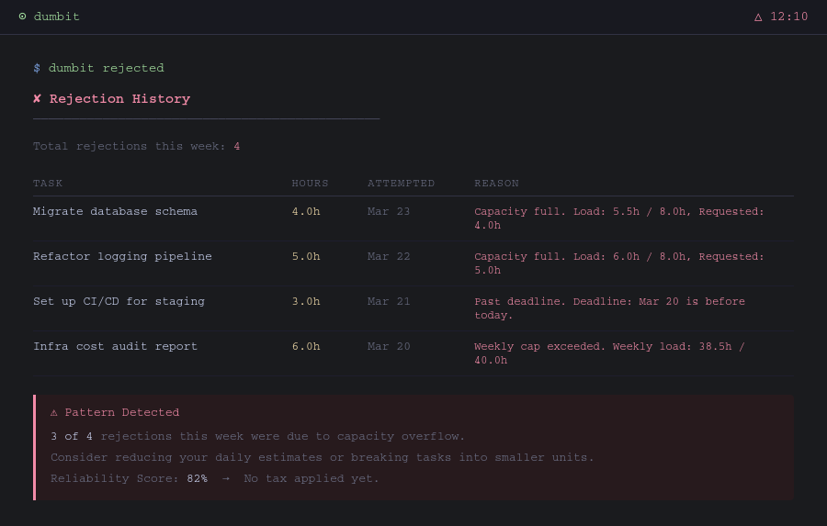 | 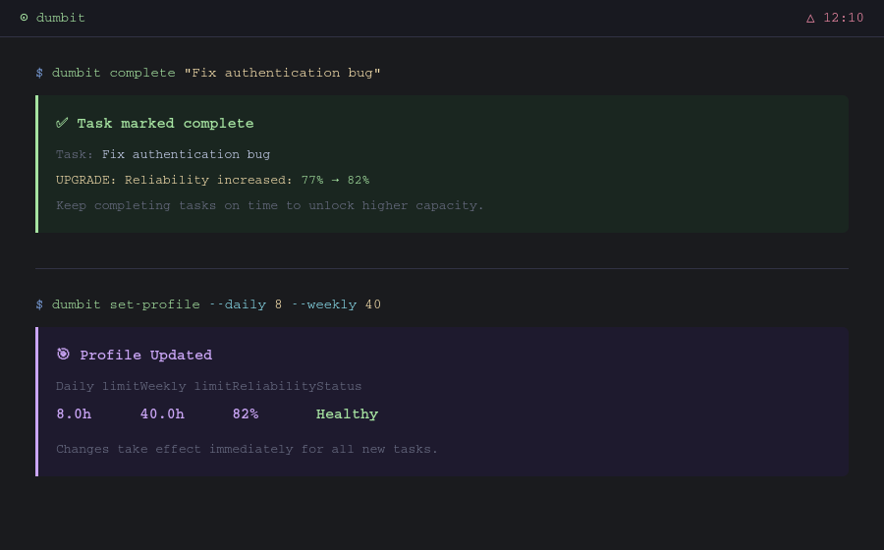
Screen 5 — dumbit rejected | Screen 6 — Complete & Set-Profile

Note: DUMBIT is a CLI tool. Screens above are terminal mockups accurately representing the real tool output.

4. Design Decisions & Why
The following table documents the five most significant design decisions made during DUMBIT's development, along with the reasoning behind each choice.

# | Design Decision | Rationale
1 | Layered Architecture | CLI tools have no traditional UI layer. Input parsing, business logic, and storage map cleanly to three independent layers — each with one job. This style also makes each layer independently testable.
2 | Decision Engine as Isolated Module | Centralizing all validation (capacity check, date validation, reliability tax) in one module means adding a new validation rule touches exactly one place in the codebase. This directly enforces low coupling and high cohesion.
3 | Embedded SurrealDB over External Database | No server to manage, no authentication complexity, zero infrastructure cost. Data is local and private by default. This was a deliberate product decision: local-first is a feature, not a limitation.
4 | Reliability Tax System | Instead of passively tracking completion, DUMBIT penalizes low reliability by shrinking effective capacity. This creates a behavioral feedback loop that enforces discipline at the decision point, not after the fact.
5 | Rust over Python or Go | Rust's type system eliminates null pointer and data race bugs at compile time. For a daily-use CLI tool, sub-second response time is non-negotiable. Rust delivers this without a runtime or garbage collector pauses.

Future Design Considerations
The current architecture is intentionally designed to accommodate future extensions without requiring structural changes. The layered model allows a web interface or mobile companion to be added as a new interface layer without touching the Decision Engine or data layer. The reliability scoring logic is encapsulated such that the algorithm can be upgraded (for example, to ML-based time estimates) by modifying a single module. The local-first data model can be extended with optional cloud sync as a new persistence backend, again isolated to one layer.

GitHub: github.com/magarmach-hash/DUMBIT | Stack: Rust 2021 · SurrealDB 2.0 · Clap 4.5 · Tokio 1.40

