## Problem 9 – Ewoks Fans

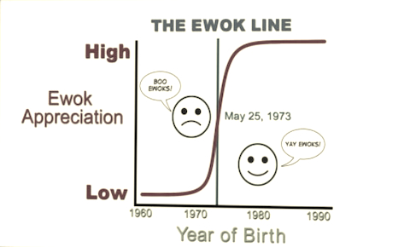

Barney Stinson has a theory about ewoks. There is a correlation between the birth year of a person and the subsequent appreciation of Ewoks (fictional teddy bear-like creatures from the 1983 film Return of the Jedi). Those born **on or before** **May 25, 1973** have a low appreciation of the film's creatures, while those born after this date have an affinity for them. This is because those who saw the Ewoks in Return of the Jedi, which was released theatrically on May 25, 1973, who were 10 or under still loved their teddy bears, giving them an increased appreciation for the Ewoks.

You have a list of birthdays. People born **on** **25.05.1973** **and after** are **fans** of Ewoks and these **before** **that** – **haters**. The biggest hater is the **oldest** person born **before** **25.05.1973**.The biggest far is the **youngest** person born **after** **25.05.1973**. Find the biggest fan and hater of Ewoks. **Exclude** people born **on or before 01.01.1900** and those **born on and** **after 01.01.2015**, because most of them are either dead or not born yet.

### Input

The input data comes as array of strings containing dates in the format “dd.mm.yyyy”. The input data will always be valid and in the format described. There is no need to check it explicitly.

### Output

Print at the console when the biggest fan and the biggest hater of Ewoks were born. Use the method "**date.toDateString()"** to format the date at the output. If there is **only one** **fan** or **hater**, print out the date of his birth. If there are no people between **01.01.1900** and **01.01.2015** print “**No result**”. **Whitespace** and character **casing** are important, so please use the same as in the below examples.

### Constraints

* The input is passed to the first JavaScript function found in your code as array of **strings**.
* All **strings** contain dates in the format “**dd.mm.yyyy**”.
* The strings count will be in the range [1… 100].
* Allowed working time for your program: 0.2 seconds. Allowed memory: 16 MB.

### Examples

|  |  |
| --- | --- |
| **Input** | **Output** |
| 22.03.2014  17.05.1933  10.10.1954 | The biggest fan of ewoks was born on Sat Mar 22 2014  The biggest hater of ewoks was born on Wed May 17 1933 |
| **Input** | **Output** |
| 22.03.2000 | The biggest fan of ewoks was born on Sat Mar 22 2000 |
| **Input** | **Output** |
| 22.03.1700  01.07.2020 | No result |