## Problem 5 – Unresponsive to Responsive Site

You are given an unresponsive Web site (**HTML** + **CSS** + images). Your task is to **make the site responsive**. The site layout should change according to the browser viewport / screen size. You need to implement only two layouts: **width ≤ 780px** and **width > 780px**. The figure on the left represents the site when the screen width is larger than 780px. The figure on the right displays the site on screens widths smaller than 780px.

### 

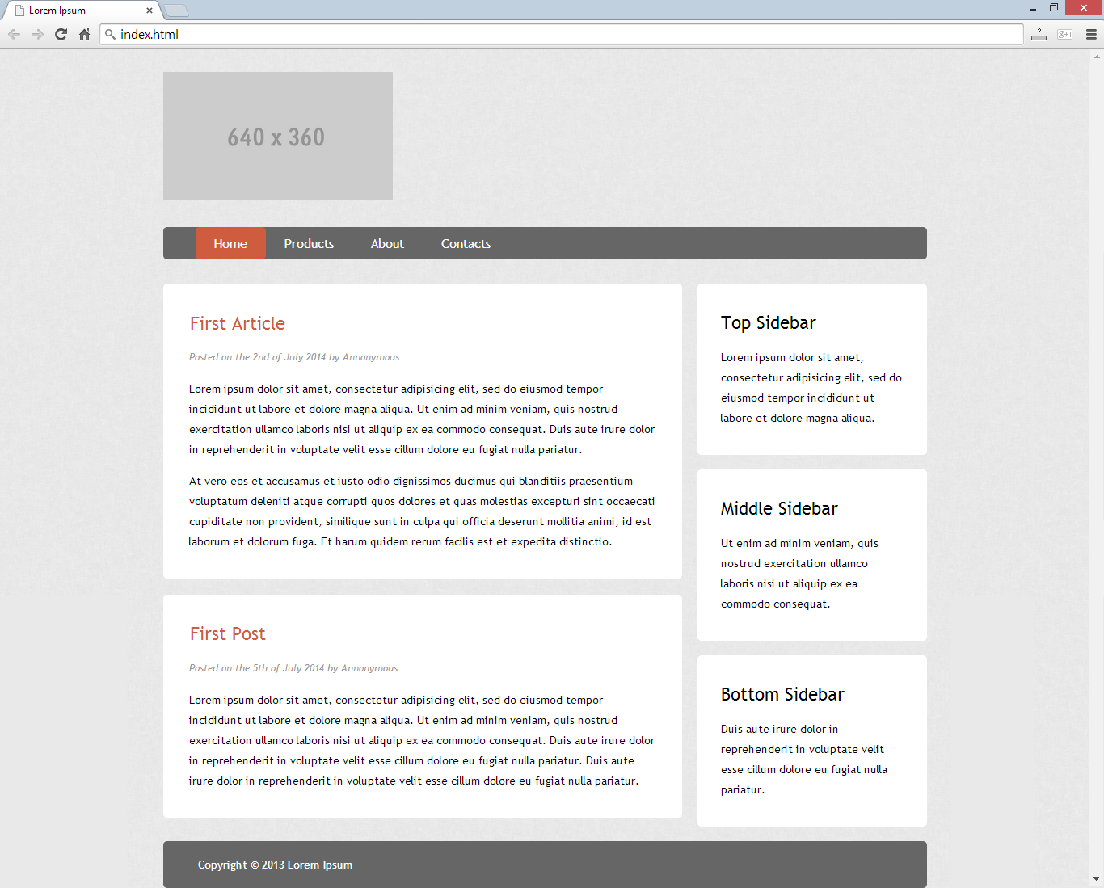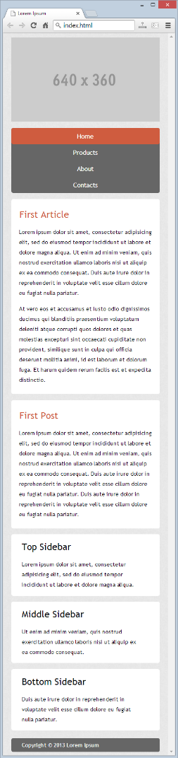

### Input

You are given the unresponsive site as HTML + CSS + images.

### Output

The output should be valid HTML5 + CSS3 + images that implement the above responsive site.

### Constraints

* You are free to change the HTML and CSS, as well as use external frameworks like Bootstrap.
* Pixel-perfect implementation is not required.