Instructions

# Files needed

* Python code files (from folder “Python code files” in this GitHub repository)
* Excel files “flows_into_rec_suitability_sec_mat” and “demand_reduction” (from folder “Excel data files” in this GitHub repository)
* Excel file “Database” from *Data in Brief* article ‘A High-Resolution Dataset on the Plastic Material Flows in Switzerland’ by Magdalena Klotz and Melanie Haupt
* *optional:* SQL views creation scripts (from folder “SQL scripts for views creation” in this GitHub repository)

# Database creation and connection

* Create a relational database, the data of which can be queried via an SQL language with the SQL/Persistent Stored Module extension by [MySQL](https://en.wikipedia.org/wiki/MySQL)
* Change the code piece

mfa_plastics_ch = mysql.connector.connect(  
 host="<your_db_host>",  
 user="<your_db_user_name>",  
 passwd="<your_db_user_password>",  
 database="<your_db_schema_name>")

from the code file ‘0_run_all’ by adding the data for the connection to your database instead of the placeholders

<your_db_host>,

<your_db_user_name>,

<your_db_user_password>,

<your_db_schema_name>

# Calculations

* Create a new Python project and virtual environment using Python version 3.7.
* Install the following Python packages (mentioned versions) within the created environment.

|  |  |
| --- | --- |
| **Package** | **Version** |
| matplotlib | 3.2.2 |
| mysql.connector | 2.2.9 |
| numpy | 1.19.1 |
| openpyxl | 3.0.5 |
| pandas | 1.1.2 |
| scipy | 1.5.2 |
| xlrd | 1.2.0 |

* Save all code files to your project folder.
* Save the two Excel files “flows_into_rec_suitability_sec_mat” and “demand_reduction” to your project folder.
* Insert your project directory in the following two code pieces from the code file ‘opt_applicability_scenario’ instead of the three dots:

df = pd.read_excel(r'C:\\...\\flows_into_rec_suitability_sec_mat.xlsx')

demand_reduction = pd.read_excel(r'C:\\...\\demand_reduction.xlsx')

* Save the Excel file “Database” in your project folder.
* Insert your project directory in the following code piece from the code file ‘excel_read_in’ instead of the three dots:

excel = xlrd.open_workbook('C:\\...\\Database.xlsx')

* Run script “0_run_all”.

# Results

* All material flow data is available in the table ‘flows’ of your database created with the code, except for:
  + raw material flows to polymer manufacturing and flows from polymer manufacturing to product manufacturing in Switzerland and abroad
  + secondary material flows from recycling back into product manufacturing, which are listed in table ‘secondary_material_subsegments_plastic_types’
  + for the 2025 scenario, all flows to energy recovery, exported or with unknown destiny; the total waste amount for this scenario is available in table ‘waste_scen2’
* The optimization results are available in tables ‘results_optimization’ and ‘uptaken_secondary_material_subsegments_plastic_types’
* You can run the scripts provided in folder ‘SQL scripts for views creation’ to create certain views of the data from the database tables, which facilitate the exhibition of the results available in the database. Via these views, you can get:
  + the use amounts of 2017 sorted by product subsegment (view ‘use_amounts_subsegments_sorted’)
  + the separate collection amounts for 2017 and 2025 (view ‘coll_rate_scen1_subseg ‘ for 2017; for 2025, first create view ‘separate_collection_scen2’, then view ‘coll_rate_scen2_subseg’)
  + the secondary material amounts for 2017 and 2025 for each plastic type in each subsegment (view ‘sec_mat_su_pl’)
  + the overall recycling rate for the 2025 scenario as well as the true recycling rate for each sub-scenario (view ‘overall_results_opt’)
  + the total and uptaken secondary material amounts as well as recycling rates and true recycling rates for all plastic types in all sub-scenarios for 2025 (view ‘res_opt_scen_only’, already created with code)
  + for each 2025 sub-scenario, the uptaken secondary material amounts of the individual plastic types by each subsegment (views ‘uptaken_sec_mat_subseg_plast_high_applic’, ‘uptaken_sec_mat_subseg_plast_moder_applic’ and ‘uptaken_sec_mat_subseg_plast_low_applic’)
* The main database tables and the relations between them are depicted in Figure 1.

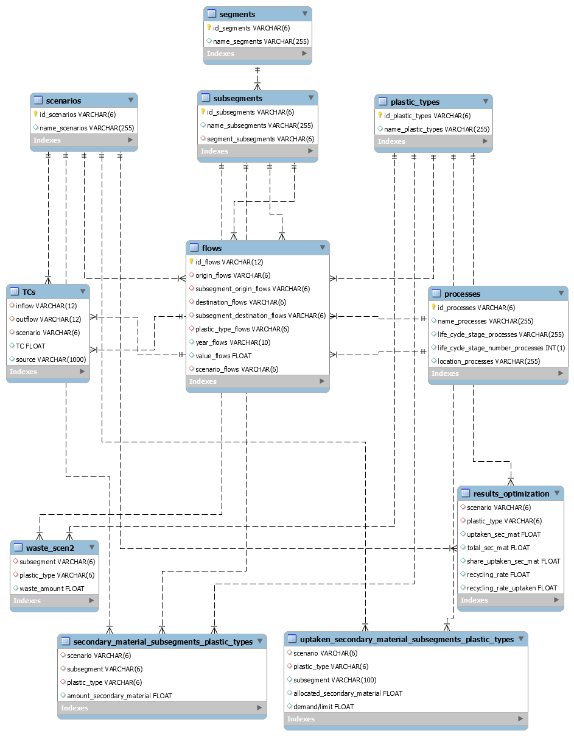

*Figure 1:* Enhanced entity-relationship diagram of the database schema