

Faculty of Engineering

Computer and Systems Engineering Department

**CSE 323: Data Structures and their Algorithms**

***Dr. Islam El-Maddah***

**Report on Simulation of Banking systems**

**Submitted by**

Magdy Mohamed Abdel Moneim Hafez ID:33800

Sherif Ahmed Hassan Kotb ID: 33762

Mohamed Ismail Mohamed Hafez ID:33808

Spring 2016

**Requirements:**

1- FCFS queues for different services

* Deposit
* Withdraw
* Transfer
* Open/close Account
* Enquiry

2- Load and save form file

3-Differnent services (Deposit – Withdraw – Transfer – Enquiry)

**Program sequence:**

1-The program loads client data form file

2-The Customer who enters the bank stand in FCFS Queue according to the desired service

3-Accountant asks the customer if he/she is already a client or he needs to create new account

4-After ensuring that the customer has an account the accountant asks him/her the service he/she needs.

* Deposit
* Withdraw
* Transfer
* Open/close Account
* Enquiry

5-The accountant tells the client whether the operation is successful or not and if not tell him/her the reason

6-After serving each customer's/client update(save) his data into a file then serve another customer if there is any or exit

**Data Structures:**

1) Queue

2) Linked list

**Algorithms:**

1. Merge sort O(nlogN)
2. Binary search O(logN)
3. Linear search O(n)

**Use cases:**

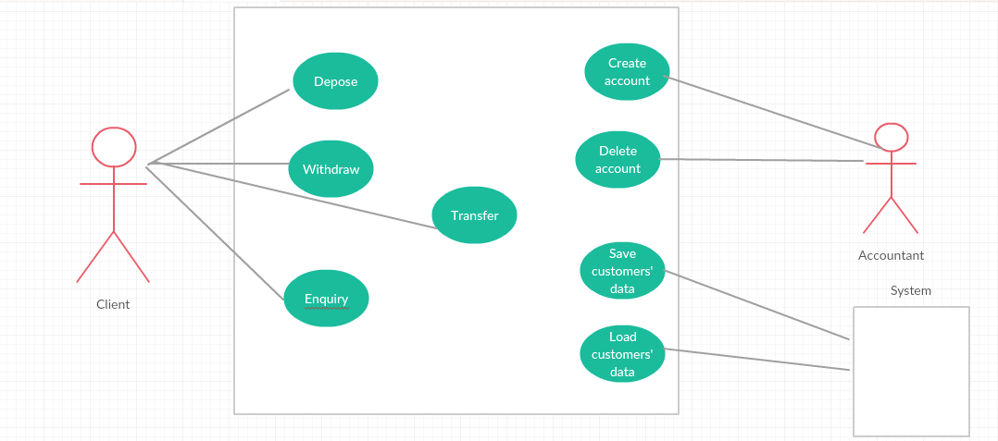

1-Depose

Preconditions: The customer has valid account

Accountant enters client ID

Accountant asks the client for the amount of money he wishes to Depose.

Accountant tell the client if the operation was successful or not

Postcondition : The client account balance has been updated correctly

Abnormal paths:

If The customer doesn't have account or his account is invalid error message appears

2-Withdraw:

Preconditions: The customer has valid account

Accountant enters client ID

Accountant asks the client for the amount of money he wishes to Withdraw.

Accountant tell the client if the operation was successful or not

Postcondition : The client account balance has been updated correctly

Abnormal paths:

* If The customer doesn't have account or his account is invalid error message appears giving reason.
* If The customer doesn't have enough balance to make the withdraw error message appear giving reason.

3-Transfer:

Preconditions: The customer has valid account

Accountant enters client ID

Accountant asks the client for the amount of money he wishes to Transfer And The account ID he wish to transfer money to.

Accountant tell the client if the operation was successful or not

Postcondition : The 2 clients accounts balances has been updated correctly

Abnormal paths:

* If The customer doesn't have account or his account is invalid error message appears giving reason.
* If The customer doesn't have enough balance to make the transfer error message appear giving reason.
* If The Target Account ID is invalid error message appear giving reason

4-Enquiry

Preconditions: The customer has valid account

Accountant enters client ID

Accountant asks the client for the needed info

Accountant tell the client The result of inquiry

Postcondition : The client got the needed info

5-Create account

Accountant asks the customer for his name and any other needed info

Accountant Creates new account for the customer And the customer has new ID

Postconditon : The customer now has a valid ID

6-Delete account

Preconditions: The customer has valid account

Accountant enters client ID

Accountant asks the client if he is sure to delete his account

Postcondition: The Account ID is Deleted

7- Load customer data: The system Loads customers Data at startup

8-save customer data: The system saves Data after each update in clients Data