

Faculty of Engineering

Computer and Systems Engineering Department

**CSE 371: Control Systems (1)**

Instructor: Prof. Wahied Gharieb Ali

Assignment#2

**Frequency Domain Analysis**

**Submitted by**

Magdy Mohamed Abdel Moneim Hafez

Student ID: 33800

Fall (2015-2016)

***Table of Contents***  Topic……………………………………………..……..……Page number

1) Problem Formulation …………………………………………………………..

2) Background……………………………………………………………………….. 3

3) Calculations………………………………………………………………………...4

3) Simulink results …………………………………………………………………..5

4) Conclusion…………………………………………………………………………. 9

5) References ………………………………………………………………………..10

***Problem Formulation***

The report consists of four systems give their transfer function (G(s)) and we need to use the matlab to plot two diagrams for each:

* Bode plot and the compute phase and gain margins.
* Nyquist diagram and investigate the stability of closed loop unity feedback.

***Background***

***Bode plot:***

Plot the frequency characteristic in a semi-log coordinate:

Magnitude response: Y-coordinate in decibels and X-coordinate in logarithm of ω: logω.

Phase response: Y-coordinate in degrees and X-coordinate in logarithm of ω: logω.

***Nyquist Diagram:***

A frequency domain stability criterion was developed by H. Nyquist in 1932 and remains a fundamental approach for the stability of linear systems.

Nyquist stability criterion determines the stability of closed-loop system from its open-loop frequency response and open-loop poles.

The Nyquist diagram is basically a plot of G (jw) where G(s) is the open-loop transfer function and w is a vector of frequencies which encloses the entire right-half plane. In drawing the Nyquist diagram, both positive and negative frequencies (from zero to infinity) are taken into account. The frequency vector used in plotting the Nyquist diagram usually looks like this (if you can imagine the plot stretching out to infinity):

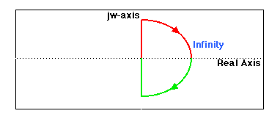

***Calculations***

a) $G\left(s\right)= \frac{\left(s+2\right)\left(s+6\right)}{s^{2}+8s+25}$ = $\frac{s^{2}+8s+12}{s^{2}+8s+25}$

b) $G\left(s\right)= \frac{5\left(s^{2}+4\right)}{s^{2}+1}$ = $\frac{5s^{2}+20}{s^{2}+1}$

c) $G\left(s\right)= \frac{10\left(s^{2}+1\right)}{s^{2}}$ = $\frac{10s^{2}+10}{s^{2}}$

d) $G\left(s\right)= \frac{1}{{\left(s+1\right)}^{3}(s+4)}$ = $\frac{1}{s^{4}+7s^{3}+15s^{2}+13s+4}$

***Simulink Results***

**Problem a:**

$$G\left(s\right)= \frac{\left(s+2\right)\left(s+6\right)}{s^{2}+8s+25}$$

* Bode plot :

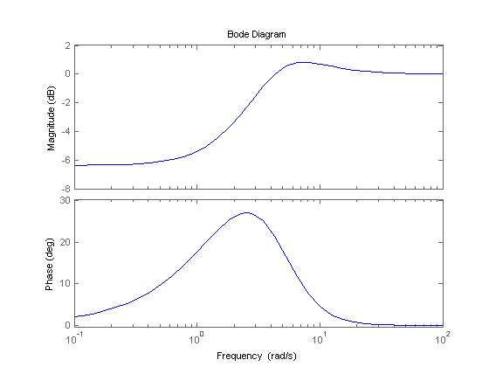

Gain margin =infinity, phase margin =-159 degrees.

* Nyquist :

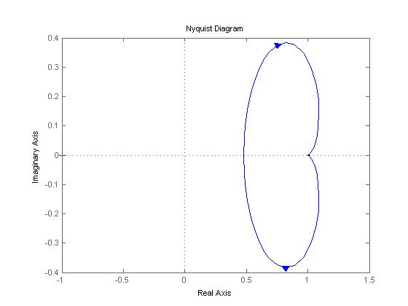

Not stable system

**Problem b:**

$$G\left(s\right)= \frac{5\left(s^{2}+4\right)}{s^{2}+1}$$

* Bode plot :

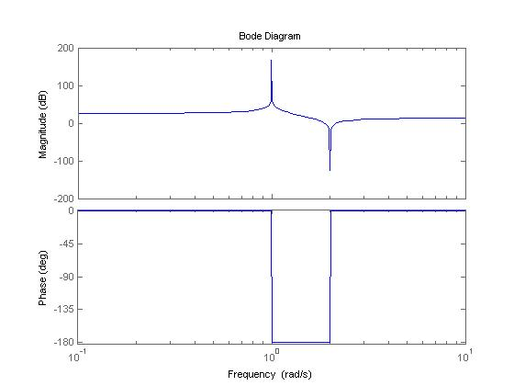

Gain margin =infinity, phase margin =0 degrees.

* Nyquist :

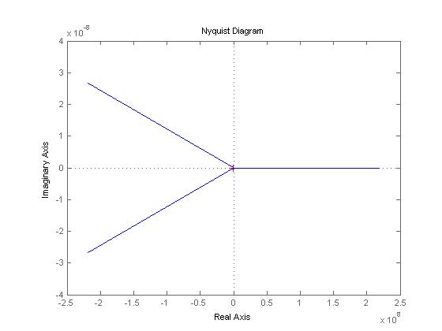

Not stable system

**Problem c:**

$$G\left(s\right)= \frac{10\left(s^{2}+1\right)}{s^{2}}$$

* Bode plot :

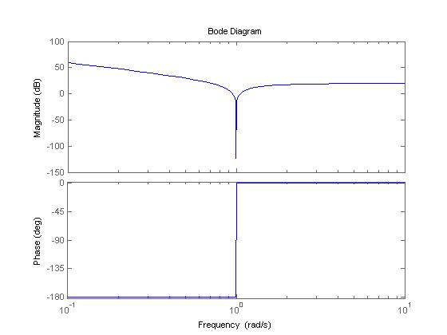

Gain margin =-infinity, phase margin =0 degrees.

* Nyquist :

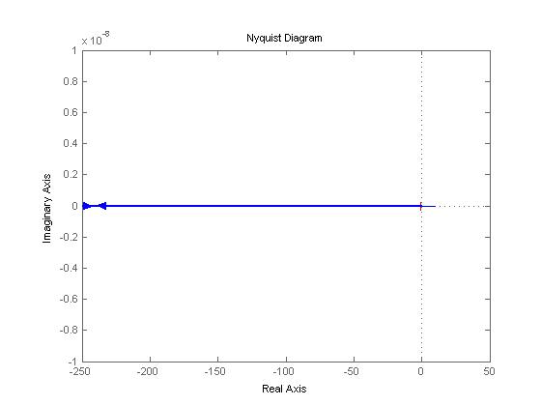

Not stable system

**Problem d:**

$$G\left(s\right)= \frac{1}{{\left(s+1\right)}^{3}(s+4)}$$

* Bode plot :

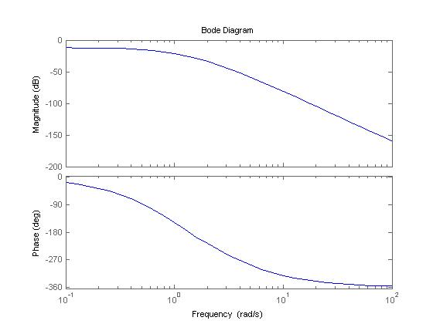

Gain margin =-26.2 DB, phase margin =infinity.

* Nyquist :

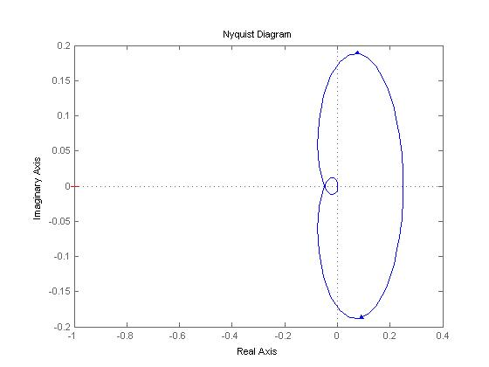

Not stable system.

***Conclusion***

* The system is said to be stable if $\frac{G(s)}{1+G\left(s\right)H(s)}$ has poles all in left side of the (s) plane.
* The Gain and Phase margins must be positive to say that the system is stable.

***References***

* CSE 371 slides By Prof. Wahied Gharieb Ali.
* Online Matlab help sites.
* Using Matlab and Simulink.
* K. Ogata, “**Modern Control Engineering**”, Fifth edition, Prentice Hall, 2010.