Ernest Golob, Malenska vas, 8216 Mirna Peč, potrjujem, da so spodaj navedena dela in deli kod last avtorsko delo in last podjetja Alter7 d.o.o. S to izjavo dokazujem, da so dela in koda nastala že pred datumom 26.05.2017.


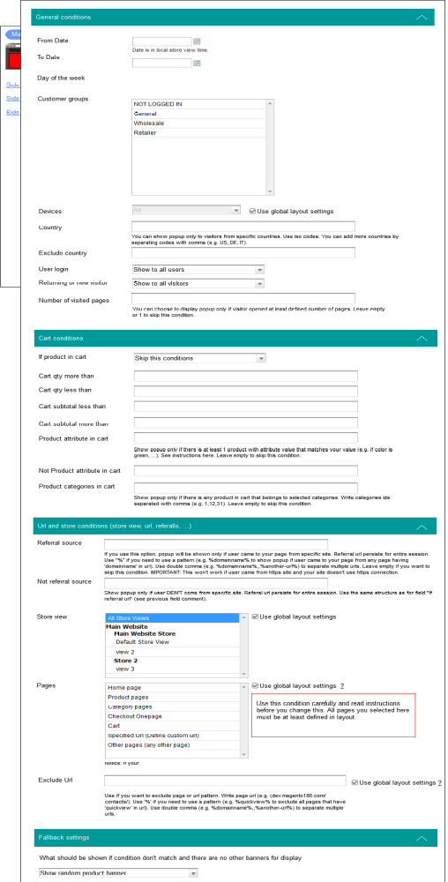
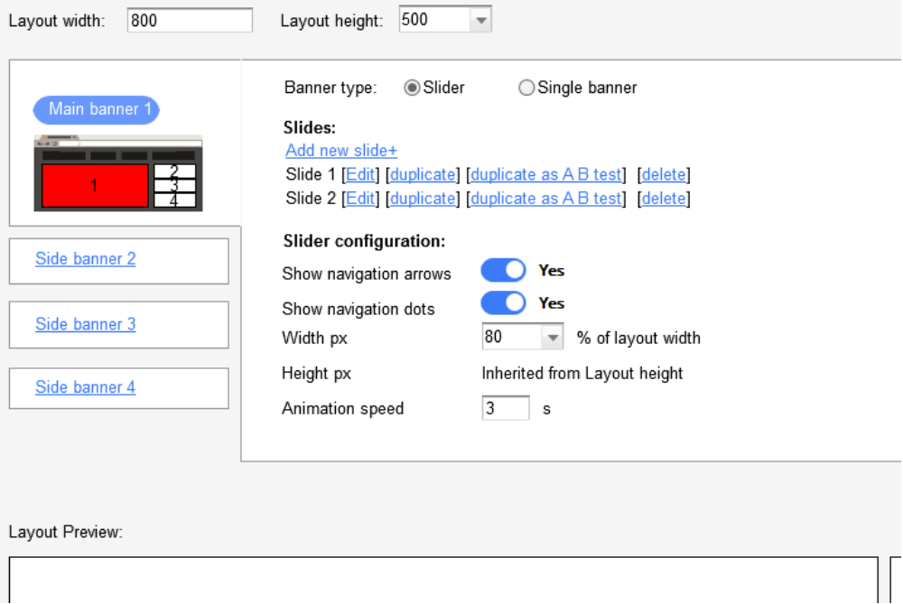
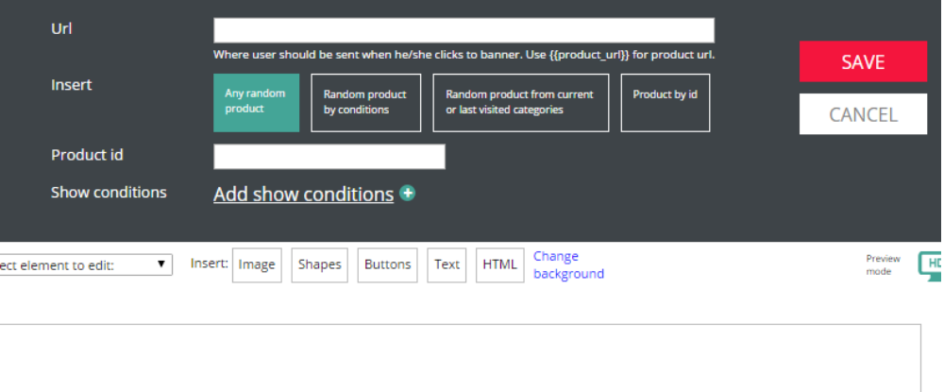

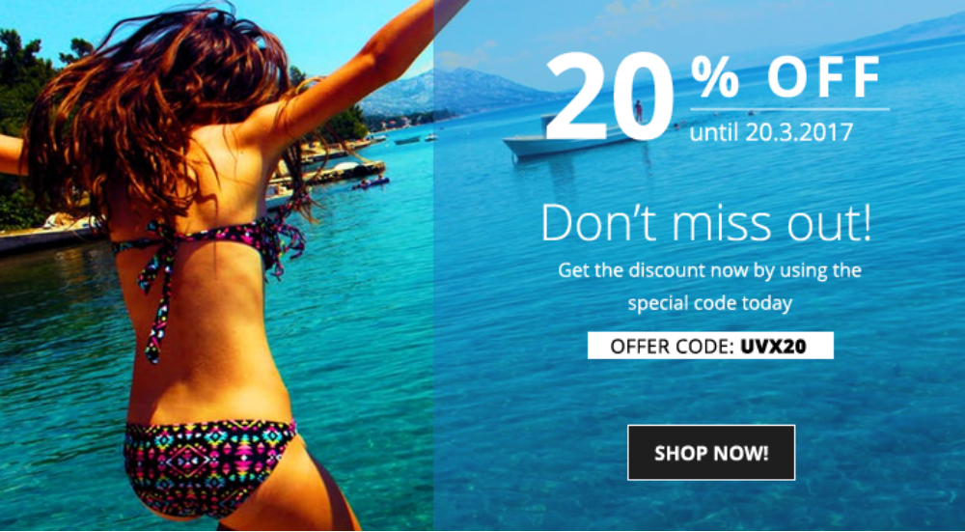

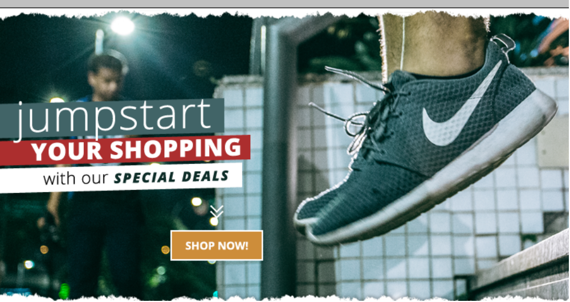
function editable(el){
if(el.hasClass('editable') || el.is('span') || el.is('p') || el.is('h1') || el.is('small')){
//el.prop('contenteditable',true).focus()
}
ElSelectionRange = saveSelection();
if(typeof selectedEl ==='undefined'
|| (!$(selectedEl).hasClass('selected') && $(selectedEl).closest('.selected').length==0)
|| (!selectedEl.isContentEditable && $(selectedEl).find('*[contenteditable="true"]').length==0)){
$(".selected").find('*[contenteditable="true"]').focus();
}else{

//$(selectedEl).find('*[contenteditable="true"]').focus();
}
}

function showElSettings(el){
$("#toolbar .inner").hide();
$("#elSettings").show();
$(".chooseColor:not(.font)").hide();
pickerN = 0;
colorPicker(1, $(".selected"), "color")
pickerN++;
handleColors(el)
el.find('*').each(function(){
if(!$(this).hasClass('locked')){
handleColors($(this))
}
});
}

function wrapSelectedEl(el){

destroyTools();

editable(el);

showElSettings(el);

$("#toolsWrap").show()
offset = el.offset()
var rotatedDegree = getRotationDegrees(el);
if(rotatedDegree){
el.css('transform','rotate(0deg)');
}

$("#toolsWrap").css('width',$("#banner")[0].offsetWidth)
$("#toolsWrap").css('height',$("#banner")[0].offsetHeight)
//IE bugfix
setTimeout(function(){
$("#toolsWrap").offset({ top: $("#banner").offset().top, left: $("#banner").offset().left});
}, 10);

$("#toolsWrap").offset({ top: $("#banner").offset().top, left: $("#banner").offset().left});
$("#toolsWrap").offset({ top: $("#banner").offset().top, left: $("#banner").offset().left});
$("#toolsWrap").offset({ top: $("#banner").offset().top, left: $("#banner").offset().left});
$("#toolsWrap").css('transform','scale('+scale+')')
$("#tools").css('width',el[0].offsetWidth)
$("#tools").css('height',el[0].offsetHeight)
$("#tools").css({ top: el.css('top'), left: el.css('left')});

if(rotatedDegree){
$("#tools").css('transform','rotate('+rotatedDegree+'deg)');
el.css('transform','rotate('+rotatedDegree+'deg)');
}else{
$("#tools").css('transform','rotate(0deg)');
}

$("#tools").addClass("edit")

var delay;

$("#tools").show();

if(el.is("[data-widthLocked]")){
$(".ui-resizable-handle").hide();
}else{
$(".ui-resizable-handle").show();
$("#tools").resizable({
handles: {
n: $('#n-resize-handle'),
e: $('#e-resize-handle'),
s: $('#s-resize-handle'),
w: $('#w-resize-handle'),
ne: $('#ne-resize-handle'),
se: $('#se-resize-handle'),
sw: $('#sw-resize-handle'),
nw: $('#nw-resize-handle')
},
resize: function( event, ui ) {
rate = 1-Math.abs(scalePercent);
var changeWidth = ui.size.width - ui.originalSize.width; // find change in width
var newWidth = ui.originalSize.width + changeWidth / rate; // adjust new width by our zoomScale

var changeHeight = ui.size.height - ui.originalSize.height; // find change in height
var newHeight = ui.originalSize.height + changeHeight / rate; // adjust new height by our zoomScale

ui.size.width = newWidth;
ui.size.height = newHeight;
$(".selected").css({'top':$("#tools").css('top'),
'left':$("#tools").css('left'),
});

//need delay, otherwise rotated elements won't get resized properly
delay = 0;
if(getRotationDegrees($("#tools"))){
delay = 1;
}
setTimeout(function(){
$(".selected")[0].style.height = $("#tools")[0].style.height
$(".selected")[0].style.width = $("#tools")[0].style.width
if($(".selected").is("[data-onResize]")){
eval($(".selected").attr('data-onResize'))
}
}, delay);

}
});
}

$jQuery3("#tools").rotatable({
rotate: function(event, ui) {
var extraTransform = '';
var splitStyle = $(".selected").attr('style').split("transform");
if(splitStyle[1]){
var transforms = splitStyle[1].split(";")[0]

var skew = transforms.split("skew(");
if(skew[1]){
skew = skew[1].split(")")[0]
extraTransform = 'skew('+skew+')';
}

var translate = transforms.split("translate(");
if(translate[1]){
translate = translate[1].split(")")[0]
extraTransform += 'translate('+translate+')';
}
}
$(".selected").css('transform','rotate('+ui.angle.current* (180/Math.PI)+'deg) '+extraTransform);
},
angle:getRotationDegrees(el) * (Math.PI/180),
transforms: {
//skew: '-20deg',
//scale: scale
//any other transforms
}

});
}

$(document).on("click","#insertText",function(event) {
$(".selected").removeClass("selected");
var newEl = "<div class='selected editable' style='position:absolute;z-index:9;left:30px;top:30px;width:300px;height:20px;overflow:hidden;'>Lorem ipsum dolor sit amet, consectetur adipiscing elit.</div>"
$("#banner").append(newEl)
wrapSelectedEl($('.selected'))
});

//$(document).on('click','#banner > div, #banner > img, #banner > p',function(event) {
$(document).on('click','#banner > *',function(event) {
$(".selected").removeClass("selected")

$(this).addClass("selected")
var $this = $(this)
wrapSelectedEl($this)

editable($(this))

if($(this).data('ui-draggable')){
$(this).draggable('destroy');
}
});
var click = {
x: 0,
y: 0
};

$(document).on('mouseenter', '#banner > p:not(.selected), #banner > div:not(.selected), #banner > img', function(e) {
dragElement($(this));
})
$(document).on('mouseenter', '#drag', function(e) {
dragElement($(this),'#tools');

}).on('mouseleave', '#drag', function() {
if($(this).data('ui-draggable')){
$(this).draggable("destroy")
}
});

function dragElement($this,draggableEl){
if(draggableEl=='#tools'){
el = $("#tools");
}else{
el = $this;
}

el.draggable({
start: function(event,ui) {
click.x = event.clientX;
click.y = event.clientY;
var left = parseInt($(this).css('left'),10);
left = isNaN(left) ? 0 : left;
var top = parseInt($(this).css('top'),10);
top = isNaN(top) ? 0 : top;
recoupLeft = (left - ui.position.left*zoomRate);
recoupTop = (top - ui.position.top*zoomRate);
},

drag: function(event, ui) {
var original = ui.originalPosition;
ui.position = {
left: (event.clientX*zoomRate - click.x*zoomRate + (original.left*zoomRate))+recoupLeft,
top: (event.clientY*zoomRate - click.y*zoomRate + (original.top*zoomRate))+recoupTop
};
setTimeout(function(){
if(draggableEl=='#tools'){
//$(".selected").css('width',$('#tools')[0].offsetWidth)
//$(".selected").css('height',$('#tools')[0].offsetHeight)
$(".selected").css({ top: $('#tools').css('top'), left: $('#tools').css('left')});
}else{
//$("#tools").css('width',$('.selected')[0].offsetWidth)
//$("#tools").css('height',$('.selected')[0].offsetHeight)
$("#tools").css({ top: $('.selected').css('top'), left: $('.selected').css('left')});
}
}, 10);
}
});
}

$(document).on("click","#delete",function(event) {
$(".edit").removeClass("edit")
$("#tools").hide();
//$(".inspect").remove()
collectElements()
});
$(document).on("click","#zindex-",function(event) {
//$(".inspect").css('z-index',$(".inspect").css('z-index')-1)
});

function rgb2hex(color) {
if(color.indexOf('rgb')==-1) return color;
rgb = color.split("(")[1].split(")")[0].split(",");
rgb = rgb[2] | (rgb[1] << 8) | (rgb[0] << 16);
return '#' + (0x1000000 + rgb).toString(16).slice(1)
}

function collectElements(){
var elementValue;
$("#elementSelector select").html('');
$("#elementSelector select").append('<option>Select element to edit:</option>');
$("#banner *").each(function(index){
if($(this).prop("tagName").toLowerCase()=="img"){
elementValue = $(this).prop("tagName") + " : " + $(this).attr('src')
}else if($(this).text()=='' && $(this).attr('data-element')){
elementValue = $(this).attr('data-element')
}else if($(this).text()==''){
//unicode characters to their equivalent HTML entity
elementValue = $(this)[0].outerHTML.replace(/[\u00A0-\u9999<>\&]/gim, function(i) {
return '&#' + i.charCodeAt(0) + ';';
});
}else{
elementValue = $(this).prop("tagName") + " : " + $(this).text()
}
$("#elementSelector select").append('<option val="'+index+'">'+elementValue+'</option>');
});
}

function selectElement(){
var element;
$("#elementSelector").on('change', function() {

element = $("#banner *").eq($(this).find(":selected").attr('val'))
wrapSelectedEl(element)
$(".selected").removeClass("selected")
element.addClass("selected")
//$(".inspect").removeClass('inspect');

element = $("#banner *").eq($(this).find(":selected").attr('val'))
//element.addClass('inspect');

$("#tools").css('top',element.offset().top-2)
$("#tools").css('left',element.offset().left-2)
$("#tools").css('width',element.width())
$("#tools").css('height',element.height())
$("#tools").addClass("edit")
$("#tools").show();
})
}

function responsive(){

parentWidth = $('#banner').parent()[0].offsetWidth;
bannerWidth = $('#banner')[0].offsetWidth;
scalePercent = (bannerWidth-parentWidth)/bannerWidth;

if(parentWidth>=originBannerWidth){
scale = 1;
scalePercent = 1;
}else{
scale = 1-scalePercent;
}
zoomRate = 1/scale;

$("#banner").css('transform','scale('+scale+')');
if(parentWidth>=originBannerWidth){
$("#respWrap").css('height',originParentHeight+'px');
}else{
$("#respWrap").css('height',originParentHeight-(originParentHeight*scalePercent)+'px');
}
}

function previewMode(){
$("#previewMode p").click(function(){
destroyTools();
$("#previewSize .active").removeClass('active');
$(this).addClass('active');
if($(this).attr("id")=="screenHD"){
$("#respWrap").css('width','2000px');
responsive();
}else if($(this).attr("id")=="screen1280"){
$("#respWrap").css('width','1280px');
//$("#banner").css('width','1280px');
responsive();
}else{
$("#respWrap").css('width','360px');
responsive();
}
//$("#previewWrap").scrollLeft(($("#respWrap").width() - $("#previewWrap").width()) / 2);
$("#previewWrap").mCustomScrollbar('destroy');
if($(this).attr("id")!="screenMobile"){
$("#previewWrap").mCustomScrollbar({
axis:"x",
scrollbarPosition:'outside',
//setLeft:($("#respWrap").width() - $("#previewWrap").width()) / 2,
setLeft:(($("#respWrap").width() - $("#previewWrap").width()) / 2)+'px',
scrollButtons:{enable:true},
theme:"dark-thick",
scrollbarPosition:"outside",
callbacks:{
onCreate:function(){
$('#banner').css('transform-origin','top left')
},
whileScrolling:function(){
if($(".selected").length>0){
wrapSelectedEl($(".selected"));
}
}
},
advanced:{ updateOnContentResize: true }
});

}
});
}

function getRotationDegrees(el) {
var transform = el.css("-webkit-transform")
|| el.css("-moz-transform")
|| el.css("-ms-transform")
|| el.css("-o-transform")
|| el.css("transform");
if(transform === 'none') return 0;
var values = transform.split('(')[1].split(')')[0].split(',');
var angle = Math.round(Math.atan2(values[1], values[0]) * (180/Math.PI));
return (angle < 0) ? angle + 360 : angle;
}

function destroyTools(){
if($jQuery3("#tools").rotatable()){
$jQuery3("#tools").rotatable('destroy')
}

/*Need for resizable*/
$("#tools").clone().attr('id','tools1').insertAfter('#tools');
$("#tools").remove();
$("#tools1").attr('id','tools');
$("#tools").hide();
$("#toolsWrap").hide();
}

//click outside tools
$(document).on("click",function(event) {
if($("#tools").is(":visible")
&& !$(event.target).hasClass("insertEl")
&& ($(event.target).closest(".selected")==null || $(event.target).attr('id')=='banner')
&& !$(event.target).hasClass("tool")
&& $(event.target).parents('#editButtons').length==0
&& $(event.target).parents('.color-picker').length==0
&& $(event.target).attr('id')!='popup'){
//destroyTools()
$(".cancel").click();
}
});

$(document).on("click",'#delete',function(event) {
destroyTools();
$(".selected").remove();
});

$(window).click(function(event) {
$("#arrangeTools").hide();
});

$(document).on("click",'#arrange',function(event) {
if(!$("#arrangeTools").is(':visible') && $(event.target).attr('id')!='arrangeTools'){
$("#arrangeTools").show();
event.stopPropagation();
}
});

$(document).on("click",'#bringFront',function(event) {
$(".selected").css('z-index',parseInt(getNextHighestZindex()))
});
$(document).on("click",'#bringForward',function(event) {
$(".selected").css('z-index',parseInt($(".selected").css('z-index')+1))
});
$(document).on("click",'#bringBack',function(event) {
$(".selected").css('z-index',parseInt(getLowestZindex())-1)
});
$(document).on("click",'#bringBackward',function(event) {
$(".selected").css('z-index',parseInt($(".selected").css('z-index')-1))
});

$(document).on("click",'.cancel',function(event) {
$("#toolbar .inner").hide();
$("#defaultSettings").show()
destroyTools()
$(".selected").removeClass('selected')
});

$(document).on("mousedown",'#editButtons button',function(event) {
if($(this).hasClass('active')){
//$(this).removeClass('active');
}else{
//$(this).addClass('active');
}
});

var buttons = [];
buttons["#textU"] = 'underline';
buttons["#textB"] = 'bold';
buttons["#textI"] = "italic";
buttons["#textLeft"] = "justifyLeft";
buttons["#textRight"] = "justifyRight";
buttons["#textCenter"] = "justifyCenter";
$(document).on("click",'.selected',function(event) {
if($(event.target)[0].isContentEditable){
for (var buttonId in buttons) {
if(document.queryCommandState(buttons[buttonId])==true){
$(buttonId).addClass('active');
}else{
$(buttonId).removeClass('active');
}
}
$(".font-select a span").css('font-family',document.queryCommandValue('fontName'));
$(".font-select a span").text(document.queryCommandValue('fontName'))
$("#fontSize").val(parseInt($(window.getSelection().anchorNode).parent().css('font-size')))
}
});

for (var buttonId in buttons) {
$(document).on("mousedown",buttonId,function(event) {
event.preventDefault();
if($(this).attr('id')== 'textLeft' || $(this).attr('id')== 'textRight' || $(this).attr('id')== 'textCenter'){
$("#textLeft,#textRight,#textCenter").removeClass('active');
}

document.execCommand(buttons['#'+$(this).attr('id')]);
if(document.queryCommandState(buttons['#'+$(this).attr('id')])==true){
$(this).addClass('active');
}else{
$(this).removeClass('active');
}
});
}

$(document).on('keyup',"#fontSize",function() {
//ElSelectionRange = saveSelection();
ElSelectionRange = saveSelection();
});

$(document).on("mousedown",'#fontSize',function(event) {
ElSelectionRange = saveSelection();
});

$(document).mousemove(function(e){
if($('#respWrap:hover').length == 1 &&
($('#respWrap > *:hover').length == 0 || ($('#respWrap #banner > *:hover').length == 0))){
var cpos = { top: e.pageY + 10, left: e.pageX + 10 };
//$('#bkgTooltip').show();
//$('#bkgTooltip').offset(cpos);
$("#respWrap").addClass('hover');
}else{
$('#bkgTooltip').hide();
$("#respWrap").removeClass('hover');
}
});
$(document).on("click",'#respWrap',function(e) {
if (e.target !== this) return;
$("#toolbar .inner").hide();
$("#defaultSettings").show()
//showPopup('image.php?target=bannerBkg',true,'addImage')
});
$(document).on("click",'#banner',function(e) {
if (e.target !== this) return;
//showPopup('image.php?target=bannerBkg',true,'addImage')
$("#toolbar .inner").hide();
$("#defaultSettings").show()
});

function fontSizeToPx(fontPx){
$('#banner font').each(function(index, element) {
if($(this).attr('size')==4){
$(this).removeAttr('size')
$(this).css('font-size',fontPx+'px')
$(this).closest('.mbElement').find('*').each(function(index, element) {
if($(this).is("[data-onFontChange]")){
eval($(this).attr('data-onFontChange'));
}

if($(this).is("[data-height]")){
$(this).css('height',$(this).closest('.mbElement').outerHeight()/2)
}
if($(this).is("[data-border-width]")){
$(this).css('border-width',$(this).closest('.mbElement').outerHeight()/2)
}
});
}
});
}

$(document).on('change', '#fontSize', function (e) {
e.preventDefault();
var fontPx = $(this).find("option:selected").val();
restoreSelection(ElSelectionRange);
document.execCommand("fontSize", false, "4");
fontSizeToPx(fontPx);
$(document).on('keyup',".selected",function() {
fontSizeToPx(fontPx);
});
});

function getNextHighestZindex(){
var zindex = 1;

$("*").each(function() {
var current = parseInt($(this).css("z-index"), 10);
if(current && zindex < current) zindex = current;
});

return zindex+1;
}
function getLowestZindex(){
var zindex = 1;

$("#banner *").each(function() {
var current = parseInt($(this).css("z-index"), 10);
if(current && zindex > current){
zindex = current;
}
//if(current && zindex > current) zindex = current;
});

return zindex-1;
}

function faceToCss(font){
$('#banner font').each(function(index, element) {
if($(this).is("[face]")){
$(this).removeAttr('face')
$(this).css('font-family',font)
//$(this).find('*').css('font-family',font)
}
$(this).closest('.mbElement').find('*').each(function(index, element) {
if($(this).is("[data-onFontChange]")){
eval($(this).attr('data-onFontChange'));
}

if($(this).is("[data-height]")){
$(this).css('height',$(this).closest('.mbElement').outerHeight()/2)
}
if($(this).is("[data-border-width]")){
$(this).css('border-width',$(this).closest('.mbElement').outerHeight()/2)
}
});
});
}
$(document).on('click','#ungroup',function(){
var position = $(".selected.mbGroup").position();
var left = position.left;
var top = position.top;
var clone = $(".selected.mbGroup").clone()

var elTopPositions = [];
var elLeftPositions = [];
$(".selected.mbGroup").find('.mbElement').each(function(index){
elTopPositions[index] = parseInt($(this).css('top'));
elLeftPositions[index] = parseInt($(this).css('left'));
});
var totalIndex = clone.find('.mbElement').length;
clone.find('.mbElement').each(function(index){
if (index === totalIndex - 1) {
$(this).addClass('selected')
}
$(this).css('left',parseInt(elLeftPositions[index]+left));
$(this).css('top',parseInt(elTopPositions[index]+top));
});
$("#banner").append(clone.html())
$(".selected.mbGroup").remove();
//Chrome bugfix
$(".mbElement").hide();
setTimeout(function(){
$(".mbElement").show();
wrapSelectedEl($(".selected"));
}, 10);
//End Chrome bugfix
});

