# 操作步骤

1、注册github

<https://github.com/> 在这个网址使用自己的邮箱注册帐号

<https://www.cnblogs.com/SKuang/p/gitDetails.html> github简单注册教程

<http://blog.csdn.net/javaandroid730/article/details/53522872> github详细注册教程

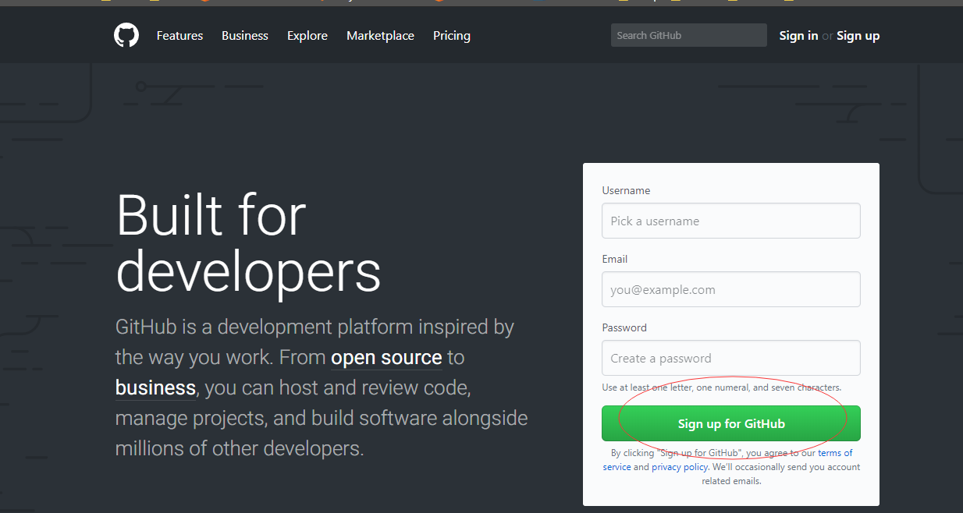

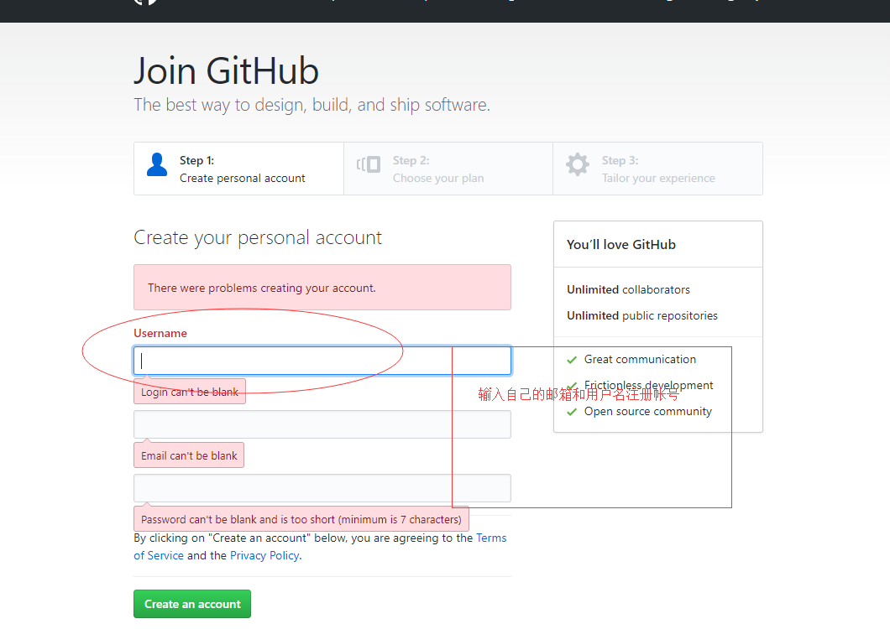

2、将注册好的github帐号的邮箱，私信给班主任，让她帮忙加入马哥教育python组织

<https://github.com/magedus/python-11> 组织地址

<https://github.com/magedus/python-11> 这是我们教作业的项目地址，以后的作业都是在这个仓库里面.

3、检查自己的邮箱是否有收到加入马哥教育python组织的邮件，如果没有检测邮件是否在垃圾桶中



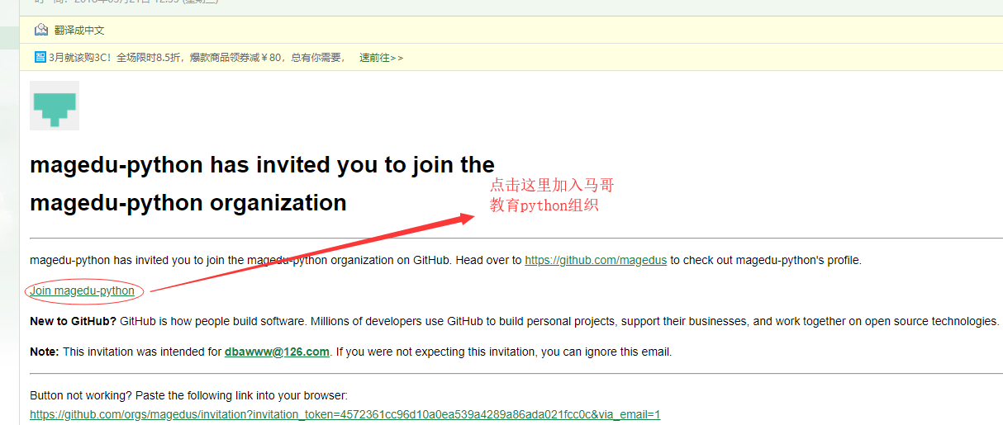

加入组织成功后能在组织里面找到自己的个人帐号

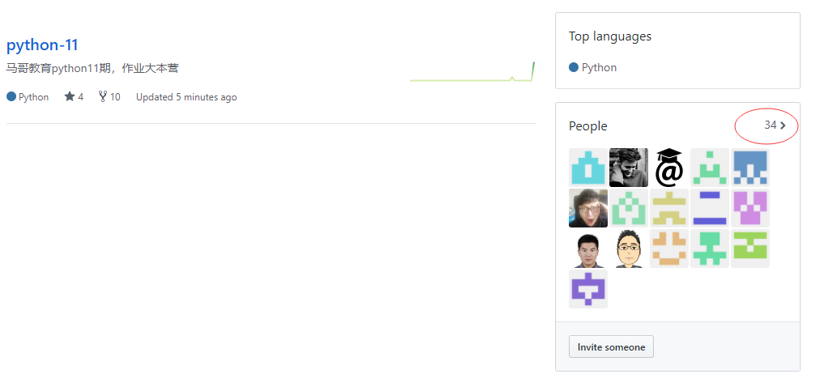

4、下载 git，安装git

<https://www.liaoxuefeng.com/wiki/0013739516305929606dd18361248578c67b8067c8c017b000> git教程

<http://rj.baidu.com/soft/detail/19969.html?ald> 在这里下载git软件包，点击下一步下一步就行

如果想使用图形工具，可以下载 <https://desktop.github.com/>

5、加入组织后，将组织中python-11项目clone到自己本地

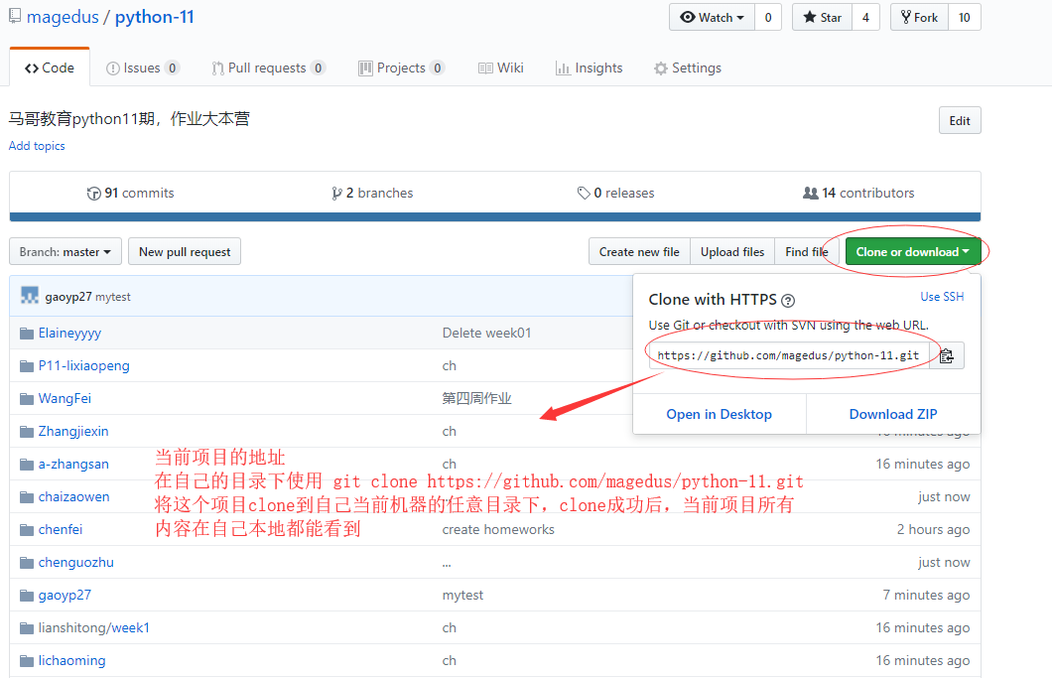

6、安装git成功后，在鼠标右键

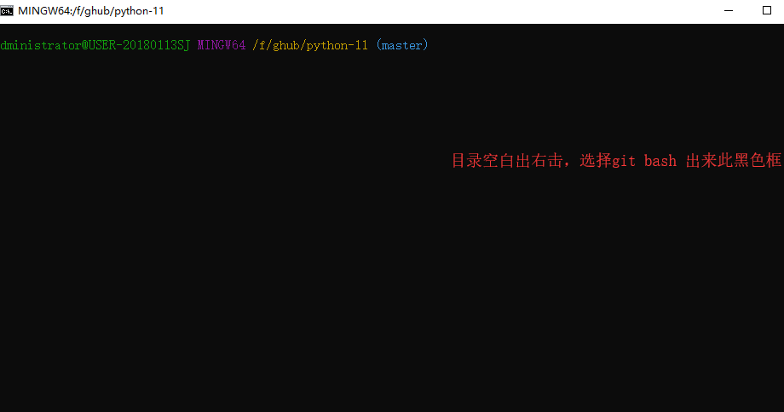

在命令行输入 git clone <https://github.com/magedus/python-11.git>

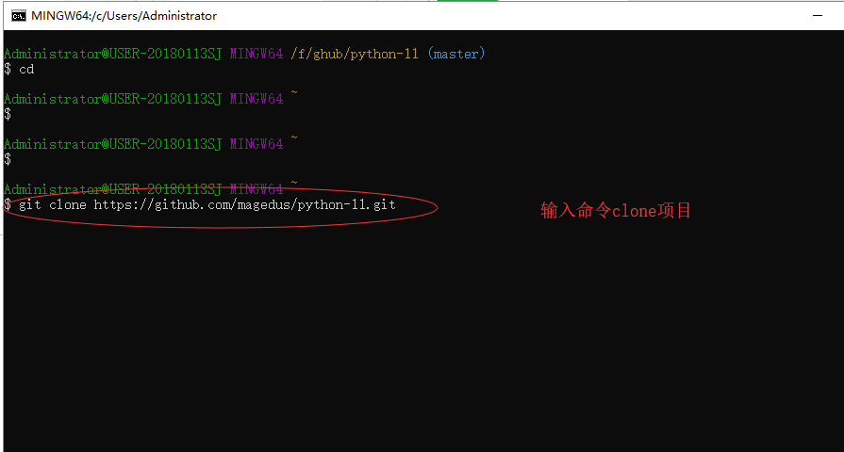

7、创建自己的个人作业目录

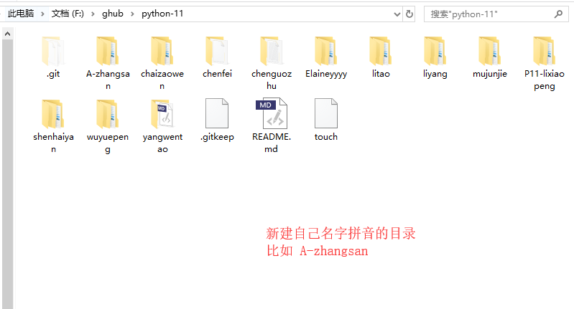

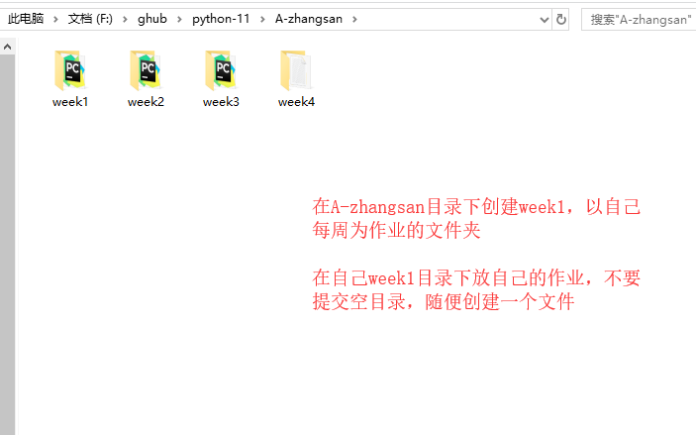

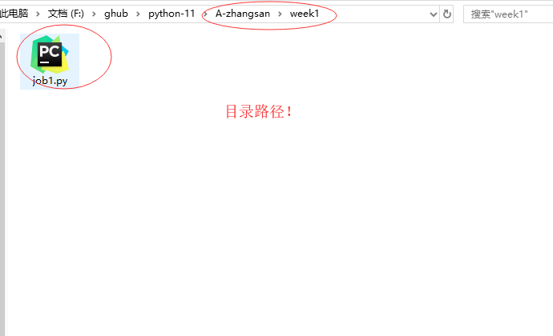

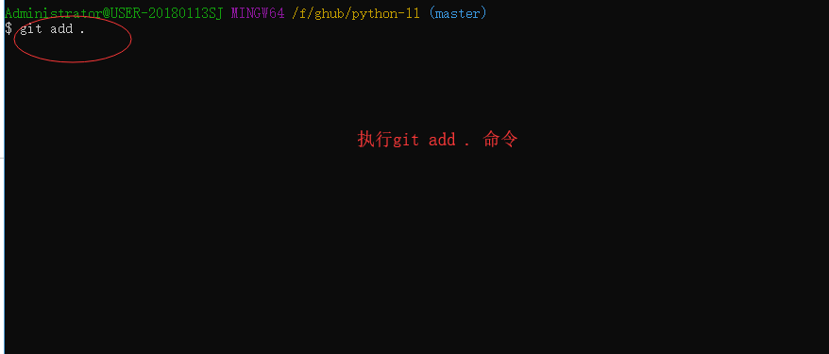

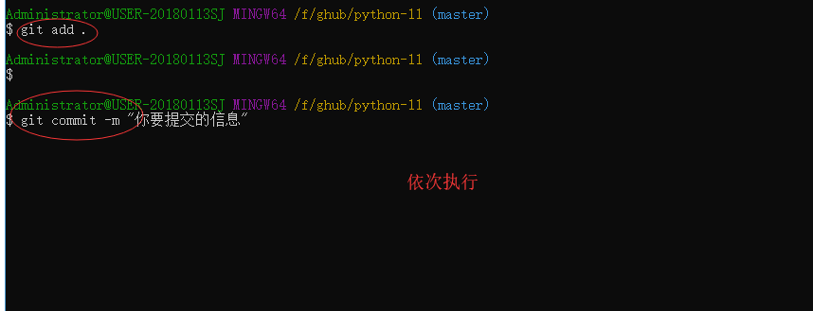

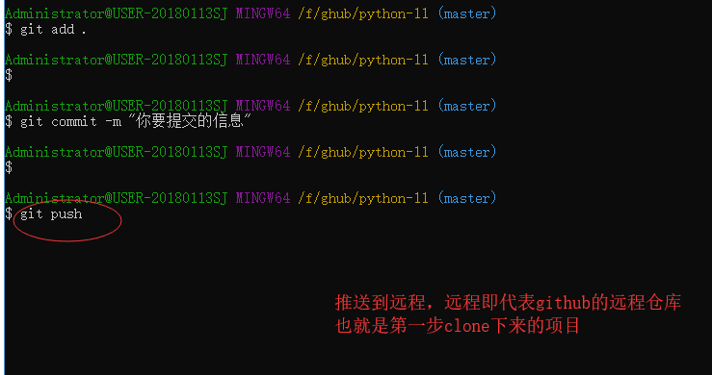

上交作业完成

以上演示了用命令如何操作github ，如果使用图形工具，大同小异，更加简单

下面是另外同学的操作记录，大家可以参考他的执行方式：

-----------------------分割线------------------------------------------

Administrator@U14PRP4WZWPTE2F MINGW64 /e/homework/python-11 (master)

$ git config --list

core.symlinks=false

core.autocrlf=true

core.fscache=true

color.diff=auto

color.status=auto

color.branch=auto

color.interactive=true

help.format=html

rebase.autosquash=true

http.sslcainfo=d:/Program Files/Git/mingw64/ssl/certs/ca-bundle.crt

http.sslbackend=openssl

diff.astextplain.textconv=astextplain

filter.lfs.clean=git-lfs clean -- %f

filter.lfs.smudge=git-lfs smudge -- %f

filter.lfs.process=git-lfs filter-process

filter.lfs.required=true

credential.helper=manager

user.name=jowinchai

user.email=chaizaowen@163.com

color.ui=true

gui.recentrepo=E:/homework

core.repositoryformatversion=0

core.filemode=false

core.bare=false

core.logallrefupdates=true

core.symlinks=false

core.ignorecase=true

remote.origin.url=git@github.com:magedus/python-11.git

remote.origin.fetch=+refs/heads/*:refs/remotes/origin/*

branch.master.remote=origin

branch.master.merge=refs/heads/master

Administrator@U14PRP4WZWPTE2F MINGW64 /e

$ mkdir homework

Administrator@U14PRP4WZWPTE2F MINGW64 /e

$ cd homework/

Administrator@U14PRP4WZWPTE2F MINGW64 /e/homework

$ git clone git@github.com:magedus/python-11.git

Cloning into 'python-11'...

Warning: Permanently added the RSA host key for IP address '13.250.177.223' to the list of known hosts.

remote: Counting objects: 44, done.

remote: Compressing objects: 100% (32/32), done.

remote: Total 44 (delta 3), reused 14 (delta 0), pack-reused 0

Receiving objects: 100% (44/44), 9.88 KiB | 37.00 KiB/s, done.

Resolving deltas: 100% (3/3), done.

Administrator@U14PRP4WZWPTE2F MINGW64 /e/homework

$ ls

python-11/

Administrator@U14PRP4WZWPTE2F MINGW64 /e/homework

$ cd python-11/

Administrator@U14PRP4WZWPTE2F MINGW64 /e/homework/python-11 (master)

$ mkdir -pv chaizaowen/week{1,2,3}

mkdir: created directory 'chaizaowen'

mkdir: created directory 'chaizaowen/week1'

mkdir: created directory 'chaizaowen/week2'

mkdir: created directory 'chaizaowen/week3'

Administrator@U14PRP4WZWPTE2F MINGW64 /e/homework/python-11 (master)

$ vim chaizaowen/week1/.gitkeep #git不允许提交空目录

##################################

注：.gitkeep文件内容为

# Ignore everything in this directory

*

# Except this file !.gitkeep

##################################

Administrator@U14PRP4WZWPTE2F MINGW64 /e/homework/python-11 (master)

$ cp !$ chaizaowen/week2/

cp chaizaowen/week1/.gitkeep chaizaowen/week2/

Administrator@U14PRP4WZWPTE2F MINGW64 /e/homework/python-11 (master)

$ cp chaizaowen/week1/.gitkeep chaizaowen/week3/

Administrator@U14PRP4WZWPTE2F MINGW64 /e/homework/python-11 (master)

$ git add chaizaowen/

warning: LF will be replaced by CRLF in chaizaowen/week1/.gitkeep.

The file will have its original line endings in your working directory.

warning: LF will be replaced by CRLF in chaizaowen/week2/.gitkeep.

The file will have its original line endings in your working directory.

warning: LF will be replaced by CRLF in chaizaowen/week3/.gitkeep.

The file will have its original line endings in your working directory.

Administrator@U14PRP4WZWPTE2F MINGW64 /e/homework/python-11 (master)

$ git commit -m "jowin's homework directory"

[master 98a18fd] jowin's homework directory

3 files changed, 9 insertions(+)

create mode 100644 chaizaowen/week1/.gitkeep

create mode 100644 chaizaowen/week2/.gitkeep

create mode 100644 chaizaowen/week3/.gitkeep

Administrator@U14PRP4WZWPTE2F MINGW64 /e/homework/python-11 (master)

$ git push origin master

Warning: Permanently added the RSA host key for IP address '52.74.223.119' to the list of known hosts.

Counting objects: 5, done.

Delta compression using up to 2 threads.

Compressing objects: 100% (4/4), done.

Writing objects: 100% (5/5), 440 bytes | 220.00 KiB/s, done.

Total 5 (delta 1), reused 0 (delta 0)

remote: Resolving deltas: 100% (1/1), completed with 1 local object.

To github.com:magedus/python-11.git

5dca0a8..98a18fd master -> master