**Preliminary Goal Planner tool screens**

These are the current prototype page designs. The site uses existing Foundersuite assets and styles as a basis for the design. New elements are designed to be consistent with the FS theme. The prototype is navigable and simulates all interactions other than data edits/additions.

Production logic is under development and will be added to screens following finalization of designs.

## goal management

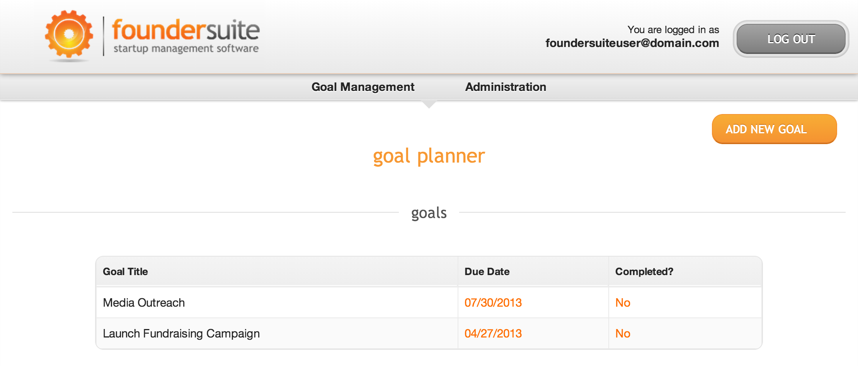

In progress: add/edit goal screen allowing users to select

## goal-specific screens (overview and details)

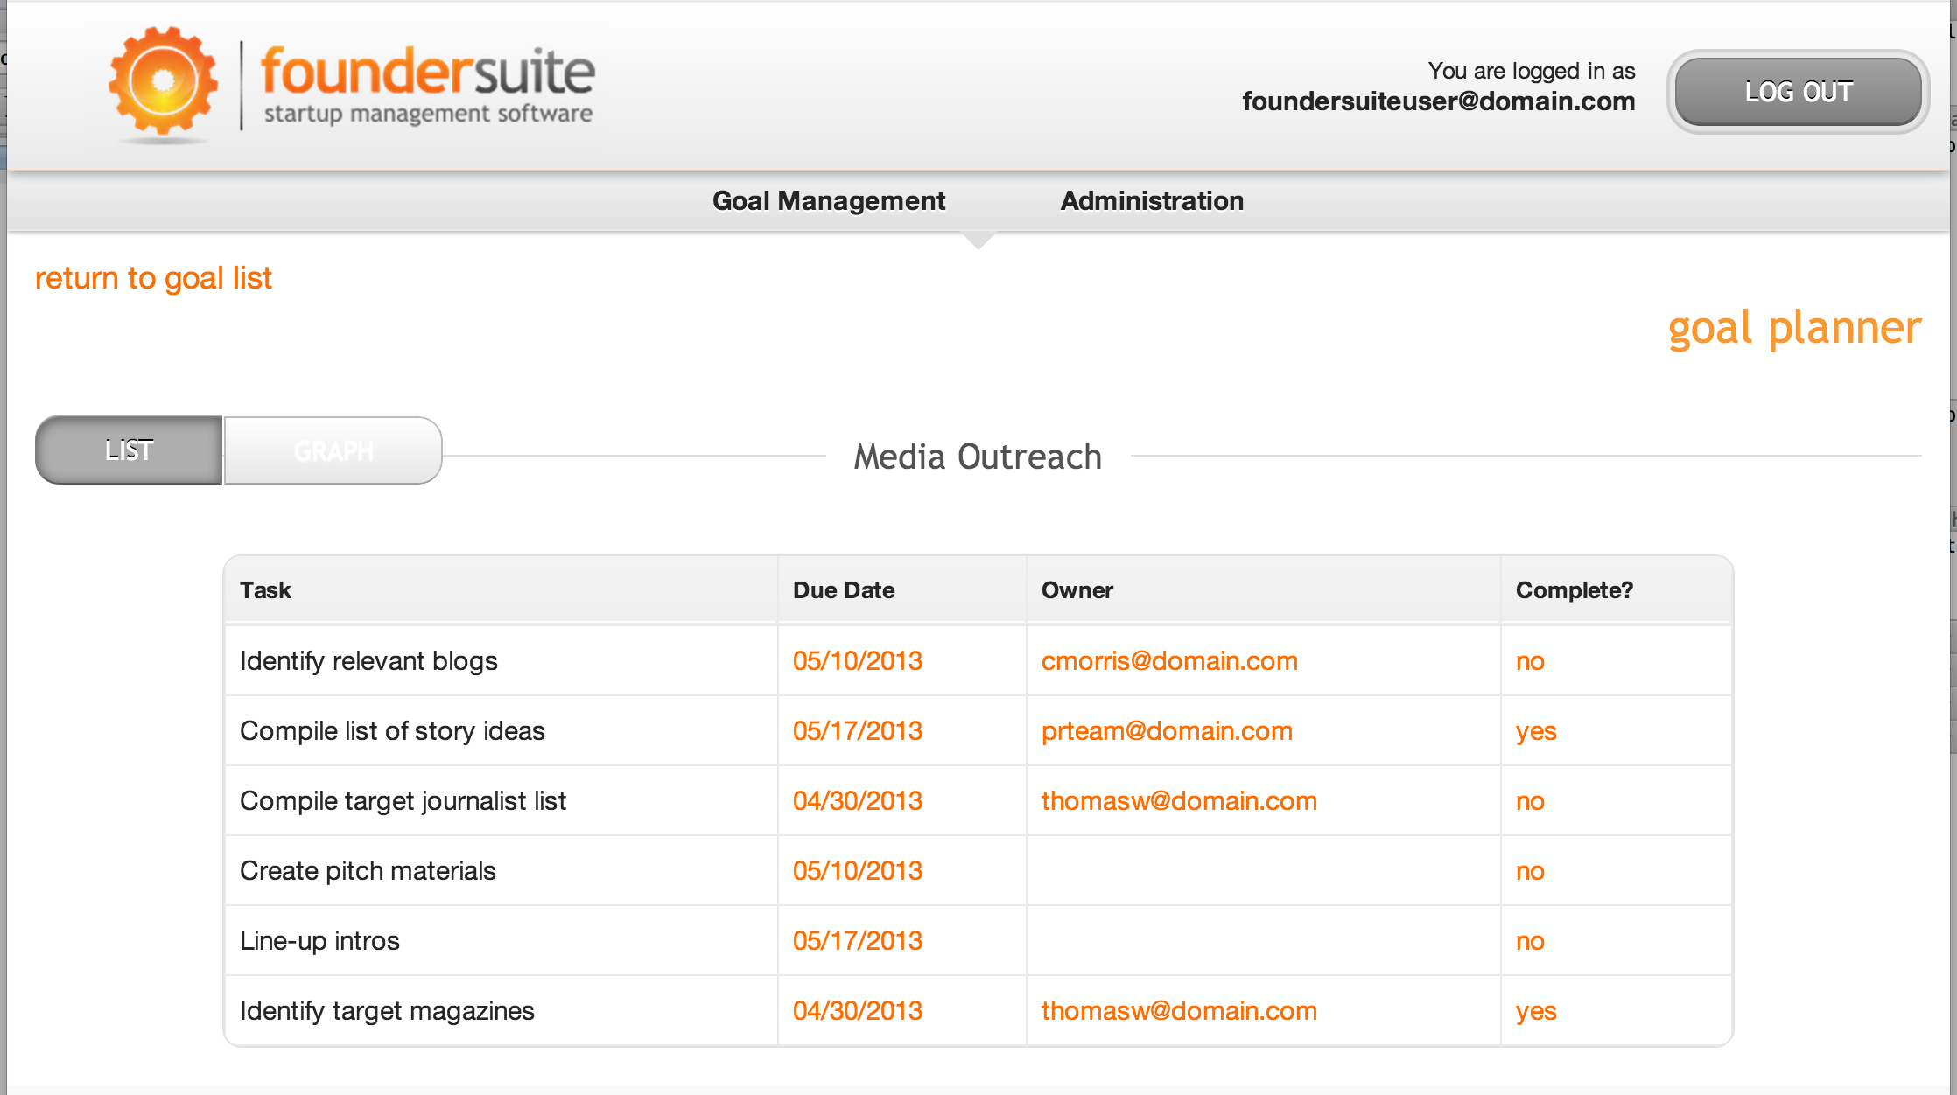

Note: button names have been changed from “list & graph” to “overview & details.”

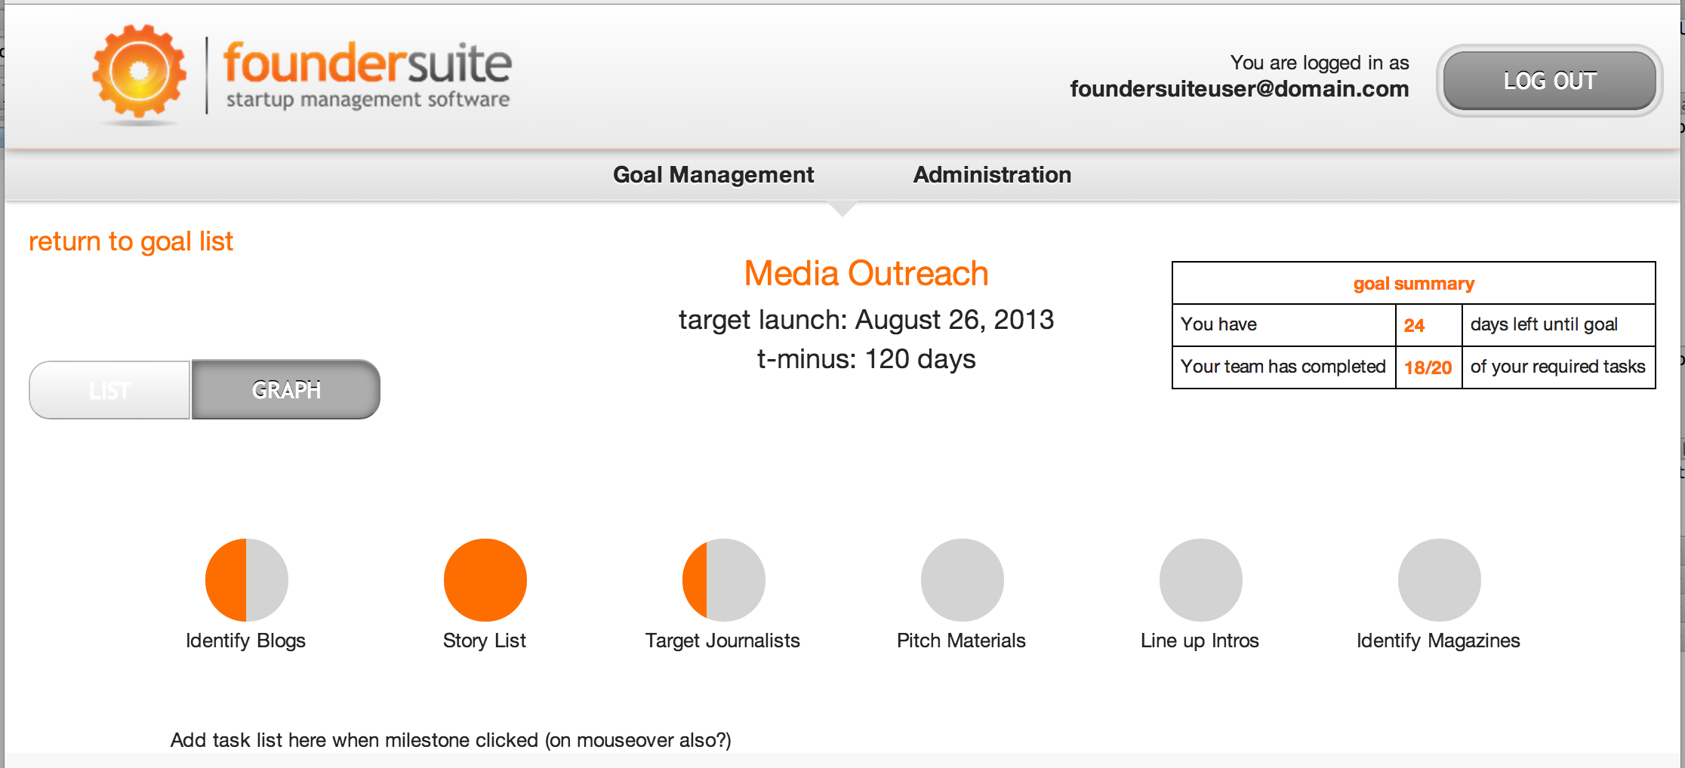

In progress. To be added: on click of each milestone progress dot/label above, the list of subordinate tasks will appear below. Users will be able to check off tasks, assign users and due dates for each.

Note: button names have been changed from “list & graph” to “overview & details.”

## team member administration

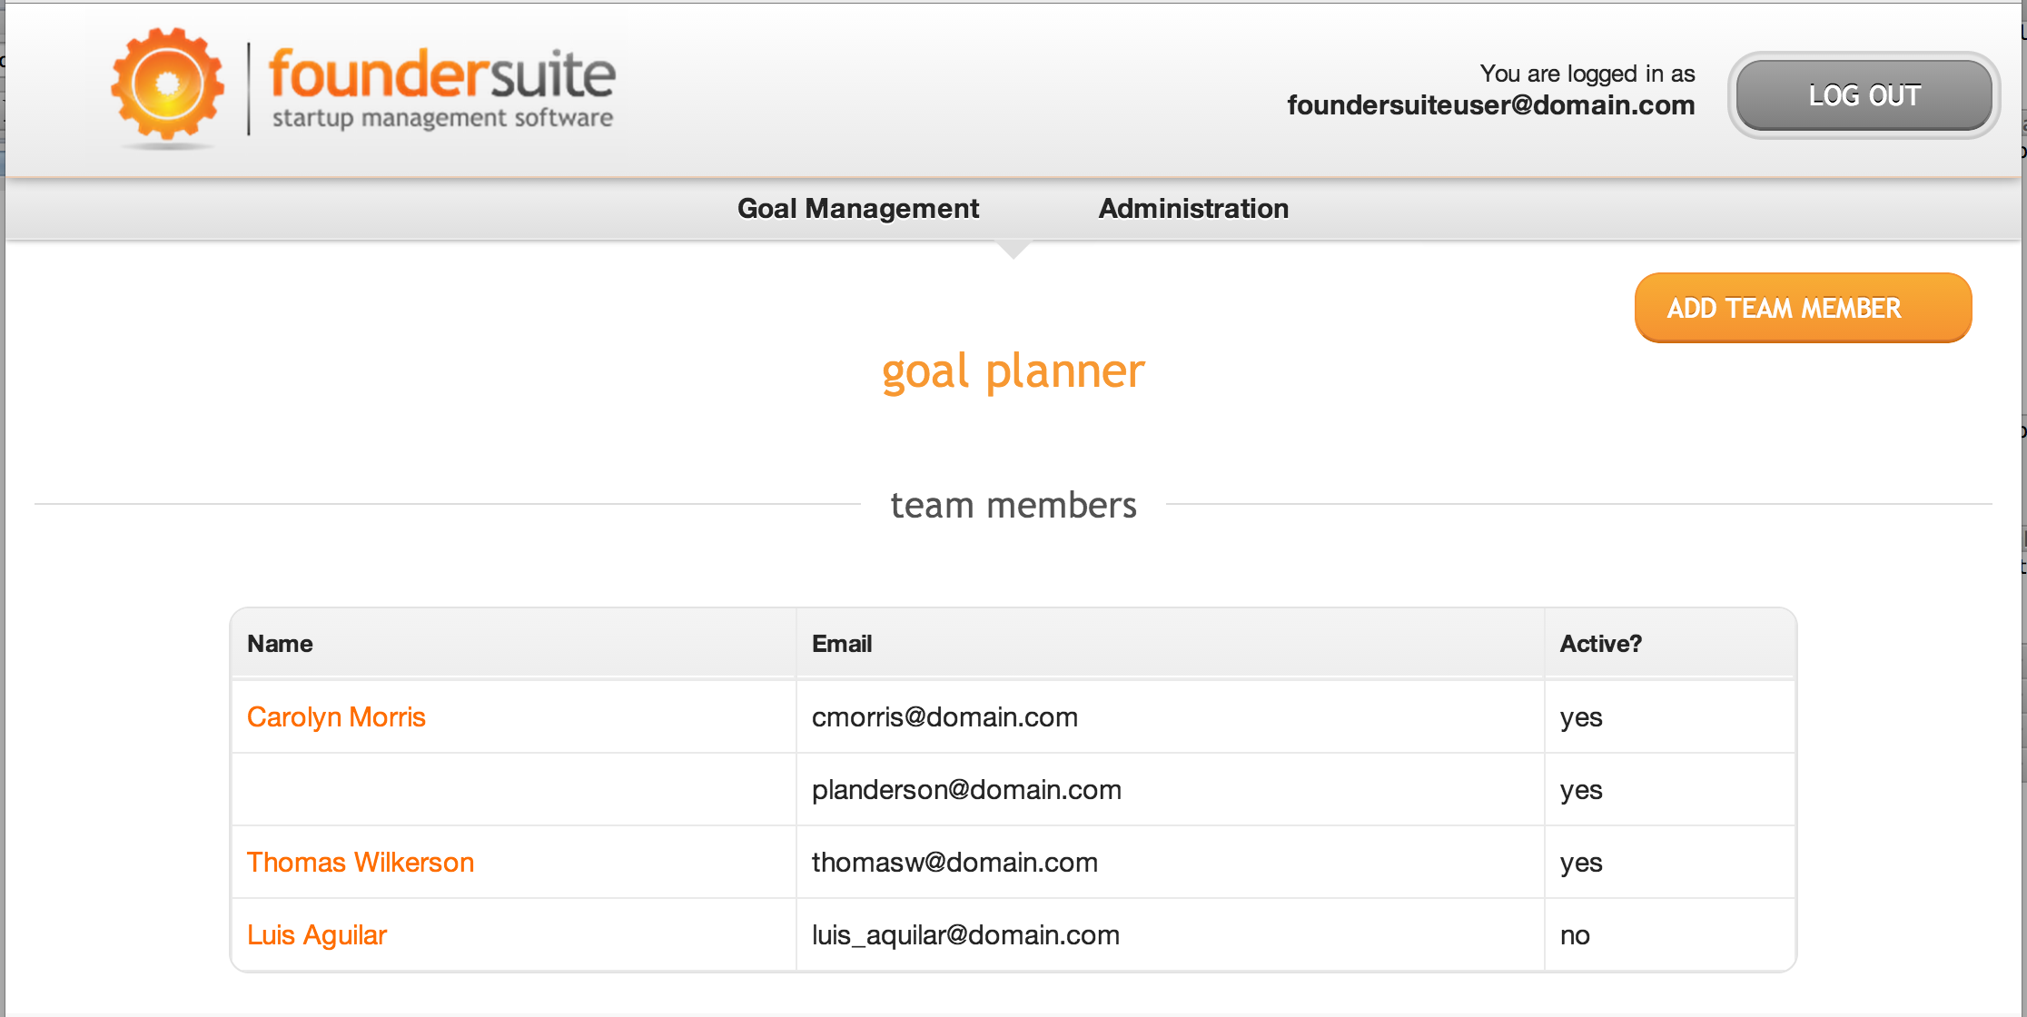

In progress: Team member details page under development. To be complete today. Each detail page will allow the user to modify first and last name, add an email address, set the user’s status to active or inactive. In addition, an optional section will show all assigned tasks for that user (time permitting).

## template administration

In progress.