AdminExtra  
for Magento® 1

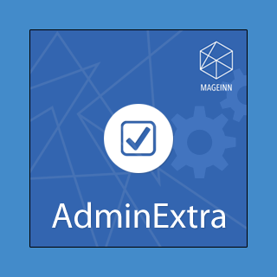

### User Guide

### Configuration

To enable module go to “**System->Configuration->Mageinn->AdminExtra**” section.

There are 2 settings:

1. Enabled – switches module on/off
2. Don’t copy images when duplicating product – allows to clear images gallery on product duplicate.
3. Reset URL key when duplicating – allows to unset “Create Permanent Redirect for old URL” checkbox when duplicating product

Set “Enabled” parameter to “Yes” and click “Save Config” button to save configuration.

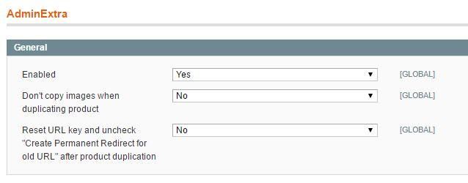

### Product Duplication

If you don’t want to copy images when duplicating product, module allows you to do that. Set module’s configuration parameter “Don’t copy images when duplicating product” to “Yes”. Then when you click “Save & Duplicate” button on product edit page media gallery will be cleared for the new product.

### 

### Attributes Mass Action

Module allows you to set/reset “Use Default Value” option for any attributes and images on a store level using adminmass action.

Select several products and choose “Update attributes” action from dropdown.

### 

Select Store View first and then set required “Use Default” checkboxes or “Copy from Default”.

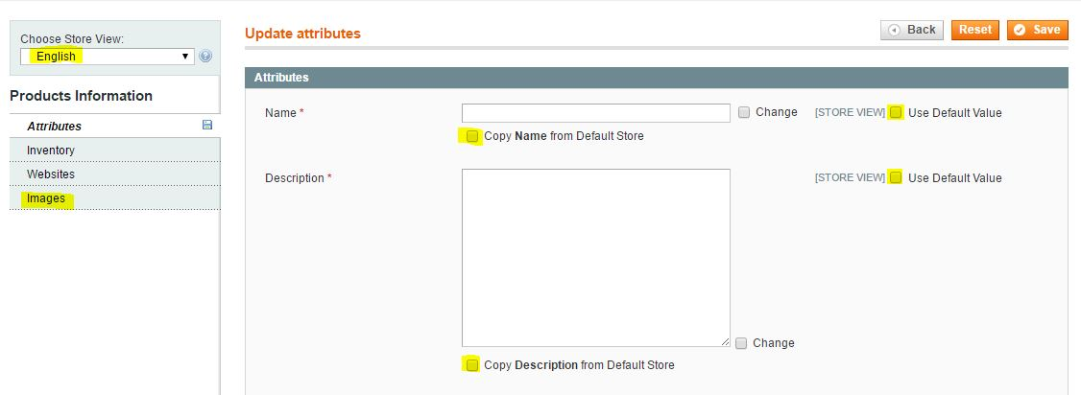

### Enjoy it https://mageinn.atlassian.net/images/icons/emoticons/smile.png

If you have any issues with the module please raise a support ticket [here](https://mageinn.atlassian.net/servicedesk/customer/portal/1).