Hints  
for Magento® 1

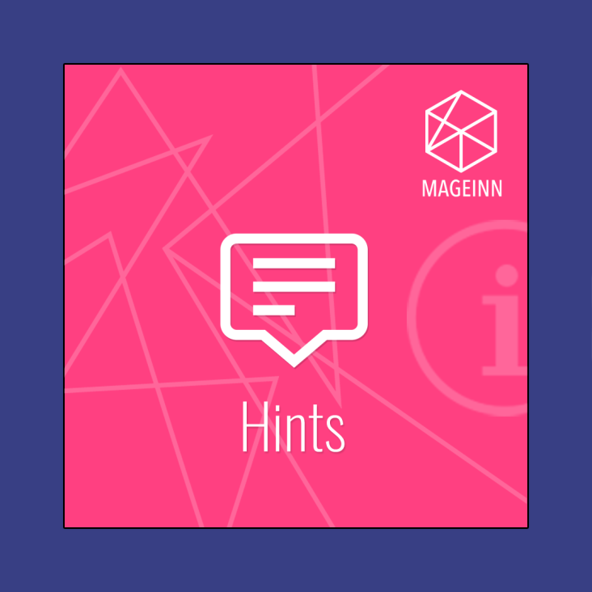

### User Guide

### User Guide

To enable module go to “System->Configuration->Mageinn->Attribute’s Hints” section.

You can create your own template for module and use it instead of default. If you want to do that please set "Use Default Templates" parameter to "No" and change appropriate template path to point to your custom template.

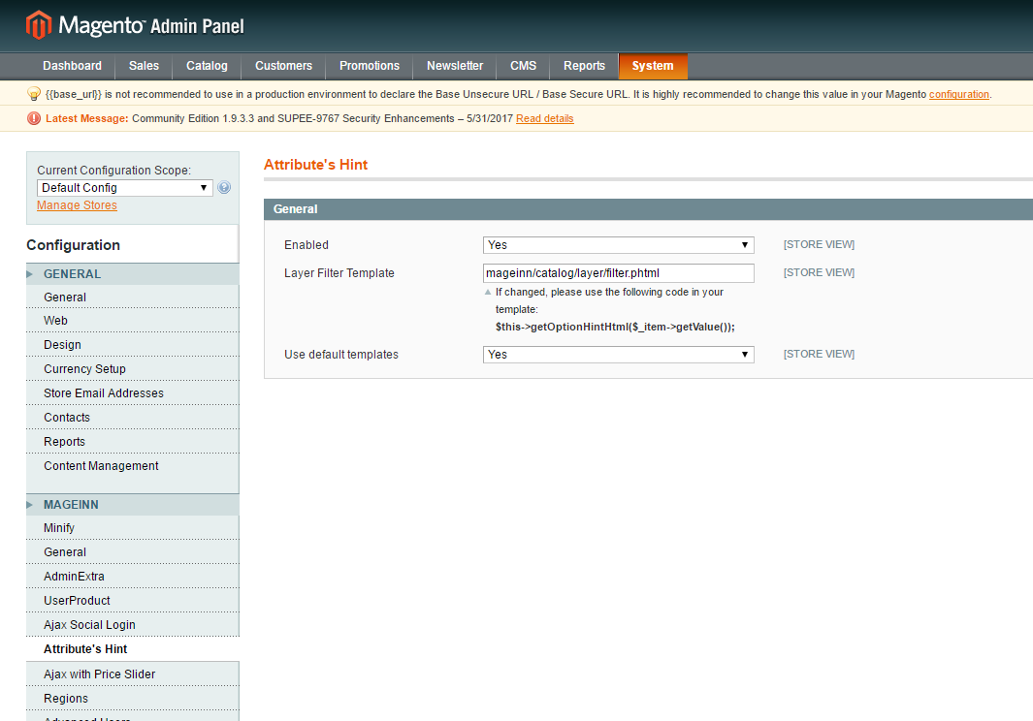

### Hints for Attributes

1. Module allows you to set custom hints for attribute’s title. Select “Hints” tab in attribute edit page and add hint for attribute using WYSIWIG editor.

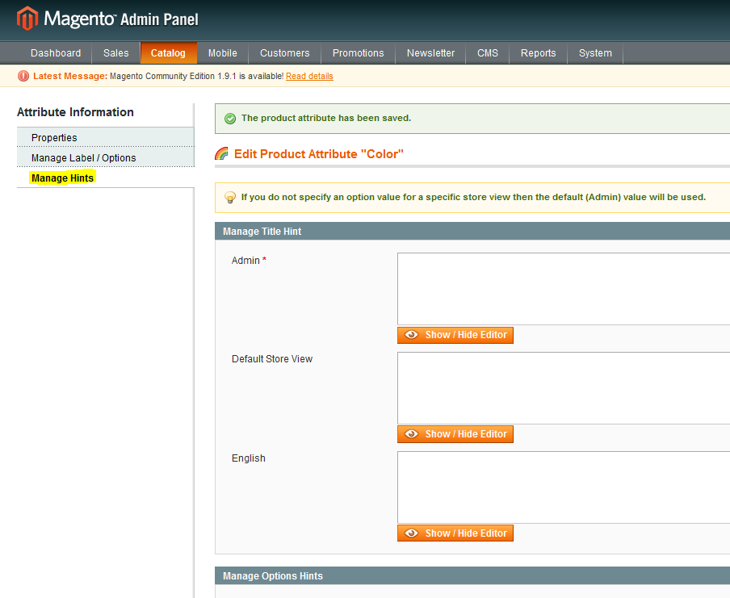

…you can also set tooltips for attribute’s options.

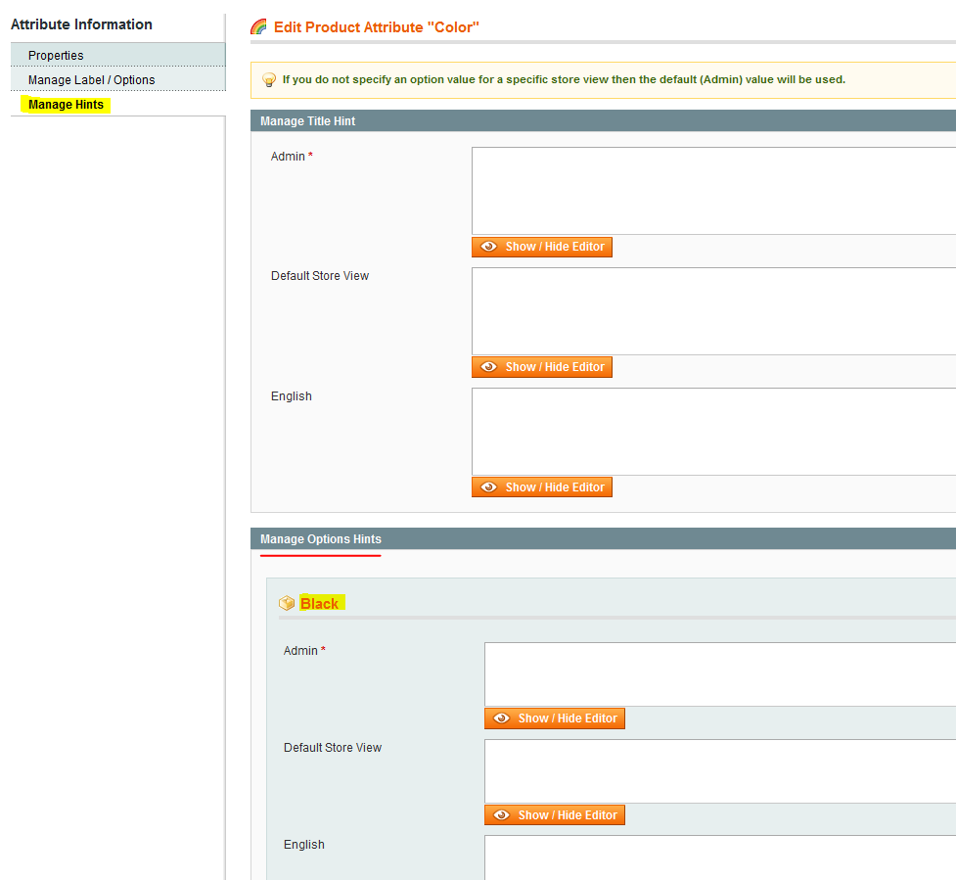

When an attribute or its option has a tooltip, it will have an info icon created next to the name on the frontend.

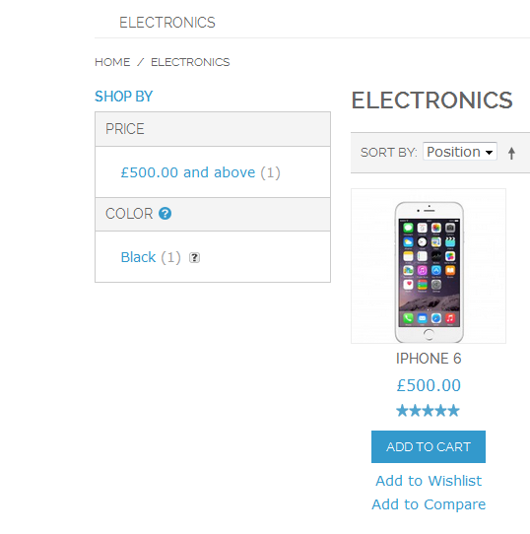

Info icons are being created in the layered navigation block as well as on the product view page and in the compare window. When the icon is hovered, a tooltip with a description will pop up.

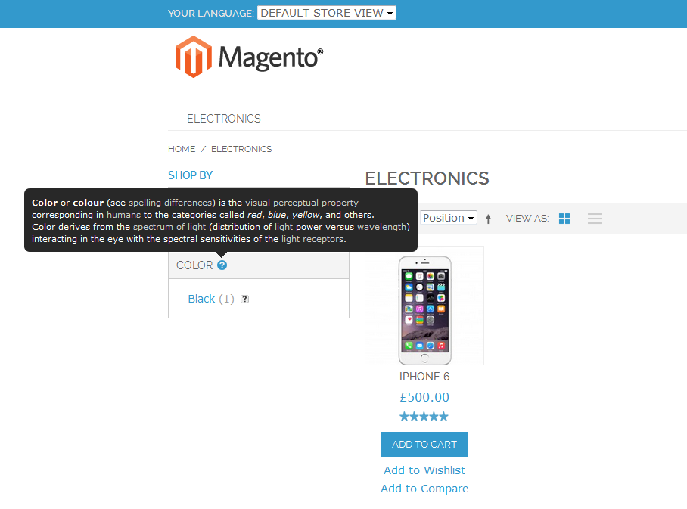

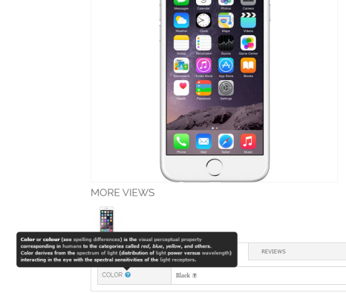

1. Module also allows you to set hints for product’s custom options

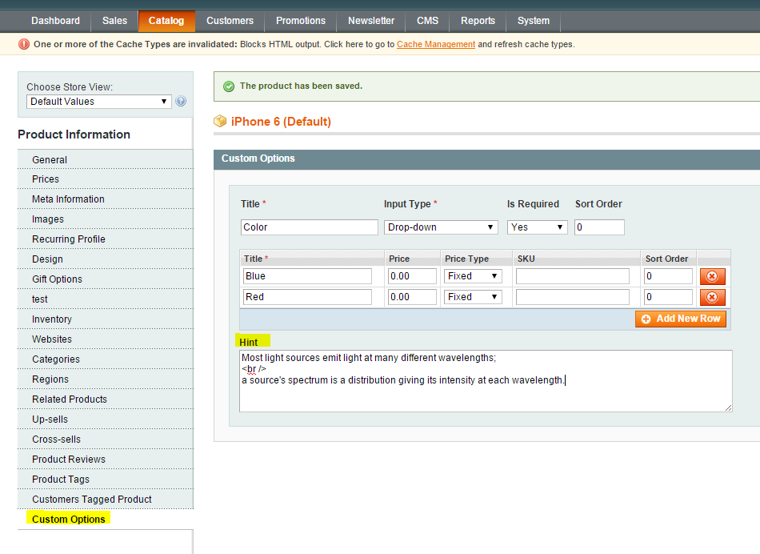

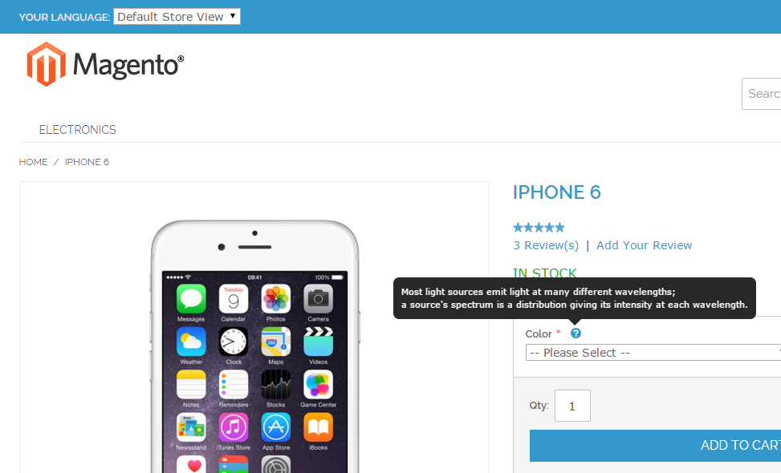

1. Enjoy it https://mageinn.atlassian.net/images/icons/emoticons/smile.png

If you have any issues with the module please raise a support ticket [here](https://mageinn.atlassian.net/servicedesk/customer/portal/1).