AJAX Price Slider with Multiselect  
for Magento® 1



### User Guide

### User Guide

To enable module go to “System->Configuration->Mageinn->Ajax with Price Slider” section. Set “Enable Module” to “Yes” and refresh Magento cache.

1. **Configuration options**

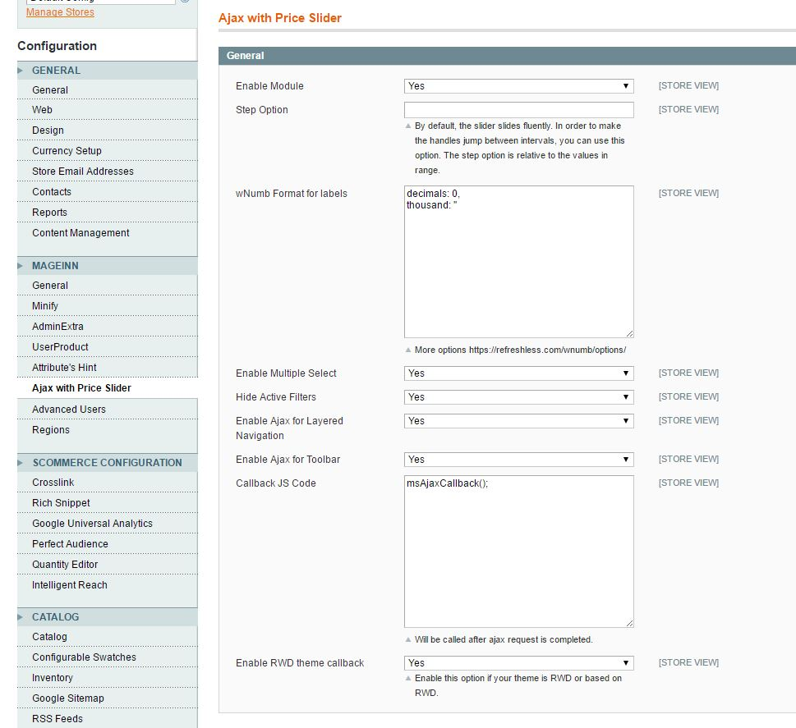

**Step Option**

By default, the slider slides fluently. In order to make the handles jump between intervals, you can use this option. The step option is relative to the values in the range

**wNumb** **Format for labels**

You can use wNumb options to format prices output. You can use additional options described here <https://refreshless.com/wnumb/options/>

**Enable Multiple Select**

This option allows you select multiple attribute values with checkboxes

**Hide Active Filters**

Hides active filters on the filter panel

**Enable Ajax for Layered Navigation**

If “Yes” then AJAX request will be used to update results instead of whole page refresh.

**Enable Ajax for Toolbar**

If “Yes” then AJAX call will be used on the toolbar instead of whole page refresh

**Callback JS Code**

You can use custom JavaScript code callback after AJAX call to do custom jobs after update

**Enable RWD theme callback**

Enable this option if your theme is RWD or based on RWD

1. **Using**

After installation and configuration you will see improved layered navigation on the frontend

Example of Layered navigation panel with enabled module

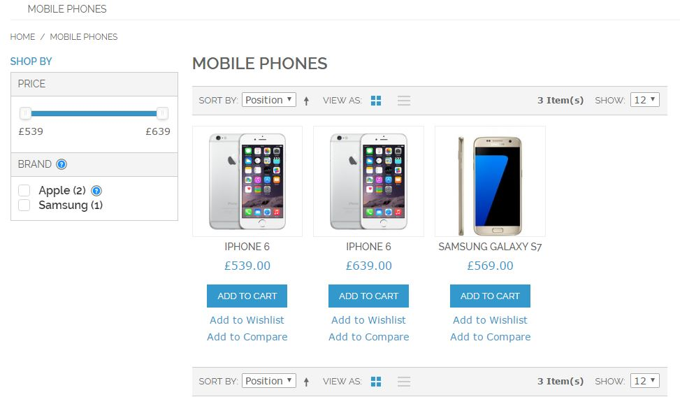

Responsive layout on mobile devices

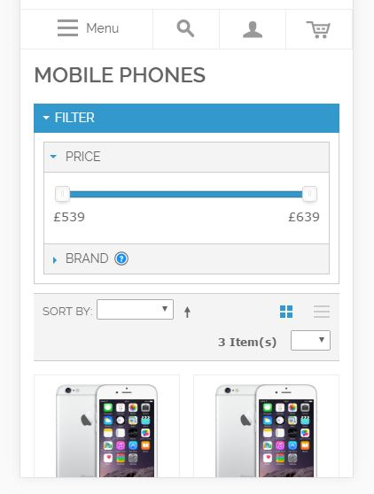

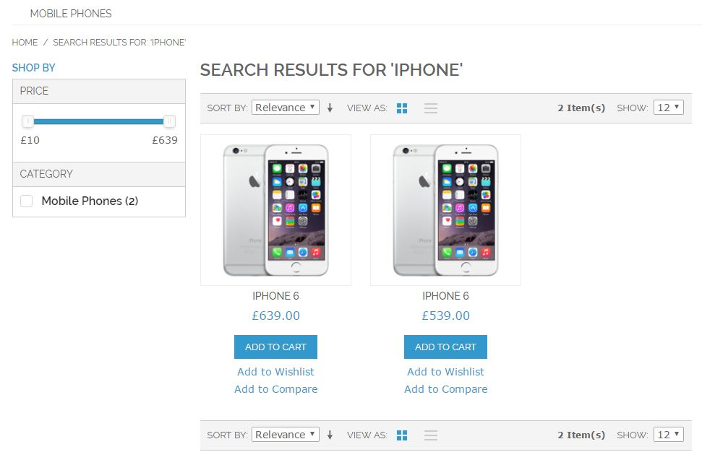

1. **Enjoy it** https://mageinn.atlassian.net/images/icons/emoticons/smile.png

If you have any issues with the module please raise a support ticket [here](https://mageinn.atlassian.net/servicedesk/customer/portal/1).