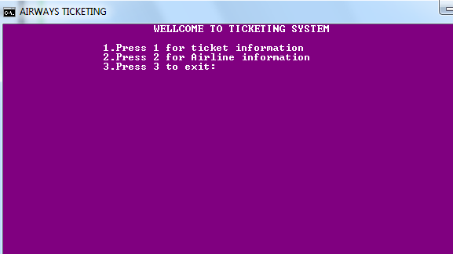

CS360_C++LAB_FINAL_PROJECT
GROUP MEMBERS
SHAHED & GUOJINDONG
April 15, 2014

EXECUTIVE SUMMARY

Objective Airplane Ticket System

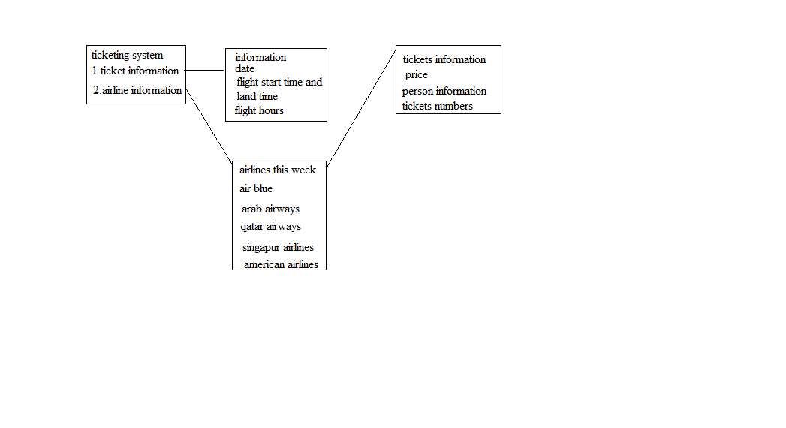Goals
1. Set up airline schedule for one week. Initiate pilot, flight attendances, and airline for each airline on main function or use file open.
2. Use switch to show options for checking airline and ticket option.
3. Input passenger information when purchase ticket.
4. Display all passengers for one airline.

Knowledge
1. Three different constructor and destructor. Get and set functions.
2. Display function.
3. Inheritance, composition, and aggregation.
4. Overloading and overriding functions.
5. Operator overloading.
6. Polymorphs and virtual function.
7. Constant variables or methods.
8. Dynamic memory allocation.
9. This pointer.
10. Friend function.
11. File open.
12. Exception.

Project Outline
1.Person class with first_name, last_name, gender, age, address, city, state, zip_code, phone_number .get and set functions for accessing and modifying elements. Display function to display information.
2.Pilot class by inherit Person class, and add flight_hour, position get and set functions for accessing and modifying elements. Display function to display information.
3. FlightAttendance class by inherit Person class, and add height, weight, and position (purser or crew member), get and set functions for accessing and modifying elements. Display function to display information.
4.Airline class with start_city, land_city, start_time, and land_time, flight_hour (=land_time - start_time), company, ID, type, pilots and flight_attendances. function to set up crew and Display information.
5. Ticket class with number, price, airline, and passenger. setPrice function to set up price based on age, flight_hour, and seat_class (coach, business, or first). setAirline function to set up airline, setPassenger to set up passenger, Display function for display information .

Thanks
Thanks to our Instructor Ms.Zhang,Irene , whiteout her advice project will not doing perfectly.
Thanks to all group members hardworking.

screen shorts

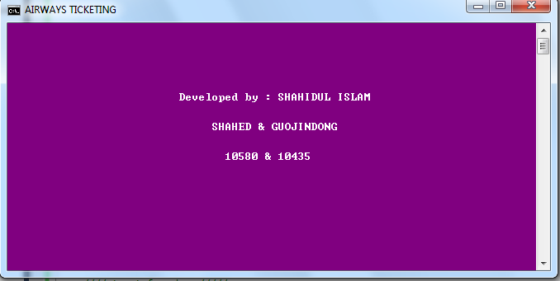

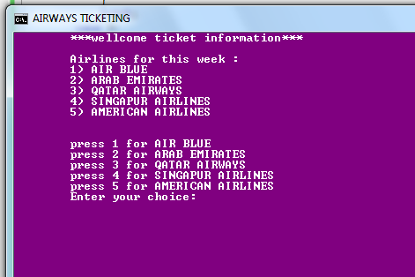

system’s menu
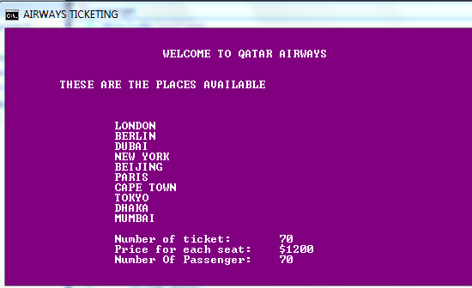
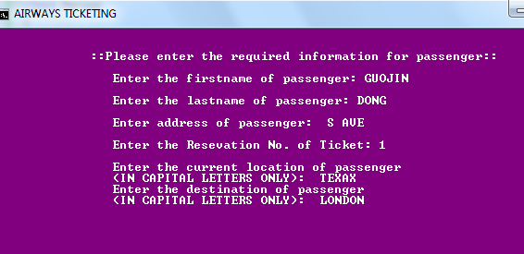
when customers purchasing tickets

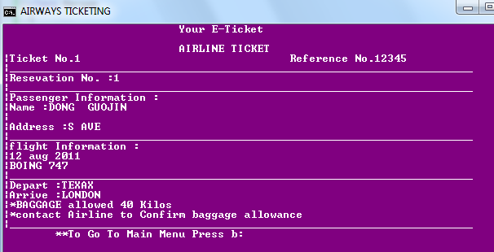

this the show function which shows the detail of tickets purchased by customers.

Improvement
We want make our own website run own database, have a nice GUI make it more friendly use.

