CPR Broker
How to setup CPR Broker to work with Serviceplatformen

© Copyright 2015

Last Updated: 11 Dec 2015

Table of Contents
Introduction 3
Service Agreement 4
Required Services 6
Service CPR Abonnement 6
Service ADRSOG1 7
Service STAM+ 7
Service Familie+ 8
SFTP 9
TODO: Key-type + key-length + WINSCP & Putty-keyformat 9
Certificate Installation 10
Configure Data provider 11

Introduction
This document will describe how to setup CPR Broker to work with Serviceplatformen as a data provider. For instructions on installing and configuring CPR Broker in general you should consult the documentation dedicated to these topics.
This document will go through the services that needs to be activated at Serviceplatformen by the entering of a service agreement and provide links to the videos and guides at Serviceplatformen regarding this.
The document will also cover configuring Serviceplatformen as a data provider for CPR Broker – as well as the installation of a certificate needed to secure the communication between the CPR Broker installation and the services at Serviceplatformen.

Service Agreement

CPR Broker utilizes a set of services at Serviceplatformen, and all these services must be available for CPR Broker to use Serviceplatformen as a data provider. To make the services available for CPR Broker the municipality must enter into a service agreement (“serviceaftale”) with Serviceplatformen. The next chapter lists the needed services. In this chapter links will be provided to guides to establish the needed service agreement for the municipality. In the process to establish the needed service agreement Serviceplatformen stipulates particular steps to be taken by the vendor of the IT-system (i.e. CPR Broker) and the municipality. Serviceplatformen has provided the following two small videos, to guide you through the steps needed to establish the needed service agreement, whether you're playing the part representing the vendor or you're representing the municipality. (If you're representing a municipality and wish to play both the parts of vendor and municipality in establishing the service agreement, you should probably contact support at Serviceplatform for questions regarding feasibility and guidance).
The link for the videos can be found here: https://www.serviceplatformen.dk/administration/help/provider-guidance
The direct links are provided below:
Vendor Guide Video: | https://vimeopro.com/user10267807/serviceplatformen/video/127578621
Municipality Guide Video: | https://vimeopro.com/user10267807/serviceplatformen/video/127578619

For more details, you may choose to consult the guides below:
Vendor Guide PDF: | https://www.serviceplatformen.dk/administration/doc/USM0002%20Vejledning%20til%20leverandoerers%20brug%20af%20Serviceplatformen.pdf
Municipality Guide PDF: | https://www.serviceplatformen.dk/administration/doc/USM0003%20Vejledning%20til%20kommuners%20brug%20af%20Serviceplatformen.pdf

To sum up the process of establishing the service agreement:
a) Both the municipality and the vendor must be each have logins at Serviceplatformen in accordance with their role in the agreement.
b) The vendor must have a certificate (“funktions-signatur”) from NETS, that is to be used with the particular CPR-Broker installation.

c) The vendor registers the particular installation of CPR Broker as a separate IT-System at Serviceplatformen. The before-mentioned certificate is tied to the IT-system as part of this process.
d) The vendor configures the service agreement, including all the needed services (listed in the next chapter), to be used with the particular CPR Broker installation and requests that the relevant municipality approves the service agreement.
e) The municipality approves the service agreement.

As already stated, the services that should be included in the service agreement is listed in the next chapter.

Required Services
The diagram included below provides an overview of the needed services – and in the sections below the needed services are listed in more detail.
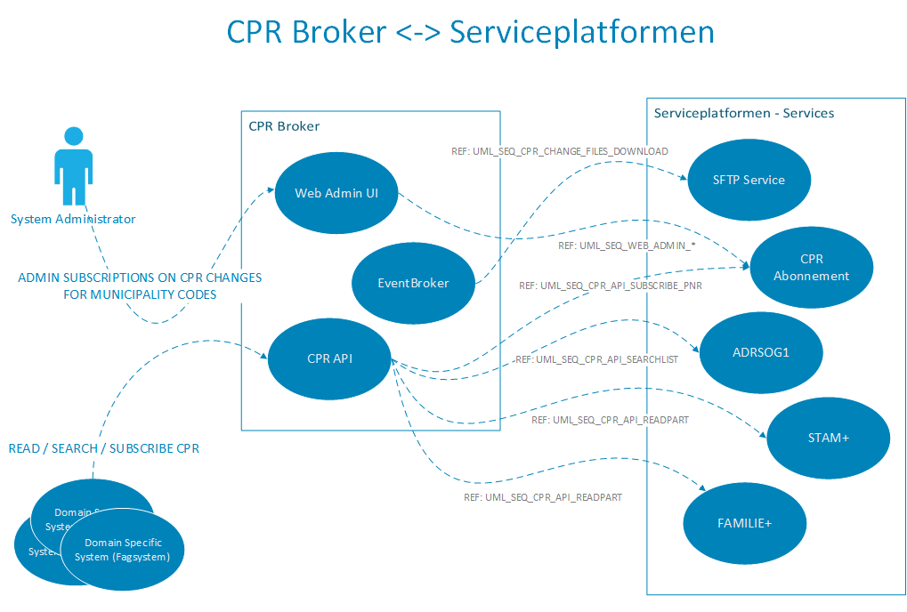Illustration 1: CPR Broker and Serviceplatformen services

Service CPR Abonnement

Service | Serviceplatformen Service UUID | URL
CPR Abonnement | 9cdccc2f-3243-11e2-8fef-d4bed98c5934 | https://www.serviceplatformen.dk/administration/serviceOverview/show?uuid=9cdccc2f-3243-11e2-8fef-d4bed98c5934

The 'CPR Abonnement'-service is needed for CPR Broker to receive updates from Serviceplatformen, when changes occur related to relevant CPR numbers. Serviceplatformen will generate files with the changed CPR numbers relevant for the particular CPR Broker installation and provide the files for download at a protected SFTP-account at their SFTP-service. Consult the URL in the table above for more information regarding the service.

Service ADRSOG1

Service | Serviceplatformen Service UUID | URL
ADRSOG1 - CPR Opslag (lokal) | 6538f113-b1e6-4b21-8fe1-28b7bf78a1bd | https://www.serviceplatformen.dk/administration/serviceOverview/show?uuid=6538f113-b1e6-4b21-8fe1-28b7bf78a1bd

The 'ADRSOG1 - CPR Opslag (lokal)'-service is needed for CPR Broker to perform searches in the replica of CPR data hosted by Serviceplatformen. Consult the URL above for more information regarding the service.

Service STAM+

Service | Serviceplatformen Service UUID | URL
STAM+ - CPR Opslag (lokal) | 7baec3a5-26a5-4922-80fd-37f3bad3dfcb | https://www.serviceplatformen.dk/administration/serviceOverview/show?uuid=7baec3a5-26a5-4922-80fd-37f3bad3dfcb

The 'STAM+ - CPR Opslag (lokal)'-service is needed for CPR Broker to read CPR records in the replica of CPR data hosted by Serviceplatformen. It supplements the service 'Familie+' by directly returning street and post district names in the lookup operations. Consult the URL above for more information regarding the service.

Service Familie+

Service | Serviceplatformen Service UUID | URL
Familie+ - CPR Opslag (lokal) | a34cf599-26e4-4609-bfbd-2490d3d1c3ab | https://www.serviceplatformen.dk/administration/serviceOverview/show?uuid=a34cf599-26e4-4609-bfbd-2490d3d1c3ab

The 'Familie+ - CPR Opslag (lokal)'-service is needed for CPR Broker to read CPR records in the replica of CPR data hosted by Serviceplatformen. It is supplemented by the service 'STAM+', that is also required (covered by the section dedicated to that service). Consult the URL above for more information regarding the 'Familie+'-service.

SFTP
For CPR Broker to be able to download the files with CPR changes from Serviceplatformen - (cf. the section regarding 'Service CPR Abonnement' above) – the IT-system (i.e. 'CPR Broker - municipality X') registered by the vendor at Serviceplatformen, must be tied to the public key of a key pair used in the encrypted and authorized communication between the particular CPR Broker installation and the SFTP-service hosted by Serviceplatformen.
Serviceplatformen has provided the following guide to their SFTP-service for IT-vendors:
https://www.serviceplatformen.dk/administration/doc/USM0005%20Vejledning%20til%20Serviceplatformens%20SFTP%20Service.pdf
For configuring CPR Broker to work with the SFTP-service you need to complete the steps in the section '6.1.1.1 Generering af SSH nøgler' and in the section '4 Oprettelse af SFTP-aftale på Serviceplatformen'.

TODO: Key-type + key-length + WINSCP & Putty-keyformat

Certificate Installation

TODO!

Configure Data provider

TODO!

adresse
Studiestræde 14, 1.
1455 København K
email
info@magenta-aps.dk
telefon
(+45) 33 36 96 96

