PART Standard
for
CPR Broker

Contents
1 Overview 3
2 Use cases 4
3 Request processing layers 5
4 Data Providers 6
5 Registrations 7
6 Data structures 10
7 Read & List operations 13
8 Search operation 14
9 Events 15

Introduction

The CPR Broker is an implementation of the PART Standard.
The CPR Broker can be employed in organizations that make use of CPR.
The interface defined in the PART standard enable the organizations to use the same interface to access CPR from several sources. I allow suppliers of solutions to base their products on a single interface that can be used by many organizations.
The CPR Broker holds CPR data. This ensures better performance, less latency, and more reliability. I many cases It will also results in cost-savings for the organizations, depending of the contracts they have with providers of CPR data.
The CPR broker is also able to provide more information than is available from existing providers because it keeps more historical data, such as bi-temporal registrations and because organizations will be able to provide CPR data directly to the broker without being restricted to policies and technical limitations of external providers.
There are three kinds of interfaces

PART and Event Interface

This interface is specified by the PART standard.
It is used by applications inside organizations that need CPR data.
It also covers subscriptions to events and notification of events. I.e BirthdayRegistration allows a service to register itself to receive notifications when all or a specified subset of person reach a given age.
This interface is read-only for CPR data, but it does allow applications to change the state of the broker to e.g. maintain the list of notification registrations.

CPR Data Provider Interfaces

The interfaces towards the existing external providers of CPR data are not standardized yet. That is one of the motivations to use the CPR Broker in an organization. Therefore the CPR Broker have implemented adapters for some existing providers. In this version DPR and KMD is supported. Internally in the CPR Broker, Data Providers are represented by adapter objects, providing a common interface, to simplify addition of more data providers.
In addition to the interfaces implemented by existing data providers, the CPR Brokers also have a ReadRefresh service, that allow data providers to signal to the CPR Broker that data for specified persons have been updated. Currently no data providers have implemented such event signaling and because the events originate outside the organizations using the CPR Broker, the broker itself can not do it.
However Gentofte Municipality have developed a service that simulated propagation of events by polling DPR and on update invoking ReadRefresh on the CPR Broker.

Using PersonMaster to create UUID's for persons

PART make use of UUID's to identify persons. The CPR Broker as well as other applications based on PART will be deployed in many organizations and must be able to exchange information about persons. Therefore a CPR broker installation cannot assign its own UUID's to persons. Gentofte Municipality have developed a service, PersonMaster that can assign UUIDs to persons and provide UUIDs of persons based on current CPR numbers.

Administration Interface

This interface is for administering the CPR Broker. i.e., Configuring, authorizing applications, logging etc.

Overview

Use cases

The use case for client application is to look up person data and to subscribe to person events.

Request processing layers

Data Providers
Client requests require access to at least one data provider to ensure that the answer is up-to-date. If no data providers are accessible an error is returned to the client.
A request is handled by a method implemented the corresponding web interface.
A data provider implements one or more interfaces.
An entry is added to the log in all cases.
There are support for addition of data providers, e.g., for contact info and medical info.

Registrations

Database structure
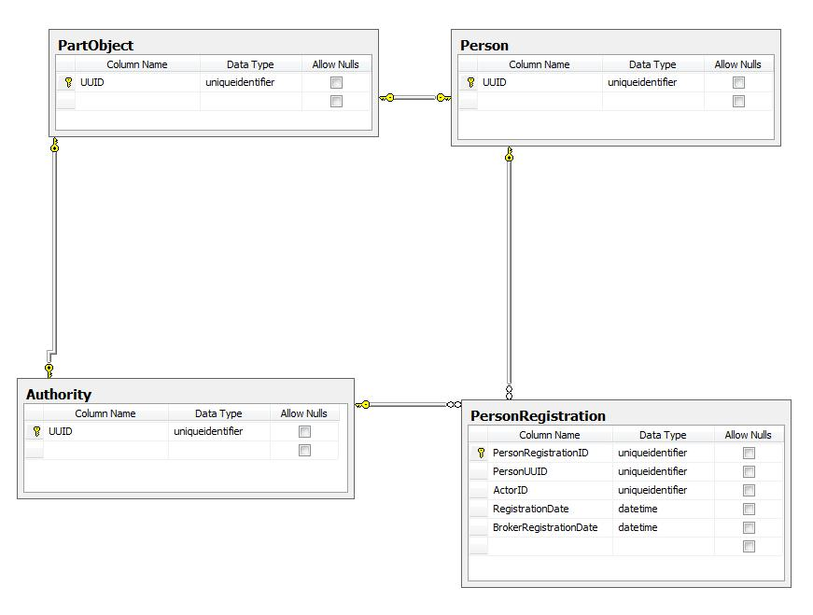

Time perspetives
The most important time perspective is the registration time. Effect time will be specified whenever available. An unknown effect start and/or end date will be expressed with a special value ( possibly null).

Mapping
The concept of a UUID is not known to the system’s data providers. Therefore the system use database table to map persons physical identifiers (UUIDs) to logical identifiers (the CPR number).
The values for mapping are obtained from a municipal API. If this is not possible, an error will be raised.

Registration object creation process

Values
Actors can be data providers, e.g., DPR or KMD. Each actor is assigned a fixed UUID. The registration date will be the latest date in the available data. If not possible, then the date when the broker got the data.
If everything goes OK, a registration is uniquely identified by person's UUID, an actor ID and a registration date. In the very rare cases when this is not unique (such as in race conditions), there might be more than one registration with the same date. They will all be saved in the local database.

Local database update

Data structures
The following diagrams describe the details of the registration object, apart from its actor and date.
Magenta will work based on this structure until the finalized schema is received from ITST.

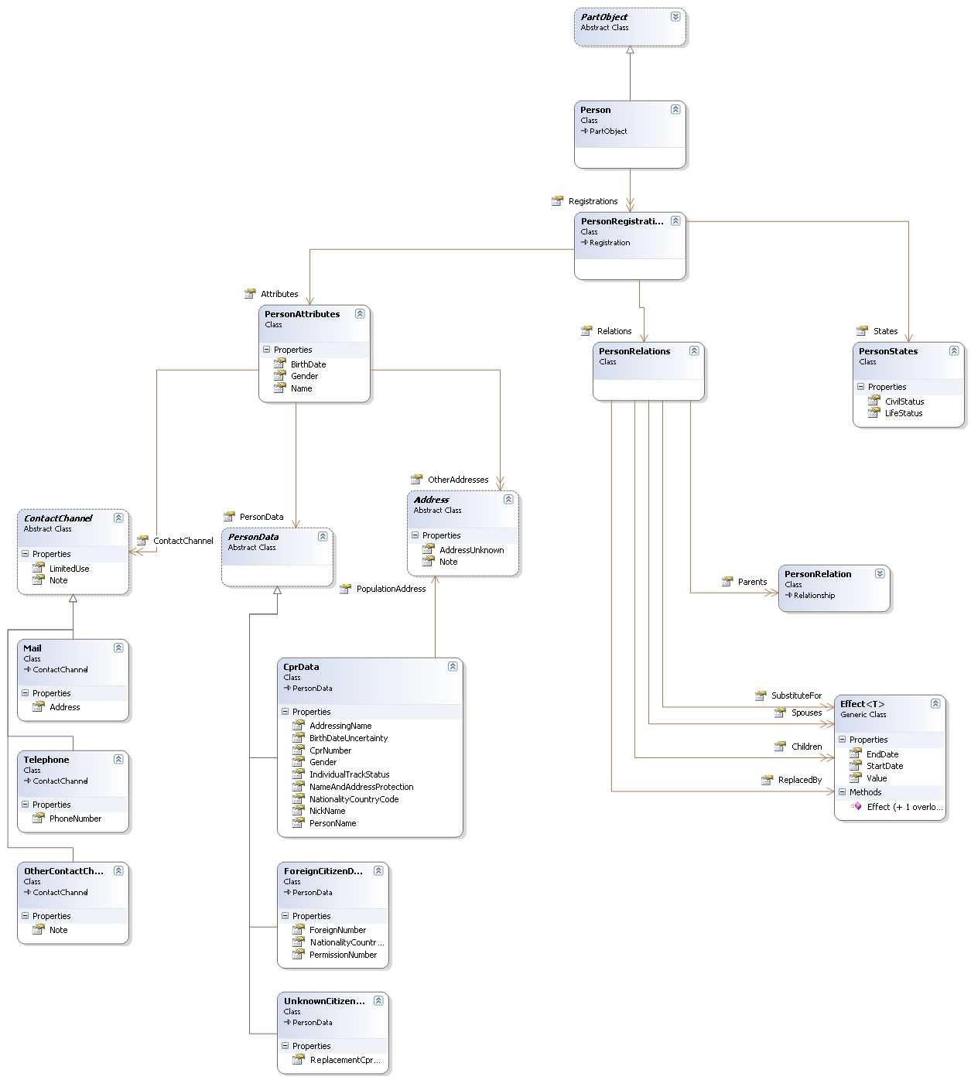

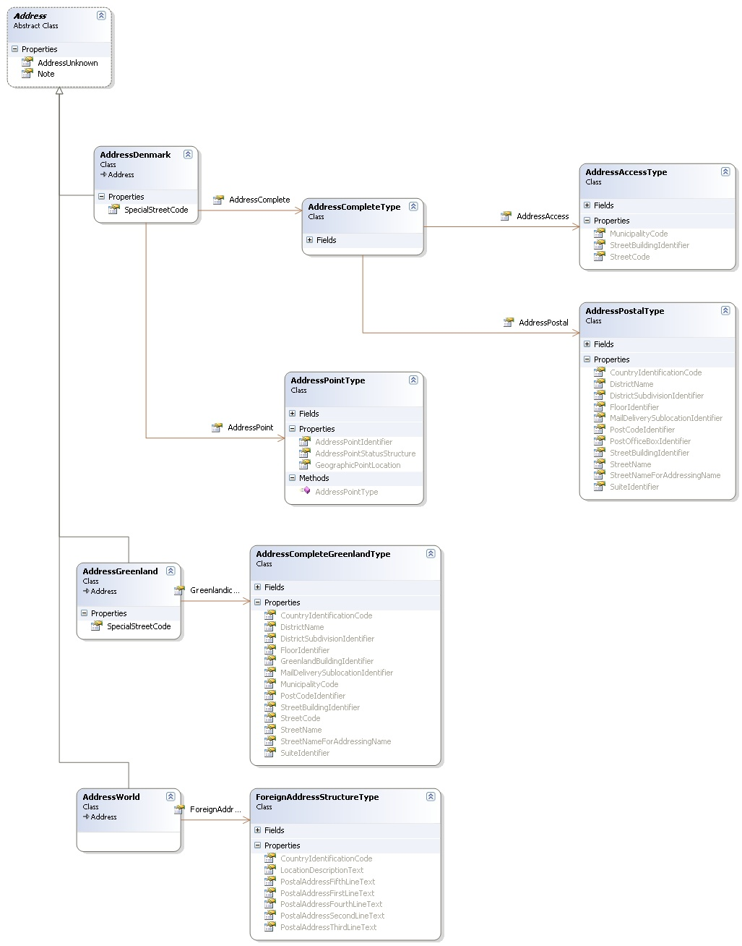

Read & List operations

There will be a refresh read operation which forces the broker to get new data from data providers.

Search operation
Search will be implemented for the local database only. It will contain the possibility to search for people by their CPR number, Age or Name.

Events

Client interface

Clients use the event broker web interface to register for events.
They receive notification as a call to the web service, they used when registering

Overall architecture

Subscription flow

Notifications

Data change events are detected as soon as they occur.
External events are detected when the PART web interfaces receives refresh calls from external event generators and the refresh call subsequent optains new data from a data provider. The external event generators can be services that polls data providers.
Birthdate events are detected daily.
The Event Broker service delivers the notifications to subscribers.

Daily notifications

Instantaneous data changed (caused by Read operations)

Notification channels

