PART Standard
for
CPR Broker

Workshop topics
Contents
1 Overview 3
2 Use cases 4
3 Request processing layers 5
4 Data Providers 6
5 Registrations 7
5.1 Database structure 7
5.2 Time perspetives 7
5.3 Mapping 7
5.4 Registration object creation process 8
5.4.1 Values 8
5.5 Local database update 9
6 Data structures 10
7 Read & List operations 12
8 Search operation 13
9 Events 14
9.1 Overall architecture 14
9.2 Subscription flow 15
9.3 Notifications 16
9.3.1 Daily notifications 16
9.3.2 Instantaneous data changed (caused by Read operations) 17
9.4 Notification channels 17

Overview
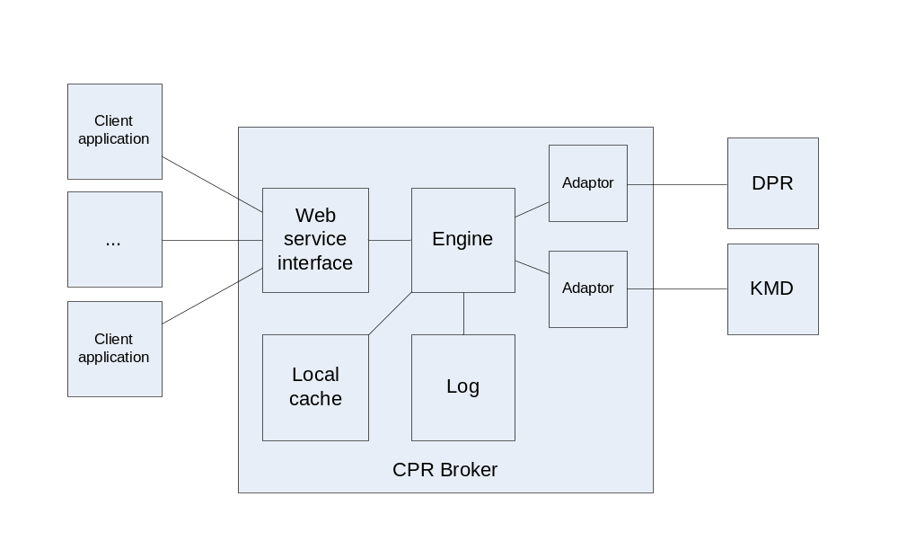

Use cases
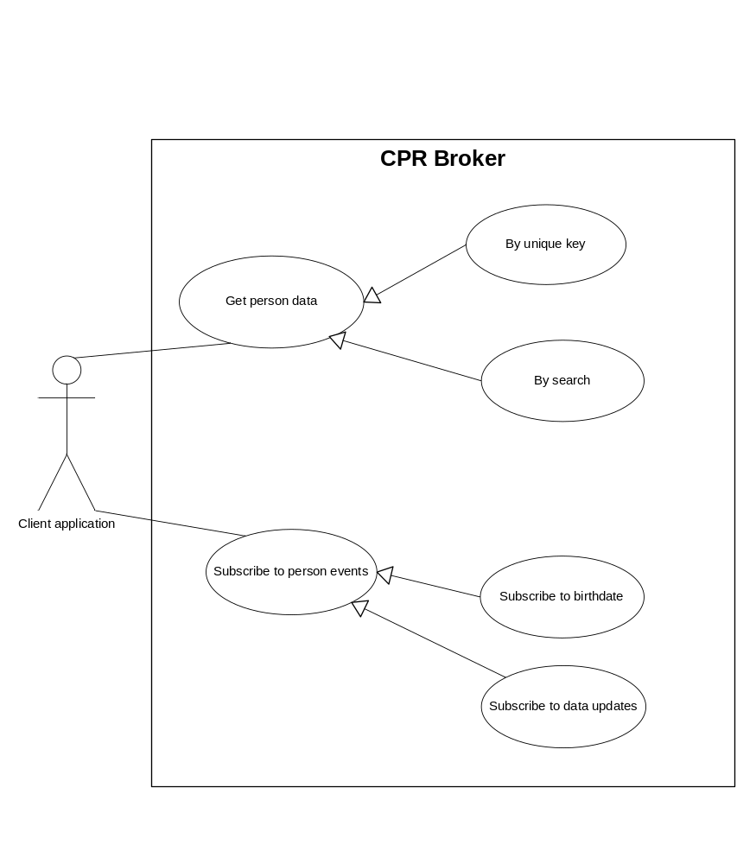

Request processing layers
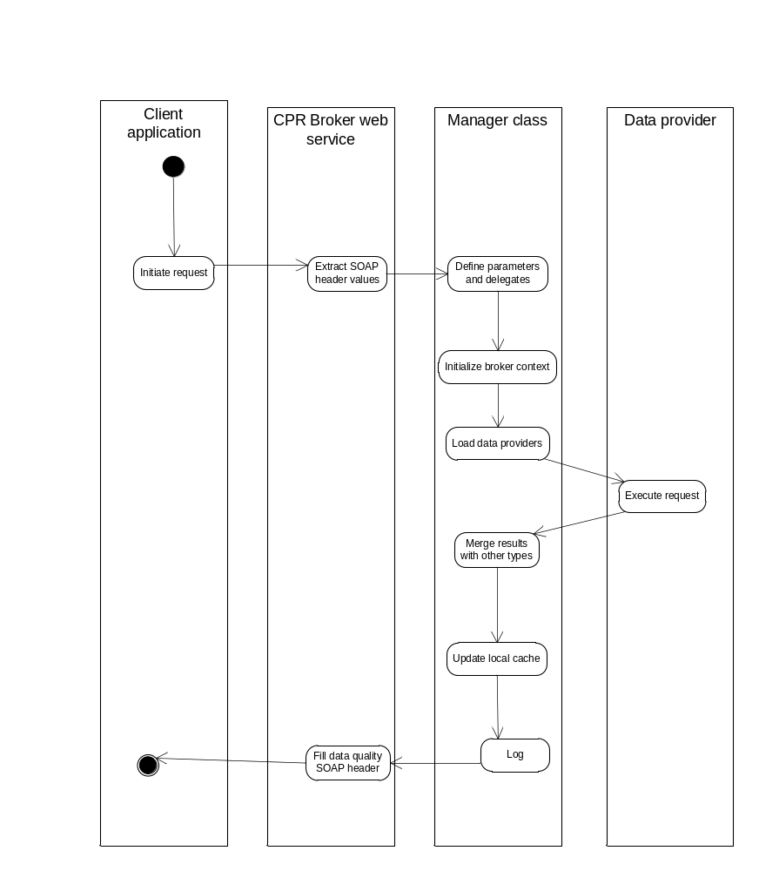

Data Providers
- Requests can only be handled with a data provider.
- A request maps to a method that is defined in a certain interface.
- A data provider implements one or more interface(s)
- An entry is added to the log in all cases
- There will be support for addition of data providers for contact info and medical info. However, no real data providers wll be implemented.
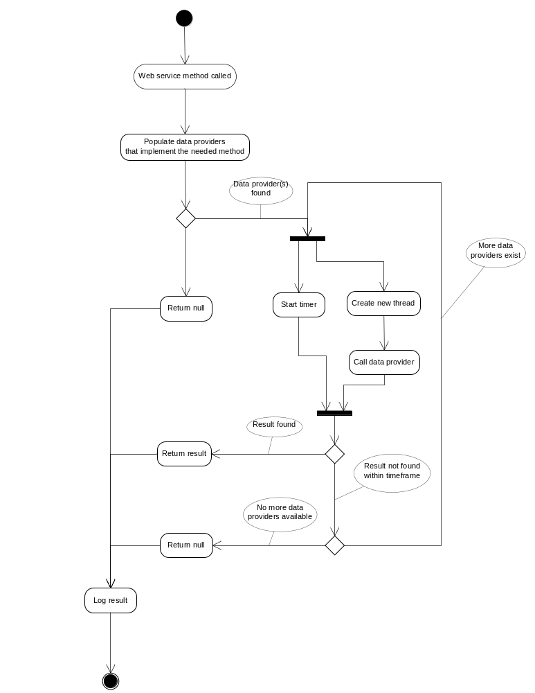

Registrations

Database structure
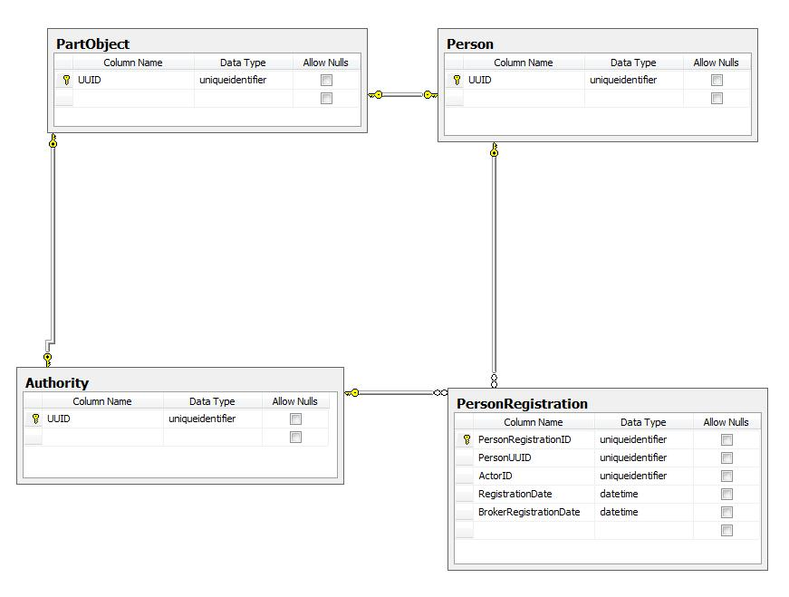

Time perspetives
The most important time perspective is the registration time. Effect time will be specified whenever available. An unknown effect start and/or end date will be expressed with a special value ( possibly null).

Mapping
The concept of a UUID is not known to the system’s data providers. To solve this, the system will have a mapping object (database table) that maps a person’s physical identifier (UUID) to his logical identifier. The logical identifier would be the CPR number.
The values for mapping will be obtained from a municipal API. If this is not possible, an error will be raised.

Registration object creation process
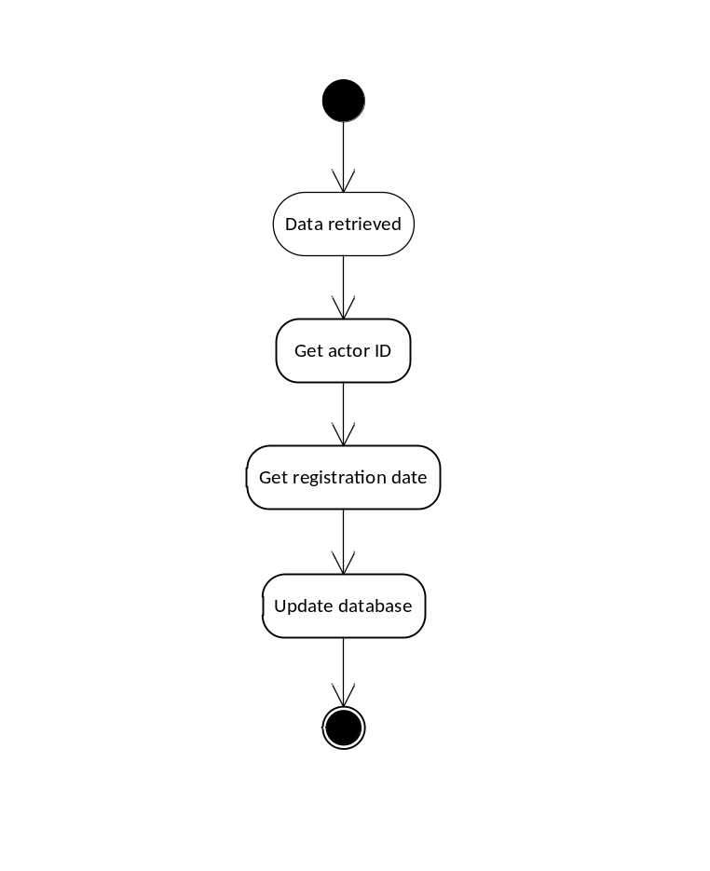

Values
The actor will be considered either DPR or KMD. Each will be assigned a fixed UUID. The registration date will be the latest date in the available data. If not possible, that would be the date when the broker got the data.
If everything goes OK, then a registration is uniquely identified by person's UUID, an actor ID and a registration date. In the very rare cases when this is not unique (such as in race conditions), there might be more than one registration with the same date. They will all be saved in the local database.

Local database update
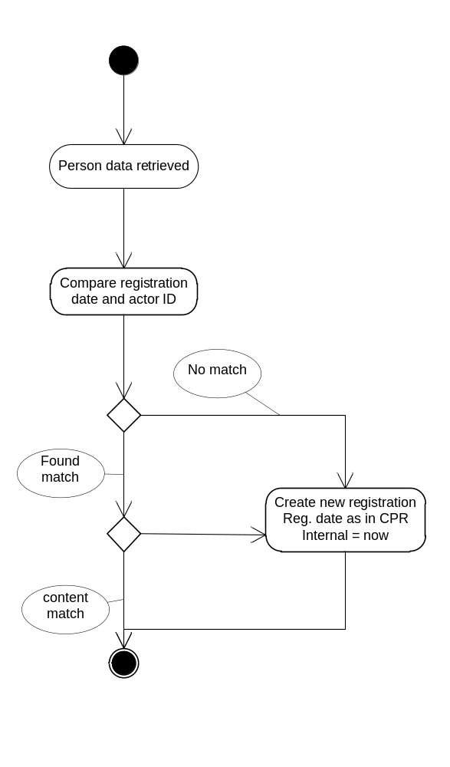

Data structures
The folowing diagrams describe the details of the registration object, apart from its actor and date.
Magenta will work based on this structure until the finalized schema is received from ITST.

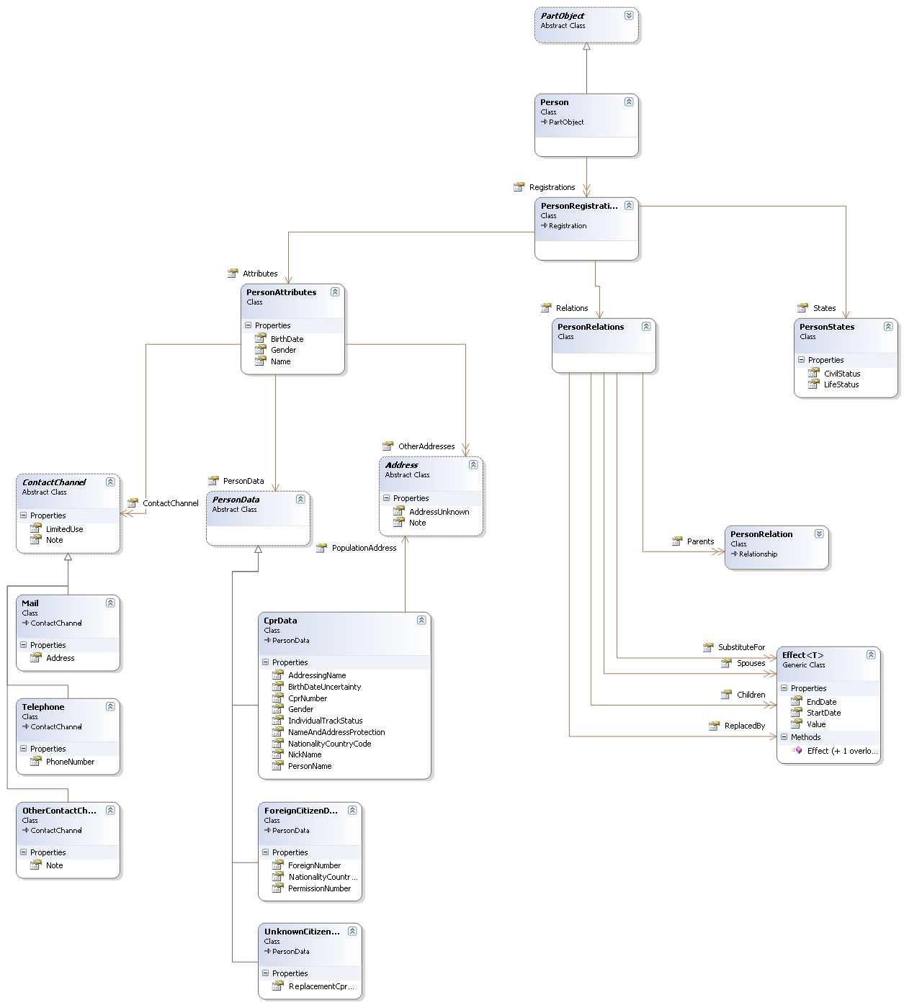

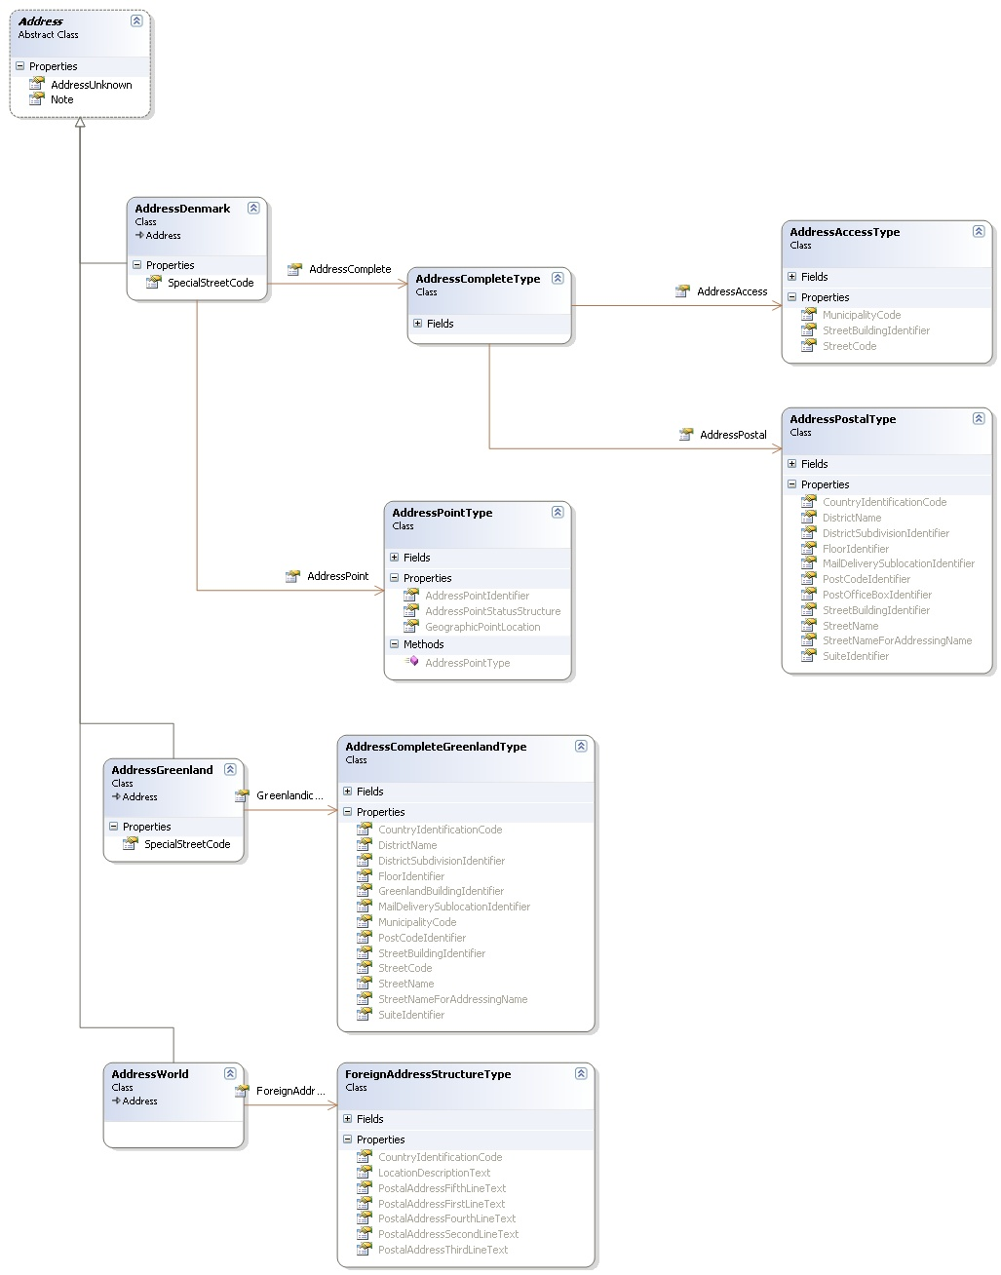

Read & List operations
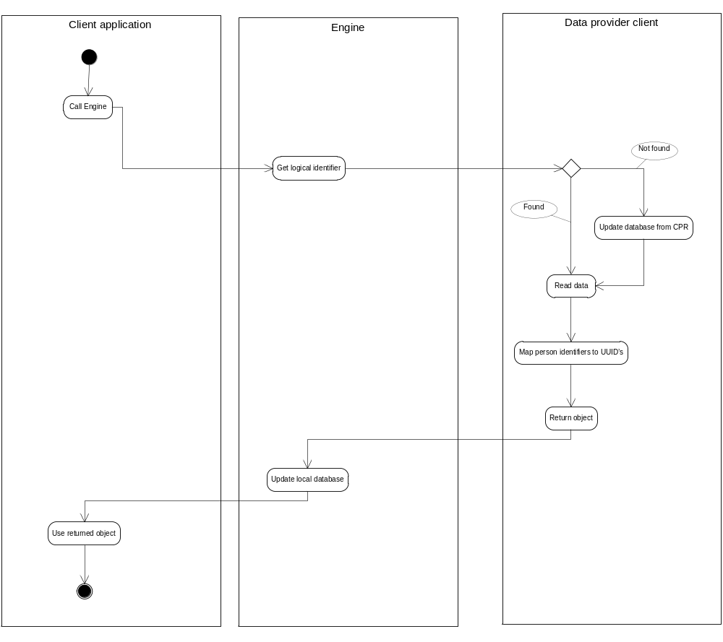
There will be a refresh read operation which forces the broker to get new data rom data providers.

Search operation
Search will be implemented for th local database only. It will contain the posibility to search for people by their CPR number, Age or Name.
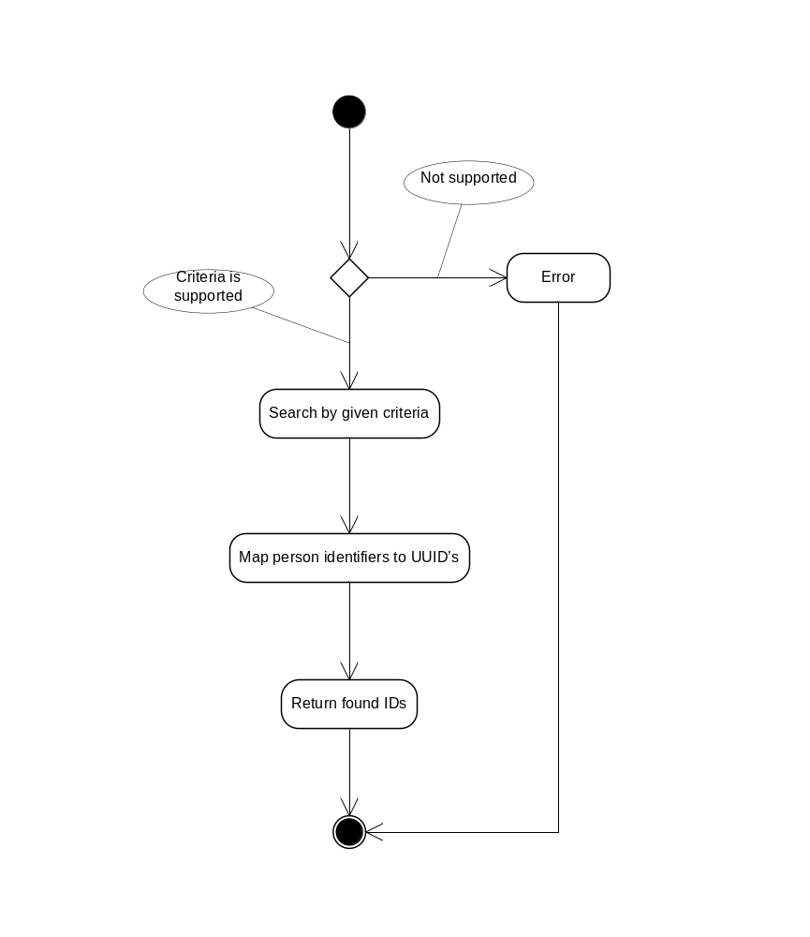

Events

Overall architecture
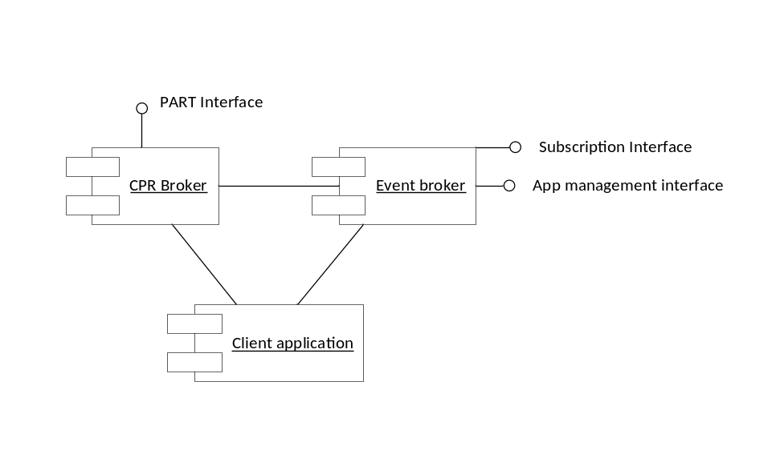

Subscription flow
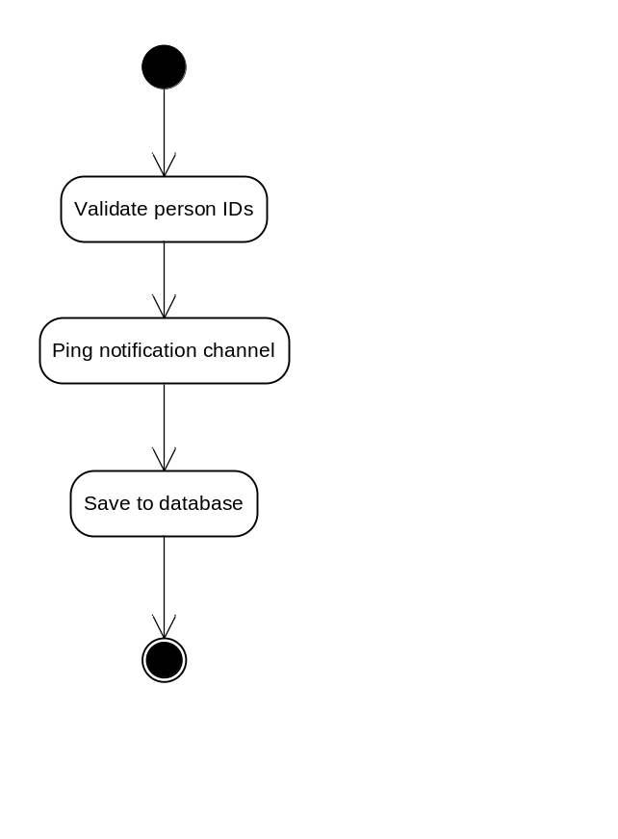

Notifications
- Data change events are detected as soon as they occur.
- An extract from DPR might be parsed daily to find which people have changed.
- Birthdate events are detected daily.
- A separate windows service handles the notifications.

Daily notifications
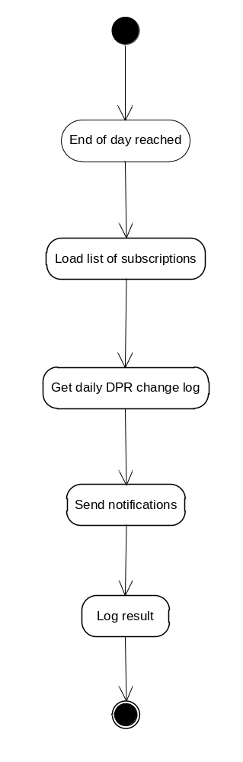

Instantaneous data changed (caused by Read operations)

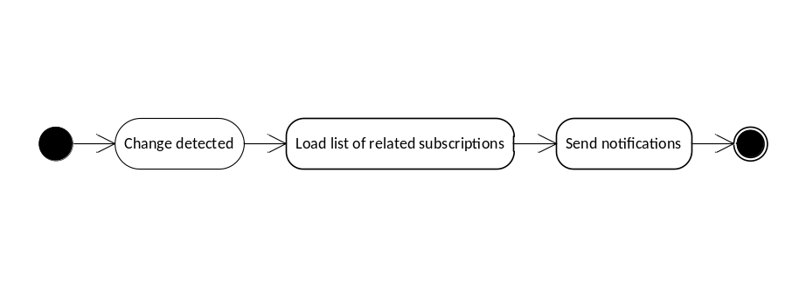

Notification channels
