Table of Contents

Chapter No: 1 2

1.1. Introduction 2

1.2. Scope 3

1.3. Functional Requirements 3

The functions of the system are 3

Chapter No: 2 5

2.1 Hardware/Software requirements 5

1.3.2. Hardware 5

1.3.3. Software 5

Database Design 6

Flow Diagram 7

# Chapter No: 1

**INTRODUCTION**

## Introduction

Haqeeqi is a global online marketplace. Haqeeqi marketplace is a platform for buying

And selling services and goods e.g. Real Estate, Electronics, Furniture, Household goods, Vehicles.

## Scope

This marketplace will allow a user to make post for buying and selling things on online platform. A user will buy and sell any product online by communicate with each other. It will allow a user to find any product of his interest.

## Functional Requirements

Using this online marketplace platform, users will be able to find products of their interest and they will be able to buy and sell any product e.g. Household goods, Vehicles, Furniture etc.

The functions of the system are**:**

1. Signup
2. Login
3. Make Profile
4. Make Post
5. View Posts
6. Search Post
7. Select Post
8. Chat with seller

#### Login

In this the user gives his email and password as input, the system then verifies whether the account stored in data base matches or not, if it matches then it allows the user to use the system else it asks to enter the email and password again.

#### Signup

In this the user will enter his valid email address after submit user will have a verification code after putting verification code he will be redirected to the page in which system will ask for the password after enter your password user will be redirected to page that will ask user valid phone number after putting valid phone number he will receive the confirmation code on his phone number and after enter verification code his account will be created and he will redirect to dashboard of his account .

#### Make Profile

This system will ask the user to put his information like about the user, address where he used to live and his profile picture for the account. He can update his profile.

#### Make Post

In this function of the system user will be able to sell his product. He will have to make a post to sell his product to show his product. System will ask few things to make a post. After enter every required fields post will be created and will be gone to admin for verification it will take a time to be visible for user after activated from admin the post will be shown to any user.

#### View Posts

In the system user will be able to see any post of his interest. He can view post by using filters like post of specific category, post of specific sub-category, post of specific place, post of specific price, post of specific region etc.

#### Search Post

The user will be able to search a post. He can search post of his interest like by category, sub-category, location, type, name of product, price or within the range of location etc.

#### Select Post

After search any post user will be able to select/view a post of his need or interest. After selecting a specific post he can view the details, description, price and location of the post where form it being posted.

#### Chat with seller

After selecting a post of your interest user will be able to see the seller user number he can make a call with seller on mobile phone for further details or he can chat with that user through the system.

**TECHNOLOGIES TO BE USED**

1. **Language to be used: Php7, Laravel, Jquery,AJAX**
2. **Tools to be used: Github, Sublime, SourceTree**

# Chapter No: 2

**Software Requirements and System Design**

## Hardware/Software requirements

### Hardware

1. A minimum computer system that will help you access all the tools in the courses is a Pentium 166 or better
2. 64 Megabytes of RAM or better
3. Windows 98 (or higher if possible)

### Software

**Either or combination of the following Software’s are to be used:**

* Sublime/HTML editor/Laravel editor
* XAMPP Server

# Database Design

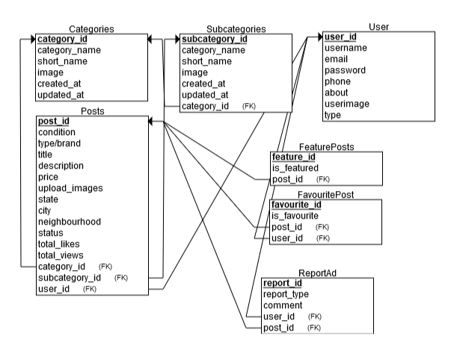

# Flow Diagram

Login

See all Posts

Make Post

Logout

Connect with seller

Search Post

Haqeeqi